Unit 4: Research Based Instructional Strategies (RBIS) Math

Lesson 4.07: Productive Struggle: Encouraging Productive Struggle in the Classroom

Lesson at Glance
Warm-Up (10 mins)  - Bellringer (5 mins)  - Bellringer Review (5 mins) | Instruction (10 mins)  - Notes: Encouraging Productive Struggle through the Use of High-Quality Instructional Materials (5 mins)  - Modeling: Analyzing Mathematics Tasks from High-Quality Instructional Materials (5 mins) | Application (25 mins)  - Guided Practice: Analyzing Mathematics Tasks from High-Quality Instructional Materials (10 mins)  - Practice: Reflection on Field Experiences (5 mins)  - Debrief (5 mins)  - Exit Ticket (5 mins)

TEKS | 4 | The student understands the learning and learning process. The student is expected to:  - Apply principles and theories about the learning process to specific teaching or training situations.  - Analyze the dynamics of educator and student behaviors that facilitate the learning process.  - Analyze teaching skills that facilitate the learning process
TEKS | 5 | The student interacts effectively in the role of educator. The student is expected to:  - Demonstrate and evaluate techniques that promote literacy and numeracy
TEKS | 6 | The student plans and uses effective instruction. The student is expected to:  - Apply research-based practices to create lessons plans that meet instructional goals.  - Analyze the development of effective instructional strategies.  - Evaluate and analyze effectiveness of lessons plans and instructional strategies used in a lesson or series of lessons
Objectives | - Identify and apply strategies that encourage productive struggle in mathematics instruction
Rationale/  Summary | Students will continue to build on the discussion of productive struggle in mathematics instruction. Students will explore how the use of high-quality instructional materials encourages productive struggle in the classroom and supports students in developing their understanding of mathematics.
Formative Assessment and Exemplar Response | Review the mathematics questions below and respond to the questions that follow.  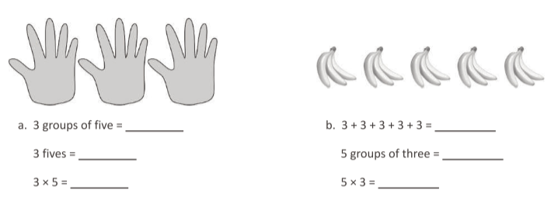  Question from Eureka Math: TEKS Edition, Grade 3, Modules 1 & 2. Learn Book.  Do these questions align with the mathematics TEKS for third grade that we reviewed in class?  Do these questions provide multiple entry points for a student? If so, how?  How might students struggle with these questions? How would you help struggle productively through those challenges?  See Exit Ticket Answer Key for exemplar responses.
Vocabulary

Est Time | Instructional Activities (including formative assessments) | Materials
5 mins | Bellringer:  Think about the strategies for productive struggle from the last lesson. Which of these strategies will be most difficult for you to use as a teacher? Why? Which strategy will be easiest to use? Why? | Student Guide
5 mins | Bellringer Review  T: In your bellringer, you thought about using the strategies we discussed during our last lesson. Can I have a volunteer share which strategy they think will be most difficult to use as a teacher? Please share your reasoning.  S: Responses may vary but may include:  - It will be most difficult for me to ask questions when students get stuck because I will not want them to get discouraged.  - It will be most difficult for me to give students time to struggle. I will be worried that they will just give up if they cannot get the correct answer quickly.  T: Can I have a volunteer share which strategy they think will be easiest to use as a teacher? Please share your reasoning.  S: Responses may vary but may include:  - It will be easiest for me to give students time to engage in productive struggle because I work slowly, so I always like to give people time to figure things out.  - It will be easiest for me to praise students even when they do not solve a problem successfully because I will want to encourage them to try their best. | Student Guide
5 mins | Notes: Encouraging Productive Struggle through the Use of High-Quality Instructional Materials  T: Throughout this course, we have discussed the importance of using high-quality instructional materials. Another reason to use them is how they encourage students to engage in productive struggle. In your Student Guide, you will find a blank graphic organizer where you can add details on how the materials do this.  T: High-quality instructional materials ask students to engage with grade-level content, which ensures that there are high expectations for students to meet.  T: High-quality instructional materials also give students opportunities to engage with the content in different ways. As we discussed in the previous lessons, one of the ways that students can struggle productively is by trying to solve problems in different ways.  T: When a teacher plans to use high-quality instructional materials, part of the planning process can focus on identifying the misconceptions that students might have and how they can support them with struggling productively through those misconceptions.  T: (Display completed graphic organizer on PowerPoint slide.)  S: (Complete graphic organizer in Student Guide.) | Student Guide  PowerPoint
5 mins | Modeling: Analyzing Mathematics Tasks from High-Quality Instructional Materials  T: You will see two, related third-grade mathematics problems. I am now going to model how a teacher can review these problems and assess the extent to which they will encourage students to engage in productive struggle.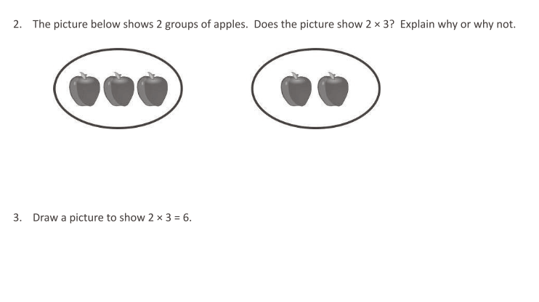Question from Eureka Math: TEKS Edition, Grade 3, Modules 1 & 2. Learn Book.  T: (Display problems on PowerPoint slide.)  T: As I model, complete the questions about these problems in your Student Guide.  T: Can I have a volunteer read the first question I need to answer?  S: How do these problems present students with grade-level content?  T: A few of the mathematics TEKS for third grades are:  - The student is expected to determine the total number of objects when equally-sized groups of objects are combined or arranged in an array up to 10 (3.4D).  - The student is expected to represent multiplication facts by using a variety of approaches such as repeated addition, equal-sized groups, arrays, area models, equal jumps on a number line, and skip-counting (3.4E).  These questions are aligned to those TEKS.  T: Can I have a volunteer read the second question I need to answer?  S: How do these questions give students opportunities to engage with the content in different ways?  T: For the first question, students need to explain their answer, and they can do so using words, pictures, or other methods. Additionally, when explaining their answer, they can use their knowledge of any of the ways to conceptualize multiplication. For the second question, they can show multiplication in a few different ways.  T: Can I have a volunteer read the third question I need to answer?  S: What misconceptions might students have? How can I help them struggle through them?  T: For the first question, students could struggle because they see groups of apples, and they think that multiple groups of items represented a multiplication problem. Based on this thinking, they might answer “yes” to the question. One of ways I can help them is by asking them how many apples appear in each group. For the second question, students may have memorized that 2 X 3 is 6, but they may not know how to draw it. One of the ways I can support them is by asking them to explain verbally what multiplication is. This might help them think about how to draw it.  S: (Complete questions in Student Guide.) | Student Guide  PowerPoint
10 mins | Guided Practice: Analyzing Mathematics Tasks from High-Quality Instructional Materials  T: Now, let us work through the process together. Take two minutes to review this mathematics problem.  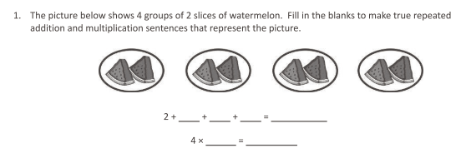  Question from Eureka Math: TEKS Edition, Grade 3, Modules 1 & 2. Learn Book.  T: (Display problem on PowerPoint slide.)  T: This time, you will answer the questions. Add the answers to your Student Guide.  T: How do these problems present students with grade-level content?  S: They are aligned with the same TEKS as the first two problems.  T: How do these questions give students opportunities to engage with the content in different ways?  S: The two equations with the blanks represent different ways of conceptualizing multiplication.  T: What misconceptions might students have? How can I help them struggle through them?  S: The students might count the watermelon slices and know that the answer is eight. But they might now know how to fill in the blanks before the equal signs. I could help them by asking them to describe the picture in words, which might help them with filling in the blanks.  S: (Complete questions in Student Guide.) | Student Guide  PowerPoint
5 mins | Practice 2: Reflection on Field Experiences  T: In your Student Guide, you will find a series of questions that ask about times when you have seen (or not seen) teachers use high-quality instructional materials to encourage students to engage in productive struggle. Please respond to those questions. You have five minutes.  T: (Set five-minute timer).  S: (Complete questions in Student Guide.) | Student Guide
5 mins | Debrief  T: Can I have a volunteer share an example of when they have seen a teacher use high-quality instructional materials to encourage students to engage in productive struggle?  S: Responses will vary based on field site experiences.  T: Can I have a volunteer share where a teacher did not use high-quality instructional materials to encourage students to engage in productive struggle.  S: Responses will vary based on field site experiences. | Student Guide
5 mins | S: (Complete the Exit Ticket.) | Exit Ticket

