Unit 4: Research Based Instructional Strategies (RBIS) Math

Lesson 4.09: Curriculum-Embedded Supports

Lesson at Glance
Warm-Up (5 mins)  - Bellringer | Instruction (17 mins)  - Bellringer Debrief (2 mins)  - Notes: Curriculum Embedded Supports (5 mins)  - Teacher Model Example: Curriculum Embedded Supports (10 mins) | Application (23 mins)  - HQIM Analysis for UDL Guidelines (13 mins)  - Debrief (5 mins)  - Exit Ticket (5 mins)

TEKS | 4 | The student understands the learner and learning process. The student is expected to:  - demonstrate and evaluate effective instructional practices to accommodate diversity such as learning differences, learner exceptionality, and special-needs.
TEKS | 5 | The student interacts effectively in the role of educator. The student is expected to:  - demonstrate and evaluate techniques that promote literacy and numeracy
Objectives | - Identify examples of curriculum-embedded supports  - Analyze samples of curriculum-embedded supports to determine alignment with UDL guidelines for engagement, representation, and/or action & expression
Rationale/  Summary | A knowledge of the Universal Design for Learning (UDL) Guidelines provides a framework to guide teaching and instructional decision-making. Through UDL, teachers can help all students engage with the grade level content. The approach to supporting unfinished learning is important in math because math builds on itself. In this lesson, students will identify the UDL approaches in high quality instructional materials and how those approaches will increase opportunities for student learning.
Formative Assessment and Exemplar Response | Consider your own field experience during your classroom visits. What examples of UDL strategies have you seen your teacher (or other teachers) use?  Mr. L is teaching his fourth-grade math students how to add decimal numbers. The students are doing well with the content. Therefore, as an in-class activity to show their understanding, Mr. L asks students to write their own word problem using decimals and demonstrate how to solve the problem. How does this assignment meet the criteria for UDL guidelines? How does it not? What else could Mr. L do to make this assignment more accessible for all students?  See Exit Ticket Answer Key for exemplar responses.
Vocabulary | Universal Design for Learning (UDL) |  | An educational framework to guide the development of flexible learning environments that can accommodate individual learning differences through engagement, representation, and expression. UDL minimizes barriers and maximizes learning for all students.

Est Time | Instructional Activities (including formative assessments) | Materials
 | This lesson potentially needs multiple class periods to complete. Please consider your specific scheduling needs when determining the timing of activities in this lesson.
5 mins | Bellringer:  Do you agree or disagree with the quote below?  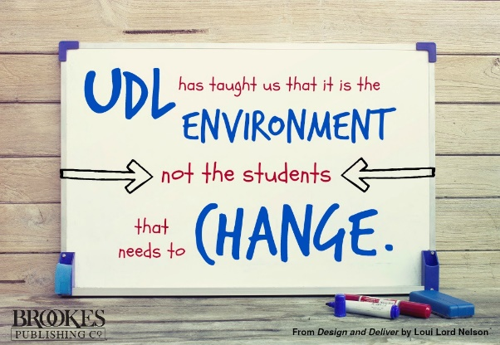  Why might some teachers find UDL practices to be challenging to implement in the math classroom? | Student Guide  PowerPoint
2 mins | Bellringer Debrief  T: Do you agree or disagree with the quote in your bellringer? Why?  S: (Share answers.)  T: Why do you think that some teachers would find UDL practices challenging in their math class?  S: (Share answers.) | Student Guide  PowerPoint
5 mins | Notes: Curriculum Embedded Supports  T: Let us recall some of our notes from our previous class. What is UDL?  S: UDL is the Universal Design for Learning. It is an educational framework to guide the development of flexible learning environments that can accommodate individual learning differences through engagement, representation, and expression.  T: Today we are going to look at high quality instructional materials for evidence of multiple means of engagement, representation, and action and expression. First, we will quickly review what those strategies look like in a classroom.  T: Will someone read the description of multiple means of engagement? (Display on PPT.)  S:  - Allowing students choice in how they might reach a learning target.  - Providing opportunities for students to engage in learning experiences that are relevant and valuable to their goals and individual interests.  - Creating a supportive environment where students feel safe to learn and take risks.  T: Great. Multiple Means of Engagement deals with how students are motivated to learn. Different motivations will exist for the students in your classroom, so allowing them to have some ownership in how they learn materials can help the students to better engage with the content and increase their interest in learning.  T: Will someone read the description of multiple means of representation?  S:  - Offering options for customizing the display of information  - Offering alternatives for auditory information  - Offering alternatives for visual information  T: Multiple Means of Representation focuses on how content is presented to students. It is important that teachers consider what supports may help students to learn and implement those supports when discussing new material.  T: Lastly, would someone please read the description of Multiple Means of Action and Expression?  S:  - Allowing students to share their learning in different ways.  - Providing alternative ways for students to interact with instructional materials and their environment.  - Providing access to and support with tools and assistive technologies  - Providing opportunities for students to communicate using multiple forms of media.  - Supporting learners in setting challenging and authentic goals  - Provide flexible tools and processes to support organization and memory.  T: Students do not always express what they know with the same strengths. Some students are great at written responses, while some might need to explain something orally or through drawings. If students can explain their learning through multiple means, the teacher can better understand what the student has mastered and the skills with which they are still struggling. | Student Guide  PowerPoint
10 mins | Teacher Model Example: Curriculum Embedded Supports  T: Let us look together at an example of a fourth-grade lesson from Eureka Math. (Pass out lesson plan copies or share digitally.)  T: You can choose to review this lesson plan on your own or with a partner. Take five minutes to annotate your lesson plan. Highlight all the areas where you see UDL strategies being used and make a note of what they are.  S: (Annotate document.)  T: (Circulate to assist students when necessary.)  T: Did you notice anything unique about this lesson plan regarding the UDL practices we have discussed?  S: There was a box that had notes on Multiple Means of Representation.  T: Correct. This lesson identifies ways to assist English Language Learners by scaffolding the use of variables. Why might this be helpful?  S: Because students who struggle with reading and/or are not native English speakers may be confused by the addition of letters into the math concept. The use of blanks and then question marks could give them a visual cue of what the letters represent.  T: There were other ways this lesson addresses the UDL guidelines we have discussed, although not explicitly written in the lesson. What did you notice that might fit one of our UDL guidelines?  S: (Answers will vary, fill out classroom chart on board.) | Student Guide  PowerPoint  Eureka Math Grade 4 Lesson
13 mins | HQIM Analysis for UDL Guidelines  T: Now it is your turn to analyze a lesson for the use of UDL strategies. You will look for evidence of Multiple Means of Engagement, Representation, and Action and Expression. Find the graphic organizer in your Student Guide titled “HQIM Analysis for UDL Guidelines.”  S: (Locate graphic organizer.)  T: You will notice you also have a space in this graphic organizer to indicate your own UDL strategies that you think would be appropriate for meeting the guidelines for engagement, representation, or action and expression. This is a good way for you to begin considering your own instruction and how you would adapt materials to help students in your classroom.  T: (There are four lesson plan samples, allow students to pick or assign to students/groups. Some lesson plans may be used more than once.)  T: I will circulate and help you as you work on this task. You may work independently or with a partner.  T: (Circulates to help students when needed.)  S: (Analyze the HQIM sample for use of UDL strategies.) | Student Guide  PPT  Copies of Math Lesson Plan Samples (K-3rd grade)  Highlighters
5 mins | Debrief  T: What were some strategies that you noticed were used in the lesson plan you analyzed?  S: (Share with class what they noticed.)  T: What were some UDL strategies that you thought might be used to help students better understand the content?  S: (Share their unique UDL strategies.)  T: Using UDL strategies is important for learning because not all students learn the same ways. Providing multiple means of engagement, representation, and action and expression allows the student access to the strategies that help them learn best. | Student Guide
5 mins | S: (Complete the Exit Ticket.) | Exit Ticket

