Student Guide – Answer Key

Lesson 4.09: Curriculum Embedded Supports
Date:
Bellringer:
Do you agree or disagree with the quote below? Answers will vary.

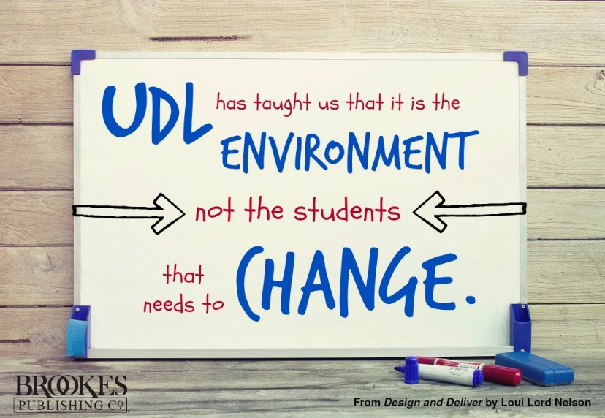

Why might some teachers find UDL practices to be challenging to implement in the math classroom?
Answers will vary but may include: teachers might struggle to produce multiple means of representation, the materials the teacher is using does not include UDL strategies for math.

Teacher Model Example: Curriculum Embedded Supports
 | MM of Engagement | MM of Representation | MM of Action & Expression
What I Noticed | Answers will vary | Answers will vary but should include the example in the margin of text (scaffolding unknowns represented as letters.) | Answers will vary
Class Notes | Answers will vary | Answers will vary | Answers will vary

HQIM Analysis for UDL Guidelines
Lesson Title/Grade Level: Answers will vary
Examples of MM of Engagement | Answers will vary
Examples of MM of Representation | Answers will vary
Examples of MM of Action & Expression | Answers will vary
My Own UDL Suggestions for this Lesson | Answers will vary

