Student Guide

Lesson 4.11: Just-In-Time Supports for Acceleration
Name:
Date:
Bellringer:
Ms. L teaches Algebra 1. This week, she is introducing the slope-intercept form linear equation: y = mx + b. She feels confident that her students will be able to understand the terms and graph examples but is concerned that a few of her students have struggled to solve for an unknown variable in an equation. Once students need to solve for x, some of them will not be able to complete the assignment.
She decides to provide a targeted review of how to solve for unknown variables in an equation during her school’s study hall block the day before the lesson and asks the students who have the most difficulty on this topic attend. By providing this support, nearly 90 percent of her students were proficient on her exit ticket the following day.

1. Describe how Ms. L set her students up for success using the terms “acceleration” and “just-in-time interventions.”

Instruction: Planning Effective Just-In-Time Interventions Notes
Steps for Effective Just-In-Time Interventions | Description
- Identify Prerequisite Skills and Knowledge
- Schedule within the Scope and Sequence
- Design and Implement Appropriate Interventions

Practice 1: Applying the Steps of Just-in-Time Interventions for Acceleration
Mr. H is in his fourth-year teaching second grade. This year, he wants to be more intentional about using just-in-time interventions to support students with engaging in grade level content. Follow along with Mr. H as he completes the steps to developing a plan for his just-in-time interventions and respond to the questions along the way.

Step 1: Identify Prerequisite Skills and Knowledge
Mr. H first needs to identify the prerequisite skills and knowledge his students need to master his upcoming unit on Addition and Subtraction of Length Units. Using the following standards and assessment results, identify which prerequisite skills and knowledge Mr. H. should focus on with his Just-in-Time Intervention.
Grade 2, Module 2: Addition and Subtraction of Length Units
Grade Level Content Standards
Geometry and Measurement | The student applies mathematical process standards to select and use units to describe length, area, and time. The student is expected to:
2.9A | find the length of objects using concrete models for standard units of length;
2.9B | describe the inverse relationship between the size of the unit and the number of units needed to equal the length of an object;
2.9C | represent whole numbers as distances from any given location on a number line;
Foundational Standards
1.7A | use measuring tools to measure the length of objects to reinforce the continuous nature of linear measurement;
1.7B | illustrate that the length of an object is the number of same-size units of length that, when laid end-to-end with no gaps or overlaps, reach from one end of the object to the other;
1.7D | describe a length to the nearest whole unit using a number and a unit.

- Based on the standards above, what foundational concepts should students know to be successful on the 2nd-grade content?

- Why is it important that a student can do this before moving onto grade level content?

Based on his analysis of the standards, Mr. H provided a pre-test that includes the following questions:
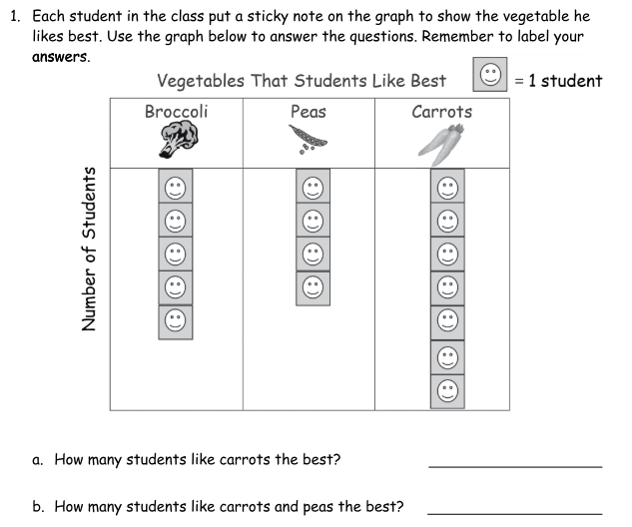
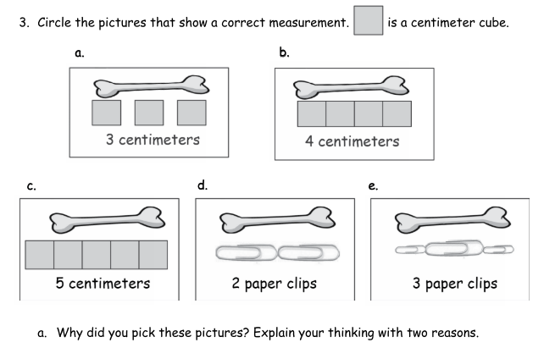
Source: Eureka Math, Grade 1, Module 3 Assessment.
In his class of 18 students,
- 17 students were able to correctly compare the units to identify student’s preferred vegetable.
- 12 students were able to correctly identify what pictures had the correct measurements in centimeter cubes.

- Given the results of this assessment, what concept should Mr. H focus on with his just-in-time intervention? How many students should be in this intervention group?

Step 2: Schedule within the Scope and Sequence
Mr. H uses the Eureka Math curriculum provided by his district. These high-quality instructional materials provide the following overview of the topics and objectives featured in this upcoming unit.
TEKS | Lesson Number | Lesson Topics |  | A
2.9A  2.9D  2.9B | 1 | Connect measurement with physical units by using multiple copies of the same physical unit to measure. |  | A
2.9A  2.9D  2.9B | 2 | Use iteration with one physical unit to measure.
2.9A  2.9D  2.9B | 3 | Apply concepts to create unit rulers and measure lengths using unit rulers.
2.9A  2.9D  2.9E  2.2E  2.2F | 4 | Measure various objects using centimeter rulers and meter sticks. |  | B
2.9A  2.9D  2.9E  2.2E  2.2F | 5 | Develop estimation strategies by applying prior knowledge of length and using mental benchmarks. |  | B
2.9A  2.9B  2.9D  2.2E  2.2F | 6 | Measure and compare lengths using centimeters and meters. |  | C
2.9A  2.9B  2.9D  2.2E  2.2F | 7 | Measure and compare lengths using standard metric length units and non-standard length units; relate measurement to unit size. |  | C
2.2E  2.2F  2.9C  2.9D  2.9E | 8 | Solve addition and subtraction word problems using the ruler as a number line.
2.2E  2.2F  2.9C  2.9D  2.9E | 9 | Measure lengths of string using measurement tools and use strip diagrams to represent and compare the lengths.
2.2E  2.2F  2.9C  2.9D  2.9E | 10 | Apply conceptual understanding of measurement by solving two-step word problems.

- Based on the sequence of topics and objectives provided by Mr. H’s high-quality instructional materials, at what point should he provide this just in time intervention (A, B, or C)? Explain your choice.

Step 3: Design and Implement Appropriate Interventions
To ensure his students get the most out of his just-in-time intervention, Mr. H’s needs to know how the skill in his intervention connects to the grade-level content his students are learning. Examine the Unit assessment question for the end of this unit below.
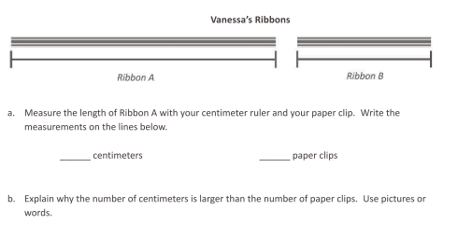
Source: Eureka Math, Grade 2, Module 2 Assessment.
- How does the content of his intervention connect to the grade level content his students must master?

Mr. H found the following math problems from the first-grade curriculum that he can use to support his students in reviewing the foundational skills within his just-in-time intervention.
Option: | Problem
 | 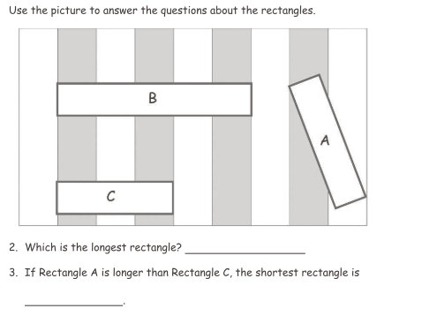
 | 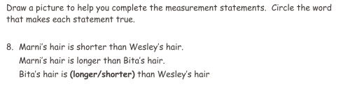
 | 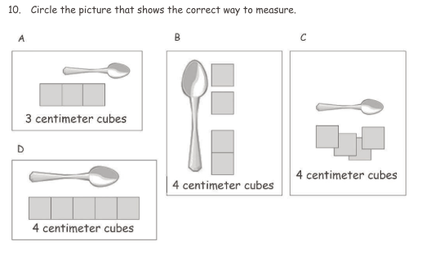
Source: Eureka Math, Grade 1, Module 3 Assessment.

- Which problem do you think best helps students access the grade level content shown in the unit assessment question? Explain your reasoning using the sample unit test question above.

