RBIS Math Intervention Portfolio Project

As part of your portfolio, you will be asked to plan, and if applicable implement, a just-in-time intervention in your internship classroom. This will require you work with your cooperating teacher to:
- Identify skills or knowledge that students need support with to master upcoming grade level math content.
- Select students for this intervention.
- Plan and implement a brief intervention (no more than 30 minutes) that provides a just-in-time intervention.
Respond to the following prompts to help plan and implement this intervention. If your cooperating teacher does not have a math block, please use the Sample Math Intervention Scenario to plan your intervention.

Step 1: Identify Prerequisite Skills and Knowledge
Based on your discussion with your field site teacher, summarize the selection of the just-in-time intervention content using the reflection questions below.
- What data was used to identify the gaps in student knowledge? (Pre-Test, Quiz, Unit Test, Benchmarks, STAAR results from previous year, etc.)

For my just-in-time intervention, I used data from a pre-test diagnostic that my cooperating teacher gave at the beginning of the school year.

- What grade-level content standards will be taught?

Grade 2 Math Standard 2.2D: use place value to compare and order whole numbers up to 1,200 using comparative language, numbers, and symbols (>, <, or =);
- Based on the data, what foundational skills or standards need to be addressed with just-in-time supports?

First Grade Math Standard 1.2G: use place value to compare and order whole numbers up to 1,200 using comparative language, numbers, and symbols (>, <, or =);

Step 2: Schedule using Scope and Sequence
Based on your discussion with your field site teacher, summarize the scheduling of the just-in-time intervention using the reflection questions below.
- When will you provide this intervention?

This intervention will be administered prior to lesson 15: Compare Numbers to 1,200 with <, >, and =. My cooperating teacher holds a small group math intervention during stations activities, and they will allow me to provide this intervention the week of October 19th.
- When will students engage with the grade level content this intervention supports?

Students will engage in this grade level content beginning in lesson 15, which will be taught the following week.
- What size group will benefit from this intervention (full group, small group, one on one)?

I will provide this intervention to a group of 5-6. If it goes well, I will provide the intervention to 5-6 more students later in the week.
Step 3: Design and Implement Appropriate Interventions
Based on your discussion with your field site teacher, summarize the design of the just-in-time intervention using the reflection questions below.
- Provide at least two examples of math problems that address the foundational skills taught in your just-in-time intervention.

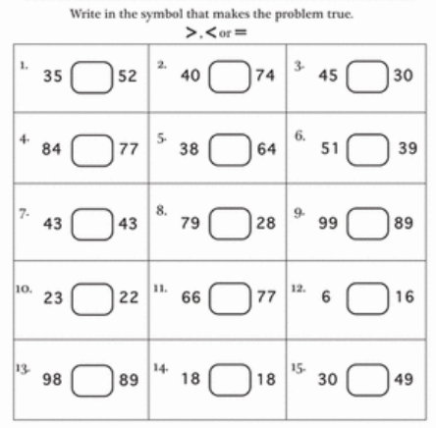
- Provide an example of a math problem that addresses the grade-level content standard students must be prepared to engage.

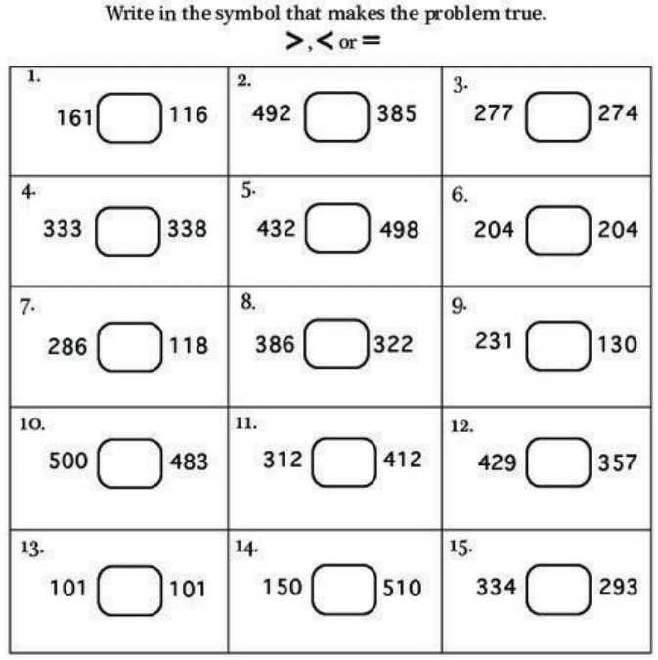
- Explain how the foundational skills address knowledge needed to master the grade level content.

For students to be able to know how to compare these integers up to 1,200 using greater than, less than or equal to, they must be able to know how to compare integers up to 100. They need to know how to use the symbols, and understand how place value of ones, tens, and hundreds so that they can apply the same concept to the thousands place.
- What instructional pitfall should you most need to avoid when leading this intervention? How will you avoid it?

It is easy for students to just drill problems using less than, greater than, and equal to. It will be important to provide multiple ways to engage with the content and use creative ways to visualize the differences between numbers to know how they compare.

Step 4: Reflection
If you WERE ABLE to lead this just-in-time intervention with students, answer the following reflection prompts. (If not applicable, write N/A)
- From your perspective, do you think students were able to improve their foundational skills addressed in the just-in-time intervention? How do you know?

Yes, students consistently were able to correctly identify the relationship between the integers and use the correct symbol for greater than, less than, or equal to. They were also able to do it when it was presented in different formats, including visual representations of numbers as opposed to the integers themselves.
- Did this help students engage with the grade level content? (You may need to discuss with your supervising teacher.)

Yes, students who received the intervention were able to master the grade level content, based on their exit ticket. Ms. Q indicated that students felt more comfortable with the grade-level content because they had the practice beforehand.
If you WERE NOT ABLE to lead this just-in-time intervention with students, answer the following reflection prompts: (If not applicable, write N/A)
- How would you know if students were successful in improving their foundational skills during the just-in-time intervention?

Students would know how to use each symbol, they would recognize the relationship between the place value and the need for each symbol, they would be able to apply the information regardless of if the numbers being compared are presented as integers or as pictures or manipulatives.
- What other foundational skills may students need to master to successfully engage with the grade-level content standards?

Students would need to know the thousands place and how to write these expressions in a sentence, not just as a symbol. They would also need to be able to define whole numbers and place value.

