Student Guide

Lesson 4.07: Productive Struggle: Strategies in Action
Name:
Date:
Bellringer:
Think about the strategies for productive struggle from the last lesson. Which of these strategies will be most difficult for you to use as a teacher? Why? Which strategy will be easiest to use? Why?

Notes: Encouraging Productive Struggle through the Use of High-Quality Instructional Materials
How do high-quality instructional materials encourage productive struggle?
1
2
3

Guided Practice: Analyzing Mathematics Tasks from High-Quality Instructional Materials
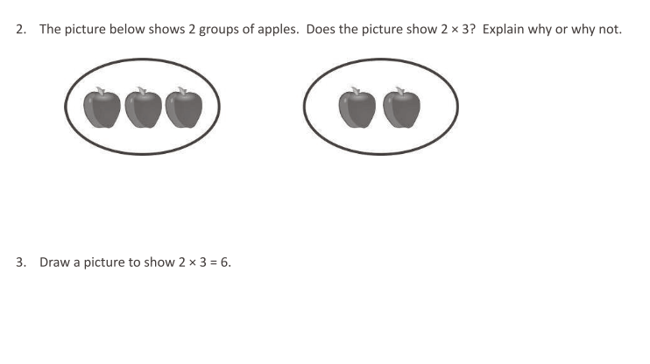
Question from Eureka Math: TEKS Edition, Grade 3, Modules 1 & 2. Learn Book.
How do these problems present students with grade-level content?

How do these questions give students opportunities to engage with the content in different ways?

What misconceptions might students have? How can I help them struggle through them?

Guided Practice: Analyzing Mathematics Tasks from High-Quality Instructional Materials
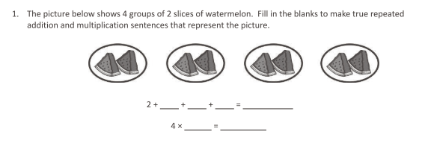
Question from Eureka Math: TEKS Edition, Grade 3, Modules 1 & 2. Learn Book.
How do these problems present students with grade-level content?

How do these questions give students opportunities to engage with the content in different ways?

What misconceptions might students have? How can I help them struggle through them?

Practice: Reflection on Field Experiences
In your field site, you may have seen teachers use high-quality instructional materials to encourage students to engage in productive struggle. If you have, describe a few examples below. What was the outcome? If you have not seen teachers engage students in productive struggle using high-quality instructional materials, provide examples of a few opportunities where they could have done so. How could they have engaged students in a more productive way?

