Student Guide – Answer Key

Lesson 4.07: Productive Struggle: Strategies in Action
Name:
Date:
Bellringer:
Think about the strategies for productive struggle from the last lesson. Which of these strategies will be most difficult for you to use as a teacher? Why? Which strategy will be easiest to use? Why?
Responses may vary but may include:
- It will be most difficult for me to ask questions when students get stuck because I will not want them to get discouraged. It will be easiest for me to give students time to engage in productive struggle because I work slowly, so I always like to give people time to figure things out.
- It will be most difficult for me to give students time to struggle. I will be worried that they will just give up if they cannot get the correct answer quickly. It will be easiest for me to praise students even when they do not solve a problem successfully because I will want to encourage them to try their best.

Notes: Encouraging Productive Struggle through the Use of High-Quality Instructional Materials
How do high-quality instructional materials encourage productive struggle?
1 | High-quality instructional materials ask students to engage with grade-level content, which ensures that there are high expectations for students to meet.
2 | High-quality instructional materials also give students opportunities to engage with the content in different ways. As we discussed in the previous lessons, one of the ways that students can struggle productively is by trying to solve problems in different ways.
3 | When a teacher plans to use high-quality instructional materials, part of the planning process can focus on identifying the misconceptions that students might have and how they can support them with struggling productively through those misconceptions.

Guided Practice: Analyzing Mathematics Tasks from High-Quality Instructional Materials
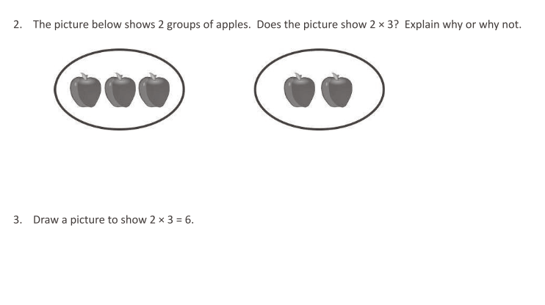
Question from Eureka Math: TEKS Edition, Grade 3, Modules 1 & 2. Learn Book.
How do these problems present students with grade-level content?
A few of the mathematics TEKS for third grades are:
- The student is expected to determine the total number of objects when equally-sized groups of objects are combined or arranged in an array up to 10 (3.4D).
- The student is expected to represent multiplication facts by using a variety of approaches such as repeated addition, equal-sized groups, arrays, area models, equal jumps on a number line, and skip-counting (3.4F).
These questions are aligned to those TEKS.

How do these questions give students opportunities to engage with the content in different ways?
For the first question, students need to explain their answer, and they can do so using words, pictures, or other methods. Additionally, when explaining their answer, they can use their knowledge of any of the ways to conceptualize multiplication. For the second question, they can show multiplication in a few different ways.

What misconceptions might students have? How can I help them struggle through them?
For the first question, students could struggle because they see groups of apples, and they think that multiple groups of items represented a multiplication problem. Based on this thinking, they might answer “yes” to the question. One of ways I can help them is by asking them how many apples appear in each group. For the second question, students may have memorized that 2 X 3 is 6, but they may not know how to draw it. One of the ways I can support them is by asking them to explain verbally what multiplication is. This might help them think about how to draw it.

Guided Practice: Analyzing Mathematics Tasks from High-Quality Instructional Materials
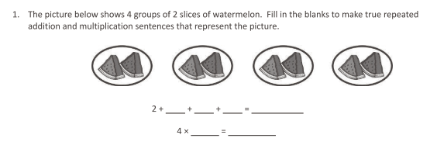
Question from Eureka Math: TEKS Edition, Grade 3, Modules 1 & 2. Learn Book.
How do these problems present students with grade-level content?
They are aligned with the same TEKS as the first two problems.

How do these questions give students opportunities to engage with the content in different ways?
The two equations with the blanks represent different ways of conceptualizing multiplication.

What misconceptions might students have? How can I help them struggle through them?
The students might count the watermelon slices and know that the answer is eight. But they might now know how to fill in the blanks before the equal signs. I could help them by asking them to describe the picture in words, which might help them with filling in the blanks.

Practice: Reflection on Field Experiences
In your field site, you may have seen teachers use high-quality instructional materials to encourage students to engage in productive struggle. If you have, describe a few examples below. What was the outcome? If you have not seen teachers engage students in productive struggle using high-quality instructional materials, provide examples of a few opportunities where they could have done so. How could they have engaged students in a more productive way?
Responses will vary based on field site experiences.

