Field-Based Experience: Practicum Teacher

Tool Name: Lesson Scaffolding & Gradual Release
Name:
Date:
Objectives:
- Design and implement a lesson that is intentionally structured to build student understanding.
- Explore and apply the stages of gradual release of responsibility to scaffold student learning.
- Evaluate and reflect on the impact of scaffolding and gradual release within a lesson plan.
Purpose: The purpose of this tool is for students to plot lesson activities on a Gradual Release of Responsibility graphic, to develop and perform a modeling activity, and to reflect on components of both effective and ineffective student practice.
Summary: Students are first asked to observe a lesson or series of lessons and plot lesson activities on the Gradual Release of Responsibility graphic, which includes demonstration (“I do, you watch”), shared demonstration (“I do, you help”), guided practice (“You do, I help”), and independent practice (“You do, I watch”). Next, students are invited to design a modeling activity for future use in a lesson, if appropriate. Finally, students will reflect on the essential characteristics of student practice and what strategies are effective in contrast with examples of ineffective strategies.
Connections to Instructional Practices:
Lesson 6.07: Scaffolding a Lesson | Intro to Gradual Release
Lesson 6.08: Scaffolding a Lesson | Modeling, Part I
Lesson 6.00: Scaffolding a Lesson | Modeling, Part II
Lesson 6.10: Scaffolding a Lesson | Practice
Connected Instructional Practices TEKS:
- Standard 3: The student explores the teaching and training profession. The student is expected to: (B) summarize and apply pedagogical knowledge and skills needed by teaching and training professionals.
- Standard 6: The student plans and develops effective instruction. The student is expected to: (A) explain the role of the Texas Essential Knowledge and Skills in planning and evaluating instruction; (C) explain the rationale for and process of instructional planning components such as vertical alignment and scope and sequence; and (F) demonstrate lesson planning to meet instructional goals.
Connected Practicum TEKS:
- Standard 6: The student plans and uses effective instruction. The student is expected to: (A) apply principles and theories that impact instructional planning.
- Standard 13: The student continues to participate in field-based experiences in education or training. The student is expected to: (A) apply instructional strategies and concepts within a local educational or training facility; (B) document, assess, and reflect on instructional experiences.

Field-Based Experience: Student

Tool Name: Lesson Scaffolding & Gradual Release
Name:
Date:
Objectives:
- Design and implement a lesson that is intentionally structured to build student understanding.
- Explore and apply the stages of gradual release of responsibility to scaffold student learning.
- Evaluate and reflect on the impact of scaffolding and gradual release within a lesson plan.

Observe: Observe a lesson and record evidence of the teacher gradually releasing responsibility for learning to the students. Use the chart below to guide your observations and record your notes in the table provided.

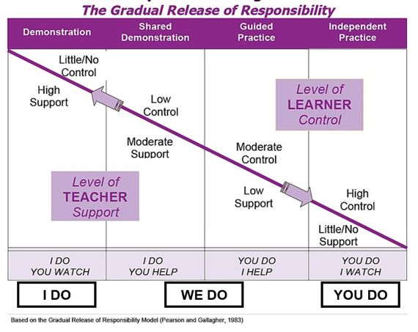
Gradual Release of Responsibility
 | Demonstration | Shared demonstration | Guided Practice | Independent Practice
What is the teacher doing?
What are the students doing?

Field-Based Experience: Student

Tool Name: Lesson Scaffolding: Gradual Release
Name:
Date:
Objectives:
- Design and implement a lesson that is intentionally structured to build student understanding.
- Explore and apply the stages of gradual release of responsibility to scaffold student learning.
- Evaluate and reflect on the impact of scaffolding and gradual release within a lesson plan.
Apply:
Discuss with the field site campus teacher:
How they use scaffolding and gradual release to build student understanding?
With the field site campus teacher, develop a plan for you to:
Rehearse and teach part or all of a lesson plan that is intentionally structured to build student understanding using the gradual release of responsibility framework or “I do, we do, you do.”

It is encouraged that the student uses the curriculum already used by the field site teacher, and it is not the expectation that the student makes it up themself.
Date & Time:
Class / Subject:
Demonstration
Shared Demonstration
Guided Practice
Independent Practice
Ask the field site campus teacher for their feedback, after:
Rehearsing and teaching part or all of a lesson plan that is intentionally structured to build student understanding using the gradual release of responsibility framework or “I do, we do, you do.”

Field-Based Experience: Student

Tool Name: Lesson Scaffolding: Gradual Release
Name:
Date:
Objectives:
- Design and implement a lesson that is intentionally structured to build student understanding.
- Explore and apply the stages of gradual release of responsibility to scaffold student learning.
- Evaluate and reflect on the impact of scaffolding and gradual release within a lesson plan.
Reflect: Use the questions in the table to help you reflect on gradual release
Questions | Answers
Why is the gradual release of responsibility framework useful for scaffolding student learning?
What evidence do you have that the intentional structuring a lesson to build student understanding using the gradual release of responsibility framework supported student learning?

