1. Fork and Clone

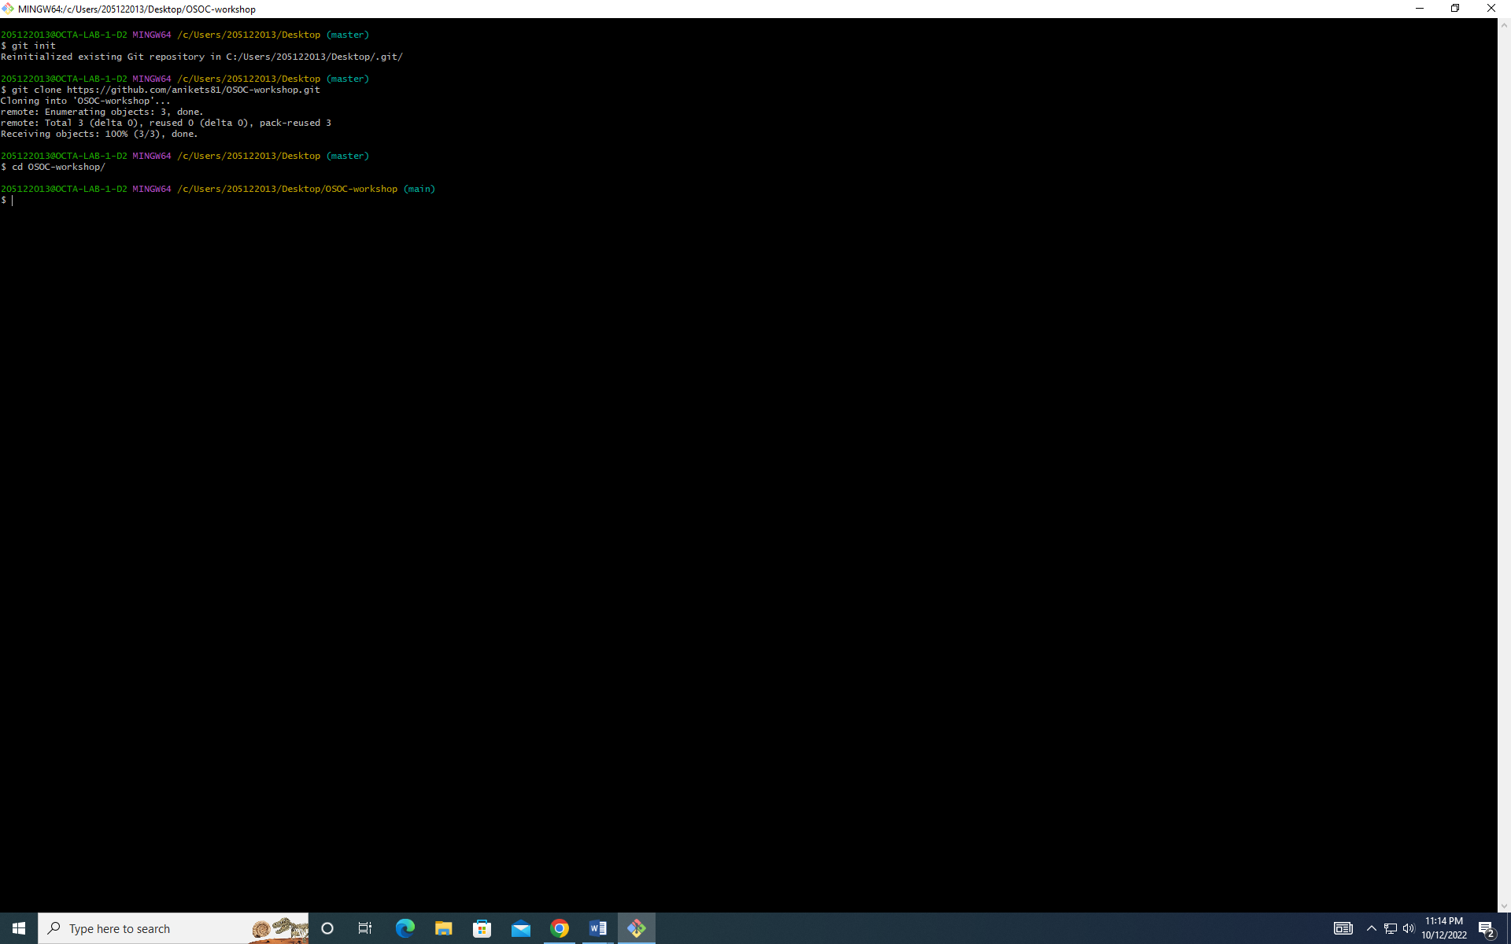

1. Make commit in Main branch



3)Make a branch name Learner and commit

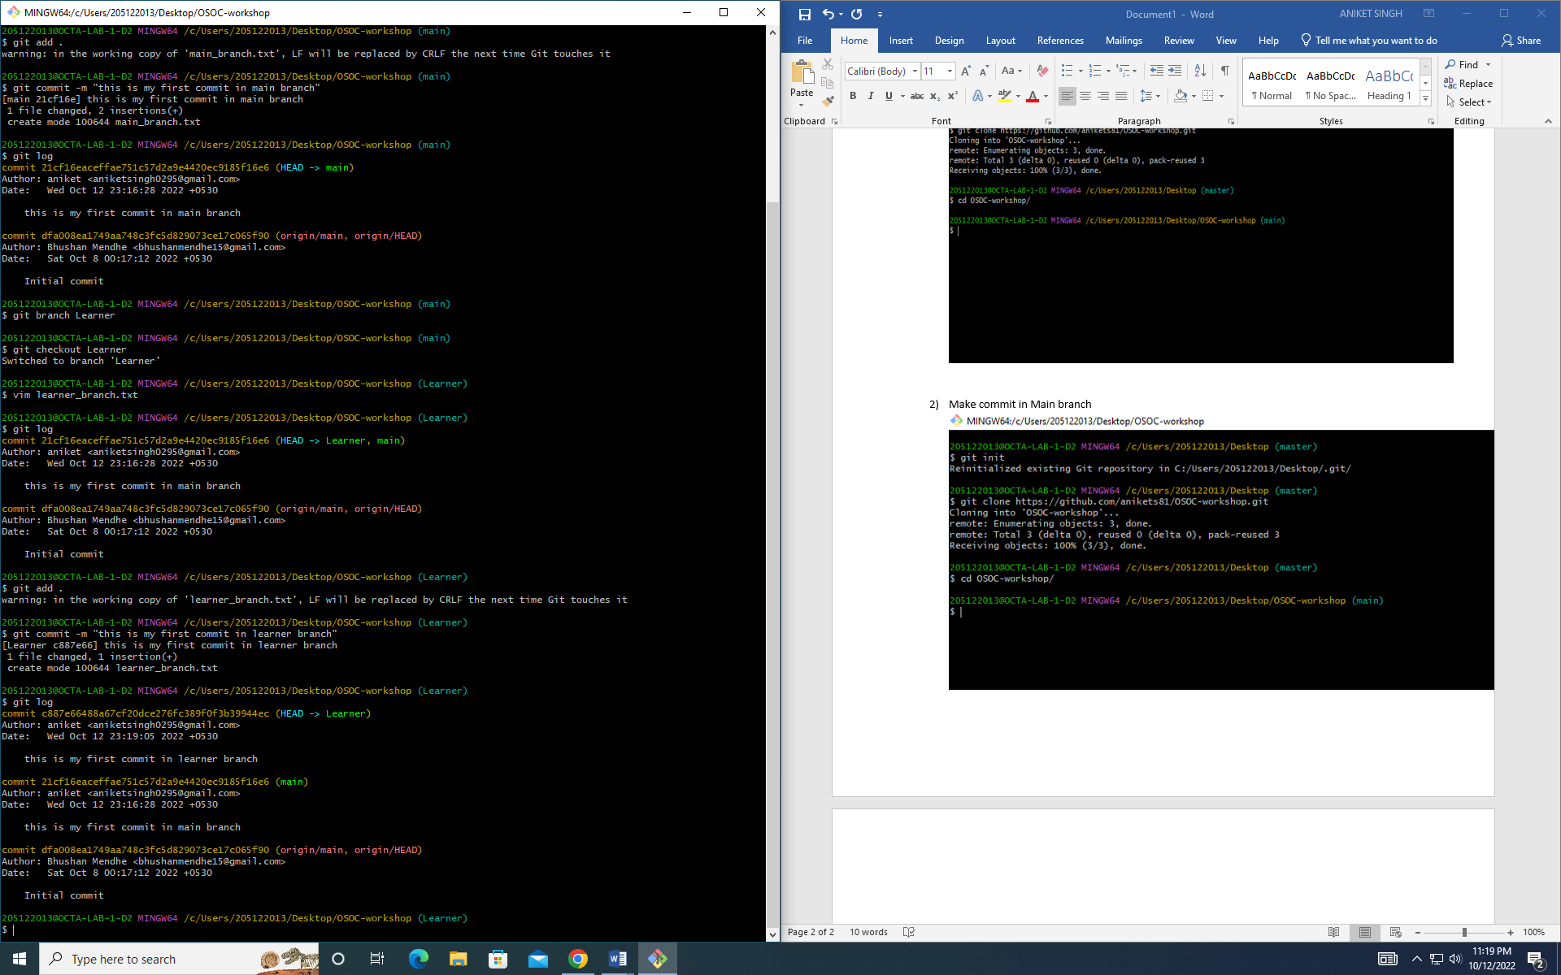

4)Merge the branches

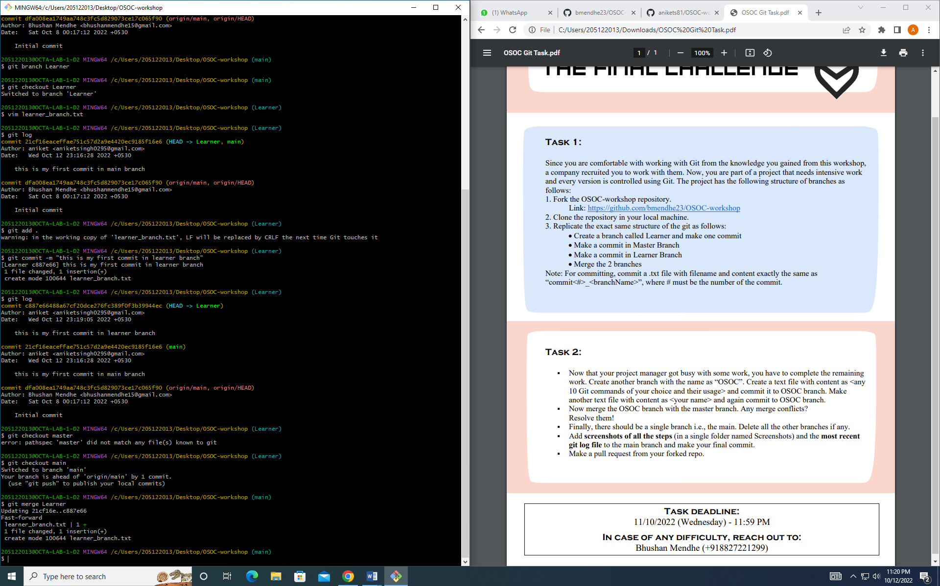

Task 2 –

1. Create a branch name OSOC and commit in it

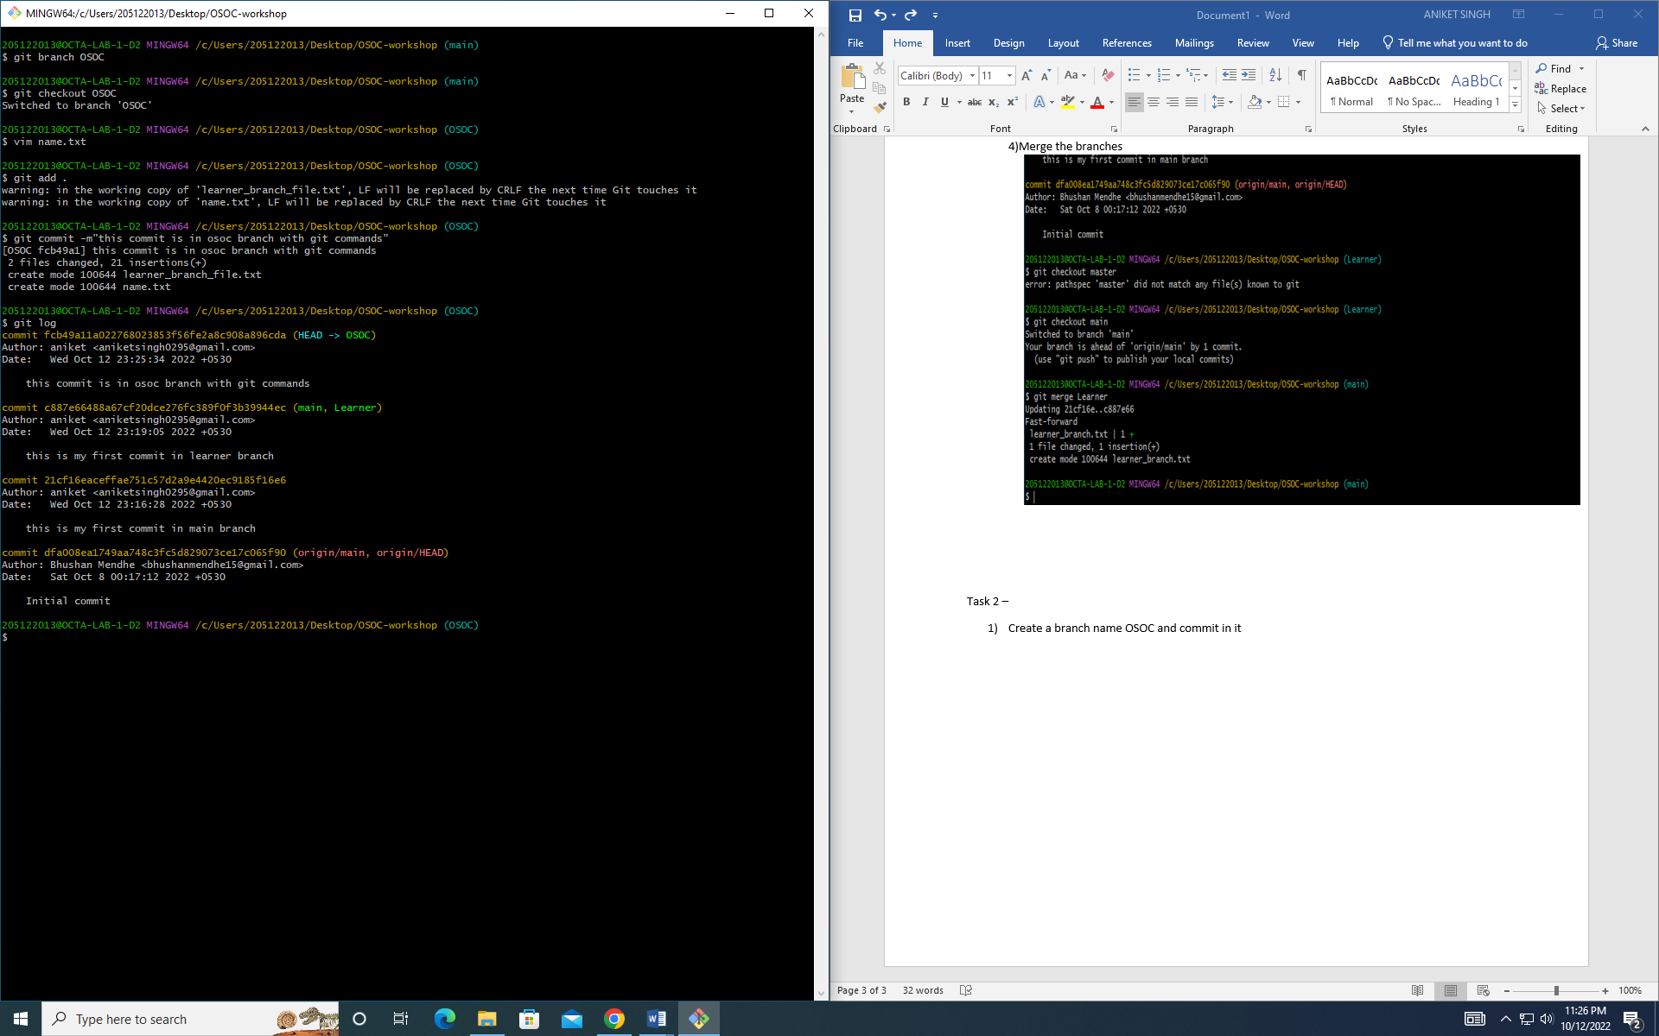

2)Make a file with name in it and commit it



3)Merge OSOC branch with main branch

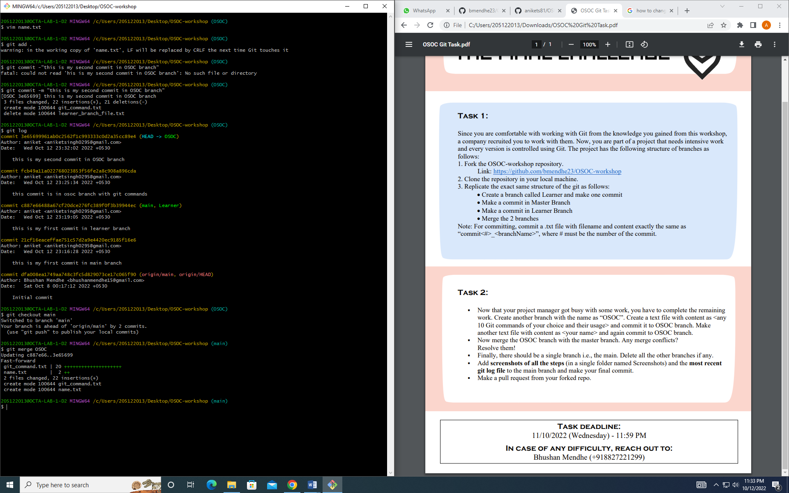

4)Delete all other branches

