To compile and run the program, you need to have the ASP.NET extention for Visual Studio.

Open AlgoritmaProje1.sln

First, you need to change the paths of the underlined lines ( lines 60 and 63 )

The first path ( line 60) needs to be the location of your Python executable.

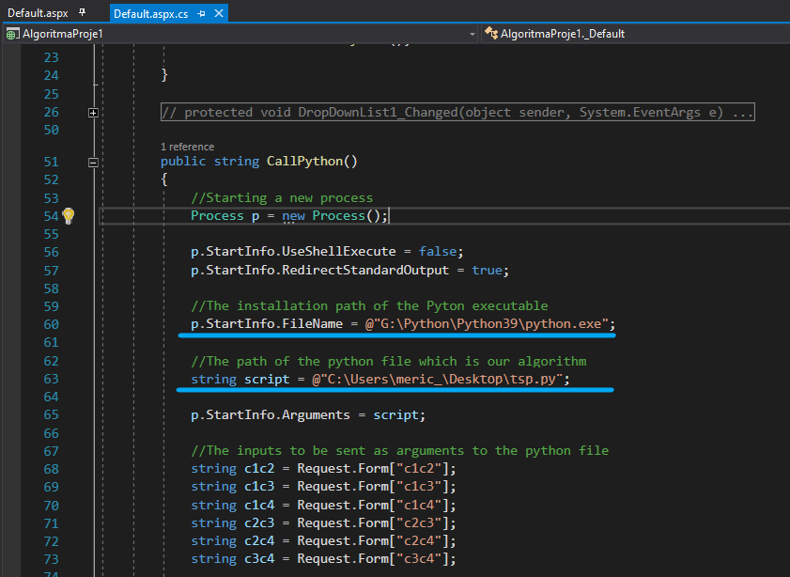

The program can simply be run with the underlined button. (IIS Express)

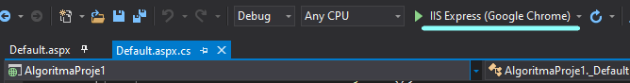

After you run the program, you can enter the distances between the cities and then click the “Submit” button.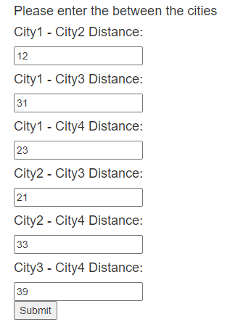

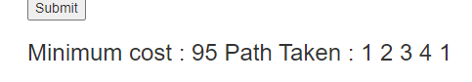

After clicking the button, you will the results. The minimum cost of the path taken and the path itself

**ABOUT THE PROJECT**

Our project calculates the shortest possible route that visits each city exactly once and returns to the origin city with a list of cities and the distances between each pair of cities.