

Developer: Blake Merry

Date: January 31, 2026

IT 145 Global Rain Summary Report Template

Directions
Place your pseudocode, flowchart, and explanation in the following sections. Before you submit your report, remove all bracketed text.

Pseudocode
When you are done implementing the Pet class, refer back to the Pet BAG Specification Document and select either the pet check in or check out method. These methods are detailed in the Functionality section of the specification document.

Write pseudocode that lays out a plan for the method you chose, ensuring that you organize each step in a logical manner. Remember, you will not be creating the actual code for the method. You do not have to write pseudocode for both methods. Your pseudocode must not exceed one page.

Inputs: petType, petName, petAge, isReturning, daysStay, groomingRequested
Outputs: Valid Grooming Criteria, Error Message OR Confirmation Summary
- START
- PROMPT for petType (dog/cat)
- VALIDATE petType (if not dog/cat, re-prompt)
- CHECK capacity based on petType
  - If petType = dog AND dogSpaces >= maxDogSpaces
    - DISPLAY “No dog boarding space available” and END
  - If petType = cat AND catSpaces >= maxCatSpaces
    - DISPLAY “No cat boarding space available” and END
- PROMPT for petName AND petAge
- PROMPT for isReturning
  - IF isReturning = true THEN UPDATE existing pet info as needed
  - ELSE CREATE a new pet record
- PROMPT for daysStay
- VALIDATE daysStay is a positive integer (if invalid, re-prompt)
- Grooming logic
  - IF petType = dog AND daysStay >= 2
    - PROMPT for groomingRequested (yes/no)
  - ELSE
    - SET groomingRequested = no
    - DISPLAY “Grooming only available for dogs staying 2+ days”
- ASSIGN boarding space number
  - IF petType = dog
    - ASSIGN dogSpaceNumber = first available dog space
    - SET dogSpaces = dogSpaces + 1
  - IF petType = cat
    - ASSIGN catSpaceNumber = first available cat space
    - SET catSpaces = catSpaces + 1
- DISPLAY confirmation summary
  - petName, petType, assigned space number, daysStay, groomingRequested
- END

Flowchart
Based on the pseudocode you wrote, create a flowchart using a tool of your choice for the method you selected. In your flowchart, be sure to include start and end points and appropriate decision branching, and align the flowchart to the check in or check out process. Your flowchart must be confined to one page.

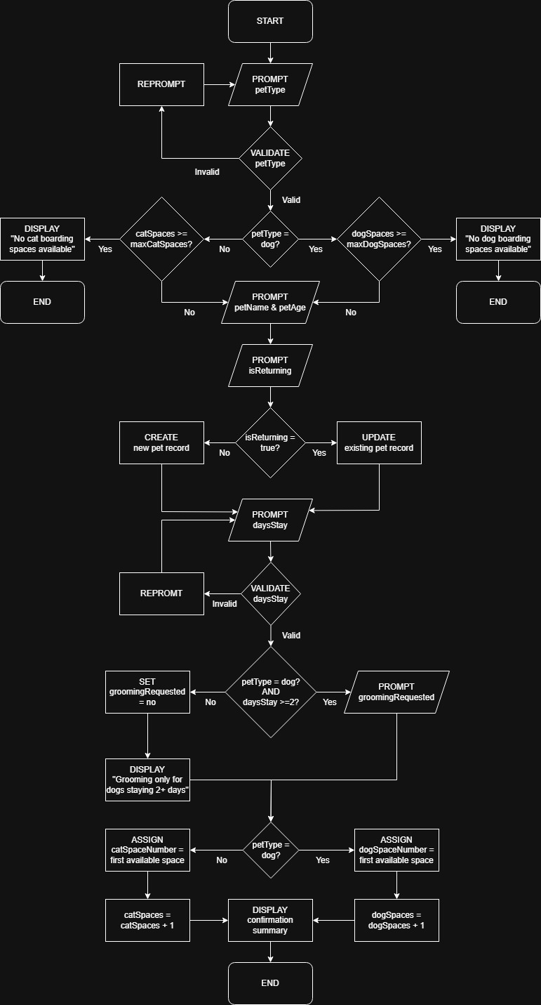

OOP Principles Explanation
Briefly explain how you applied object-oriented programming principles and concepts (such as encapsulation, inheritance, and so on) in your software development work thus far. Your explanation should be one paragraph, or four to six sentences.

In my Pet class, I focused on encapsulation by keeping the attributes private and using getters and setters to control how the data is accessed and updated. This keeps the object’s state consistent and makes it easier to validate or adjust behavior later without breaking other parts of the program. I also used abstraction by modeling the real-world pet as a simple, reusable blueprint that holds the information the rest of the app will need for check-in and check-out. Even though I’m only building the base class right now, the design supports inheritance later, since a Dog or Cat class could extend Pet and add behaviors like grooming rules or size specific pricing. Overall, the goal was to keep the class clean and reusable so the rest of the system can build on it without needing to rewrite the same logic in multiple places.

