The combination of features in Arrowgrams make it ideal for distributed applications.

Arrowgrams Components cannot share memory, so message sending is simple and easy.

Message Sending remains simple in Arrowgrams. Messages are routed from Component to Component by their enclosing Schematic.

Diagrams instantly show where messages and wires are tangled and have become too complicated. Designers can untangle wires using the hierarchical rules of Arrowgrams.

The model for Arrowgrams Designs is shown in Fig. <$n:figure:degenerate>

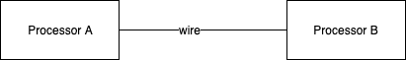

Fig. <$n:figure:degenerate>

All Arrowgrams Components “run to completion” and cannot be interrupted.

