

JOINT INSTITUTE FOR NUCLEAR RESEARCH
Veksler and Baldin Laboratory of High Energy Physics

FINAL REPORT ON THE
START PROGRAMME

Development of High Precision Low Noise HV Power Supply for SiPM Semiconductor
Detectors

Supervisor:
Mr. Mikhail Buryakov
Student:
Han Sijia China
National Research University Higher School of Economics

Participation period:
July 05 - August 15
Summer Session 2026

Dubna, 2026

Contents

Participation period: 1
Contents 2
Report scope 3
Abstract 3
1. Introduction and Motivation 4
2. Circuit development and LTspice simulation 5
3. Schematic and PCB design in Altium Designer 5
4. PCB assembly and ESP32 integration 6
5. Firmware and digital filtering 7
5.1 ADC filtering 7
5.2 Voltage-setting and regulation algorithm 7
6. Web interface 8
7. Voltage calibration 8
7.1 Initial no-load characterization 8
8. Characterization with a 47.22 kΩ load 9
9. Current-monitor calibration 10
10. Oscilloscope measurements and power-source comparison 11
11. Discussion 13
12. Conclusions and next steps 13
Appendix A. Firmware Source Code for HVunit ESP32S 14
A.1. DAC Voltage Control (voltageToDac & updateDacRamp) 14
A.2. ADC Measurement & Filtering 15
A.3. HV Enable/Disable Logic (turnHVOn & turnHVOff) 16
References 18
Acknowledgement 19

Abstract
A compact programmable high-voltage bias unit for silicon photomultipliers (SiPMs) was designed, assembled, integrated with an ESP32 controller, and experimentally characterized. The work included circuit simulation in LTspice, schematic capture and printed-circuit-board design in Altium Designer, PCB assembly, connection to a NodeMCU ESP-32S controller, development of embedded firmware, implementation of a mobile-oriented web interface, and calibration of the voltage and current monitoring channels.
The high-voltage stage provides an adjustable output in the range of approximately 0–80 V. The ESP32 uses its internal DAC to set the output voltage, two ADC channels to monitor output voltage and load current, and Wi-Fi to provide a standalone web interface. Calibration measurements were performed. A Keithley 6485 picoammeter was used as the reference instrument for current measurements. The analog voltage- and current-monitoring circuits showed good linearity. The main residual errors were associated with ESP32 ADC non-linearity and with low-voltage supply variation under load. These effects were compensated in firmware by calibration lookup tables, digital filtering, and a slow closed-loop correction of the DAC code using the measured output voltage.

Introduction and Motivation
Silicon Photomultipliers (SiPMs), also referred to as Multi-Pixel Photon Counters (MPPCs), represent a revolutionary advancement in low-light-level detection technology. These semiconductor-based devices offer significant advantages over conventional photomultiplier tubes (PMTs): compact footprint, low operating voltage, high photon detection efficiency (PDE), and remarkable insensitivity to magnetic fields [1]. These properties make SiPMs particularly attractive for applications in high-energy physics experiments, where magnetic fields are ubiquitous.
The breakdown voltage $U_{b}$ is defined as the minimum reverse bias voltage at which the avalanche multiplication coefficient tends to infinity under constant primary photocurrent. For a silicon p+-n junction with depletion width WW, the breakdown condition is given by [2, Ch. 5]:
$$[exp\left(α_{n}W\right)-1][exp\left(α_{p}W\right)-1]=1$$
where${ α}_{n}$and${ α}_{p}$are the impact ionization coefficients for electrons and holes, respectively. For silicon at 300 K, these coefficients are well approximated by [3]:
$$α_{n}(E)=3.8×10^{6}exp\left(-\frac{1.75×10^{6}}{E}\right){cm}^{-1}$$
$$α_{p}(E)=2.25×10^{7}exp\left(-\frac{3.26×10^{6}}{E}\right){cm}^{-1}$$
where E=U/W is the electric field strength in V/cm. The gain MM of a single pixel in Geiger mode is not a fixed number — unlike linear-mode APDs — but rather the avalanche is a binary event: either it triggers (producing a standard charge pulse) or it does not. The photon detection efficiency (PDE) is therefore the product of three factors [2, Ch. 4]:
$$PDE=ϵ⋅η⋅F_{ge}$$
where ϵ is the quantum efficiency of the silicon, η is the avalanche triggering probability (which depends on the over-voltage), and ${ F}_{ge}$ is the geometric fill factor.
SiPMs require a stable and accurately adjustable bias voltage, typically in the range of several tens of Volts, while drawing relatively small currents. For laboratory use it is convenient to combine the high-voltage converter, voltage and current monitoring, digital control, and user interface in a compact unit.
The objectives of the work were:
- To study and simulate a compact high-voltage converter suitable for SiPM biasing.
- To develop the complete electrical schematic and PCB layout.
- To assemble and test the PCB.
- To integrate the high-voltage board with an ESP32-based controller.
- To implement digital setting of the output voltage and monitoring of output voltage and current.
- To develop a web-interface suitable for operation from a mobile phone or computer.
- To calibrate the control and monitoring channels and characterize the unit under no-load and resistive-load conditions.
- To investigate the influence of the low-voltage power source on the observed output noise.

2. Circuit development and LTspice simulation
The high-voltage converter was first studied using LTspice. The simulation stage was used to verify the basic boost-converter operation, the feedback network, the output-voltage control range, and the expected behavior of the monitoring nodes before PCB fabrication.
The final circuit is based on an LT3482 high-voltage DC/DC converter. Three analog interface paths connect the converter to the ESP32 controller:
- Voltage control: ESP32 DAC output → AD8606 buffer → 10 kΩ / 10 kΩ divider → CTRL input.
- Voltage monitoring: high-voltage output → 1 MΩ / 33 kΩ divider → AD8606 buffer → ESP32 ADC.
- Current monitoring: converter MON output → 6.2 kΩ current-to-voltage resistor → AD8606 buffer → ESP32 ADC.
A separate digital line controls the shutdown input. The 10 kΩ / 10 kΩ divider in the control path reduces the buffered ESP32 DAC voltage by approximately a factor of two. Measurements later confirmed a ratio close to 0.5 over the operating range.
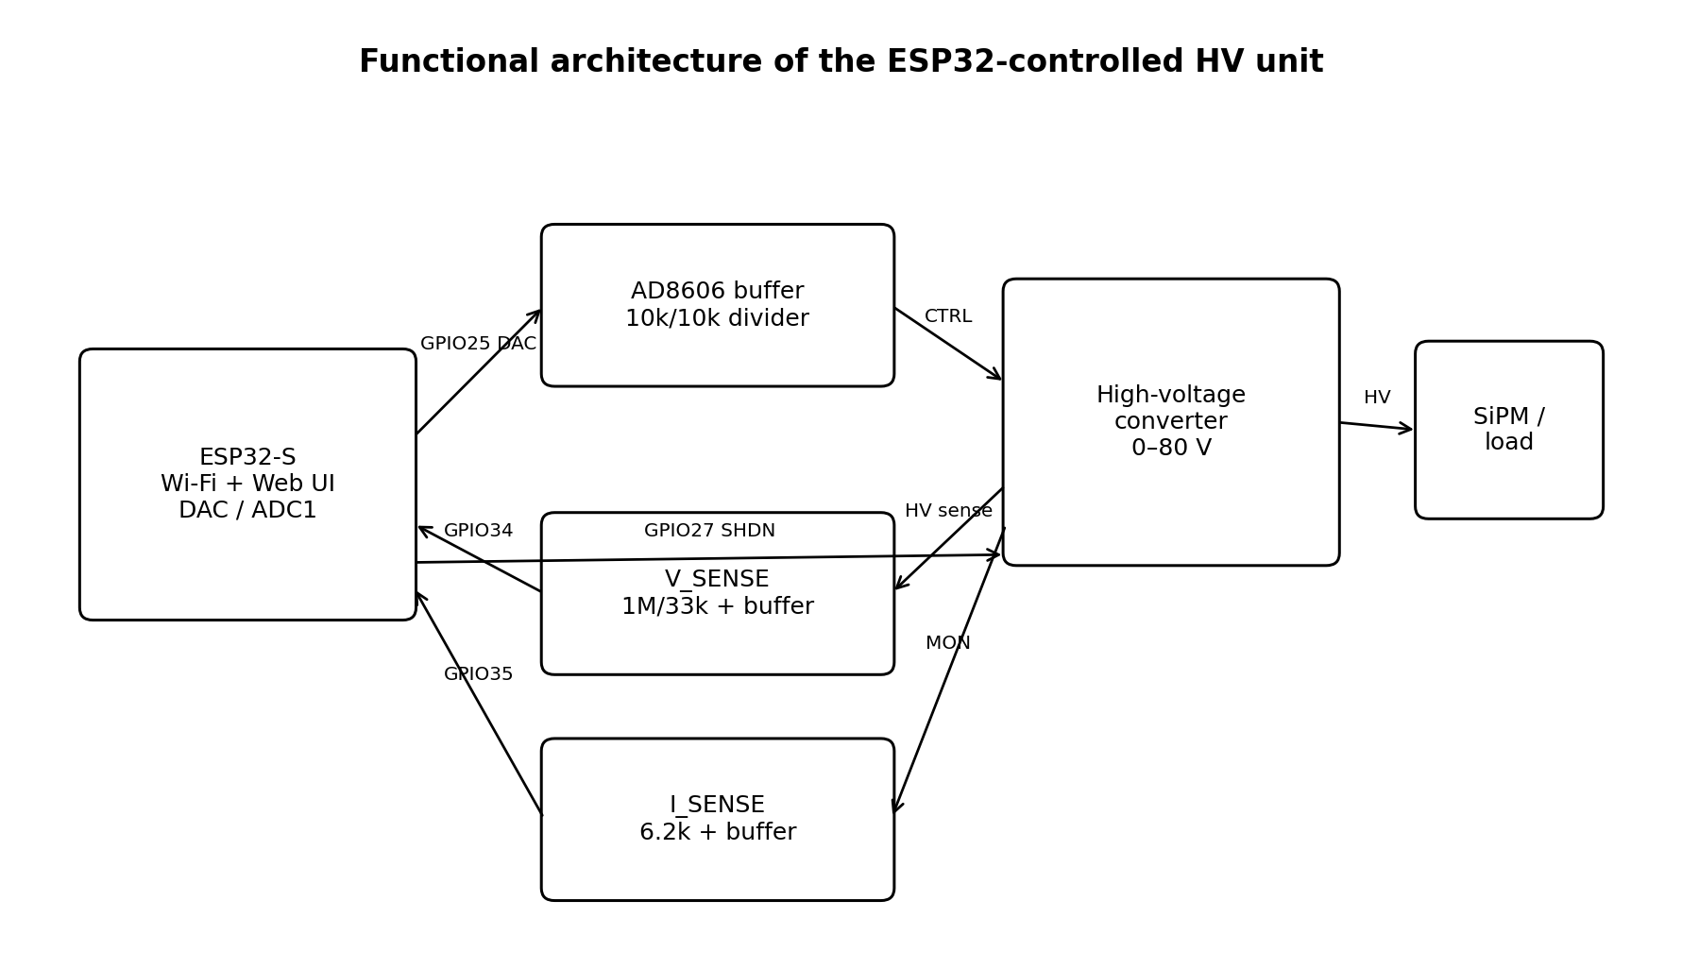
Figure 1. Functional architecture of the ESP32-controlled high-voltage unit.

3. Schematic and PCB design in Altium Designer
After simulation, the electrical schematic and PCB were developed in Altium Designer. Particular attention was paid to the separation of the switching power section from low-level monitoring signals, short current loops in the converter section, high-voltage clearances, and convenient access to the control and monitoring signals.
The PCB provides connections for low-voltage power, high-voltage output, analog control, voltage monitor, current monitor, shutdown control, ground, and the ESP32 controller. The board was fabricated and assembled after the schematic and PCB layout were completed.
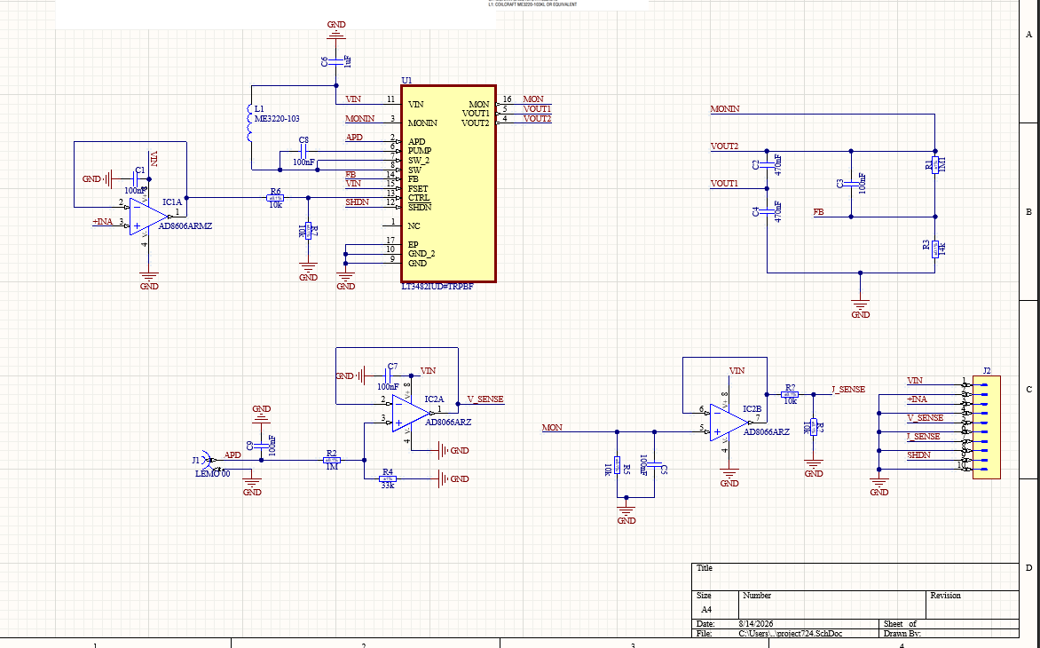
Figure 2: Complete circuit schematic of the HV power supply (LT3482 + AD8606 + monitoring)
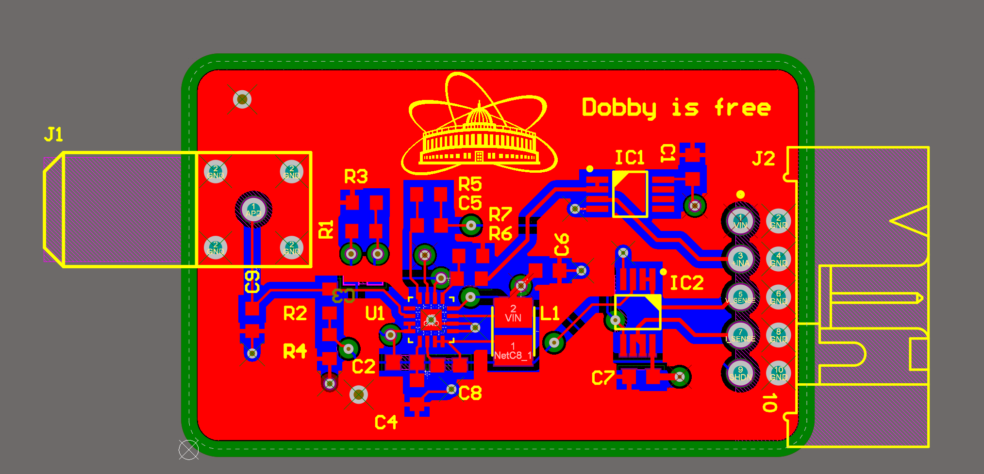
Figure 3: 4-layer PCB layout of the HV power supply

4. PCB assembly and ESP32 integration
The assembled PCB was connected to a NodeMCU ESP-32S v1.1 module based on ESP-WROOM-32. The final controller pin assignment is shown below.
Function | ESP32 pin | Purpose
Voltage control | GPIO25 / DAC1 | Analog DAC output to control buffer
Shutdown | GPIO27 | High-voltage enable/disable
Voltage monitor | GPIO34 / ADC1 | Buffered V_SENSE
Current monitor | GPIO35 / ADC1 | Buffered I_SENSE
HV status LED | GPIO2 | On-board HV indication

ADC channels were selected so that voltage and current measurements remain available while Wi-Fi is active. The converter board was tested from the regulated 3.3 V rail of the ESP32 module.
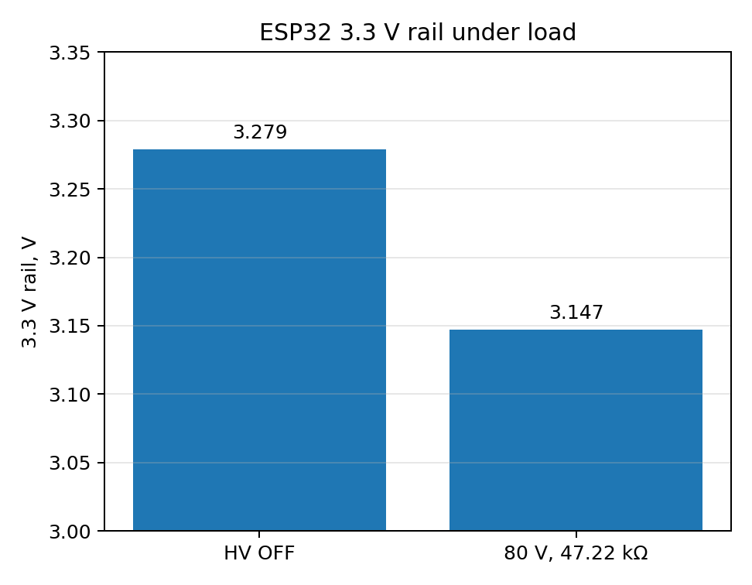
Figure 4. Measured ESP32 3.3 V rail with HV disabled and at the high-load test point.
With a 47.22 kΩ load and the output near the upper end of the range, the 3.3 V rail changed from approximately 3.279 V with the high-voltage stage disabled to 3.147 V under load. This variation is significant enough to influence open-loop output voltage and was one reason for adding closed-loop correction in firmware.

5. Firmware and digital filtering
Firmware was developed in the Arduino IDE for the ESP32. It performs DAC-based voltage setting, high-voltage ON/OFF control, continuous voltage and current measurements, Wi-Fi access-point operation, an embedded HTTP server, calibrated conversions, and slow closed-loop output correction.

5.1 ADC filtering
The ESP32 ADC has noticeable conversion noise and non-linearity. To stabilize the measurements, 32 ADC conversions are averaged for each measurement update. The averaged value is then passed through a first-order IIR low-pass filter. The measurement block is updated every 100 ms. The filtered values are used for the main display, while averaged raw ADC codes remain available in the diagnostic area for calibration.

5.2 Voltage-setting and regulation algorithm
Because the internal ESP32 DAC is only 8 bit, the relationship between requested high voltage and DAC code was calibrated experimentally rather than calculated only from ideal component values. A piecewise-linear lookup table provides the initial DAC code. The output is then ramped smoothly to the target.
The latest firmware additionally implements slow closed-loop correction. After the initial ramp and a settling delay, the measured output voltage is compared with the requested voltage. If the error exceeds the defined dead band, the DAC target is adjusted by one code. This compensates load-dependent voltage drop and low-voltage supply variation while avoiding rapid hunting caused by the coarse 8-bit DAC.

6. Web interface
The ESP32 operates as a standalone Wi-Fi access point and serves the control page directly, so no external router is required. The web interface was designed for use from a mobile phone or a computer.
- A large circular indicator displays the measured high voltage.
- The circle outline is green when HV is enabled and gray when disabled.
- A numeric field sets the requested voltage.
- A dedicated ON/OFF button controls the high-voltage stage.
- The measured external load current is displayed below the voltage indicator.
- RAMP, REG, ON, and OFF states indicate the current control condition.
- A small diagnostic area displays DAC code, feed-forward and target DAC codes, ADC voltage/current codes, and calibrated monitoring values.
The diagnostic values were particularly useful during calibration because the behavior of the complete control and measurement chain could be recorded without recompiling the firmware for each point.

7. Voltage calibration

7.1 Initial no-load characterization
The first calibration was performed without an external load. The measured control and monitoring values are summarized below.
SET (V) | DAC | GPIO25 (mV) | CTRL (mV) | V_SENSE (mV) | Real HV (V)
0 | 0 | 110 | 54 | 3.5 | 0.1
10 | 21 | 366 | 182 | 369 | 11.48
20 | 43 | 625 | 311 | 682 | 21.3
30 | 64 | 889 | 442 | 1000 | 31.25
40 | 85 | 1144 | 569 | 1307 | 40.81
50 | 107 | 1404 | 699 | 1621 | 50.4
60 | 128 | 1645 | 819 | 1911 | 59.4
70 | 149 | 1897 | 945 | 2215 | 68.9
80 | 171 | 2158 | 1073 | 2528 | 78.5

The V_SENSE divider and buffer showed very good linearity. The ideal divider ratio for 1 MΩ and 33 kΩ is 31.303, and the measured data are consistent with this value within the expected resistor and measurement tolerances.
The ESP32 ADC showed a low-end offset/non-linearity when the 11 dB attenuation range was used. In particular, analogReadMilliVolts() returned approximately 142 mV even when the raw ADC code was already zero. The firmware therefore uses the raw ADC value for zero detection and applies the voltage calibration only above the zero region.
The linear voltage-monitor calibration used in firmware is:
V_HV [V] = 0.0304459 × V_ADC [mV] + 0.7013
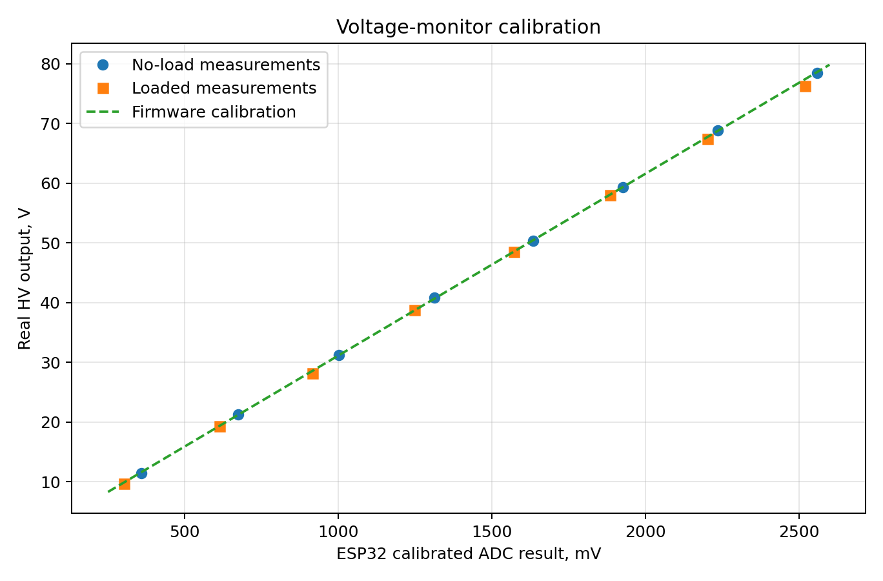
Figure 5. Calibration of the voltage-monitor channel using no-load and loaded measurements.
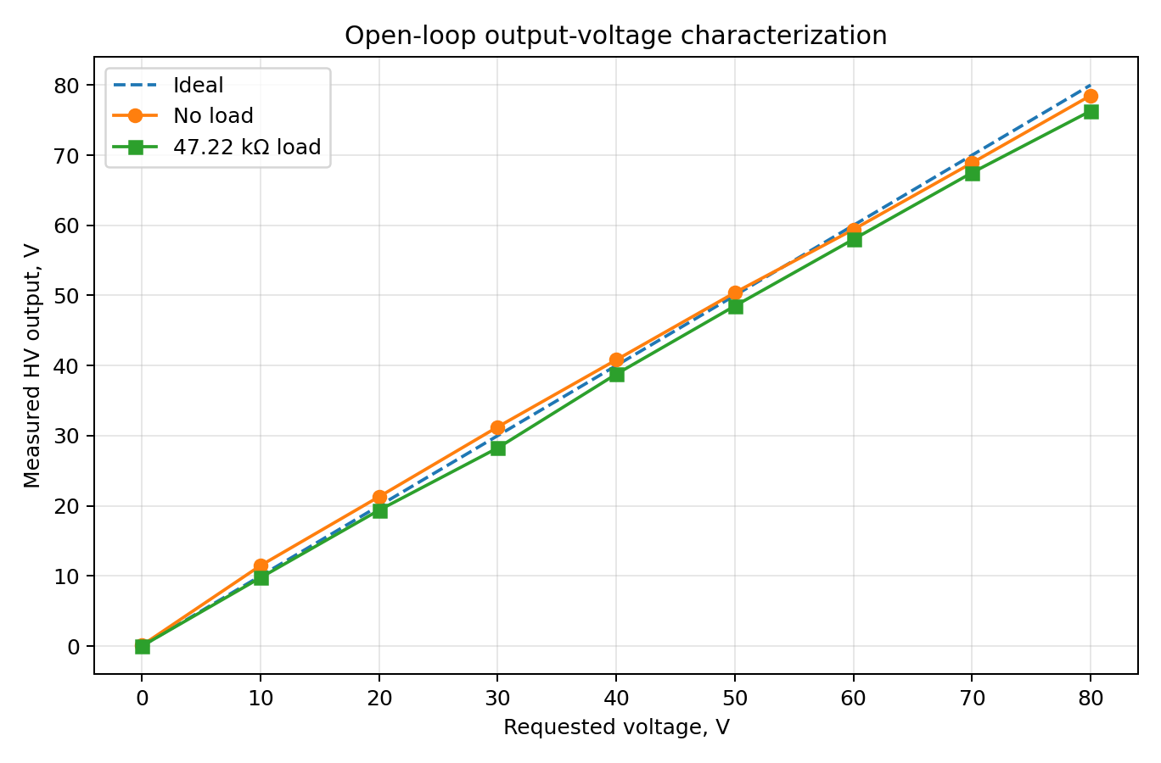
Figure 6 Open-loop requested voltage versus measured output voltage.

8. Characterization with a 47.22 kΩ load
A second measurement series was performed with a 47.22 kΩ resistive load. The load current was measured independently with a Keithley 6485 picoammeter. The following values correspond to the calibrated feed-forward firmware before final verification of the newly added closed-loop voltage correction.
SET | DAC | ADC V | ADC I | VADC | IADC | GPIO25 | CTRL | Keithley  (mA) | V_SENSE | I_SENSE | HV
0 | 0 | 0 | 0 | 142 | 142 | 111 | 55 | 0.000 | 0.1 | 0 | 0.00
10 | 18 | 194 | 141 | 302 | 259 | 329 | 163 | 0.206 | 311 | 266 | 9.75
20 | 40 | 571 | 458 | 613 | 520 | 587 | 291 | 0.410 | 620 | 531 | 19.38
30 | 61 | 937 | 773 | 915 | 780 | 840 | 417 | 0.609 | 919 | 787 | 28.25
40 | 83 | 1337 | 1120 | 1248 | 1066 | 1115 | 552 | 0.823 | 1242 | 1064 | 38.78
50 | 106 | 1731 | 1459 | 1571 | 1349 | 1384 | 685 | 1.035 | 1555 | 1340 | 48.50
60 | 129 | 2109 | 1790 | 1885 | 1620 | 1638 | 813 | 1.239 | 1860 | 1604 | 58.00
70 | 152 | 2493 | 2133 | 2203 | 1903 | 1910 | 944 | 1.452 | 2172 | 1879 | 67.50
80 | 174 | 2877 | 2443 | 2519 | 2159 | 2152 | 1062 | 1.640 | 2450 | 2124 | 76.30

The open-loop measurements show an increasing difference between requested and actual output voltage at higher load. At SET = 80 V the measured output was 76.3 V. The 3.3 V supply rail simultaneously decreased under load. Instead of incorporating one particular load into the feed-forward DAC calibration, the current firmware retains the no-load lookup table and uses V_SENSE feedback to trim the DAC code.

9. Current-monitor calibration
The converter current-monitor output produces a current proportional to the total current drawn from the high-voltage node. A 6.2 kΩ resistor converts this monitor current into a voltage. The measured I_SENSE values showed excellent agreement with the expected analog transfer function. The dominant non-linearity originated from the ESP32 ADC, so a piecewise-linear calibration was generated directly between averaged raw ADC code and the physically measured I_SENSE voltage.
ADC I raw | Measured I_SENSE (mV)
0 | 0
141 | 266
458 | 531
773 | 787
1120 | 1064
1459 | 1340
1790 | 1604
2133 | 1879
2443 | 2124

The current monitor includes the current drawn by the V_SENSE divider itself. With a total divider resistance of approximately 1.033 MΩ, the external load current is calculated as:
I_load = I_total − V_HV / 1.033 MΩ
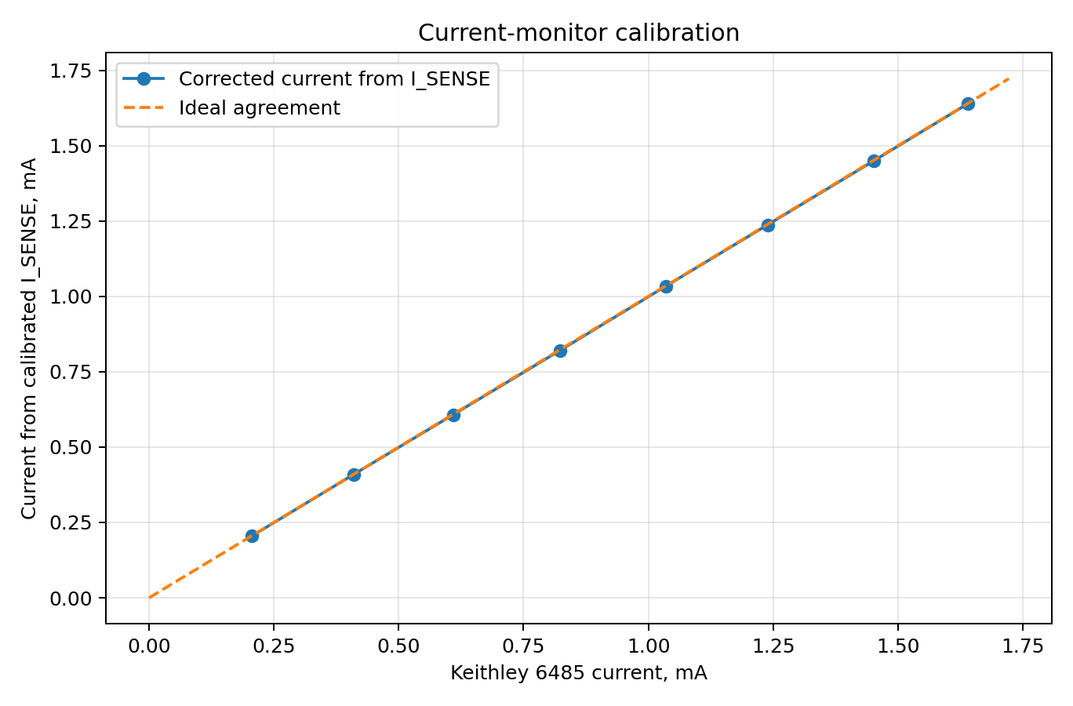
Figure 7. Current obtained from calibrated I_SENSE compared with the Keithley 6485 reference measurement.
After the ADC calibration and subtraction of the V_SENSE divider current, the calculated current agreed with the Keithley 6485 measurements to within approximately 2.5 µA over the measured range up to about 1.64 mA. This confirms that the analog current-monitor path is highly linear and that software calibration effectively compensates the ESP32 ADC non-linearity.

10. Oscilloscope measurements and power-source comparison
Oscilloscope measurements were performed to observe the high-voltage output and to compare the noise environment for different low-voltage power sources. The project repository contains four source captures:
Repository file | Measurement
10VDC.png | Output waveform at approximately 10 V
43VDC.png | Output waveform at approximately 43 V
43V_powerUSB.png | Approximately 43 V with conventional USB power
43V_powerPBank.png | Approximately 43 V with power-bank power

The USB and power-bank captures provide a qualitative comparison of noise coupled through the low-voltage supply path and grounding arrangement. The comparison shows why the power source must be considered as part of the complete noise-performance evaluation. For a quantitative ripple specification, the measurement should be repeated with identical probe connection, oscilloscope bandwidth limit, time base, and grounding configuration.
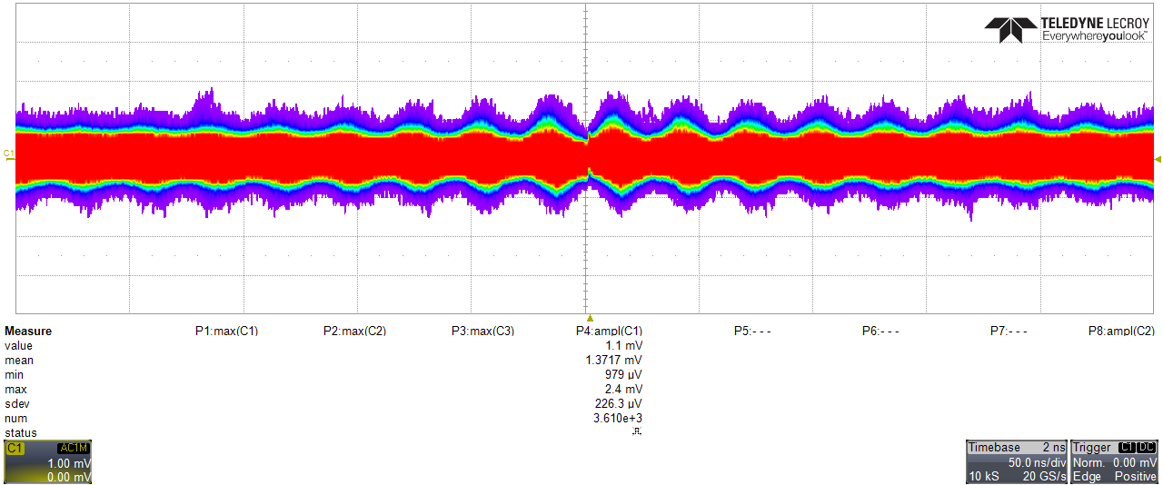
Figure 8: Output ripple measurement at 43V output with USB power supply.
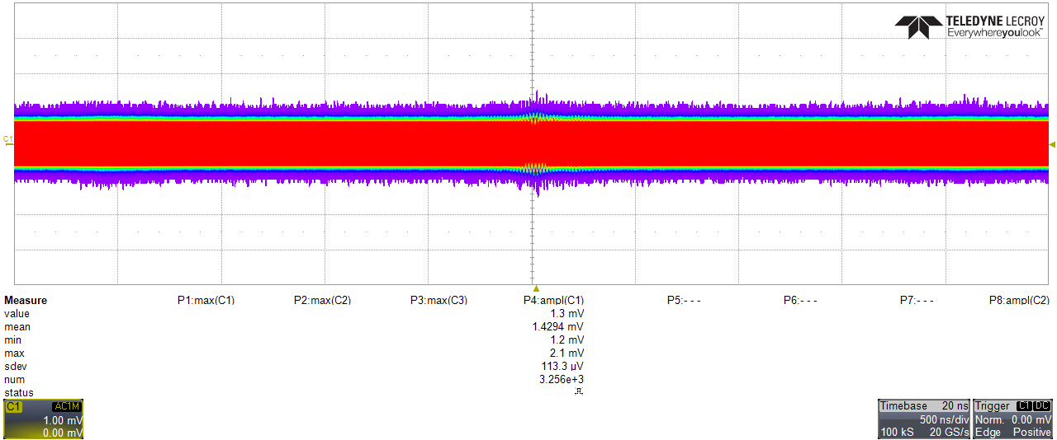
Figure 9: Output ripple measurement at 43V output with power bank
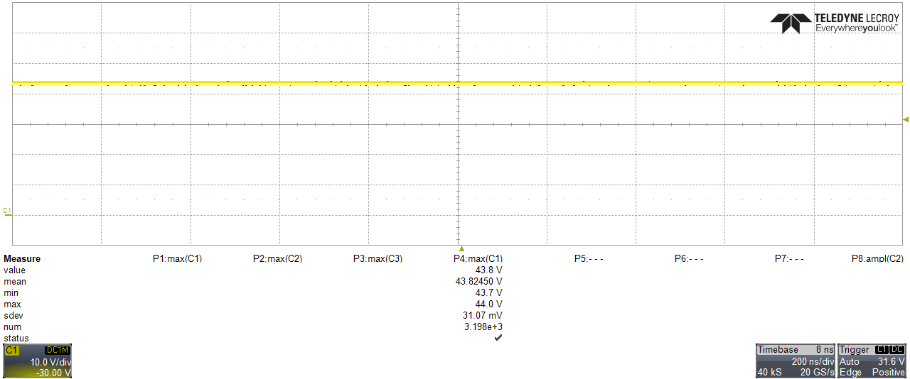
Figure 10: Output ripple measurement at 10V DC output with power bank

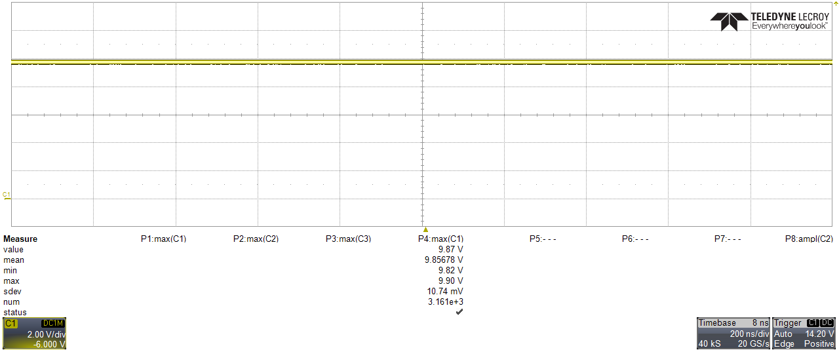
Figure 11: Output ripple measurement at 10V DC output

11. Discussion
The project covered the complete engineering cycle: simulation, schematic design, PCB layout, assembly, embedded integration, firmware development, user-interface development, and experimental calibration. Several effects became visible only after the hardware and controller were integrated.
- The nominal ESP32 DAC characteristic is insufficient for accurate open-loop voltage setting with an 8-bit DAC; an experimental lookup table substantially improves the initial setting.
- The ESP32 ADC is not sufficiently linear over the full attenuated range for precision monitoring without calibration.
- 32-sample averaging followed by IIR filtering greatly improves the stability of the displayed measurements.
- The analog V_SENSE and I_SENSE circuits are highly linear; software calibration is mainly required to compensate ESP32 conversion characteristics.
- The low-voltage supply rail varies with high-voltage load and contributes to open-loop output droop.
- The current consumed by the voltage-monitor divider is not negligible compared with small SiPM currents and must be subtracted from the total current monitor reading.
- A slow V_SENSE-based closed-loop trim is a practical way to compensate remaining load and supply variations without requiring a higher-resolution external DAC for the prototype.

12. Conclusions
A working compact high-voltage bias unit with ESP32 control and monitoring was successfully developed and tested. The student completed the simulation and PCB design stages, assembled the hardware, and integrated the converter with the ESP32 controller. A dedicated firmware and mobile-oriented web interface were developed for voltage setting, high-voltage ON/OFF control, and real-time voltage/current monitoring.
The voltage- and current-monitoring analog circuits demonstrated good linearity. Calibration of the ESP32 ADC and DAC was required to obtain useful measurement accuracy. Current measurements with a Keithley 6485 and a 47.22 kΩ load confirmed the validity of the current-monitoring scheme after correction for the current drawn by the V_SENSE divider.
The current firmware contains calibrated voltage and current conversion, digital filtering, smooth DAC ramping, and closed-loop voltage correction.

Appendix A. Firmware Source Code for HVunit ESP32S
The complete firmware for the ESP32-based high-voltage supply is archived at:
https://github.com/bmg466/HVunit_ESP32s
Below are the core routines for DAC control, voltage/current sensing, and the web interface

A.1. DAC Voltage Control (voltageToDac & updateDacRamp)
// --------------------------------------------
// Convert target HV voltage to 8-bit DAC code
// --------------------------------------------
uint8_t voltageToDac(float voltage) {
voltage = constrain(voltage, HV_MIN, HV_MAX);

const float feedbackGain = 1.0f + FB_R_TOP / FB_R_BOTTOM;
float requiredCtrl = voltage / feedbackGain;
float requiredDacVoltage = requiredCtrl / CTRL_DIVIDER;
requiredDacVoltage *= DAC_CALIBRATION;

float code = requiredDacVoltage / DAC_FULL_SCALE_V * 255.0f;
code = constrain(code, 0.0f, 255.0f);
return (uint8_t)roundf(code);
}
// --------------------------------------------
// Ramp DAC output gradually to target
// --------------------------------------------
void updateDacRamp() {
if (!hvEnabled) return;

unsigned long now = millis();
if (now - lastRampTime < DAC_RAMP_INTERVAL_MS) return;
lastRampTime = now;

if (currentDacCode < targetDacCode) {
++currentDacCode;
dacWrite(CTRL_DAC_PIN, currentDacCode);
} else if (currentDacCode > targetDacCode) {
--currentDacCode;
dacWrite(CTRL_DAC_PIN, currentDacCode);
}
}

A.2. ADC Measurement & Filtering
// --------------------------------------------
// Read ADC pin with averaging filter
// --------------------------------------------
AdcSample readAdcAverage(uint8_t pin) {
uint32_t rawSum = 0;
uint32_t mvSum = 0;

for (uint8_t i = 0; i < ADC_SAMPLES; i++) {
rawSum += analogRead(pin);
mvSum += analogReadMilliVolts(pin);
delayMicroseconds(ADC_SAMPLE_DELAY_US);
}

AdcSample result;
result.raw = (uint16_t)roundf((float)rawSum / ADC_SAMPLES);
result.millivolts = (uint16_t)roundf((float)mvSum / ADC_SAMPLES);
return result;
}

// --------------------------------------------
// Update measured voltage & current with IIR filter
// --------------------------------------------
void updateMeasurements() {
unsigned long now = millis();
if (now - lastAdcTime < ADC_INTERVAL_MS) return;
lastAdcTime = now;

// Voltage sensing (HV divider: 1M / 33k)
AdcSample voltageSample = readAdcAverage(VSENSE_PIN);
vSenseRaw = voltageSample.raw;
vSenseMilliVolts = voltageSample.millivolts;

float vSense = (float)vSenseMilliVolts / 1000.0f;
const float voltageSenseGain =
(VSENSE_R_TOP + VSENSE_R_BOTTOM) / VSENSE_R_BOTTOM;

float newMeasuredVoltage = vSense * voltageSenseGain * HV_CALIBRATION;
newMeasuredVoltage = constrain(newMeasuredVoltage, 0.0f, 100.0f);

// Current sensing (IMON ratio: 0.20 * I_APD, RMON = 6.2k)
AdcSample currentSample = readAdcAverage(ISENSE_PIN);
iSenseRaw = currentSample.raw;
iSenseMilliVolts = currentSample.millivolts;

float iSense = (float)iSenseMilliVolts / 1000.0f;
float monVoltage = iSense / ISENSE_ADC_DIVIDER;
float iApdAmpere = monVoltage / R_MON / MON_CURRENT_RATIO;
float newMeasuredCurrent =
iApdAmpere * 1000.0f * CURRENT_CALIBRATION;

if (newMeasuredCurrent < 0.0f) newMeasuredCurrent = 0.0f;

// IIR low-pass filter (alpha = 0.10)
if (firstAdcMeasurement) {
measuredVoltage = newMeasuredVoltage;
measuredCurrent = newMeasuredCurrent;
firstAdcMeasurement = false;
} else {
measuredVoltage += ADC_FILTER_ALPHA *
(newMeasuredVoltage - measuredVoltage);
measuredCurrent += ADC_FILTER_ALPHA *
(newMeasuredCurrent - measuredCurrent);
}

if (measuredVoltage < 0.05f) measuredVoltage = 0.0f;
if (measuredCurrent < 0.002f) measuredCurrent = 0.0f;
}

A.3. HV Enable/Disable Logic (turnHVOn & turnHVOff)
// --------------------------------------------
// Safely enable HV with ramp from zero
// --------------------------------------------
void turnHVOn() {
currentDacCode = 0;
dacWrite(CTRL_DAC_PIN, 0);
targetDacCode = voltageToDac(setVoltage);

digitalWrite(SHDN_PIN, HIGH);
hvEnabled = true;
setHVLed(true);

Serial.printf("HV ON | SET %.2f V | DAC target %u\n", setVoltage, targetDacCode);
}

// --------------------------------------------
// Immediate shutdown (hardware + DAC reset)
// --------------------------------------------
void turnHVOff() {
digitalWrite(SHDN_PIN, LOW);
dacWrite(CTRL_DAC_PIN, 0);

currentDacCode = 0;
targetDacCode = 0;
hvEnabled = false;
setHVLed(false);

Serial.println("HV OFF");
}

References
[1] Hamamatsu Photonics, "What is an MPPC (SiPM)?" [Online]. Available: https://www.hamamatsu.com/eu/en/product/optical-sensors/mppc/what_is_mppc.html.
[2] Z. Ya. Sadygov, Physics of Solid-State Photoelectron Multipliers (in Russian). Dubna: JINR Publishing, 2023.
[3] C. A. Lee, R. A. Logan, R. L. Batdorf, J. J. Kleimack, and W. Wiegmann, "Ionization Rates of Holes and Electrons in Silicon," Phys. Rev., vol. 134, no. 3A, pp. A761–A774, 1964.

Acknowledgement
I would like to express my deepest gratitude to my supervisor, Mr. Mikhail Buryakov, for his guidance and support throughout this project. He has been more than a supervisor — he has been a true role model. I have always admired the way he approaches his work: with the precision and care of an artist, carefully thinking through every detail, every layout, every connection, not just for function but for elegance. He has a rare gift for explaining complex physical principles in the simplest possible terms, and he never runs out of patience, no matter how many times I ask. I have learned from him not only how to design a circuit, but also how to think clearly and work responsibly.
I also wish to thank the other members of the laboratory for their warmth and kindness. They made me feel welcome from the very first day, and they are genuinely interesting and fun people to work alongside. I am grateful for the conversations, the jokes, and the willingness to help whenever I needed it.
Finally, I thank the Veksler and Baldin Laboratory of High Energy Physics at JINR for providing me with the opportunity, the facilities, and the resources to carry out this work. This summer has been an unforgettable experience, both professionally and personally.

Sincerely, Han Sijia

