The Visitor design pattern exercise has three parts, each with separate goals and deliverables:

- The first part goals are to gain an understanding of the basic Visitor pattern as described in the GoF Design Patterns book. We will do this part of the exercise in class. Read through the chapter on the Visitor pattern to help recall the details of the basic GoF Visitor pattern variant.
- The second part goals are to examine and enhance some example code that nominally applies a Visitor pattern to the reading and parsing of simple files formatted using eXtensible Markup Language (XML). The base code for this part of the exercise was downloaded from a sub-link of the web location www.hilbertinc.com. It is example of how XML parsers can be built and used to process XML-formatted information.
As background for this part of the exercise, we will examine and discuss the downloaded code, install it, and execute two demonstrations of using this code to parse simple XML files. Some background XML tutorial documentation will be available for those desiring more information on the details of using XML.
These code demonstrations produce simple ASCII text files that summarize the structure of parsed XML files. The summaries verify that the code recognized and interpreted the XML-formatted information properly.
*** The assignment for this second part of the Visitor pattern exercise is to design, implement and demonstrate the operation of a NEW visitor class/object that will output summary information similar to that provided by the existing demonstration code, BUT IN HTML FORMAT, rather than the simple ASCII text format produced by the base demonstration code. <HTML> <BODY> ….. </BODY></HTML> text tags must be output surrounding the summary output information. IN ADDITION, you must surround each different type of XML “element” information with <Hn>….</Hn> tags to cause appropriate “header” text styling to take place (n is a numeric digit from 1-7; 1 indicating the LARGEST header text size, 7 indicating the SMALLEST). Make sure that the resulting output file names have the .htm extension. Your results must be viewable using a Microsoft Internet Explorer 5 browser.
The deliverables for this part of the exercise are:
- design documentation showing the changes you are making to the code, and a sequence diagram showing the sequence of actions that takes place when your code is executed
- implementation code for your new HTMLVisitor demonstration
- printout of the results of executing your HTMLVisitor demonstration code – this must include BOTH a printout of the raw HTML-formatted output file, AND a screen snapshot of the output file when viewed using an IE browser.
- The third and final part of this exercise examines the approach used by the base demonstration code, and adjusts it to apply a variant of the Visitor pattern that takes advantage of the “reflection” features of Java to alleviate some of the issues that arise when applying the basic GoF Visitor pattern.
We will discuss in class how and why the Visitor approach used by the author of the demonstration code may or may not be a reasonable application of visitor principles. We will discuss how and why the code design might be adjusted to more closely adhere to these principles.
You will need to read and discuss two articles (handouts) that describe the value and applicability of leveraging “reflection” when implementing the Visitor pattern (termed a “reflective visitor”).
*** The assignment for this third and final part of the exercise is to re-design and re-implement your HTMLVisitor from part 2 of this exercise so that it performs the same functions, BUT does so by applying a “reflective visitor” variant of the pattern design. IN ADDITION, your new design should apply this new ReflectiveHTMLVisitor to EVERY individual element of the XML input that is iterated over when summarizing the XML information (again, in HTML format).
NOTE 1: This is a significant difference from the approach used by the base demonstration code, as well as your previous HTMLVisitor design. Those previous designs applied the visitor object ONCE to the parser itself, which in turn executed appropriate “callbacks” into the visitor object to perform needed functions. YOUR NEW DESIGN should utilize a specific iterator to apply your ReflectiveHTMLVisitor object to each XML element as it is identified and summarized by that iterator. In the base demonstration code, the “parser” itself performed all these iteration operations.
NOTE 2: The base demonstration code for the parser interestingly DOES NOT use any externally available XML parser to perform the parsing actions. Instead, this parser implements all the details itself. In your design solution, use the Parser class/object that is available from the XML4j parser library that is available in the handout materials for this exercise. You will also be given a set of browsable .html files as well as tutorial .pdf files that describe how to use this Parser and the DOM objects it generates as a result of the parsing process. Because of this approach, you will not specifically be writing a parser in your design, but rather an iterator that USES an available parser to generate a tree of Node elements. This NodeIterator then iterates over the tree Nodes (created and populated by the parser) in an appropriate manner to apply your visitor and generate required results.
NOTE 3: When you take the approach of visiting each element as it is recognized by the iterator, you will notice that you no longer have separate control or notification of when “begin” and “end” tags are encountered in the XML input files. Your iterator will only have access to ALL the information of the elements of the XML file AFTER it has been processed into an internal tree of Nodes. In this situation, it would require extra, duplicated processing to simulate the recognition of node “begin” and “end” tags. The good news is that, since you are only summarizing the information of the XML file, you DO NOT NEED TO REACT TO BEGIN AND END TAGS AS THEY ARE RECOGNIZED BY THE PARSER! Rather, you only need to output node identification and content information (in HTML format, of course) as each node is “traversed” by the node iterator.
HINT: By this time, you may have noticed that the base demonstration code for the parser can be significantly optimized. In particular, it is not necessary to have two different looping methods to perform what is essentially a single, recursive iteration process. These two different methods can be collapsed into a single, recursive method.
The deliverables for this part of the exercise are:
- design documentation showing the changes you are making to the code, and a sequence diagram showing the sequence of actions that takes place when your code is executed
- implementation code for your new ReflectiveHTMLVisitor demonstration
- printout of the results of executing your ReflectiveHTMLVisitor demonstration code – this must include BOTH a printout of the raw HTML-formatted output file, AND a screen snapshot of the output file when viewed using an IE browser.
The following sections present supporting information for this exercise.
Appendix A
Support materials for Part 1 – Understanding the basic Visitor Pattern

Visitor
visitConcreteElementA( )
visitconcreteElementB( )
ConcreteVisitor1
visitConcreteElementA( )
visitConcreteElementB( )
ConcreteVisitor2
visitConcreteElementA( )
visitConcreteElementB( )
ConcreteElementA
accept(aVisitor )
operationA( )
ConcreteElementB
accept(aVisitor )
operationB( )
aVisitor -> visitConcreteElementA(this);
aVisitor -> visitConcreteElementB(this);
o
o
Element
accept(aVisitor )
ObjectStructure
1..*

Figure A1. Structure of the basic Visitor pattern

- Review the chapter of the GoF Design Patterns book devoted to the Visitor pattern. Understand the intent, applicabilities, structure, participants, collaborations and consequences of this basic Visitor pattern variant. This will provide a basis for comparison with the other visitor variants that will be investigated in this exercise.

Appendix B
Support materials for Part 2 – Developing an HTMLVisitor

- For this part of the exercise, it is assumed that you have a basic understanding of the use of HyperText Markup Language (HTML) by Internet browsers (in particular, Microsoft Internet Explorer - IE). For the purposes of this exercise, it is only necessary that the ABSOLUTE MINIMUM of HTML tags be generated by your HTMLVisitor, to produce a summary of parsed XML information in a form that can be viewed by an IE browser.
- Your HTMLVisitor will need to do the following:
a) begin the summary output with <HTML><BODY> tags
b) end the summary output with </BODY></HTML> tags
c) wrap each specific summary of individual XML element information with <Hn>…</Hn> tags
(where “n” is an integer 1-7, indicating the level of heading style to use)
b) respond to appropriate callbacks when various XML elements are recognized by the parser
(this will take the form of writing the appropriate tags and information to a “writer”)
- To do this, it is important to understand the design and operation of the demonstration code. A package diagram of the major elements of the demonstration code is shown in Figure B1. Class diagrams of the three main packages are shown in Figures B2, B3 and B4.

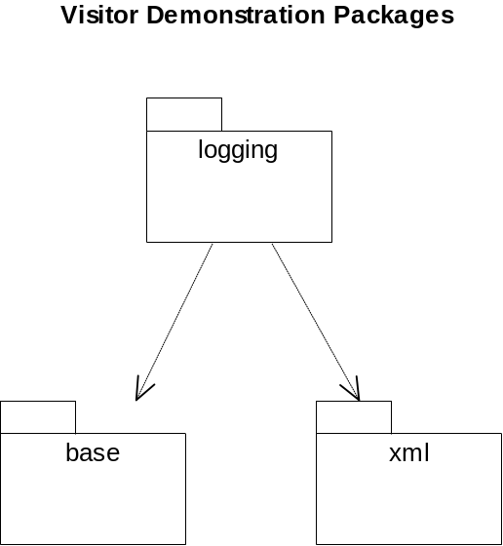

Figure B1. Demonstration code package diagram

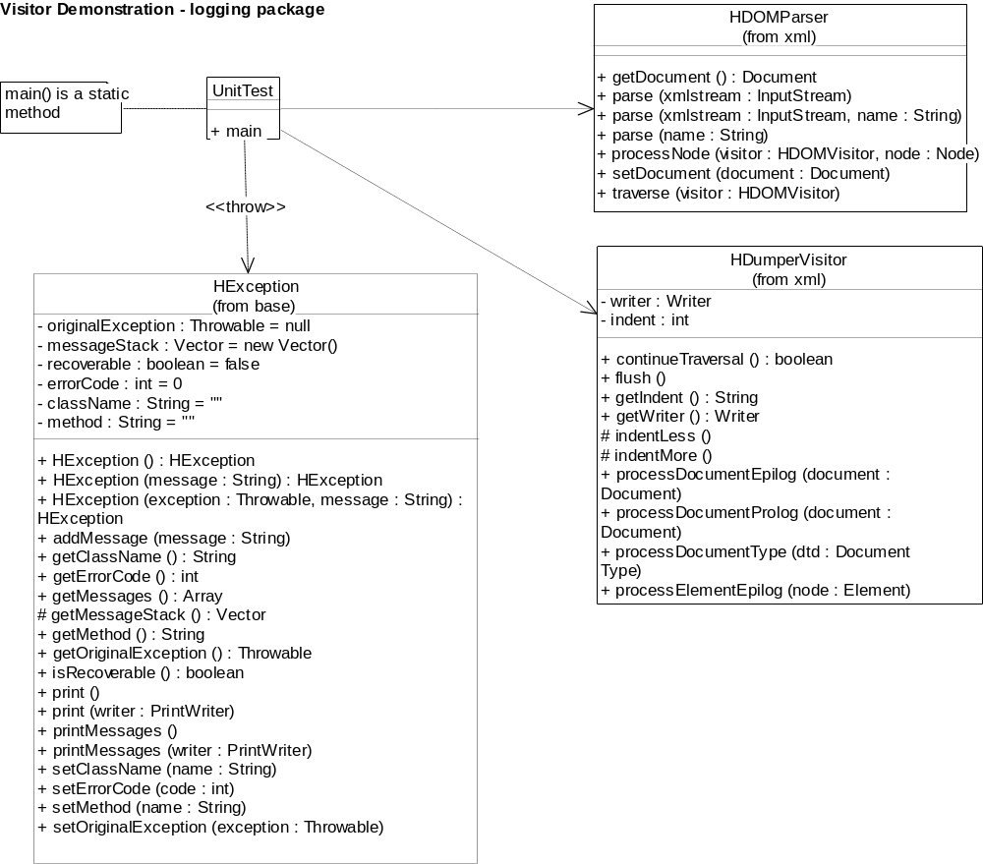

Figure B2. Logging package class diagram

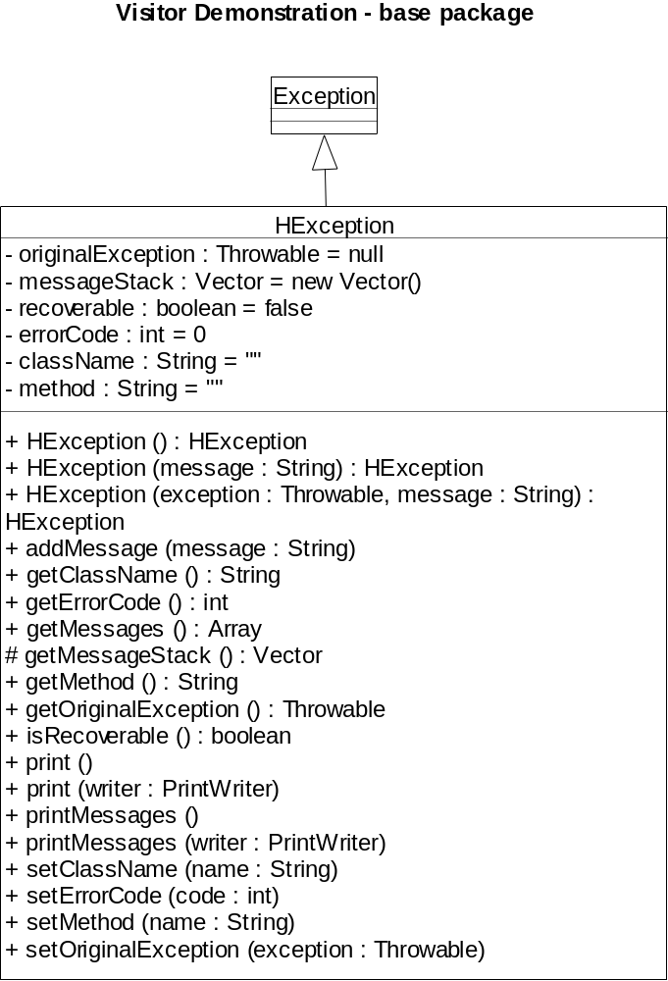

Figure B3. Base package class diagram

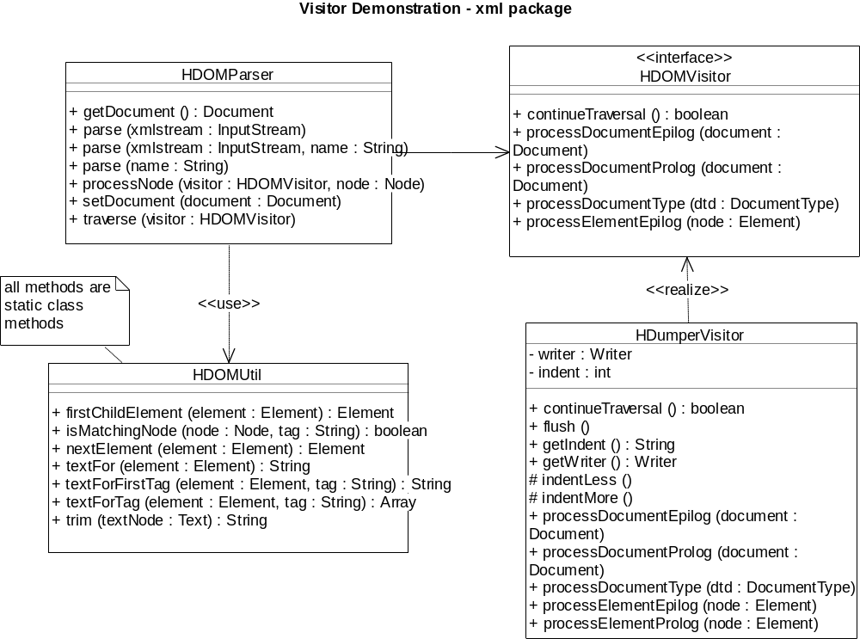

Figure B4. XML package class diagram

- Figure B5 shows a general flowchart of the XML parsing/summarization process that takes place when the demonstration code is executed.

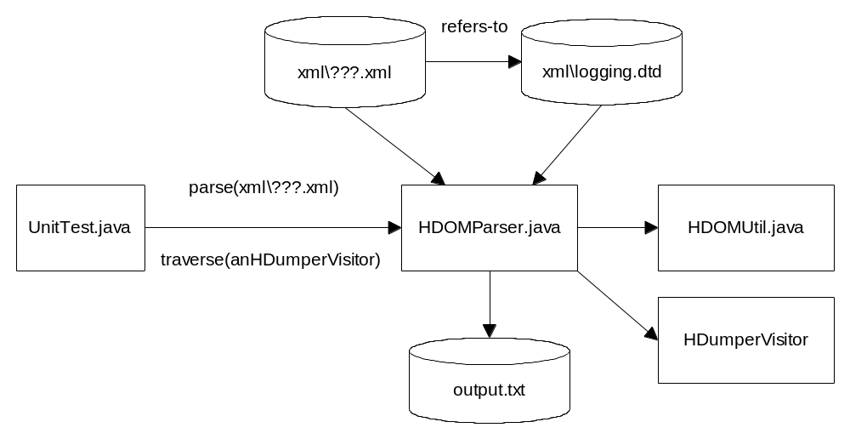

Figure B5. General flowchart of the XML parse/summarization process

- Demonstration operation narrative - The UnitTest program creates an HDOMParser instance, specifying an output production visitor to be used by the parser, and an input .xml format file name (???.xml in the flowchart above). The XML input file uses standard XML features to refer to the Document Type Definition (DTD) file that describes the valid structure of an input file (logging.dtd is used in this exercise). In the demonstration code, the parser expects the visitor to provide specific callback methods that will be called if and when specific XML elements are recognized by the parser (Document, DocumentType, Node, Element, Text, unknown – see the Document Object Model [DOM] API documentation in the electronic distribution files for details of these classes/objects). The parser iterates over all XML elements of the input file, and executes appropriate callback methods on the visitor object. These callback methods, in turn, use a Java “writer” to output summary information. By default, this writer sends its output to System.out.
- As an example, Figure B6 shows an example raw XML input file. Figure B7 shows the output file that results from executing the demonstration code on the input file shown in Figure B6. Please see the logging.dtd file in the electronic distribution files for the Document Type Definition information that the sample XML input file conforms to.

<?xml version="1.0"?>
<!DOCTYPE log SYSTEM "logging.dtd">
<log>
<fromdate month="08" day="31" year="1999" hour="21" minute="11" second="23" />
<todate month="08" day="31" year="1999" hour="21" minute="11" second="23" />
<metrics application="sample">
<group name="threads" category="snapshot">
<timestamp month="08" day="31" year="1999" hour="21" minute="11" second="23" millisecond="362" />
<counter name="Worker" category="queued" value="10"></counter>
<counter name="UI" category="queue" value="0"></counter>
</group>
<group name="threads" category="response">
<response name="Worker" category="threads" milliseconds="463"></response>
<response name="UI" category="threads" milliseconds="780"></response>
</group>
</metrics>
<information application="sample" level="0">
<timestamp month="08" day="31" year="1999" hour="21" minute="11" second="23" millisecond="362" />
<component name="sample"
class="COM.hilbertinc.metrics.HCollector"
method="snapshot"
line="12"
/>
<text>A snapshot was taken</text>
</information>
</log>

Figure B6. Sample XML input file

Parsing...
Done. Dumping contents of parsed document.
<!DOCTYPE log SYSTEM ...
<log>

<fromdate>
</fromdate>

<todate>
</todate>

<metrics>

<group>

<timestamp>
</timestamp>

<counter>
</counter>

<counter>
</counter>

</group>

<group>

<response>
</response>

<response>
</response>

</group>

</metrics>

<information>

<timestamp>
</timestamp>

<component>
</component>

<text>
A snapshot was taken
</text>

</information>

</log>
Done.

Figure B7. Sample demonstration output file

- Your assignment for this second part of the exercise is to design and implement a NEW HTMLVisitor class/object that will produce the same type of summary information as the HDumperVisitor whose operation is described above. HOWEVER, the output must include appropriate HTML tags, as mentioned in an earlier paragraph, so that the output can be easily viewed in a Microsoft IE browser.
You must document your design additions/changes, and implement your design. This means that you will need to make some changes to the UnitTest.java code to use your new HTMLVisitor object instead of the HDumperVisitor object.
Execute your implementation solution and hand in two printed forms of output along with your design documentation. The first printout should be of the raw text output by your code. The second printout should be of a screen snapshot of what your output looks like when viewed using an IE browser (Alt-PrtScreen will capture the current screen image to the Windows clipboard, for copying into your assignment documentation).

Appendix C
Support materials for Part 3 – Developing a ReflectiveHTMLVisitor

- The third part of this exercise is to design and implement a ReflectiveHTMLVisitor class/object. The general framework of the hilbertinc demonstration code can still be used, but two major adjustments must be made for this part of the exercise:
- The HDumperVisitor class/object used in the demonstration code is not used to “visit” objects it must operate upon at all! Instead, this “visitor” acts as a housing for callback operations, which are “hardwired” to respond to specific callback requests that are expected from the parser. This is an odd “sense” of visitor, to my mind. In this third part of the exercise, you must change this approach to a more “visitor-like” one. Specifically, you must design and implement an iterator (which may or may not be the parser) that applies your ReflectiveHTMLVisitor to each object it must operate upon. In our situation, these objects are all the various Node types that an XML parser builds during its parse process.
- In addition to the above changes, you must read and understand the two articles handed out in class and/or contained in the electronic distribution files. These articles describe the value of applying Java’s reflection capabilities under certain circumstances. You must design and implement your ReflectiveHTMLVisitor to perform its summarization and HTML-formatted output tasks using the reflection approach suggested in these articles.
- To help you implement your reflective visitor, three useful classes are provided in the electronic distribution files:
- AbstractReflectiveVisitor can be used as a base class to be used by your ReflectiveHTMLVisitor to implement “reflective visitation” of the objects it must visit. In order to understand how this works, you must read and understand the “Java Tip 98…” article – one of the handouts mentioned above. These files are closely based on the concepts presented in that article.
– Visitable and Visitor interfaces are provided if you wish to use them

HAPPY VISITING!! ☺

