Lab 01 - Small Business Network Design

1. Lab Context and Objective
This lab presents a preliminary network design for a small business technology services environment.
The objective of this lab is to demonstrate how different types of equipment and services can be organized in a more structured business network using logical segmentation, planned IP addressing, static IPs for fixed devices, DHCP for client computers, and basic communication rules between network areas.
This lab does not represent a real company network. It is an educational technical proposal based on a scenario similar to the types of services and equipment that a small IT services company may use or support.

2. Small Business IT Services Context
A small technology services company may need to support several technical environments at the same time. In addition to administrative and service-desk computers, there may be a technical area for equipment repair and configuration, a store/POS area, network printers, surveillance cameras, internal servers, and separate Wi-Fi networks for staff and visitors.
Based on this type of business context, this lab considers the following types of services and equipment:
- administrative and service-desk computers;
- printing equipment;
- POS solutions;
- business management or billing software;
- surveillance cameras / CCTV;
- technical assistance and installation;
- local network and internet access;
- customer and equipment support.
The proposed network should support organization, easier troubleshooting, basic security, and future growth.

3. Requirements Assessment
Before designing the network, it is necessary to identify the main business requirements. In a technology company with sales, support, installation, and technical assistance activities, the network must support different types of equipment and users.
Main requirements identified:
- administrative computers for management, documents, and internal operations;
- service-desk or store computers;
- POS computers or terminals for billing and customer service;
- network printers and POS receipt printers;
- CCTV cameras for security and monitoring;
- an internal server or system for applications, files, NVR, or support services;
- Wi-Fi for staff;
- separate Wi-Fi for customers/visitors;
- a technical area for configuration, testing, or equipment repair;
- the possibility of future growth to other stores or branches;
- network organization to make troubleshooting and technical support easier.

Based on these requirements, the network should be segmented by function. This prevents all devices from being mixed in the same network and improves management, security, and troubleshooting.

4. Proposed Topology
The proposed topology represents a main network for a small or medium-sized technology services company. The R1-Gateway router represents the main internet connection and the central routing point between networks. The SW1-Core switch connects the main internal devices.
The network includes administrative computers, technical support computers, a POS computer, printers, CCTV cameras, internal servers, and Wi-Fi access points. This structure represents the main environments that a small technology services company may use or support.
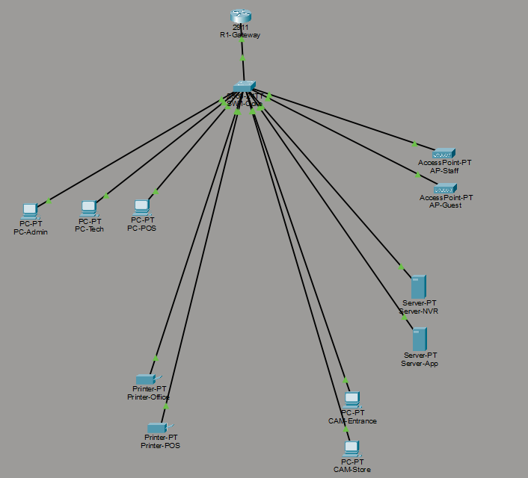

5. Logical Network Segmentation
To better organize the network, logical segmentation by function was proposed. This approach prevents all devices from being mixed in the same network and improves management, security, troubleshooting, and future growth.
In this type of business environment, there are different types of equipment and services, such as administrative computers, technical support, POS, printers, CCTV, internal servers, and Wi-Fi. Each group may have different access and security requirements.
For that reason, VLANs were created to logically separate the main business environments.
VLAN | Name | Function | Network
10 | Administration | PC-Admin and administrative tasks | 192.168.10.0/24
20 | Technical Support | PC-Tech and technical bench | 192.168.20.0/24
30 | POS / Store | PC-POS and customer service | 192.168.30.0/24
40 | Printers | Network printers and POS printers | 192.168.40.0/24
50 | CCTV | IP cameras | 192.168.50.0/24
60 | Servers | Server-App and Server-NVR | 192.168.60.0/24
70 | Staff Wi-Fi | Wi-Fi network for employees | 192.168.70.0/24
80 | Guest Wi-Fi | Wi-Fi network for visitors/customers | 192.168.80.0/24

This segmentation allows different rules to be applied by device type. For example, the Guest Wi-Fi network should have internet access only and should not access internal servers. The CCTV network should communicate mainly with the Server-NVR. The Administration and Technical Support networks may have broader access for management and troubleshooting.
Evidence: Subinterfaces configured on R1-Gateway to allow inter-VLAN routing using router-on-a-stick.
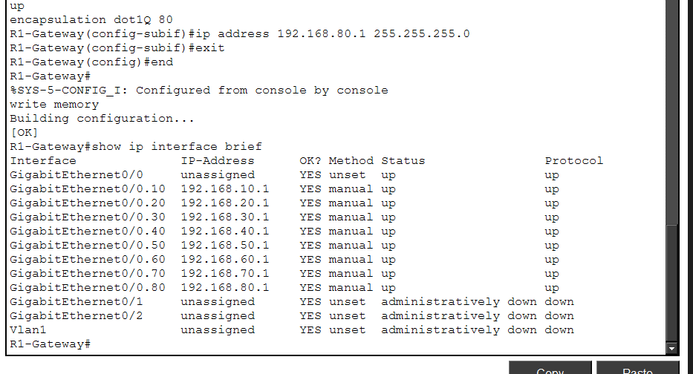
Evidence: Output of the show vlan brief command on SW1-Core, showing the VLANs created and the ports assigned to each network segment. This configuration logically separates administrative devices, technical devices, POS, printers, CCTV cameras, servers, and Wi-Fi networks.
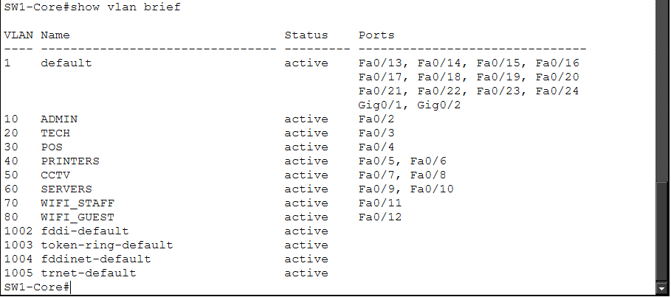
VLAN segmentation organizes the network by equipment type and prepares the infrastructure for different access rules between areas. For example, the Guest Wi-Fi network can be isolated from internal servers, while the Administration and Technical Support networks can have broader access for management and troubleshooting.
Evidence: Visual representation of the logical VLAN segmentation. Devices were grouped by function, separating Administration, Technical Support, POS, Printers, CCTV, Servers, Staff Wi-Fi, and Guest Wi-Fi.
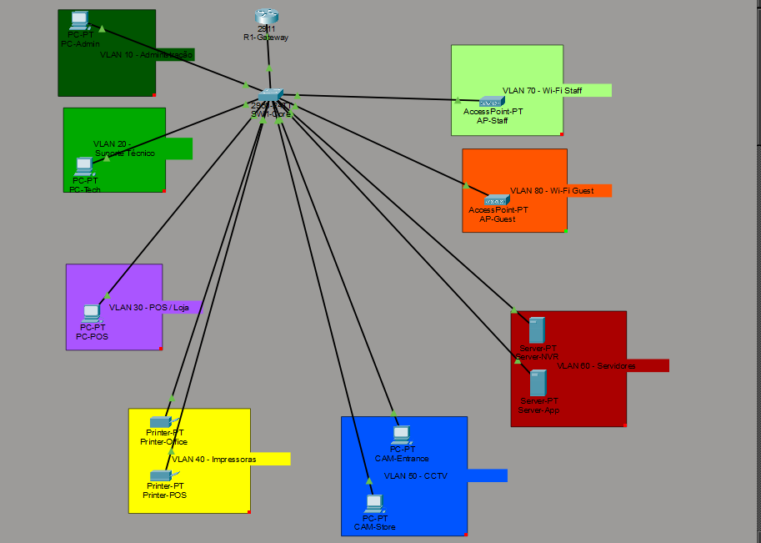
6. IP Addressing Plan
The IP addressing plan was defined according to the logical network segmentation. Each VLAN received its own /24 network, making it easier to separate devices by function and support management, troubleshooting, and future access-control rules.
In this proposal, the .1 address of each network is used as the gateway for its VLAN on R1-Gateway. Fixed devices such as printers, servers, cameras, and access points can use static IP addresses or DHCP reservations. User computers such as PC-Admin, PC-Tech, and PC-POS can receive addresses automatically through DHCP.
Proposed IP addressing plan:
VLAN | Segment | Network | Gateway | Recommended Method
10 | Administration | 192.168.10.0/24 | 192.168.10.1 | DHCP for PCs
20 | Technical Support | 192.168.20.0/24 | 192.168.20.1 | DHCP for PCs
30 | POS / Store | 192.168.30.0/24 | 192.168.30.1 | DHCP or static IP depending on POS requirements
40 | Printers | 192.168.40.0/24 | 192.168.40.1 | Static IP or DHCP reservation
50 | CCTV | 192.168.50.0/24 | 192.168.50.1 | Static IP or DHCP reservation
60 | Servers | 192.168.60.0/24 | 192.168.60.1 | Static IP
70 | Staff Wi-Fi | 192.168.70.0/24 | 192.168.70.1 | DHCP
80 | Guest Wi-Fi | 192.168.80.0/24 | 192.168.80.1 | DHCP

This organization makes it easier to quickly identify each type of device. For example, if a device is on the 192.168.50.0/24 network, the technician knows it belongs to the CCTV segment. If it is on the 192.168.40.0/24 network, it belongs to the printer segment.
Using separate gateways by VLAN allows R1-Gateway to route between the different segments using router-on-a-stick. From this foundation, firewall rules or ACLs can be applied to control which networks are allowed to communicate with each other.

Evidence: IP addresses automatically assigned by DHCP to computers in the Administration, Technical Support, and POS VLANs.
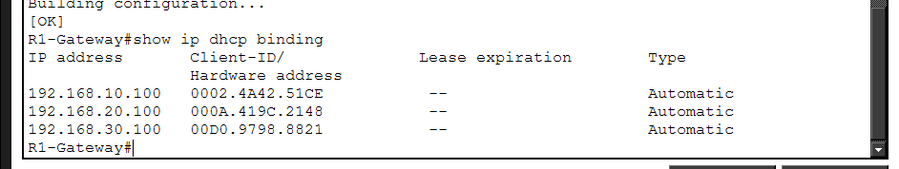
Evidence: Connectivity tests from PC-Admin confirming communication with the Administration VLAN gateway, internal servers, and a network printer through inter-VLAN routing.
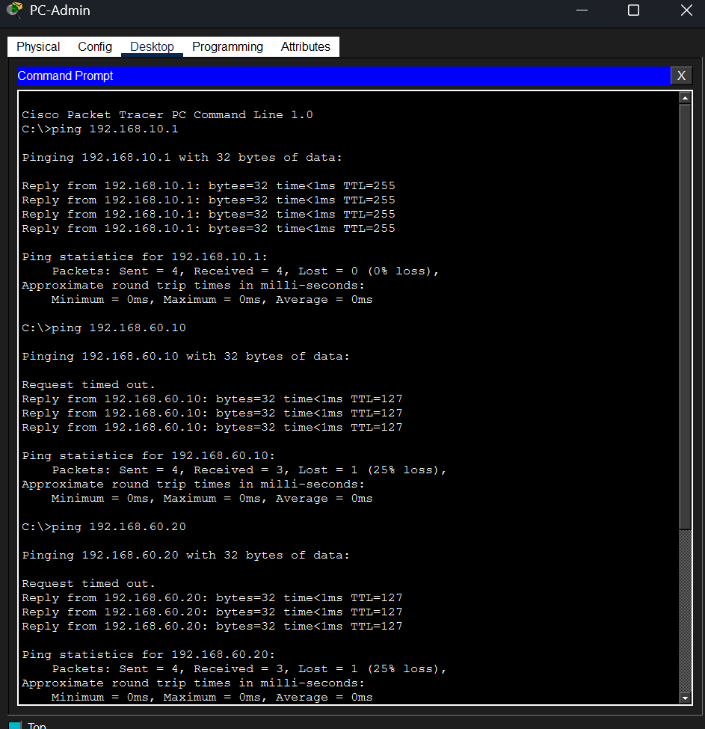

7. Expected Communication Rules Between Segments
After creating VLAN segmentation, it is important to define which networks should communicate with each other.
In this lab, inter-VLAN routing was enabled to validate connectivity between the main network segments. In a real installation, firewall rules or ACLs would be applied to better control access between networks.
Examples of expected rules:
The Administration network can access internal servers, printers, and management systems.
The Technical Support network can access printers, CCTV, and servers for troubleshooting.
The POS network should access Server-App and the POS printer.
The CCTV network should communicate mainly with Server-NVR.
The Guest Wi-Fi network should have internet access only, with no access to internal servers, printers, or cameras.
The Staff Wi-Fi network can have controlled access to internal services according to company policy.

This approach improves network organization and prepares the infrastructure for better security.

8. How to Apply Communication Rules Between VLANs
Creating VLANs logically separates the network, but VLANs alone do not define all access rules. To control which networks can communicate with each other, rules must be applied on the device responsible for routing between VLANs, such as a router, firewall, or Layer 3 switch.
In this lab, R1-Gateway is responsible for routing between VLANs through the router-on-a-stick configuration. Therefore, access rules could be applied on R1-Gateway using ACLs, or in a real installation through a dedicated firewall.

The recommended process would be:
1. Identify the network segments. | Example: Administration, Technical Support, POS, Printers, CCTV, Servers, Staff Wi-Fi, and Guest Wi-Fi.
2. Define which communications are required. | Example: PC-POS needs to communicate with Server-App and the POS printer. CCTV cameras need to communicate with Server-NVR. The Guest Wi-Fi network should not access internal servers.
3. Create a communication matrix. | This matrix defines which networks can communicate, which should be blocked, and the reason for each rule.
4. Apply rules on the router, firewall, or Layer 3 switch. | On Cisco devices, this can be done with ACLs. On firewalls, this is done with rules between interfaces or zones.
5. Test the rules. | The technician should test both allowed and blocked access. For example, confirm that PC-POS can access Server-App, while Guest Wi-Fi cannot access internal servers.
6. Document the rules. | Each rule should have a clear justification to support future troubleshooting, auditing, and support work.

Example communication rules for a small technology services company:
Source | Allowed Access | Restricted Access | Justification
Administration | Servers, printers, internal systems | Access according to company policy | Internal management and operations
Technical Support | Servers, printers, CCTV, POS | Controlled and documented access | Troubleshooting and support
POS / Store | Server-App and PRN-POS | CCTV, unnecessary servers, Guest network | Reduce exposure of the POS environment
Printers | Receive jobs from authorized PCs | Direct access from Guest Wi-Fi | Prevent misuse and operational confusion
CCTV | Server-NVR and technical management | POS, Guest Wi-Fi, and unnecessary networks | Security and camera isolation
Servers | Communication with authorized networks | Open access from all segments | Protect internal services
Staff Wi-Fi | Authorized internal services | Excessive unnecessary access | Employee use
Guest Wi-Fi | Internet only | Servers, printers, CCTV, and internal networks | Security for visitors/customers

Example ACL Implementation
On a Cisco router, one way to restrict the Guest Wi-Fi network is to create an ACL that blocks access to internal networks and allows traffic outside the business network.
Conceptual example:
- Block Guest Wi-Fi access to Administration
- Block Guest Wi-Fi access to Technical Support
- Block Guest Wi-Fi access to POS
- Block Guest Wi-Fi access to Printers
- Block Guest Wi-Fi access to CCTV
- Block Guest Wi-Fi access to Servers
- Allow Guest Wi-Fi access to internet only

Commands used:
ip access-list extended VLAN80_GUEST_IN
deny ip 192.168.80.0 0.0.0.255 192.168.10.0 0.0.0.255
deny ip 192.168.80.0 0.0.0.255 192.168.20.0 0.0.0.255
deny ip 192.168.80.0 0.0.0.255 192.168.30.0 0.0.0.255
deny ip 192.168.80.0 0.0.0.255 192.168.40.0 0.0.0.255
deny ip 192.168.80.0 0.0.0.255 192.168.50.0 0.0.0.255
deny ip 192.168.80.0 0.0.0.255 192.168.60.0 0.0.0.255
deny ip 192.168.80.0 0.0.0.255 192.168.70.0 0.0.0.255
permit ip 192.168.80.0 0.0.0.255 any
exit
interface gigabitEthernet0/0.80
ip access-group VLAN80_GUEST_IN in
exit

In this example, the ACL is applied on the VLAN 80 subinterface, which represents the Guest Wi-Fi network. The rule blocks access from the Guest network to internal networks and permits the remaining traffic, which in a real installation would be used for internet access.
In this lab, ACLs are presented as an example of access control. The complete implementation of access rules would depend on the company policy, required services, and the equipment used, such as a router, firewall, or Layer 3 switch.

9. Applying an ACL to Isolate the Guest Wi-Fi Network
After defining the expected communication rules, an ACL was applied on R1-Gateway to restrict access from VLAN 80, which represents the Guest Wi-Fi network.
The goal of this rule is to allow visitors or customers to use the Guest network without being able to access the company internal servers, printers, CCTV, POS, or administrative computers.
In this lab, the ACL VLAN80_GUEST_IN was applied on subinterface GigabitEthernet0/0.80, which represents the gateway for VLAN 80. The rule blocks traffic from the 192.168.80.0/24 network to internal networks and permits the remaining traffic.

Test result:
Before applying the ACL, PC-Guest-Test could communicate with internal networks because inter-VLAN routing was active and no blocking rules existed yet.
After applying the ACL VLAN80_GUEST_IN, PC-Guest-Test could still communicate with the Guest VLAN gateway, but it could no longer access internal servers, printers, CCTV, or other internal networks.
This test confirms that the ACL applied on subinterface GigabitEthernet0/0.80 correctly restricted access from the Guest Wi-Fi network to the company internal segments.

Test before applying the ACL: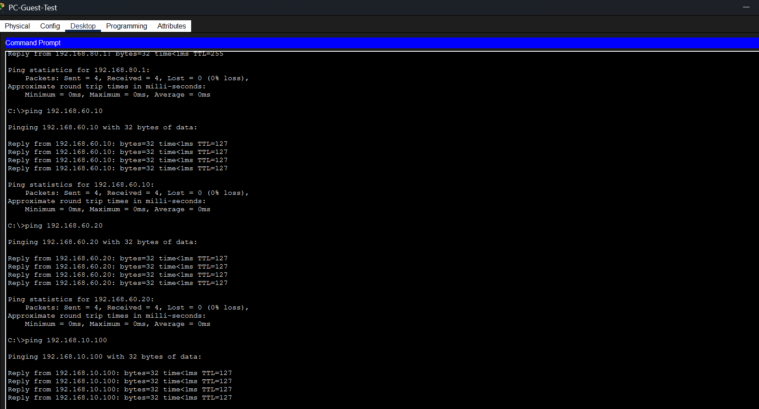
Test after applying the ACL: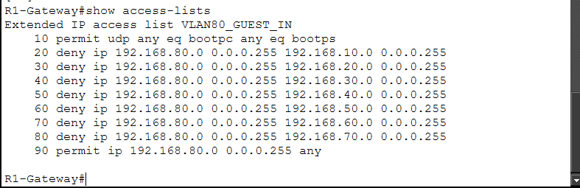
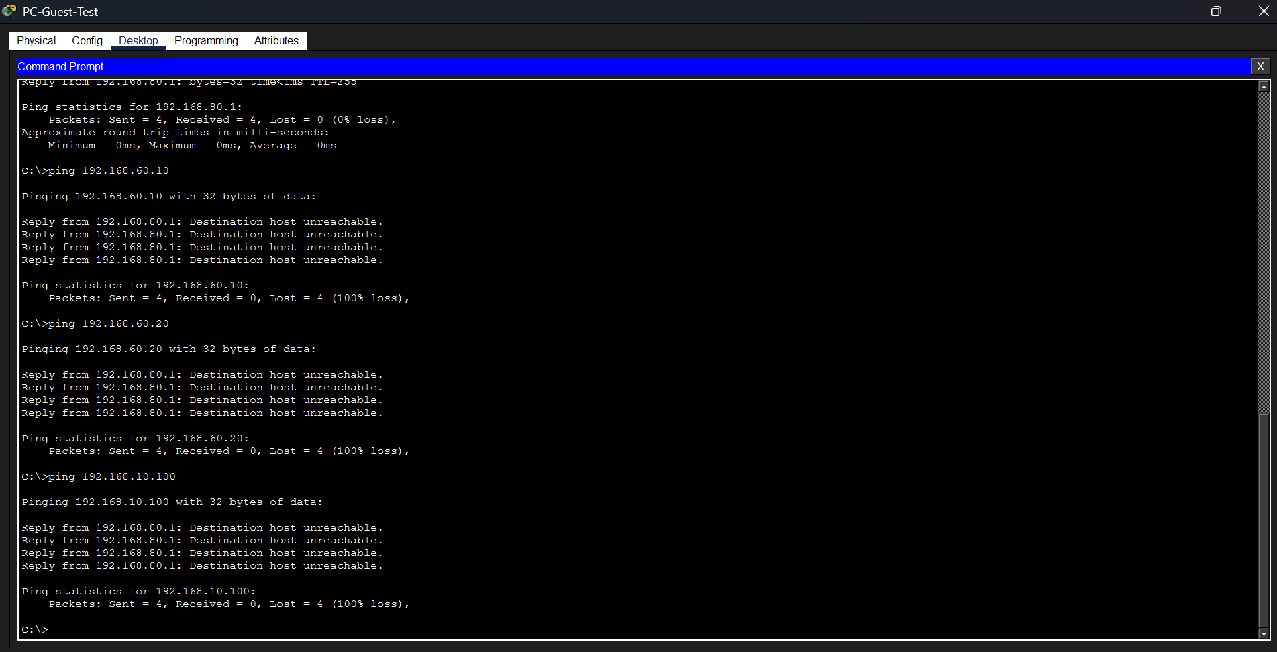
These tests validated VLAN segmentation, inter-network routing, DHCP address assignment, and the application of an ACL rule to isolate the Guest Wi-Fi network from internal segments.

10. Limitations and Next Steps
This lab represents a preliminary and educational design. The simulation demonstrates network organization, VLAN segmentation, DHCP, inter-VLAN routing, and a basic ACL implementation.
In a real installation, it would still be necessary to consider other aspects, such as:
- a real internet connection;
- a dedicated firewall;
- more detailed security rules;
- Wi-Fi authentication;
- configuration backups;
- network monitoring;
- electrical protection and UPS;
- physical documentation of cables and switch ports;
- user access policies;
- a possible VPN connection between branches.
As a next step, the network could be expanded to include a remote branch, secure VPN access, more specific ACL rules, and monitoring of the main devices.

11. Conclusion
This lab developed a preliminary network and services design for a small technology services company, integrating administrative areas, technical support, POS, printers, CCTV, servers, and Wi-Fi networks.
The network was organized using VLANs, planned IP addressing, and inter-segment routing through router-on-a-stick. DHCP pools, static IP devices, and an ACL to isolate the Guest Wi-Fi network from internal networks were also configured.
The lab demonstrates important IT infrastructure and technical support skills, including network planning, logical segmentation, router and switch configuration, DHCP, inter-VLAN routing, access control with ACLs, and technical documentation.

