Lab 03 — POS Support Lab in a Store/Office

1. Lab Context and Objective
In this lab, I simulate a realistic scenario where a small store or office uses a POS system to register sales, issue receipts, and check product information.
The objective is to understand the main components of a POS environment and demonstrate how a technician can validate network connectivity, configure essential peripherals, and follow a logical troubleshooting sequence.

2. POS Environment Topology
The topology includes a router, a switch, a POS computer, an administrative computer, a receipt printer, and a POS server.
The purpose of this topology is to simulate an environment where the POS computer can communicate with the receipt printer and with a management server/application. The administrative computer can also access the server for lookup, management, or support tasks.
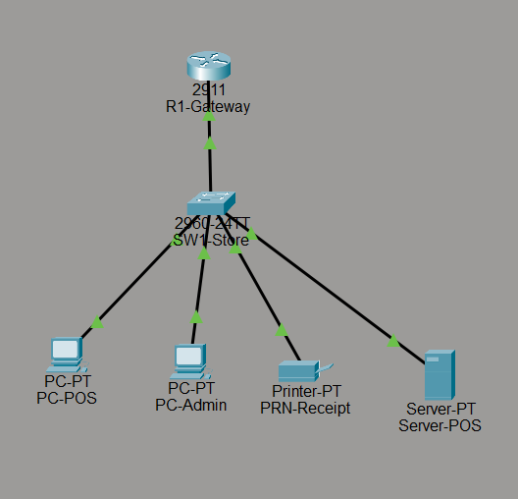

3. Components Used in the Lab
The following devices were used in this lab:
Component | Description
R1-Gateway | Local network router responsible for the gateway and DHCP IP address assignment.
SW1-Store | Switch that interconnects the store/office devices.
PC-POS | Point-of-sale computer used to simulate the terminal where sales are registered.
PC-Admin | Administrative or back-office computer used to view or manage system information.
PRN-Receipt | Receipt printer used by the POS system.
Server-POS | Server used to simulate a POS application or management system accessible on the local network.

4. IP Addressing Plan
The 192.168.20.0/24 network was used to represent the local network of the store/office.
IP plan used:
Device | IP Address / Method
R1-Gateway | 192.168.20.1
SW1-Store | No IP configured in this lab
PC-POS | DHCP
PC-Admin | DHCP
PRN-Receipt | 192.168.20.50 static
Server-POS | 192.168.20.100 static
DNS Server | 8.8.8.8

Fixed devices, such as the router, receipt printer, and POS server, were configured with static IP addresses. User computers were configured to receive IP addresses automatically through DHCP.
This separation helps keep critical devices on predictable addresses, making configuration, support, and troubleshooting easier.
Evidence: DHCP configuration on the R1-Gateway router, showing the exclusion of addresses from 192.168.20.1 to 192.168.20.100 and the creation of the STORE-LAN DHCP pool for the network computers.
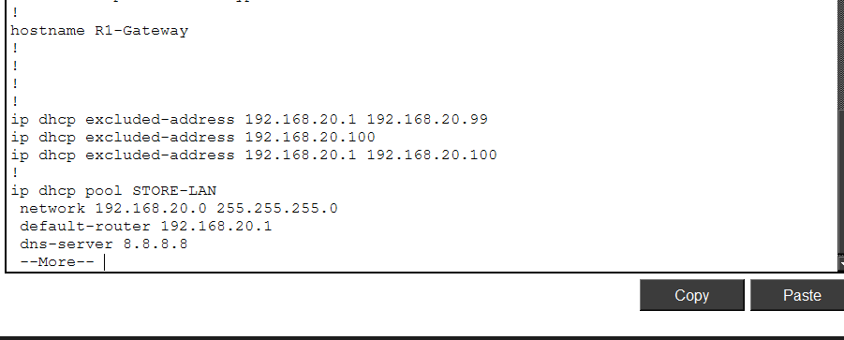
Evidence: IP addresses assigned automatically by DHCP to the computers on the network.
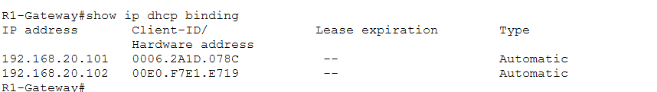

5. Server-POS Configuration with HTTP Service
To simulate a POS application or management system, the HTTP service was enabled on Server-POS.
The HTTP service allows computers on the network to access the server through a web browser. In this lab, this represents access to a management application, product lookup, stock information, or sales registration.
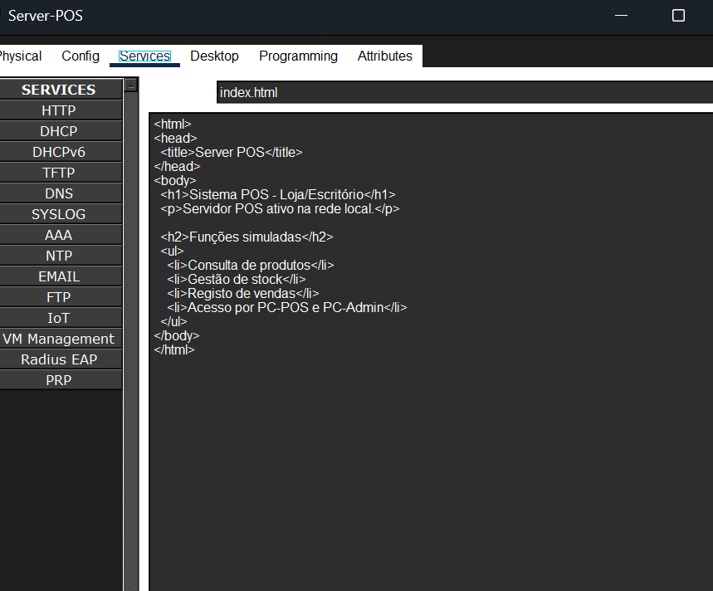

6. Server-POS Access Test
After configuring Server-POS, an access test was performed from PC-POS and PC-Admin. On PC-POS and PC-Admin, the web browser was opened and the address http://192.168.20.100 was entered. The Server-POS page opened correctly, confirming that the POS computer can access the server/application through the local network.
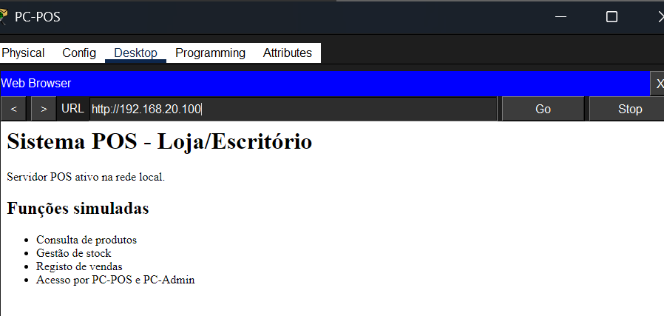

7. Connectivity Tests
After confirming that Server-POS was accessible through the web browser, connectivity tests were performed using the ping command.
The objective was to validate whether PC-POS could communicate with the main network devices: the gateway, the receipt printer, and the POS server.
Tests performed from PC-POS:
- Ping to the gateway: 192.168.20.1
- Ping to the receipt printer: 192.168.20.50
- Ping to Server-POS: 192.168.20.100
A test was also performed from PC-Admin to confirm access to Server-POS.
These tests help the technician confirm that the network infrastructure is functional before investigating software, driver, or peripheral-related issues.
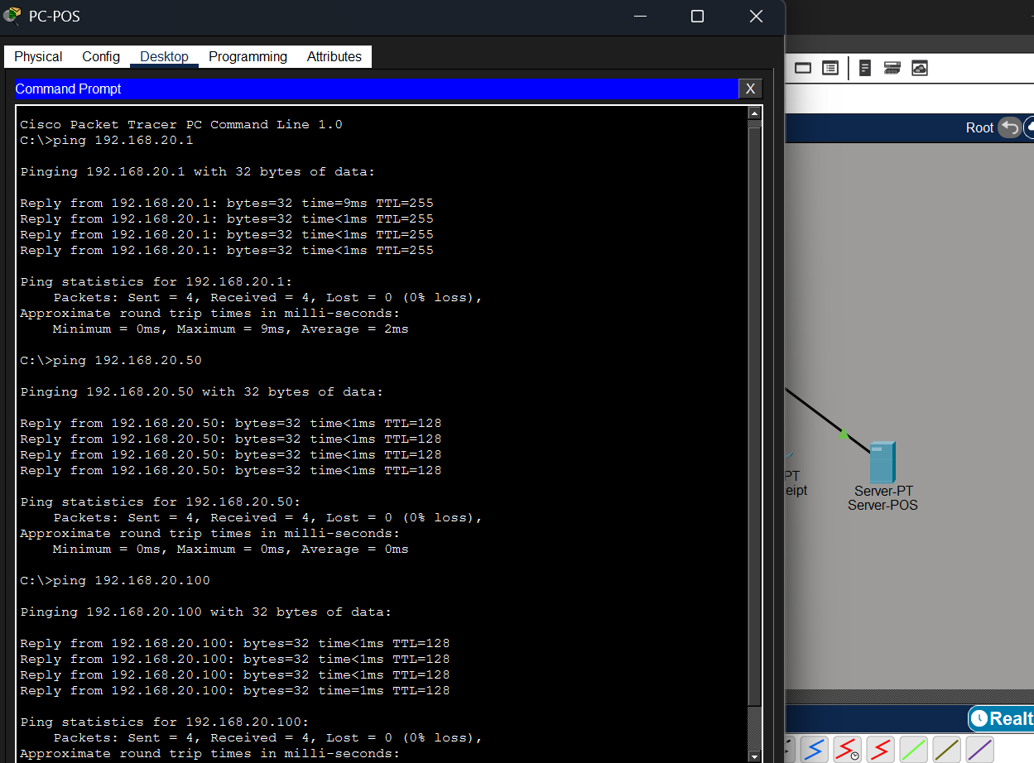

8. Common Peripherals in a POS Environment
In a real POS environment, the point-of-sale computer may be connected to several peripherals. These devices allow users to register products, issue receipts, process payments, and control store operations.
In a real POS environment, each peripheral must be installed, configured, and tested. Some peripherals may connect through USB, Ethernet, Wi-Fi, Bluetooth, or serial connection, depending on the model.
Component | Function | Common Connection | Technical Test
POS Printer / PRN-Receipt | Print receipts or sales slips. | USB, Ethernet, or Wi-Fi. | Confirm IP or USB connection, install the correct driver, print a test page, and print a receipt through the POS software.
Barcode Scanner | Read products quickly during a sale. | USB or wireless. | Test scanning in a text field or in the POS software and confirm that the product is recognized.
POS Software | Register sales, look up products, manage stock, and issue receipts. | Local installation, internal server, or web/cloud application. | Confirm that the software opens, user login works, the database/server is reachable, and a test sale can be registered.
Payment Terminal / TPA | Process card payments. | Ethernet, Wi-Fi, mobile network, or integration with the POS system. | Confirm power, network communication, and correct operation according to the responsible provider/bank.

These devices may connect to the POS computer through USB, Ethernet, Wi-Fi, Bluetooth, or serial connection, depending on the model and type of installation.
In a technical support context, the technician must confirm that each peripheral is correctly connected, powered on, using a functional cable, configured with the correct driver, and recognized by the POS software.
For example, a receipt printer may be connected to the network and respond to ping, but still fail to print if the driver is incorrect, the print queue is stuck, or the POS software is configured to use the wrong printer.

9. Integration Between POS Software, Windows, and Peripherals
In a real POS installation, the technician must ensure that the operating system, POS software, and peripherals work together.
The first level of configuration is done in the operating system. At this stage, the technician confirms the physical connections, installs drivers when necessary, validates the network, configures printers, and confirms that the devices are recognized by the computer.
The second level of configuration is done inside the POS software. At this stage, the technician selects the correct receipt printer, confirms the user/login, tests products, validates access to the server or application, and performs a test sale.
Some peripherals, such as USB barcode scanners, may work as keyboard input devices. In these cases, the technician can test the scanner in a text field before testing it inside the POS software. Other equipment, such as receipt printers, cash drawers, or payment terminals, may require a driver, specific configuration, or support from the responsible provider.
In this lab, Server-POS represents the POS application. PRN-Receipt represents the receipt printer. PC-POS represents the computer used by the operator at the point of sale.

10. Role of POS Software in the Installation
In a real POS installation, the software is the center of the point-of-sale system. It is where the user registers sales, looks up products, manages stock, issues receipts, and accesses reports.
In the InkToner context, POS solutions can be associated with hardware, technical support, installation, and configuration. One publicly shared example is InkRest, presented as POS software for areas such as restaurants, hospitality, and retail.
The technician’s role may vary depending on the software used. In some cases, the technician installs the software directly on the Windows computer. In other cases, the software may be web/cloud-based and accessed through a browser. There may also be a local server installation or an application connected to a database.
In this lab, Server-POS simulates the POS application. The goal is not to reproduce a specific commercial software product, but to demonstrate the technical logic of installing, connecting, and validating a POS environment.

11. Installation Flow in a Real Scenario
In a real scenario, the technician would follow an installation flow similar to this:
- Confirm the equipment provided to the customer.
- Check the local network and internet connection.
- Configure the PC-POS.
- Install or access the POS software.
- Configure the user/login in the software.
- Install the receipt printer driver.
- Configure the printer inside the POS software.
- Test the barcode scanner.
- Test product registration or a test sale.
- Print a test receipt.
- Confirm the operation of the cash drawer or payment terminal, if applicable.
- Explain the basic operation to the user.
- Document the installation and tests performed.

12. POS Environment Troubleshooting Checklist
When a POS system has issues, the technician should follow a logical verification sequence.
Initial checks:
- Confirm that PC-POS is powered on.
- Confirm that there is network connectivity.
- Confirm that PC-POS received an IP address correctly.
- Test communication with the gateway.
- Test communication with Server-POS.
- Test communication with the receipt printer.
- Confirm that the POS software opens correctly.
- Confirm that the receipt printer is powered on and available.
- Confirm that the barcode scanner is connected and recognized.
- Confirm that the cash drawer is connected to the printer or POS system.
- Confirm that the payment terminal/TPA has network connectivity or signal.
- Check drivers, cables, power, and software configuration.
Common issues:
- POS has no internet or no network connectivity.
- POS cannot access the server.
- Receipt printer does not print.
- Barcode scanner does not read products.
- Cash drawer does not open.
- TPA has no communication.
- POS software is slow or frozen.
- Incorrect IP address or IP conflict.
- Wrong or missing driver.
- USB, Ethernet, or power cable disconnected.

13. Conclusion
This lab simulated a basic POS environment in a small store or office. The main network elements were configured, including router, switch, POS computer, administrative computer, receipt printer, and POS server.
PC-POS and PC-Admin received local network connectivity, Server-POS was configured to simulate a management application, and browser-based access tests were performed. Ping connectivity tests were also performed to validate communication between PC-POS, the gateway, the receipt printer, and Server-POS.
This lab demonstrates important skills for technical support in commercial environments, including network configuration, connectivity validation, understanding POS peripherals, troubleshooting, and technical documentation.

