Lab 04 — CCTV / IP Camera Support

1. Lab Context and Objective
In this lab, I simulate a real-world scenario where a small store or office uses a CCTV system with IP cameras for security monitoring.
The objective is to understand the main components of a networked CCTV environment and demonstrate how a technician can configure IP addresses, validate connectivity, simulate a server/NVR, and follow a logical troubleshooting sequence.
The focus is on technical support for IP cameras, the local network, the recording/monitoring server, and administrative access to the CCTV system.
This lab does not simulate real camera video. The purpose is to represent the network infrastructure required for IP cameras to communicate with a server/NVR and to be accessible from an administrative computer.

2. CCTV Environment Topology
For this lab, I created a small local network to simulate a CCTV environment with IP cameras.
The topology includes a router, a switch, an administrative computer, a server/NVR, and three IP cameras. The router acts as the network gateway and DHCP server for the administrative computer. The switch interconnects all devices. Server-NVR represents the camera recording and monitoring system. PC-Admin represents the computer used by the technician or administrator to access the CCTV system.
The IP cameras were configured with static IP addresses because, in CCTV environments, it is important for these devices to have predictable addresses. This makes monitoring, recording, and troubleshooting easier.
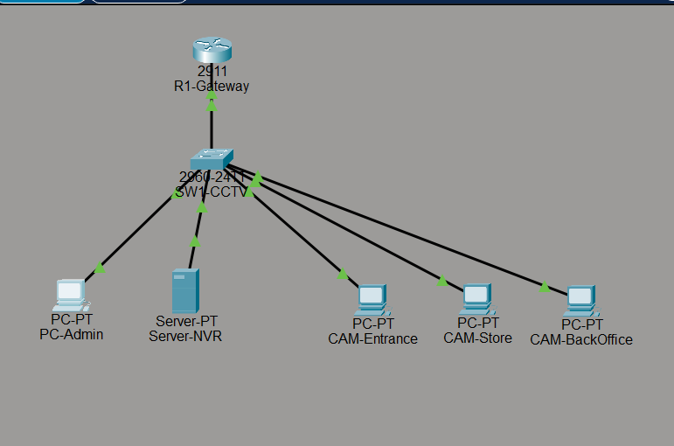
Figure 1 - CCTV environment topology with R1-Gateway, SW1-CCTV, PC-Admin, Server-NVR, and three simulated IP cameras.

3. IP Addressing Plan
The 192.168.30.0/24 network was used to represent the local network for the CCTV environment.
In this lab, the main CCTV system devices were configured with static IP addresses. This includes the IP cameras and Server-NVR, because these devices need predictable addresses for monitoring, recording, internal remote access, and troubleshooting.
PC-Admin was configured to receive an IP address automatically through DHCP, simulating a regular administrative computer inside the company network.
Device | IP Address | Method
R1-Gateway | 192.168.30.1 | Static
SW1-CCTV | No IP configured in this lab | N/A
CAM-Entrance | 192.168.30.20 | Static
CAM-Store | 192.168.30.21 | Static
CAM-BackOffice | 192.168.30.22 | Static
Server-NVR | 192.168.30.100 | Static
PC-Admin | DHCP | Automatic
DNS | 8.8.8.8 | Configured through DHCP

The R1-Gateway router was configured with the address 192.168.30.1 and also as the DHCP server. The range from 192.168.30.1 to 192.168.30.100 was reserved for fixed devices such as IP cameras, the server/NVR, and the gateway. Starting at 192.168.30.101, addresses can be assigned automatically through DHCP to PC-Admin or other computers on the network.
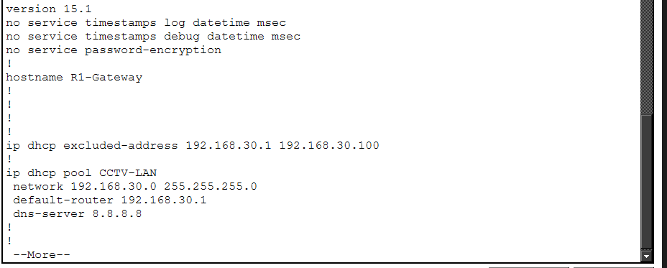
Figure 2 - DHCP configuration on R1-Gateway, showing the excluded address range and the CCTV-LAN DHCP pool.
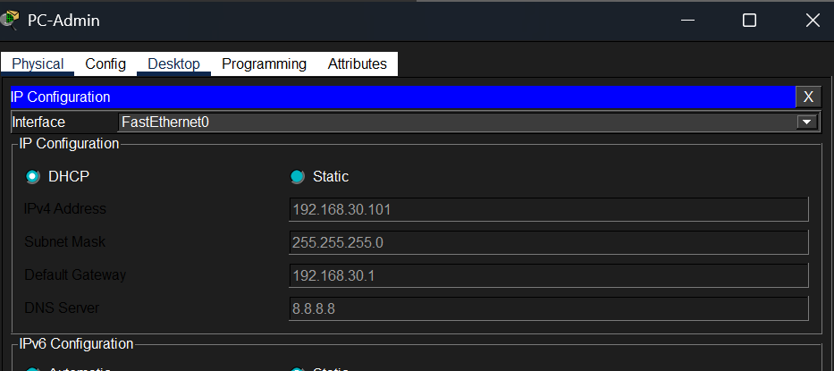
Figure 3 - PC-Admin received an IP address automatically through DHCP and joined the CCTV network.
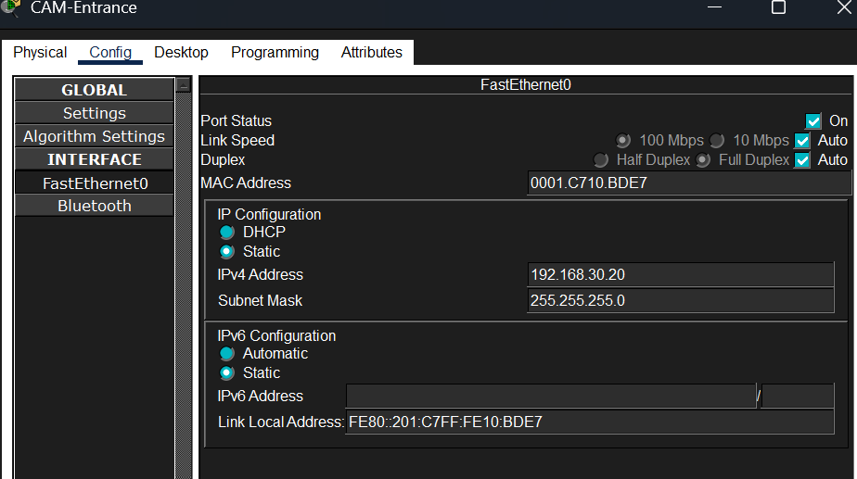
Figure 4 - CAM-Entrance configured with the static IP address 192.168.30.20.

4. IP Camera Configuration
After defining the IP addressing plan, the IP cameras were configured with static addresses. In CCTV environments, it is recommended that cameras use fixed IP addresses or DHCP reservations because the NVR must be able to locate each camera consistently. If a camera IP changes, the NVR may stop recording or displaying that camera.
In this lab, three IP cameras were simulated:
- CAM-Entrance: 192.168.30.20
- CAM-Store: 192.168.30.21
- CAM-BackOffice: 192.168.30.22
Each camera was configured with subnet mask 255.255.255.0, default gateway 192.168.30.1, and DNS server 8.8.8.8.
Camera | Simulated Location | IP Address | Method
CAM-Entrance | Store/office entrance | 192.168.30.20 | Static
CAM-Store | Customer service/store area | 192.168.30.21 | Static
CAM-BackOffice | Office/backoffice | 192.168.30.22 | Static

Using clear names for the cameras helps the technician quickly identify the location of each device during installation, monitoring, or troubleshooting.

5. Server-NVR Configuration
After configuring the IP cameras, Server-NVR was configured with the static IP address 192.168.30.100.
In a real CCTV system, the NVR, or Network Video Recorder, is responsible for receiving, recording, and allowing the viewing of images from IP cameras. The NVR needs to communicate with all cameras on the network and should also be accessible from the administrative computer.
In this lab, Server-NVR was used to simulate the central CCTV monitoring system. To represent a management interface, the HTTP service was enabled on the server, allowing PC-Admin to access the system through a web browser.
Configuration used on Server-NVR:
- IP Address: 192.168.30.100
- Subnet Mask: 255.255.255.0
- Default Gateway: 192.168.30.1
- DNS Server: 8.8.8.8
- HTTP Service: Enabled
The HTTP service was used only to simulate a web interface for accessing the CCTV/NVR system. In a real installation, NVR access could be provided through a web interface, manufacturer software, or a monitoring application.
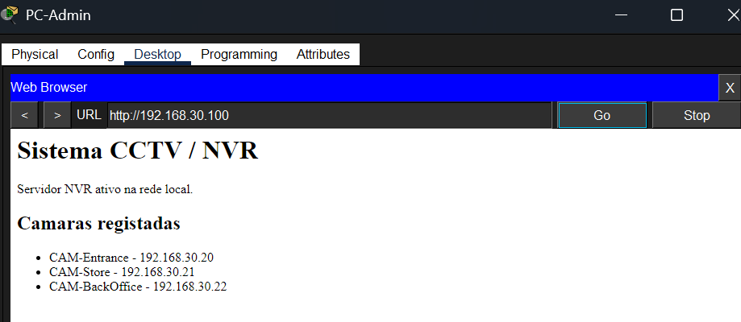
Figure 5 - HTTP service active on Server-NVR to simulate a CCTV/NVR web monitoring interface.

6. Connectivity Tests
After configuring the IP addressing plan, the IP cameras, and Server-NVR, connectivity tests were performed from PC-Admin.
The objective of these tests was to confirm whether the administrative computer could communicate with the main devices in the CCTV environment: the network gateway, the IP cameras, and Server-NVR.
In a real CCTV system, this step is important because the technician needs to confirm that the cameras are reachable on the network before configuring recording, viewing, or remote access.
Tests performed from PC-Admin:
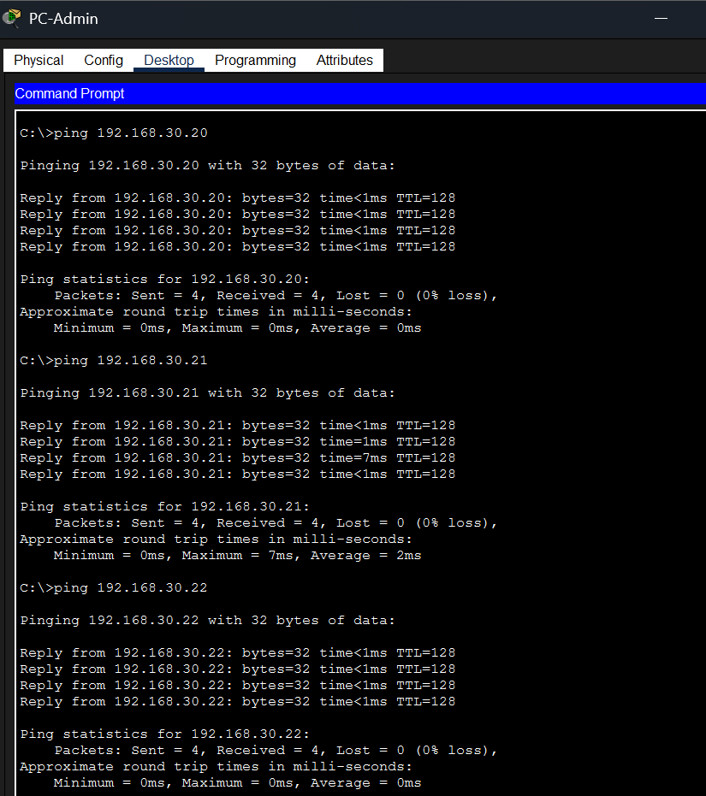
Figure 6 - Ping tests from PC-Admin confirming connectivity to the main CCTV devices.
The ping tests confirm that IP communication exists between PC-Admin and the main devices in the CCTV system. This indicates that IP addressing, physical connectivity, and basic local network communication are working.
In a real installation, after confirming connectivity, the technician could proceed with camera registration on the NVR, image validation, recording validation, and access to the monitoring system.

7. Integrating Cameras with the NVR or Monitoring Software
After configuring the network and assigning static IP addresses to the cameras, the next step in a real installation would be to integrate each camera into the NVR or monitoring software.
The real process may vary depending on the equipment manufacturer, but it usually follows this logic:
- Physically connect the camera to the network. The camera can be connected to a PoE switch, a PoE port on the NVR, or a regular switch with a separate power supply.
- Confirm power and network link. The technician checks that the camera powers on, that the network port has link, and that the cable is functional.
- Identify the camera IP address. The IP can be configured manually, received through DHCP, discovered through the router/DHCP service, found with a manufacturer tool, or detected by the NVR search function.
- Access the camera. The technician can access the camera through a web browser or manufacturer tool to confirm that it is online.
- Configure basic camera settings. At this stage, the camera name, static IP, subnet mask, gateway, DNS, date/time, administrator password, and location can be configured.
- Add the camera to the NVR or monitoring software. On the NVR, the technician adds the camera using the camera IP, username, password, supported protocol, and recording channel.
- Validate image and recording. After adding the camera, the technician confirms that the image appears, the camera name is correct, recording is active, and previous recordings can be played back.
- Test access from the administrative computer. PC-Admin should be able to access the NVR or monitoring software to view the CCTV system.
Step | Where It Is Done | What the Technician Validates
Physical connection | Camera, switch, NVR | Cable, power, PoE or external power supply
IP configuration | Camera/router/NVR | IP address, subnet mask, gateway, DNS
Initial access | Browser or manufacturer tool | Login, password, camera interface
NVR integration | NVR/CCTV software | Camera IP, username, password, protocol
Monitoring | NVR or PC-Admin | Live image and correct camera name
Recording | NVR | Storage, recording schedule, and playback
Final validation | PC-Admin | System access and camera viewing

8. CCTV Troubleshooting Checklist
When a CCTV system has problems, the technician should follow a logical verification sequence.
Initial checks:
- Confirm that the camera is powered on.
- Confirm that the network cable is connected.
- Confirm that the switch port has link.
- Confirm that the camera has the correct IP address.
- Ping the camera IP address.
- Confirm that Server-NVR is powered on and reachable.
- Confirm that PC-Admin can access Server-NVR.
- Check whether the camera is registered in the NVR.
- Confirm that the camera image appears in the system.
- Check NVR storage.
- Check date, time, and recording settings.
- Confirm username, password, and access permissions.
Common problems:
- Camera offline.
- Incorrect IP address or IP conflict.
- Network cable disconnected.
- No power or PoE problem.
- NVR cannot find the camera.
- Incorrect camera password.
- No recording.
- NVR disk full or disk error.
- No signal, slow image, or intermittent image.
- PC-Admin cannot access the monitoring system.

9. Conclusion
This lab simulated the technical foundation of a CCTV environment with IP cameras in a small store or office.
The router, switch, PC-Admin, Server-NVR, and three simulated IP cameras were configured. The cameras and Server-NVR were configured with static IP addresses, while PC-Admin received its address automatically through DHCP.
Connectivity tests were performed to validate communication between PC-Admin, the gateway, the IP cameras, and Server-NVR. Web access to Server-NVR was also configured to simulate a CCTV monitoring interface.
In this lab, the NVR model was used to simulate an IP-camera-based CCTV system. In real installations, the solution can vary: NVR for IP cameras, DVR for analog cameras, cloud-based system, or SD card recording, depending on the equipment supplied and the solution adopted by the client.
Although Packet Tracer does not simulate real video, this lab demonstrates important technical support skills for CCTV, including IP addressing, network configuration, connectivity validation, access to the monitoring system, troubleshooting, and technical documentation.

