Lab 02 - Network Printer Configuration

1. Lab context and objective
In this lab, I simulate a real-world scenario where a company purchases a network printer and the technician needs to install it correctly on the organization's network. The goal is not only to connect the printer, but also to make sure it is reachable by users, has a stable IP address, and does not conflict with other devices.
In a real installation, the company usually already has a router or firewall, switch, DHCP service, computers, and possibly servers. Before configuring the printer, the technician should analyze the existing network.
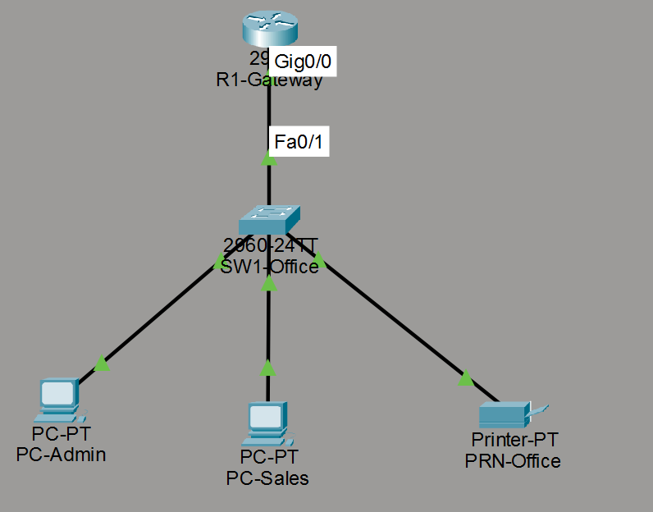
Figure 1 - Packet Tracer topology used for the network printer lab.

2. Network analysis before installation
First, I analyze the current network and confirm the IP addressing plan. If DHCP is being used, I check whether there is a DHCP reservation system or a static IP range for devices such as printers. If available, I configure a DHCP reservation for the printer. If not, and with authorization, I assign a static IP outside the DHCP range and document that configuration.
The first step is to identify how the network is configured:
- What is the network IP range?
- Is DHCP active?
- What is the default gateway?
- What is the DNS server?
- Is there a reserved range for printers, servers, or other fixed devices?
- Will the printer use a static IP address or a DHCP reservation?

3. Choosing the printer IP method
The two most common options are:
A. DHCP reservation on the router or DHCP server, associating the printer's MAC address with a fixed IP address.
Example field | Value
Printer MAC address | 00E0.F9B5.14B4
Reserved IP address | 192.168.10.150
Reservation logic | Printer1 = MAC 00E0.F9B5.14B4 = IP 192.168.10.150

The DHCP reservation method was documented as a best practice, but it was not applied in Packet Tracer due to a limitation of the simulator in this specific configuration.
B. Static IP configured directly on the printer, outside the DHCP range and without conflict with other devices.
After analyzing the network, I configured the PRN-Office printer with a static IP address. This approach is common when the technician does not have access to the router or DHCP server, or when the company uses a reserved range for fixed devices.
In this lab, the printer was configured with the IP address 192.168.10.50. This address is outside the dynamic DHCP range because the router excludes addresses from 192.168.10.1 to 192.168.10.99 from automatic assignment.
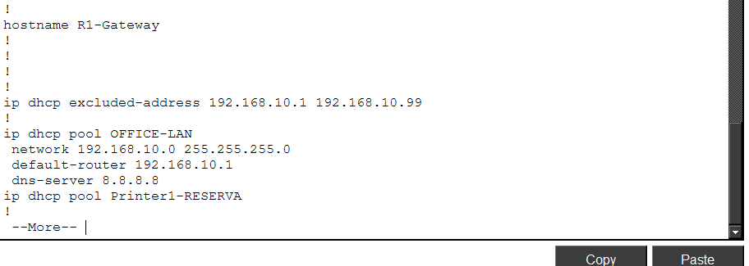
Figure 2 - DHCP excluded address range and DHCP pool configuration on R1-Gateway.
Printer configuration used in the lab:
Setting | Value
IP Address | 192.168.10.50
Subnet Mask | 255.255.255.0
Default Gateway | 192.168.10.1
DNS Server | 8.8.8.8

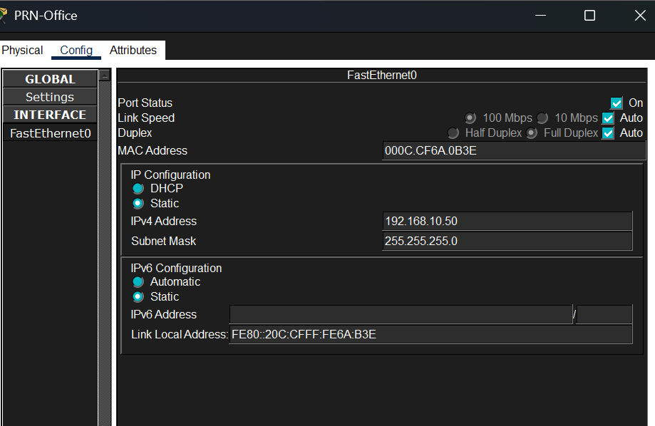
Figure 3 - Static IP configuration applied to PRN-Office in Packet Tracer.

4. Connectivity test
After configuring the printer's static IP address, I performed a connectivity test from the PC-Admin computer.
The objective of the test was to confirm that the computer could communicate with the printer through the local network. For this, I used the ping command to the printer's IP address.
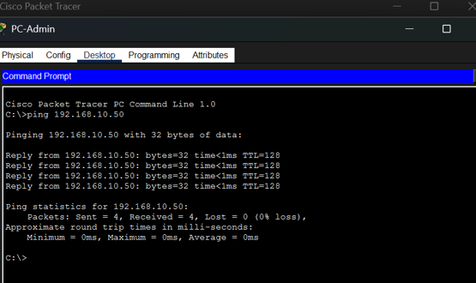
Figure 4 - Successful ping test from PC-Admin to the printer IP address 192.168.10.50.

5. Installing the printer and driver on the user computer
After confirming that the computer can communicate with the printer over the network, the next step in a real installation would be to add the printer in the user's operating system.
In Windows, this can be done through the printer settings by adding the printer using its IP address. In this case, the IP address would be 192.168.10.50.
General steps:
- Open Windows Settings.
- Go to Bluetooth & devices > Printers & scanners.
- Select Add device.
- If the printer is not found automatically, choose the option to add it manually.
- Select the option to add a printer using an IP address or hostname.
- Enter the printer IP address: 192.168.10.50.
- Install or select the correct printer driver.
- Print a test page.
To install the printer driver, the technician should first identify the exact printer model and the computer's operating system. Then, the technician should download the driver from the manufacturer's official website, avoiding unofficial sources for security reasons. After downloading the correct driver, the technician can install the manufacturer software or add the printer manually in Windows using its IP address.
During this process, the driver allows the operating system to communicate correctly with the printer model and use its features, such as color printing, duplex printing, specific paper trays, and scanning when applicable.
If the printer is multifunction, additional features may also need to be configured, such as scan to folder and scan to email.
Note: In small businesses, installation may be done manually on each computer by adding the printer using its IP address and installing the correct driver. In larger organizations, this process should be centralized through a print server, Active Directory/Group Policy, Microsoft Intune, or remote management tools. This allows the printer to be deployed automatically to multiple users without configuring each computer manually.

6. Installation documentation
After completing the printer configuration, the technician should document the main information to make future support easier.
Item | Information to record
Printer name | PRN-Office
IP address | 192.168.10.50
IP method | Static IP
Gateway | 192.168.10.1
DNS | 8.8.8.8
Connection type | Ethernet
Location/department | Office
Tested computers | PC-Admin and PC-Sales
Driver used | To be confirmed according to the real printer model
Test performed | Successful ping; in a real installation, print a test page

This documentation helps the technician or support team quickly identify the printer, troubleshoot issues, and avoid future IP conflicts.

7. Troubleshooting checklist
If the printer does not work correctly, the technician should follow a logical sequence of checks.
Initial checks:
- Confirm that the printer is powered on.
- Confirm that the network cable is connected.
- Confirm that the printer has an IP address configured.
- Confirm that the printer IP address does not conflict with another device.
- Ping the printer IP address.
- Confirm that the computer is on the same network or has a route to the printer.
- Confirm that the correct driver is installed.
- Check whether the printer is offline or paused in Windows.
- Check the print queue.
- Confirm that there is paper, toner/ink, and no physical error.
- Print a test page.
Common issues:
- Printer offline.
- Incorrect IP address.
- Wrong driver.
- Disconnected network cable.
- IP conflict.
- Stuck print queue.
- Problem with the print spooler service.
- Paper jam or missing consumables.

8. Procedure in case of printer failure
When a printer has a fault or stops working correctly, the technician should follow an organized diagnostic process before replacing parts or concluding that the device is damaged.
The first step is to identify the type of problem. The failure may be related to the network, the user computer, the driver, the print queue, consumables, paper jams, or a physical fault in the equipment.
Initial procedure:
Step | Action | Details
1 | Confirm the issue with the user. | Examples: does not print, prints with defects, appears offline, makes noise, jams paper, does not scan, or shows an error on the panel.
2 | Check the physical condition of the printer. | Confirm that it is powered on, has paper and toner/ink, has no paper jam, all covers are closed, and there is no error message on the display.
3 | Check the network connection. | Confirm that the network cable is connected, the network port light is active, and the printer still has the correct IP address.
4 | Test connectivity. | From a computer on the network, ping the printer IP address. If ping fails, the issue may be related to IP configuration, cable, switch, VLAN, gateway, or network configuration.
5 | Check the Windows configuration. | Confirm that the printer is not offline or paused, that the correct printer is selected, and that the print queue is not blocked.
6 | Check the driver. | If the printer receives the job but prints incorrectly, or if some functions do not appear, it may be necessary to reinstall or update the correct driver.
7 | Test printing. | Print a test page from Windows and, if possible, also print a configuration page directly from the printer.
8 | Escalate or send for repair. | If the problem is mechanical, electrical, related to the fuser, roller, board, sensor, scanner, or another internal component, the technician should document the symptoms and refer it for specialized repair.

The technician's goal is to follow a logical sequence: first confirm the problem, then check the basics, test the network, validate the computer and driver, and only then conclude that there is a physical fault. This approach avoids unnecessary replacements and helps resolve issues more quickly and professionally.

9. Conclusion
This lab simulated a basic network printer installation in an office environment. The configuration demonstrated the importance of analyzing the network before installation, defining a stable IP address for the printer, testing connectivity, and understanding the steps required to make the printer available to users.
In Packet Tracer, it was possible to configure the network, assign a static IP address to the printer, and validate communication using ping. In a real installation, after confirming connectivity, the technician would also need to add the printer in Windows, install the correct driver, and print a test page.
This type of procedure is important for IT support because it combines network knowledge, device configuration, troubleshooting, and technical documentation.

