

ADMINISTRATOR MANUAL

Table of contents

1. Application description 3

2. User types 3

3.Administrator manual 4

3.1 How can I manage courses? 4

3.1.1 Filter by name 5

3.1.2 Add course 5

3.1.3 Delete course 6

3.1.4 Course update 6

3.2 How can I manage trainers? 7

3.2.1 Filter by name 7

3.2.2 Add trainer 8

3.2.3 Delete course 9

3.2.4 Course update 9

3.3 How can I schedule classes? 10

3.3.1 Filter by week 10

3.3.2 Update schedule 11

3.3.3 Delete an existing schedule 11

3.3.4 Schedule a course 12

3.4 How can I manage the feedbacks? 13

3.4.1Filter by course/trainer name 13

3.4.2 Delete a feedback 13

3.5 How can I manage the packages? 14

3.5.1 Filter by name 14

3.5.2 Delete a package 14

3.5.3 Update a package 15

3.5.4 Add a package 15

3.6 How can I manage the payments? 16

3.6.1 Confirm a client’s subscription 16

3.7 How can I manage the users? 17

3.7.1 Filter by name 18

3.7.2 Create an account for a client 18

3.7.3 Delete a user? 18

3.7.4 Update an existing user account 18

# Application description

The „iLift“ application is a solution designed for fitness companies to offer a new channel of communication between them and their clients, covering the logistic problems that can come in their daily activity. To make it accessible for any user, regardless of their experience in using it, iLift comes in the form of a web application that is both modern and intuitive at the same time thanks to the state-of-the-art technologies used in the development of it and the client-oriented thinking of the developers that made it very simple and easy to be used in order to maximize performance.

Through this solution, the managers of the fitness companies can make changes in schedules, manage user subscriptions and can present different classes and trainers while also evaluating their activity by requesting feedback for each of them from their clients.

The client can manage its own subscriptions, classes and he can see and offer feedback for the trainers and contact the company in order to obtain information or to file complaints.

# User types

As it was designed to be used at the same time by both clients and companies by sharing the same user-friendly interface, the application will make a distinction between these user types:

* The unregistered user (not logged in) has access to all of the information regarding the fitness programs available, trainers, current offers and gym contact. He can register in the application using the account provided by the administrator.
* The registered user is able to also manage his subscriptions, can see and offer feedback for the trainers and classes.
* The administrator can manage user accounts, subscription packages, classes and trainers, rooms, change schedules, check unpaid packages and evaluate trainers or classes based on the user feedback.

# 3.Administrator manual

When the log in form is completed with the correct credentials for an admin you will be redirected to a new page, specially made for him, where the normal users will not have access. Here you can manage the user accounts, schedule, trainers, courses, feedbacks, packages and payments.



## 3.1 How can I manage courses?

You can navigate to the courses management page using the “Courses” button in the tab menu. Then you will be redirected to the main courses page:

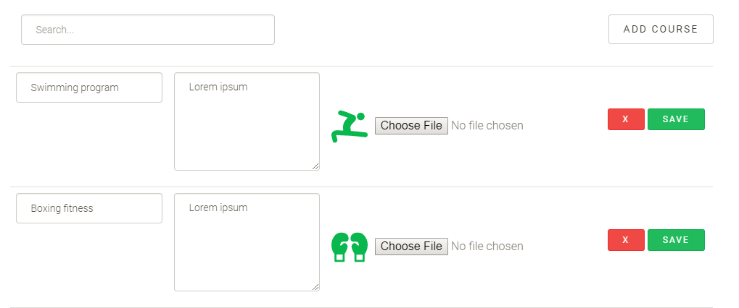

On this page you will see all the courses that are available at your gym in a table format.

### 3.1.1 Filter by name

By entering some text in the search bar you will filter the table and see only the courses that have that text in their name.

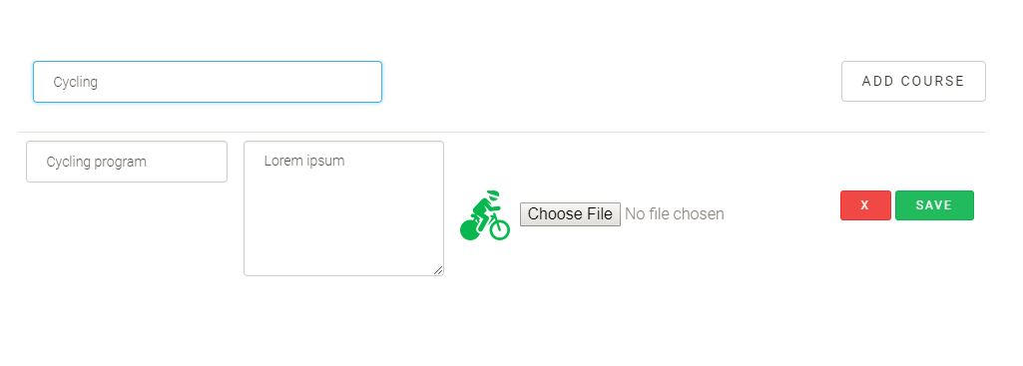

### 3.1.2 Add course

To add a new course you have to press the “ADD COURSE” button.

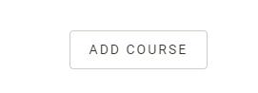

This will make a form appear on the screen.

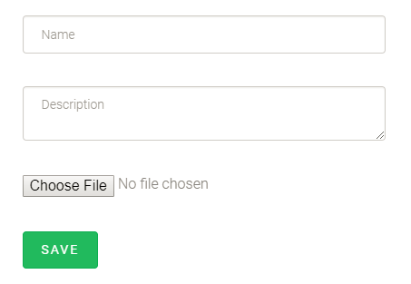

To successfully create a new course you have to complete all the fields. The picture format has to be one of the following JPG/JPEG/PNG/SVG. When the “SAVE” button is pressed the new course will be added and the form will disappear. If one of the criteria is not fulfilled the course will not be added and a message will appear informing you about the problem.

### 3.1.3 Delete course

To delete an existing entry, head to the red “X” button at the right of the table, corresponding to the specific course.

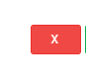

Upon pressing it you will be prompted by an alert, letting you know that you are about to delete the course.

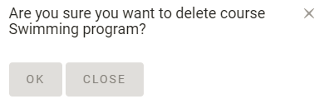

If “OK” button is pressed the course will be permanently deleted. Pressing “CLOSE” will close the alert and the course will not be deleted.

### 3.1.4 Course update

You are able to change any data regarding a course by heading over to any of its fields and change the value. To successfully update a course you cannot have empty fields. The picture format has to be one of the following JPG/JPEG/PNG/SVG. When the “SAVE” button, at the right of the table, corresponding to the specific course, is pressed the course will be updated. If one of the criteria is not fulfilled the course will not be saved and a message will appear informing you about the problem.

## 3.2 How can I manage trainers?

You can navigate to the trainers’ management page using the “Trainers” button in the tab menu. Then you will be redirected to the main trainers’ page:

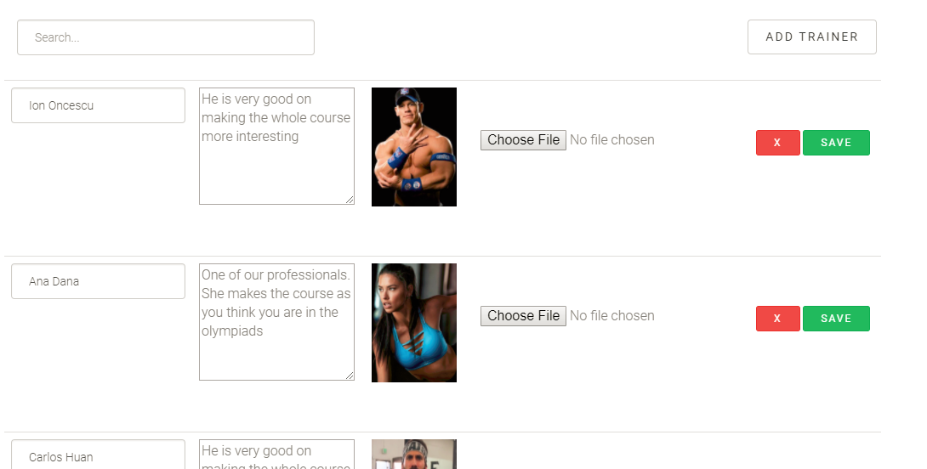

On this page you will see all the trainers that are available at your gym in a table format.

### 3.2.1 Filter by name

By entering some text in the search bar you will filter the table and see only the trainers that have that text in their name.

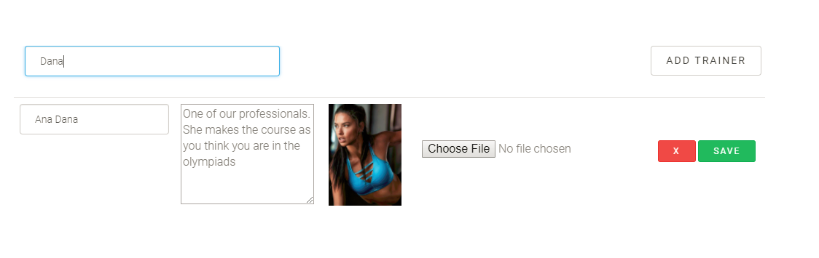

### 3.2.2 Add trainer

To add a new course you have to press the “ADD TRAINER” button.

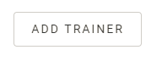

This will make a form appear on the screen.

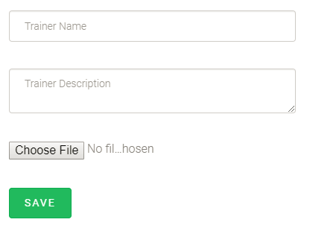

To successfully create a new trainer you have to complete all the fields. The picture format has to be one of the following JPG/JPEG/PNG/SVG. When the “SAVE” button is pressed the new trainer will be added and the form will disappear. If one of the criteria is not fulfilled the trainer will not be added and a message will appear informing you about the problem.

### 3.2.3 Delete course

To delete an existing entry, head to the red “X” button at the right of the table, corresponding to the specific trainer.



Upon pressing it you will be prompted by an alert, letting you know that you are about to delete the trainer.

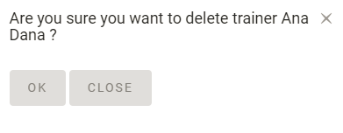

If “OK” button is pressed the entry will be permanently deleted. Pressing “CLOSE” will close the alert and the entry will not be deleted.

### 3.2.4 Course update

You are able to change any data regarding a trainer by heading over to any of its fields and change the value. To successfully update a trainer, you cannot have empty fields. The picture format has to be one of the following JPG/JPEG/PNG/SVG. When the “SAVE” button, at the right of the table, corresponding to the specific trainer, is pressed the trainer will be updated. If one of the criteria is not fulfilled the trainer will not be saved and a message will appear informing you about the problem.

## 3.3 How can I schedule classes?

First, head to the ‘Schedule’ tab in the menu of your account.

After you click on the ‘Schedule’ option, you will be redirected to another page where you can manage the current schedules and create other schedules.

### 3.3.1 Filter by week

Head down to the first dropdown, where you can see the date of the current day displayed.

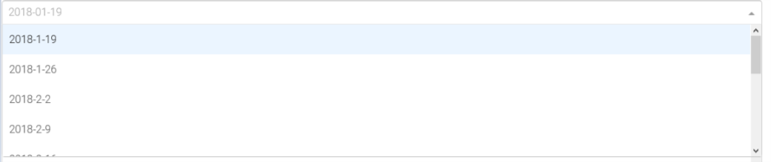

The table under the dropdown will display all courses that are scheduled in the same week as the currently selected date in the dropdown. If you select another date, the schedules will be reloaded and you will see the courses from another week. You are able select courses scheduled up to 10 weeks. You can see data regarding the course scheduled, the exact day of the course, the start and end hour, the room, as well as the trainer assigned to that class.

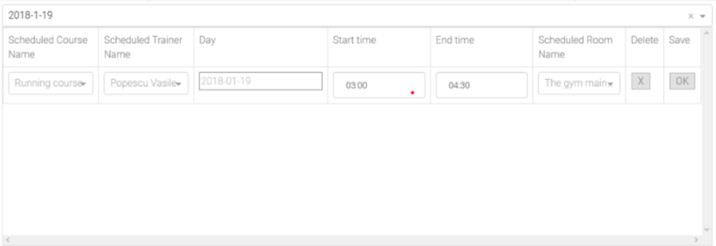

### 3.3.2 Update schedule

You are able to change any data regarding the schedule by heading over to any field in a schedule entry in the table and selecting a new value.

The trainer/course/room fields contain dropdowns with all the possible choices you have for updating an existing schedule.

The start and end time fields will can only be filled with valid hours in the format ‘HH:MM’. Writing invalid hours such as’78:00’ will result in the schedule time not being updated! Keep in mind that both minute and hour values of the time field must be completed (something like ’23:’ or ‘23’ is not allowed)!

After changing any field, you wish to update, press the green ‘Save’ button in the right, at the level of the schedule modified!

Not pressing the ‘Save’ button after changing any field will result in your changes being lost at page reload. Also, after updating an existing schedule entry, if there already exists an entry with the same exact data, the changes will not be committed!

### 3.3.3 Delete an existing schedule

If you wish to delete an existing entry, simply head over to the red ‘X’ button at the right of the table, corresponding to the specific schedule. Upon pressing it, you will be prompted by an alert, letting you know that you are about to delete that schedule.

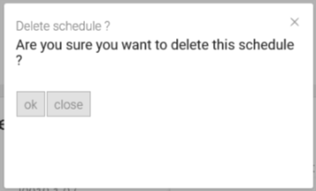

If “OK” button is pressed the entry will be permanently deleted. Pressing “CLOSE” will close the alert and the entry will not be deleted.

### 3.3.4 Schedule a course

If you wish to schedule another course, head down to the bottom of the page, below the table.

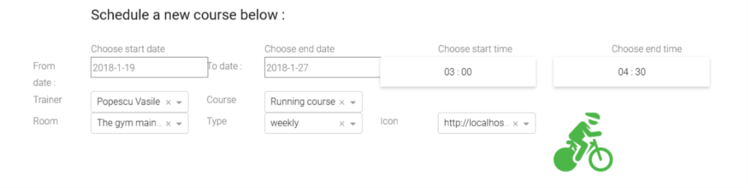

Firstly, select the course, trainer, the training room and time interval for this schedule

Secondly, in order to schedule another course, you need to select a begin and end date, and the type of that course weekly/biweekly/monthly. The beginning date must be prior to the ending date!

Depending on the type of schedule you choose (weekly/biweekly/monthly), there will be one or more schedules created:

1. weekly course-the course will be scheduled once per each week in the interval between the start and end date. The course will be scheduled on the exact date as the start date, and for the following weeks in the interval, it will be scheduled in days which are a week apart from the former schedule.

Example: choosing the starting date 10-02-2018 and the ending date 25-02-2018, with the interval of time between being of 3 weeks, the course will be scheduled as following:

Firstly on 10-02-2018, then a week later on the 17-02-2018, and finally on 24-02-2018, each date being one week later than the one prior to it.

1. bi-monthly and monthly rule will be applied, the difference being that the dates will be at a distance of 2 and respectively o month apart from each other.

Thirdly, you need to choose an icon pic for the course, which will be displayed to the client when one sees the schedule.



Head over to the ‘Add’ button. If any of your fields are left uncompleted, or you did not respect a rule explained before, your data will not be saved!

## 3.4 How can I manage the feedbacks?

Head over to the ‘Feedback’ tab in the menu of your account.

Head down to the Trainers feedback section (in the right) or the Course feedback section (in the left) to view existing feedback given by clients. The feedback will be shown from the most recent to the least recent one, the top one being the most recent.

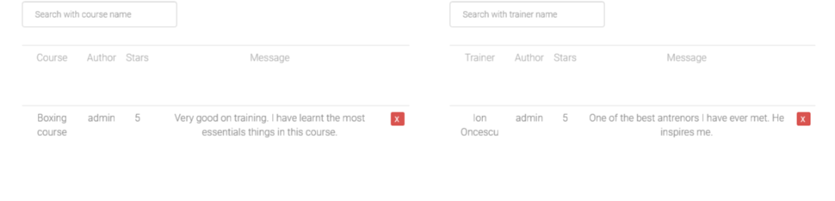

### 3.4.1Filter by course/trainer name

If you wish to filter feedback, simply type in the search bar, the trainer/course name for which you want to see the feedback.

### 3.4.2 Delete a feedback

To delete any feedback, head over to the red ‘X’ button at the right of the table, corresponding to the specific feedback entry. Upon pressing it, you will be prompted by an alert, letting you know that you are about to delete that entry.

If “OK” button is pressed the entry will be permanently deleted. Pressing “CLOSE” will close the alert and the entry will not be deleted.

## 3.5 How can I manage the packages?

In order to manage any packages available for clients, head over to the ‘Packages’ tab in the menu.

All the currently existent packages are displayed in a table, with their description, price, valid period of time and courses that are included.

### 

### 3.5.1 Filter by name

If you need to filter or search for specific packages, head over to the search bar and type in the name of the package you are looking for .

### 3.5.2 Delete a package

To delete any package, head over to the red ‘X’ button at the right of the table, corresponding to the specific entry. Upon pressing it, you will be prompted by an alert, letting you know that you are about to delete that entry.

### 3.5.3 Update a package

You cannot update packages that are already created because it may already be in use by some users.

### 3.5.4 Add a package

Head over to the ‘Add Package’ button. Upon pressing it, an input form will appear giving you the option to introduce data about a new package.

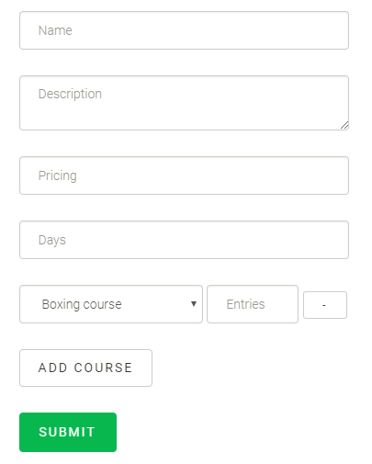

In order to add more classes for the package, click on the “Add course” button.

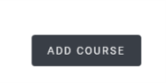

This will introduce a new option for a course. To delete one of the options just press the ‘-’ button near the entry.

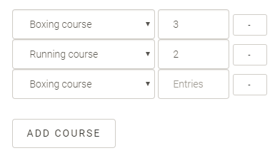

Submit the new data by clicking on the ‘Submit’ button. If there are uncompleted fields, your data will not be submitted. If you submitted the same course multiple times, in a package, the first entry will be used and the others ignored.

## 3.6 How can I manage the payments?

This section is used to confirm a client’s subscription to a package. Unfortunately, we do not support any online payment method, therefore a client would have to subscribe online to a package and pay for it at the gym. After he pays, you can confirm his payment.

### 3.6.1 Confirm a client’s subscription

Head over to the search box and type in the client’s name.

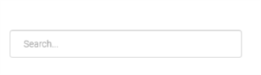

If the client subscribed for any type of packages and has not yet been confirmed, it will appear in the table below. In order to confirm the client’s subscription, simply click on the ‘ACCEPT PAYMENT’ button.

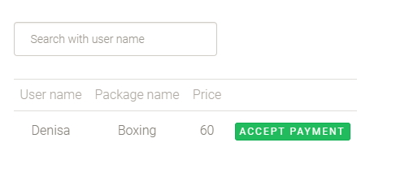

## 3.7 How can I manage the users?

In order to manage users, head over to the ‘Users’ tab in menu of your account. User accounts can only be created by a gym admin. Therefore, any client would have to come to the gym and request from a gym personnel member to create his new account.

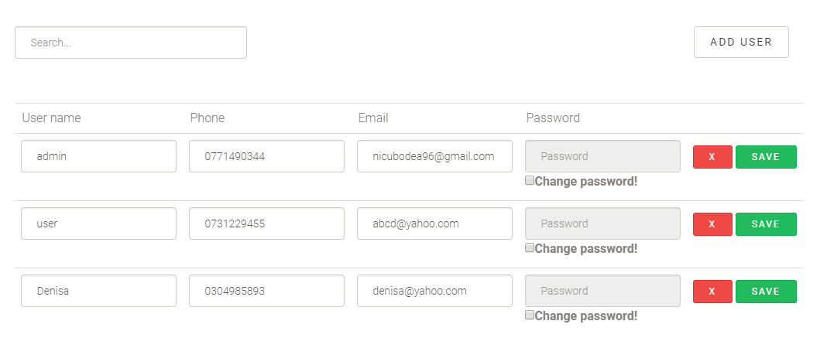

### 3.7.1 Filter by name

By entering some text in the search bar you will filter the table and see only the courses that have that text in their name.

### 3.7.2 Create an account for a client

Head down to the ‘ADD USER’ button. Upon pressing it, an input form will appear.

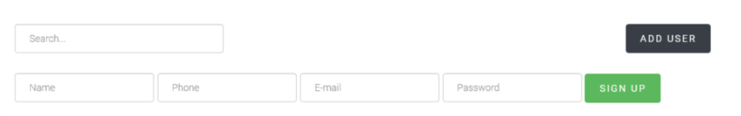

Add the name, phone number, email and the password for the new account. The same name cannot be used twice for creating an account!

You need to press the ‘SIGN UP’ button in order to create a new account! There should be no empty inputs left, otherwise the new account will not be created.

### 3.7.3 Delete a user?

To delete any user account, head over to the red ‘X’ button at the right of the table, corresponding to the specific user entry. Upon pressing it, you will be prompted by an alert, letting you know that you are about to delete that entry.

### 3.7.4 Update an existing user account

If you need to update any user account, head over to that account’s data in the table. If the account is not visible in the table, type in the search bar the name of the client in order to find it.

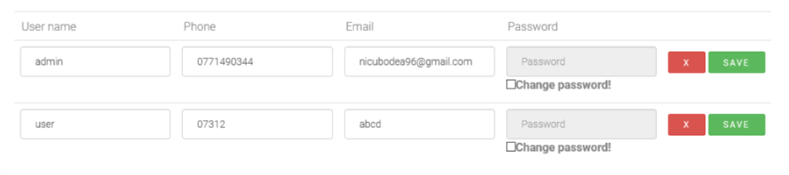

Updating the name: keep in mind that if there already is a user account with the name you’re trying to introduce, the data will not be updated!

Updating the password: in order to update the password of an account, you need to specifically check the ‘change password’ checkbox. After you checked this, you need to introduce a non-empty password!

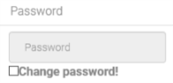 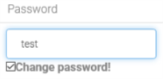

In case you checked the box by mistake, you will not be able to update the user account unless you uncheck it or you introduce a new password!