

USER MANUAL

Table of contents

1. Application description 3

2. User types 3

3. Public user 4

3.1 What can I see? 4

3.2 How can I see the courses? 4

3.3 How can I see the trainers? 5

3.4 How can I see the schedule? 6

3.5 Where can I see the prices? 7

3.6 How can I find more information about the gym? 8

3.7 How can I register to the gym? 9

3.9 How can I log in? 9

4. Registered user 10

4.1 What features do I have as a gym member? 10

4.2 How can I access my profile? 11

4.3 How can I register for a class? 14

4.4 How do I renew my subscription? 15

4.5 How can I give feedback? 16

4.6 How can I log out? 17

# Application description

The „iLift“ application is a solution designed for fitness companies to offer a new channel of communication between them and their clients, covering the logistic problems that can come in their daily activity. To make it accessible for any user, regardless of their experience in using it, iLift comes in the form of a web application that is both modern and intuitive at the same time thanks to the state-of-the-art technologies used in the development of it and the client-oriented thinking of the developers that made it very simple and easy to be used in order to maximize performance.

Through this solution, the managers of the fitness companies can make changes in schedules, manage user subscriptions and can present different classes and trainers while also evaluating their activity by requesting feedback for each of them from their clients.

The client can manage its own subscriptions, classes and he can see and offer feedback for the trainers and contact the company in order to obtain information or to file complaints.

# User types

As it was designed to be used at the same time by both clients and companies by sharing the same user-friendly interface, the application will make a distinction between these user types:

* The unregistered user (not logged in) has access to all of the information regarding the fitness programs available, trainers, current offers and gym contact. He can register in the application using the account provided by the administrator.
* The registered user is able to also manage his subscriptions, can see and offer feedback for the trainers and classes.
* The administrator can manage user accounts, subscription packages, classes and trainers, rooms, change schedules, check unpaid packages and evaluate trainers or classes based on the user feedback.

# Public user

## 3.1 What can I see?

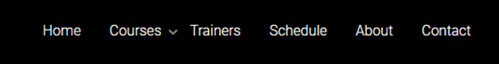

The public user can see the home page, the page with all the courses, trainers and their feedbacks, the courses schedule, pricing plan and all information about the gym. He can navigate to different pages by pressing the buttons in the tab menu.

## 3.2 How can I see the courses?

You can navigate to the courses page using the “Courses” button in the tab menu. Then you will be redirected to the main courses page.

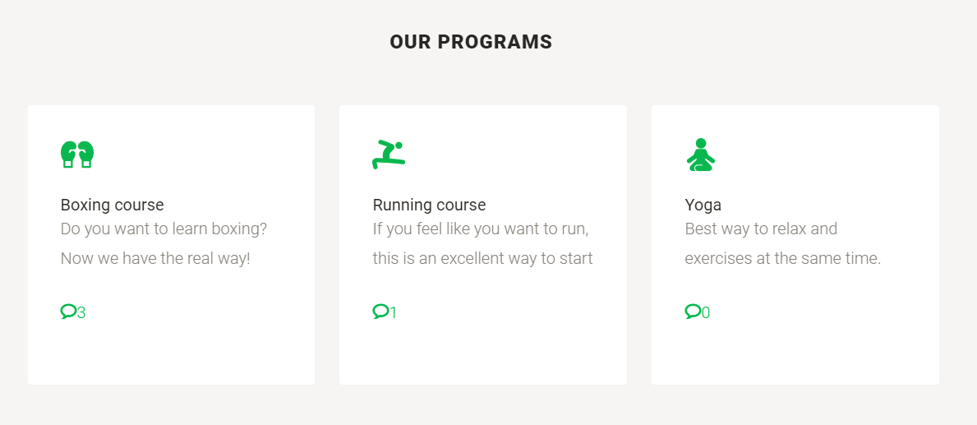

Here you can see all the courses with their description.

## 3.3 How can I see the trainers?

You can navigate to the trainers’ page using the “Trainers” button in the tab menu. Then you will be redirected to the main trainers’ page. You can also see the trainers by scrolling down on the home page.



If you hover over the trainer picture, their name, description and number of feedbacks will appear.



## 3.4 How can I see the schedule?

You can navigate to the schedule page using the “Schedule” button in the tab menu. Then you will be redirected to the main schedule page. You can also see the schedule by scrolling down on the home page.

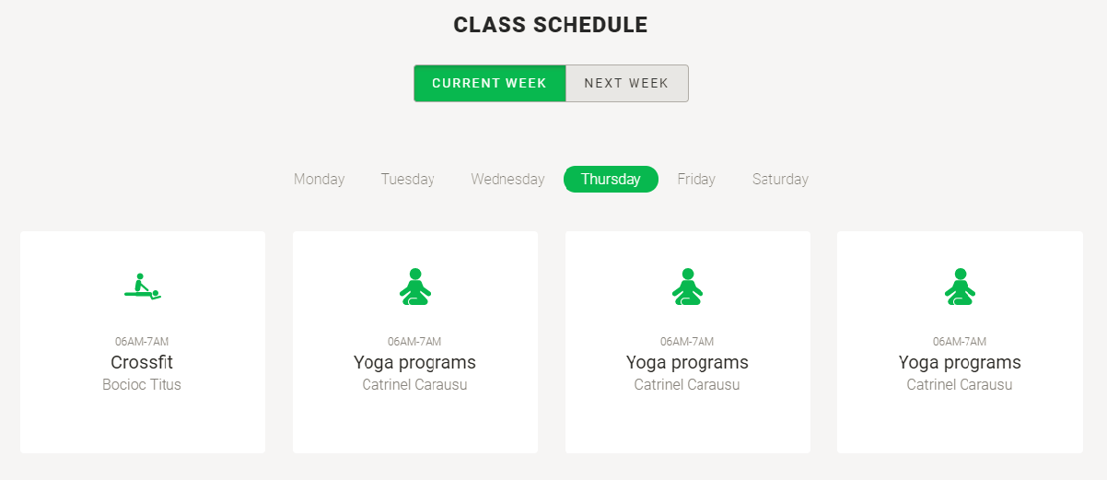

To see the schedule for another day of the current week click on the respective day name.



You can also change to the schedule of the next week by pressing the “NEXT WEEK” button.

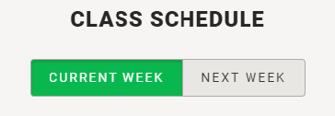

## 3.5 Where can I see the prices?

You can get to our pricing plan by scrolling down on the home page. It will appear like this:

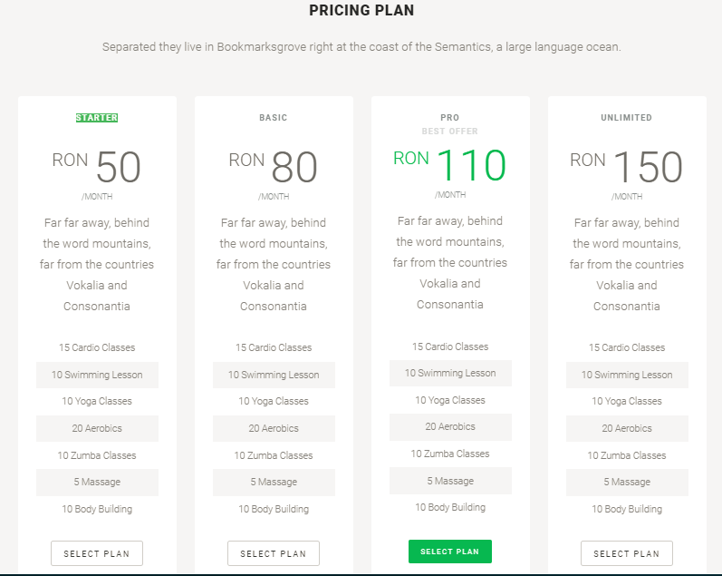

For a package you will see, the price, description and all the courses that are included in the pack with their specific number of entries.

## 3.6 How can I find more information about the gym?

For more information about the gym you can navigate to the contact page by pressing the “Contact” button in the tab menu or you can find them in the footer of any of the pages. You will be redirected to the page which contains the contact information.



There will be also a map view for the gym location.

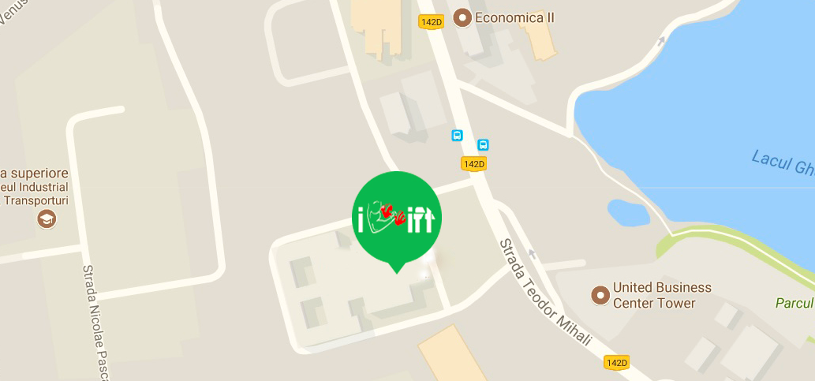

## 3.7 How can I register to the gym?

Only gym personnel can create new accounts. You need to contact them to get a user account.

## 3.9 How can I log in?

The users that have registration credentials obtained from the gym, have to press the “Sign in” button.



This will redirect you to a page with a log in form requesting the username and the password.

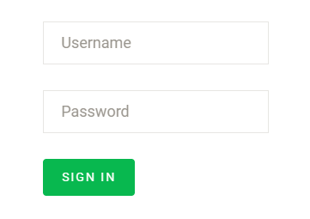

After completing them with the correct credentials you can press the “Sign in” button that is located under the password which will redirected to the start page. You will not be able to log in with wrong credentials. If the login credentials are not accepted after making sure that they were correctly introduced on the website, please contact the administrator in order to fix the issue.

# Registered user

## 4.1 What features do I have as a gym member?

As a gym member you can access all the information in the same way a public user can, but in addition you have a profile page with your subscriptions and pricing plan, the possibility to give feedback to courses and trainers and register to classes.

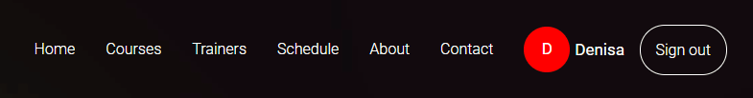

## 4.2 How can I access my profile?

You can access your profile by pressing the button which contains your name in the tab menu.

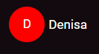

On your profile page you can see all your subscriptions for the current week.

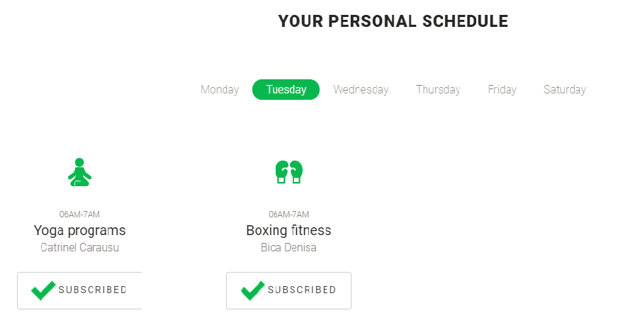

Change your password:

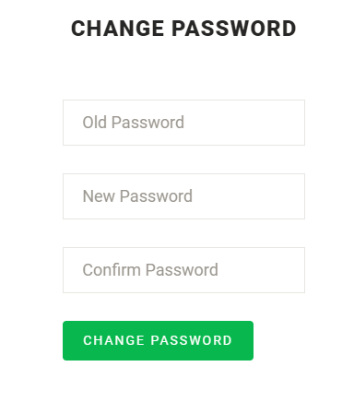

Be sure that the “Old password” field is completed with your current and correct password and that the “New Password” and “Confirm Password” are the same and that they are not left empty. After completing all the fields press the “CHANGE PASSWORD” button. If you do not remember your password please contact the gym and ask for a new one.

On your profile will also be displayed your current pricing plan, with the option of renewing it. Please take in the consideration the next page which shows an example for the above-described functionality.

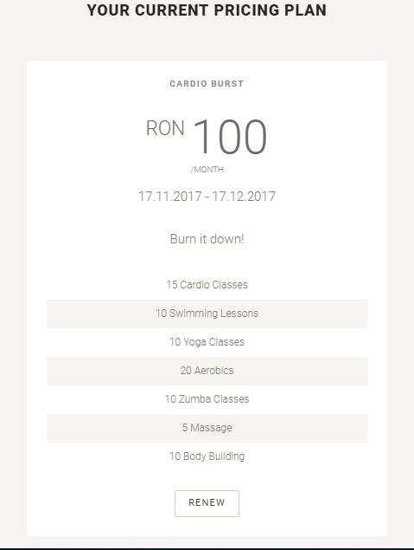

## 4.3 How can I register for a class?

On the schedule page you will get a new option. To register for a class press the “SUBSCRIBE” button under the specific course.

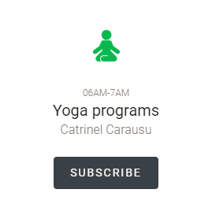 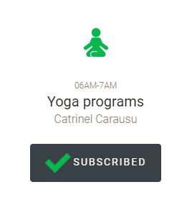

You can not subscribe to a class which is not listed in your package options or if you used all your entries for that course.

To unsubsribe from that class you have to press the button again.

 

## 4.4 How do I renew my subscription?

You have the option to renew your current pricing plan from your profile page by pressing the “RENEW” button. Or subscribe to a new one, that is available at the time, on the home page pressing the “SELECT A PLAN” button under the desired pack.

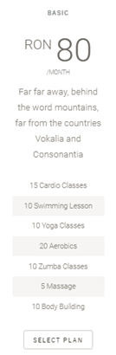

Unfortunately the online payment is not an option, you need to make all the payments at the actual gym.

## 4.5 How can I give feedback?

To get to the feedback page for a specific trainer or course you have to press the bubblebox for the specific trainer or course.



The number near the bubblebox represents the current count of feedbacks that trainer/course has.



The feedback page will contain all the feedbacks that trainer/course curently has.

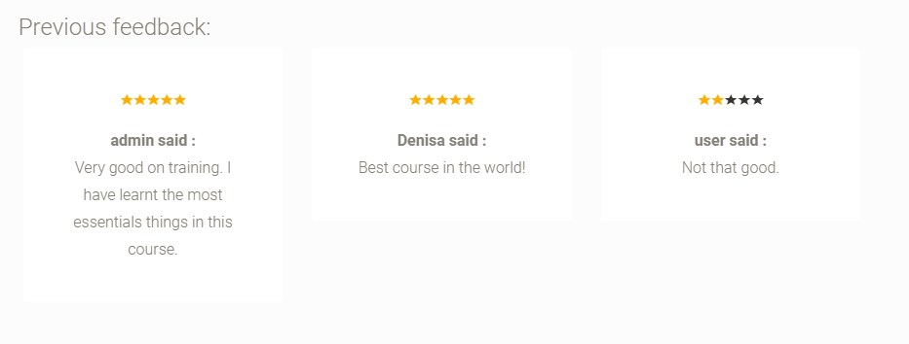

There will also be a forum where you can enter your own feedback, with a star rating. Press the “SUBMIT” button when you are done. If the message is empty or there are no stars selected the feedback will not be submitted.

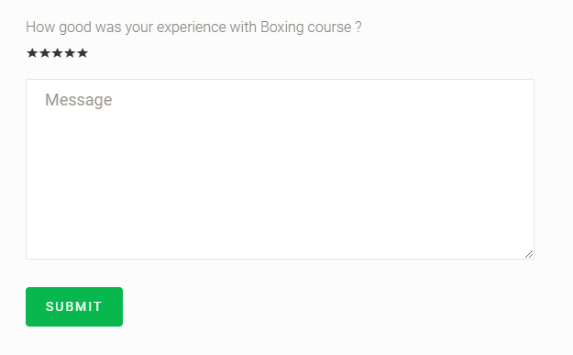

## 4.6 How can I log out?

The log out button is at the end off the tab menu.

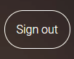

By pressing this button you will be log out and become a public user. The “SIGN IN” button will reaper on the home page.