DIY COFFEE MACHINE

Branimir Mihelčić

Table of Contents
1 MOTIVATION 3
2 MANUAL PROCESS 4
3 REQUIREMENTS 5

MOTIVATION
Our office coffee machine was producing a really bad quality, sour taste coffee extract with powder milk. That is why, when I needed an extra boost of cafeine, started making my coffee the more traditional way with ground coffee.
It’s not the best cup of coffee in the world but I much rather prefer it that way and is so much better than automatic coffee maker machine we had at our job.
The goal of this project is to automate the process of making coffee from clean water, ground coffee, sugar and fresh milk.

MANUAL PROCESS

- Put 100 mL of water in coffee pot
- Put 1 tbspn of ground coffee in the coffee pot
- Put the pot on induction heater
- Turn on the induction heater
- Stir coffee slightly
- When the coffee is just about to start boiling it’s finished. Turn off induction heater
- Wait 1-2 minute until coffee settles a bit
- Put coffee in your favourite cup
- Put 4g of sugar in your coffee
- Put 50 mL of milk in your coffee
- Stir a bit and it’s ready

REQUIREMENTS

- Coffee will be prepared in a pot compatible with induction heater
- Amount/weight of ground coffee needs to be measured (load cell)
- Amount/weight of sugar needs to be measured (load cell)
- Amount/weight of water needs to be measured (flow sensor/load cell)
- Amount/weight of milk needs to be measured (flow sensor/load cell)
- Temperature of water needs to be measured while preparing coffee
- Low level of water supply detection (load cell)
- Low level of milk supply detection (load cell)
- Low level of coffee supply detection (load cell)
- Low level of sugar supply detection (load cell)
- Milk freshness tracker (day counter, RTC)
- RGB status LED
- Buzzer for audio notifications (e.g. indicate service is needed)
- User interface will contain LCD screen, button and knobs
- Coffee cup detection / prevent spilage (photoresistor / ultrasonic sensor)
- All electronics need to be protected from induction heater (Faraday cage)
- There needs to be stiring mechanism implemented while preparing the coffee
- Pumps to have flow of at least 2000 mL/min
- Remote control, Coffee station access point, start preparing coffee remotely (ESP8266)

LIST OF ITEMS
Item | Qty | Description
Peristaltic pumps | 2 | 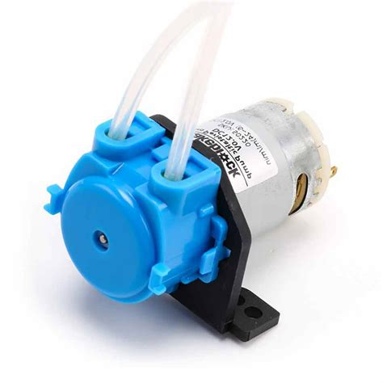
Induction heater

