# Design Document

## PDF Share and Schedule

## Activity Diagrams

Add

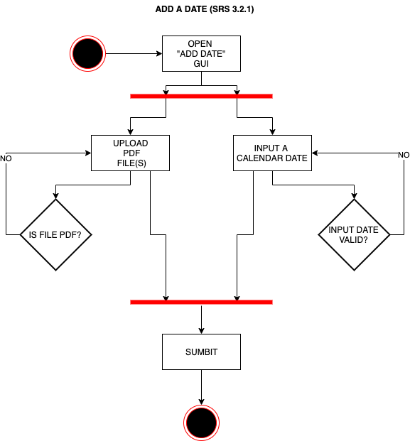

Edit

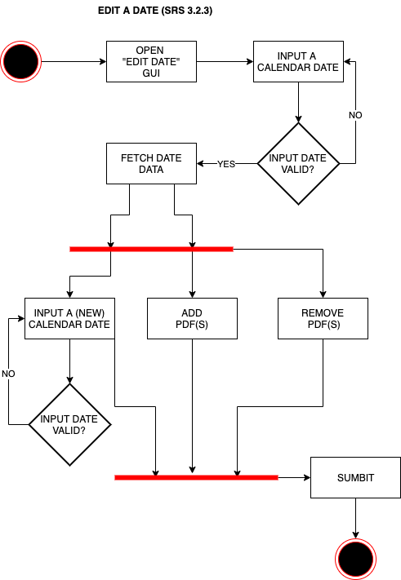

Delete

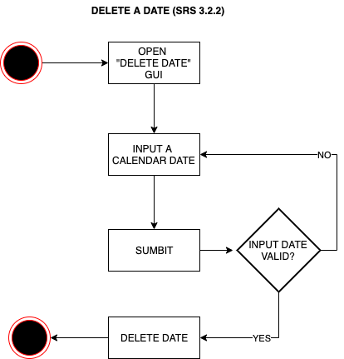

## Structural Modeling

Main Module

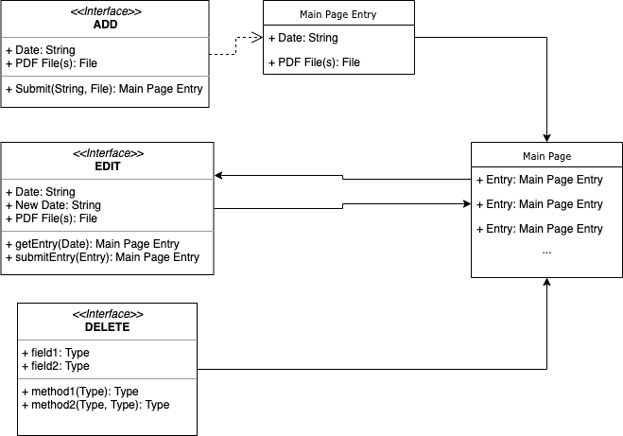

## Behavioral Modeling