Kickstarter Analysis

1. Given the provided data, what are three conclusions we can draw about Kickstarter campaigns?

An analysis of 4,000 past projects launched on Kickstarter reveals some trends that could be beneficial to future projects. These trends have been identified through a study of 4,000 projects of the over 300,000 projects launched on the successful crowdfunding service. Therefore, these insights are by no means conclusive and additional research is required to determine their relevance to other projects outside the sample. The 3 conclusions we can draw from the sample study are as follows:

1. 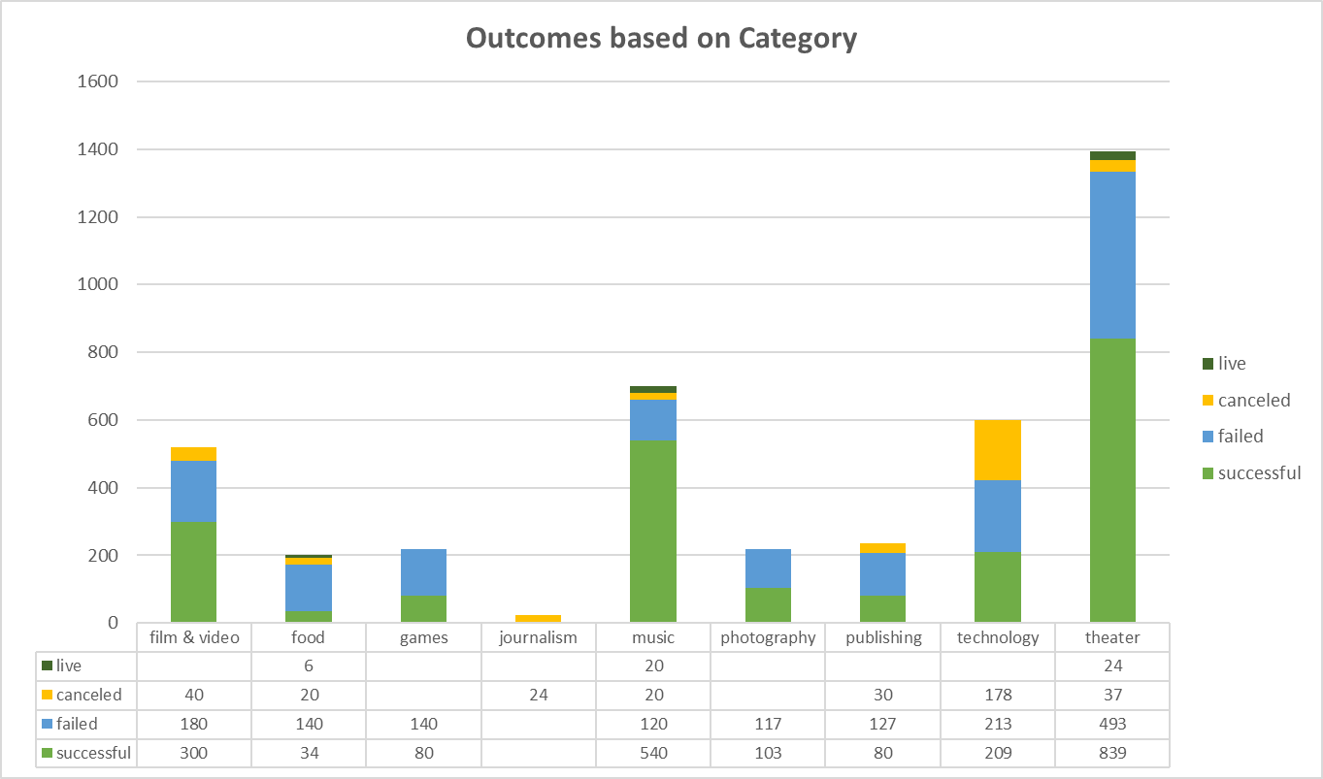Music represents the second largest category of projects, with 17% the projects or a total of 700 projects (Fig.1). However, it has a far greater rate of success with 77% of these projects being successful, as compared to a 60% success rate in Theater, the largest category with 34% of all projects. Both categories have the same rate of cancellations at 3%.

Fig. 1

1. 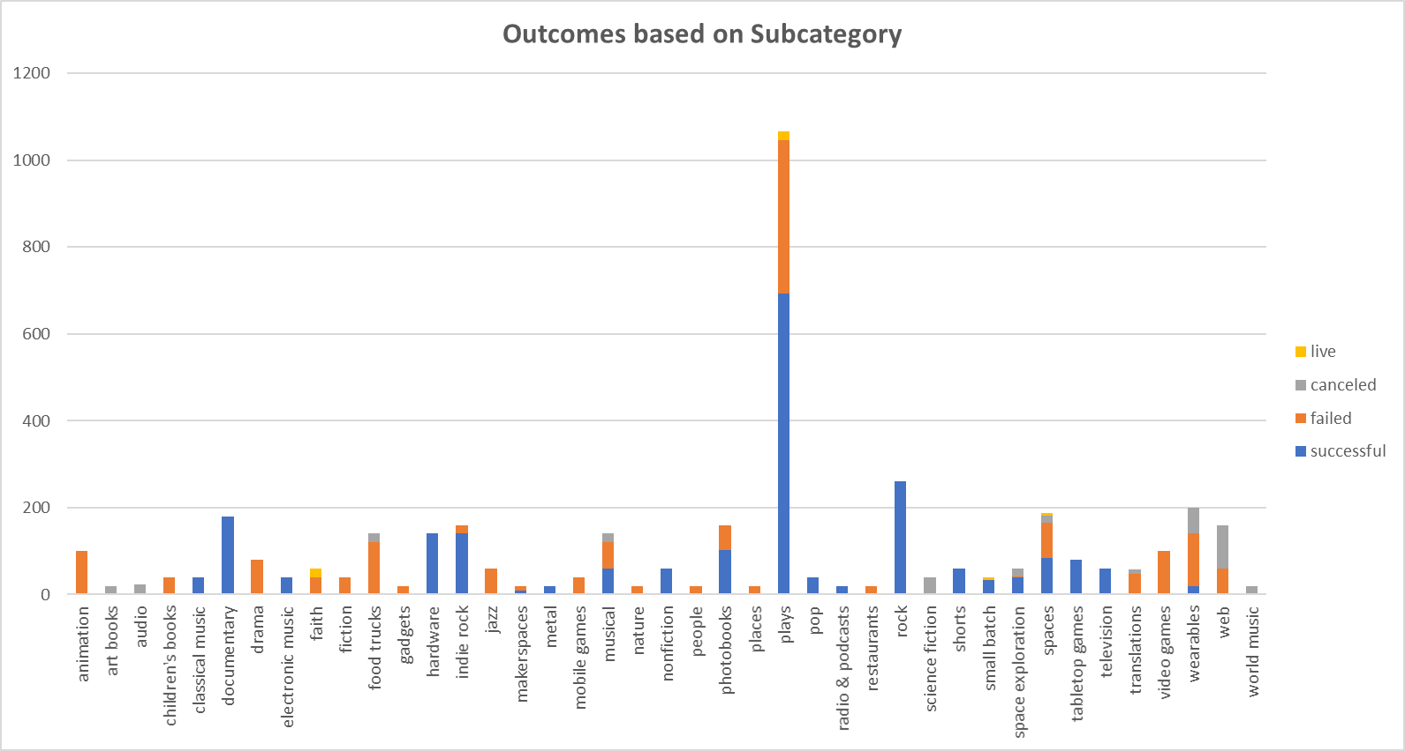The largest subcategory is Plays with 1066 projects (Fig. 2). This subcategory falls within Theater, which is the largest category. However, the subcategories within the second largest category of Music have a far greater success rate (Fig. 3). The most prominent one being Rock with 260 projects and a 100% success rate. The subcategory of Plays, on the other hand, has about a third of the projects turning into failures. Overall, although there are fewer subcategories with more projects within Theater, many of the subcategories within Music have a 100% success rate.

Fig. 2

1. 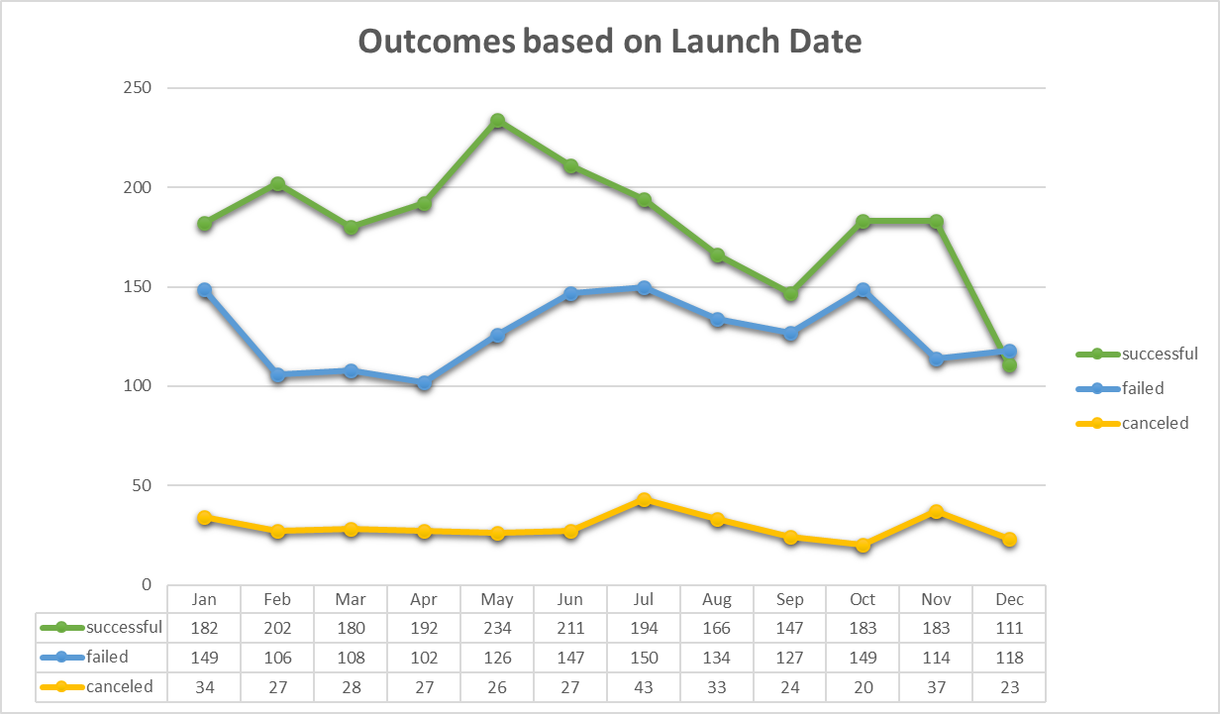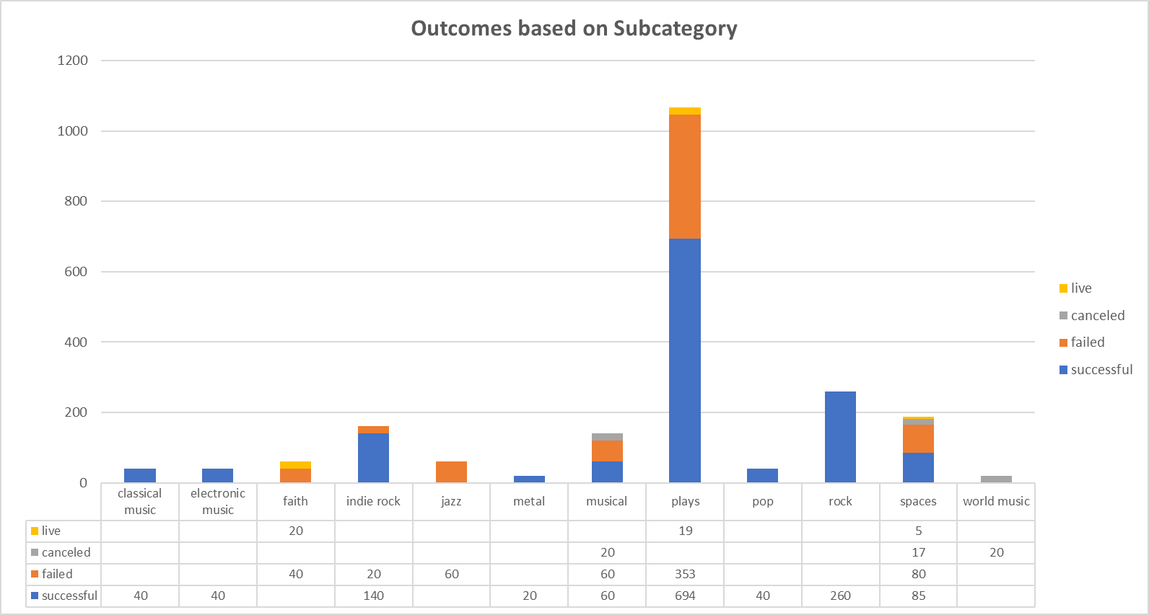There appears to be some connection between the launch date of a project and its likelihood of being a success (Fig. 4). The greatest impact appearing in projects launched during the months of April and May when the success rate jumps to 60% and 61%, respectively. The percentage of projects being canceled appears to be steady at below 10% during this time period.

Fig. 4

Fig. 3

1. What are some limitations of this dataset?

This dataset represents 4,000 projects out of over 300,000 projects on Kickstarter. No context is provided on whether these projects were a random sampling of the larger population. Without this information, there is no way to determine whether trends in this sample are representative of the larger population. In addition to this, some limitations of this dataset include the lack of information about what factors are used to determine the goals for each project. The analysis revealed a possible link between the goal of a project and its likelihood of being successful. The projects with lower goals were more likely to succeed. Further information is also required about the backers - do individual backers fund multiple projects? is there some connection between the projects and their likelihood of success?

1. What are some other possible tables and/or graphs that we could create?

Some additional tables and/or graphs that could provide additional insights are an analysis of the goal size by category/ subcategory, amount pledged by category/ subcategory, and project status by country. Since whether the goal is met is used to determine if the project is successful, it is important to understand whether the goals differ by the type of project. The first two tables and graphs will help identify trends between the amount of money being raised or expected to be raised across the different types of projects. The third table and/or graph will display any trends between whether a project meets its funding goal by country. Specifically, whether the currency in which the money is being raised factors into whether or not the target is met.