Standardized Test Result Analysis

An analysis of the district-wide standardized test results presents some apparent trends and additional questions that are worth exploring. The data studied in this analysis includes individualized math and reading scores for every student, as well as various key pieces of information about the school they attend.

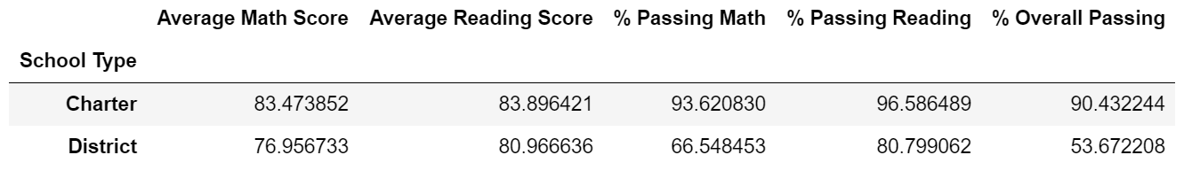Overall, there appears to be a clear distinction between student outcomes at Charter vs. District schools (Fig. 1). This is apparent when looking at schools based on the percentage of the student body who passed both the math and reading state exams. The top five schools, based on these criteria, are all charter schools. Similarly, the bottom five schools are all district Schools. Furthermore, student performance on the math state test seem to be in part responsible for the differences in overall percentage passing numbers for their schools. Charter schools had about 94% of students passing the math test, whereas, district schools had 67% passing rates.

**Fig. 1**

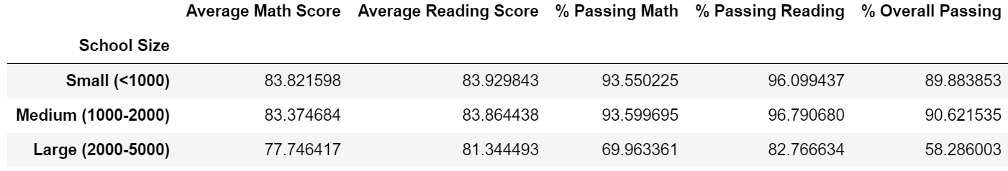One possible reason for these differences in student performance may be the size of the school they attend. The district schools have a much larger student body as compared to charter schools. For example, the smallest district school has 2917 students. The largest charter school, on the other hand, has 2283 students. The data seems to suggest that there is a link between student performance and school size (Fig. 2). Whereas about 90% of the student body passed both state exams at schools with fewer than 1000 student. This number dropped to about 58% of students passing both exams at schools with more than 2000 students.

**Fig. 2**

One aspect that could be impacted by the size of the student body is the resources available for each student. At least as far as spending goes, there does not appear to be a clear link with student performance. Across the board, district schools are spending more per student than their charter counterparts. Furthermore, a district-wide breakdown by spending per student does not present any clear link between spending and student performance. In fact, more spending in a way is tied to a decrease in student performance, specifically on the math test 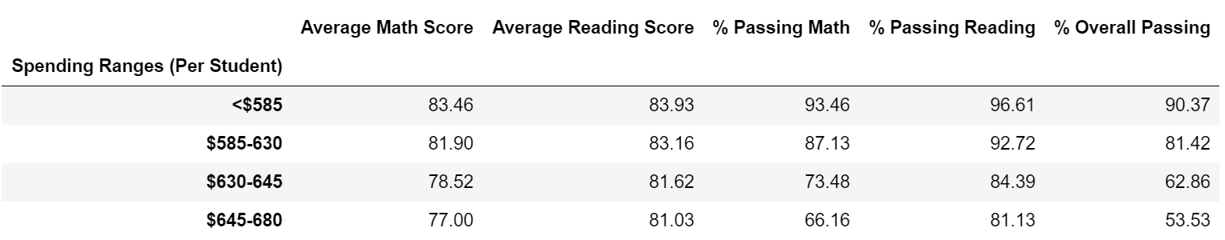(Fig. 3).

***Fig. 3***

It would be beneficial to gather additional information and conduct further analysis into the differences in student experience at district vs. charter schools. The analysis thus far presents a clear link between student performance and the type of school they attend. One factor highlighted above that could possibly be part of the answer is school size. Additional factors may range from faculty to the curriculum followed at each school. Again, further analysis will help provide more clarity.