How to Reset Your SHIPtalk NPR Password
The SHIPtalk NPR website has been updated to implement new security regulations required by the Centers for Medicare and Medicaid Services (CMS). The steps described below will guide you through the process of resetting your password.
- Go to the SHIP NPR website (https://shipnpr.shiptalk.org).
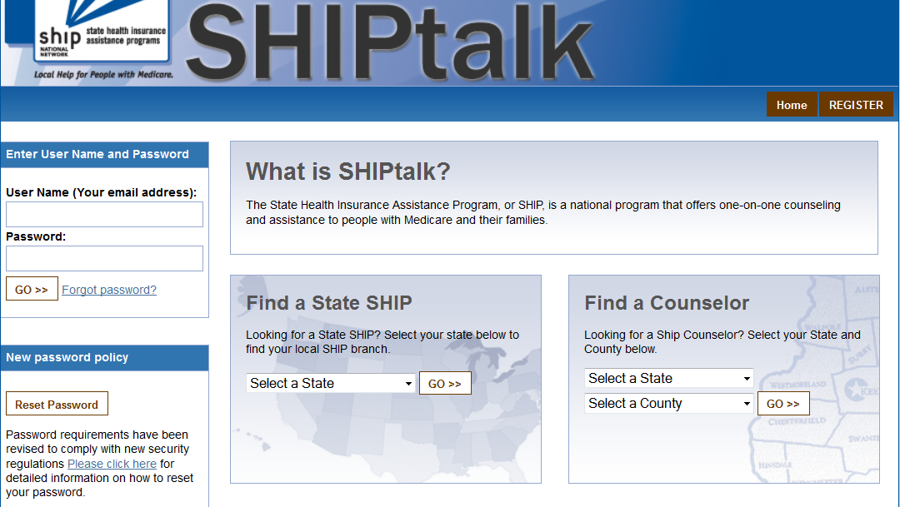
- Click on the "Reset Password” button located on the left-hand side of the page in the box labeled “New Password Policy”
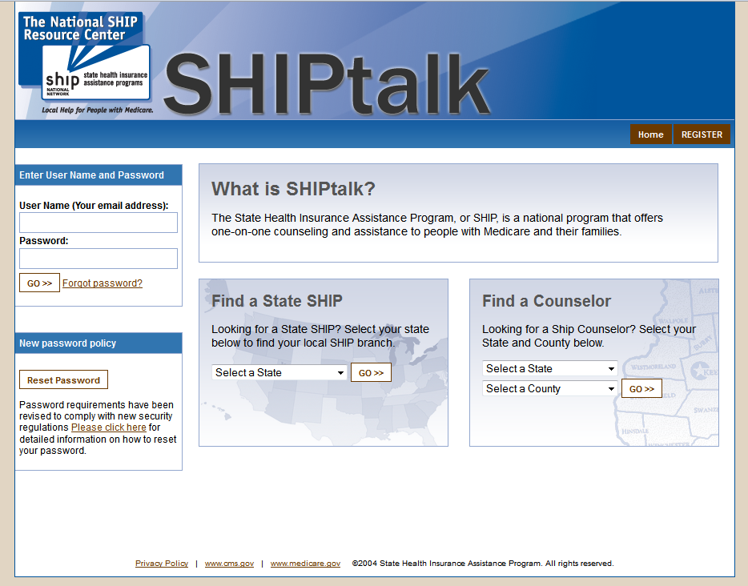

Note: You may also encounter the same password change routine by entering your existing User Name and Password in the top box and clicking the Forgot Password link or the Reset Password button.
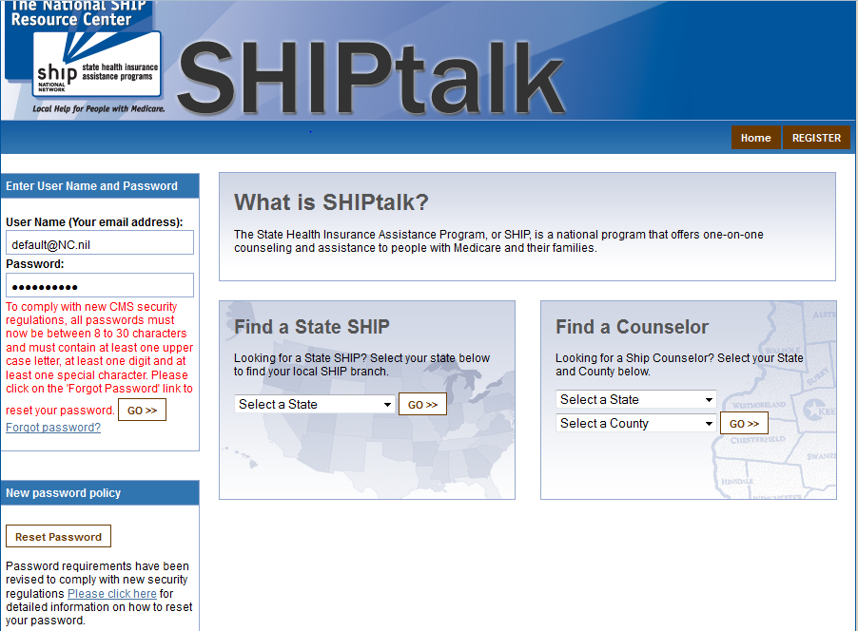

- You will reach a page like the one shown below. Enter and re-enter your e-mail address in the boxes as prompted, and type the capital letters and numbers that appear in the black box in the text box underneath it. If you cannot read the letters and numbers in the black box, click on the arrows button on the right-hand side of the box to view a new image. Click the “Submit” button when you are done. If the text you entered does not match the text in the box, you will be prompted with a new image, enter the letters and numbers displayed, and click "Submit" again.
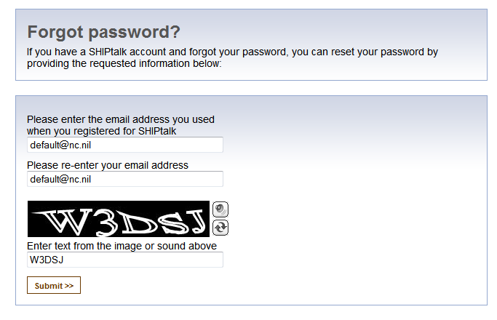
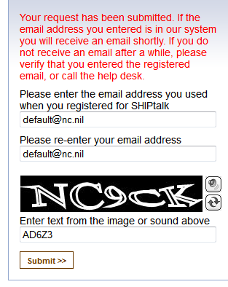
- You should see the following message in red: "Your request has been submitted. If the email address you entered is in our system you will receive an email shortly. If you do not receive an email after a while, please verify that you entered the registered email, or call the help desk.”

- You will receive an e-mail from the SHIP NPR Help Desk (shipnprhelp@air.org). If the message is not in your inbox, you may need to check your spam or junk e-mail folders.
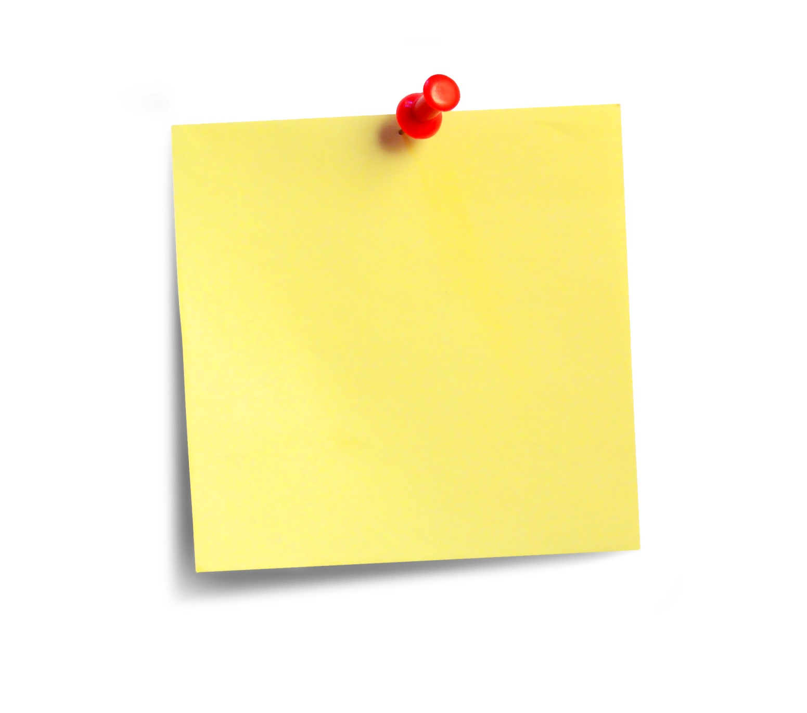
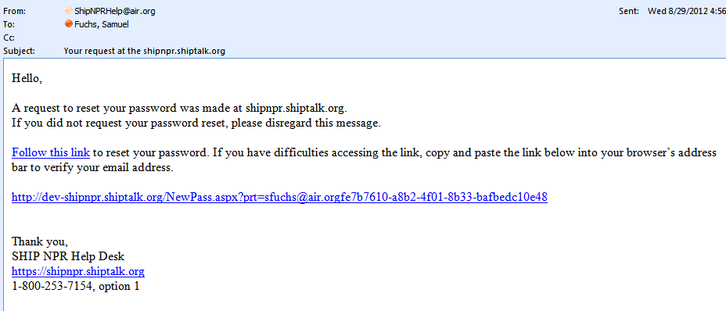
From: SHIPNPRHelp@air.org
To: default@nc.nil
Cc:
Subject: Your request at the shipnpr.shiptalk.org
You may click on either link (circled here in red).
Both will take you to the same page.

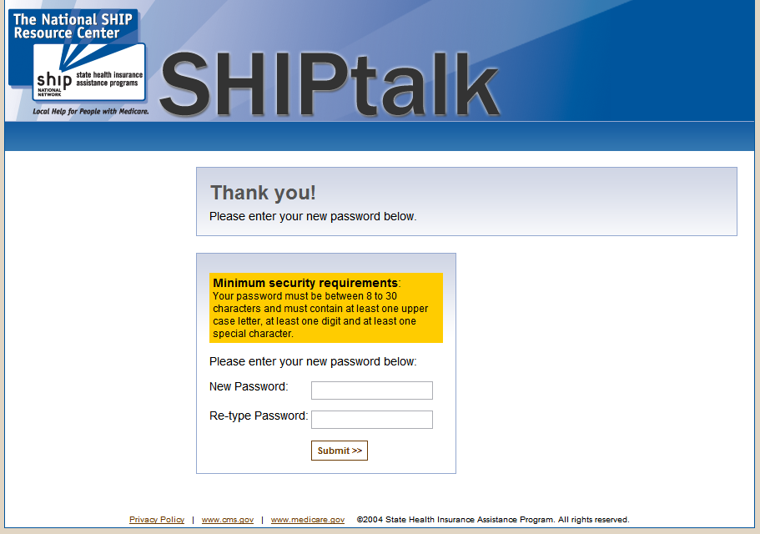
- Click on one of the links in the e-mail to go back to the SHIP NPR website, where you will be able to reset your password. The link should take you to a page that looks like the one pasted below.

- You will now have to create your new password. As described in the yellow box labeled “Minimum Security Requirements,” your password must follow these four rules:
  - Your password must be between 8 and 30 characters
  - Your password must contain at least one uppercase, or capital, letter (ex: A, B, etc.)
  - Your password must contain at least one digit (ex: 1, 2, 3, etc.)
  - Your password must contain at least one special character. Special characters can be a punctuation mark or any other symbol on your keyboard (many special characters are located on the top row of the keyboard on the same line as the numbers 1 through 9).
You may not include dictionary words in your password. For example, you cannot use the word “book” in your password, but you can use“b00k” instead (using zeroes instead of the letter “o”).
You will be prompted if your password does not meet all of the requirements with the following text in red:
Password entered does not meet minimum requirements. Please see the yellow box above for a description of what your password needs to include.

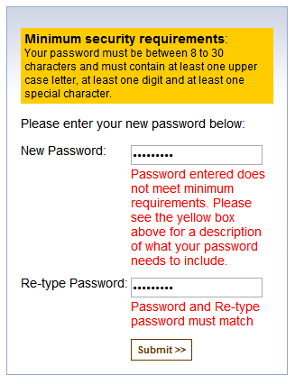
An example of an acceptable password is the following: Alfb00k*1”
This password contains an uppercase, or capital, letter; several digits, or numbers; and two special characters (the * and “ ). It also does not contain any words found in a dictionary.
- Enter your new password into the corresponding boxes in the middle of the page and click “Submit”.
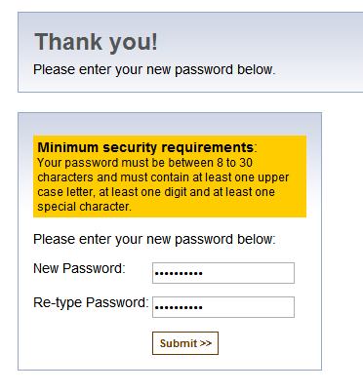
You should see a message like the image below indicating that your password has been successfully reset. You will receive an e-mail notification from the SHIP NPR Help Desk (shipnprhelp@air.org) confirming that you made changes to your account.
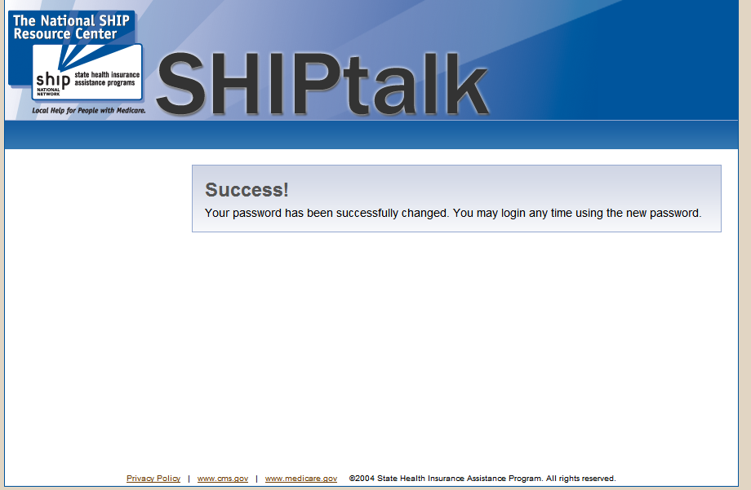

- Go to the SHIP NPR website (https://shipnpr.shiptalk.org). You should now be able to log-in to the site using your username (your full e-mail address) and your new password.

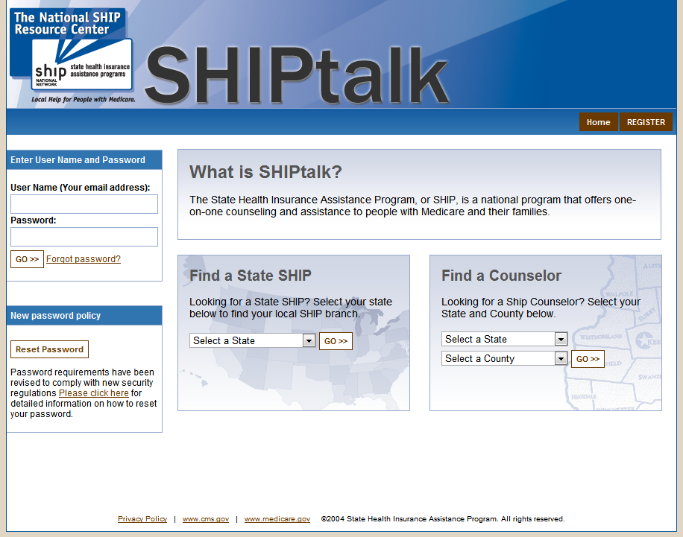

- Congratulations - you are done!

