**Exploring Concurrency**

# Introduction

In general, I am interested in concurrency and in domain modeling. This project was meant to explore concurrency models that are inspired by async/await functionality seen in other modern languages and by actor model implementations, which could then be used to model more complicated processes not easily represented by the base language.

# Overview

Asynchronous computation is an important concept in software engineering. I think many programmers don’t deal with asynchronous computations on a daily basis, but those who do cloud computing, user interface design such that the underlying processes do not block user interaction, and hardware systems are faced with asynchronous operations daily. The common thread here is that for things that interact with the real world, that is computations that are side effectful, are often best modeled as asynchronous operations.

What I wanted to explore was how to build operations such that I could wrap normal processes as asynchronous processes that could be started and interacted with later. These processes could be started, other things could occur in the program, and then if needed, the result of the asynchronous processes could be waited upon, if they are to finish. In other cases, the asynchronous processes could be started and never waited upon to finish, until the entire program is done. An example of such a use case is that of actors, which will be explained later.

Some direct inspiration comes from two languages that I have used professionally, LabVIEW and F#. In LabVIEW, a language that is multithreaded and computes on cores in parallel by default, has explicit support for asynchronous processes. An example might look like this:

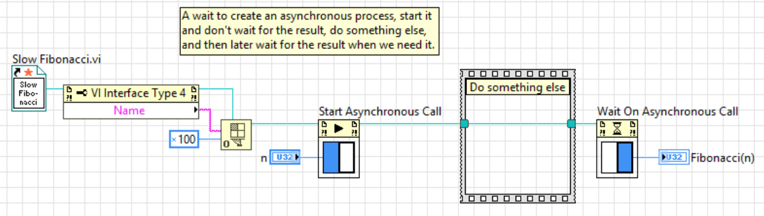

This is the maybe the simplest example of what we might want for an asynchronous process, in any language. However, part of my project was to build upon this functionality and extend it to more complicated designs.

As the final inspiration, which I think helps illustrate that we might want to “wrap” a normal process to make it into an asynchronous process automatically. In F#, such a wrapping is called an asynchronous workflow. The example is below, and I think it provides a nice counterpoint to what I will show in Scheme.



As you can see, F# has special syntax for asynchronous workflows. That means that F# has to have explicit compiler support for such a language feature. This is true in LabVIEW as well. As we shall see in Scheme, we can create the exact same behavior with ZERO additional compiler support. Everything is there to modify the language, in a rather non-trivial way.

As an example of the API I have built, the above examples would look like:



# Asynchronous Expressions API

I first created an asynchronous expressions library that allows one to create asynchronous expressions, start them as asynchronous processes, and then if needed, wait on the computed result. Additionally, I built functionality that easily allows one to build up many asynchronous expressions and start them all at once.

The API looks like this:



This API is quite usable and user friendly. And nearly self-documenting. A few examples usages are:



The major challenge in designing and implementing this API was primarily in understanding the timing of evaluation, or more explicitly, the delay of evaluation. By wrapping expressions and procedures as asynchronous expressions, we are explicitly saying “take this code and wrap it with something we can call it with later”. This is practically identical to promises, which using delay and force to delay evaluation and then later force the evaluation, but in this case, we are forcing the execution to happen asynchronously. That is, the execution happens on another thread. There was a design decision made to make every asynchronous expression be executed on its own new thread. This is so that thread management and coroutines could be avoided, as they aren’t needed to build up the conceptual ideas of the async/await API and then to use this API to do other things, like actors. This may not scale well and is maybe not “lightweight”, however, this is okay for a first pass design since these issues are not goals of this project.

To await these processes, I used the rather simple solution of a single-element queue, which is always surprisingly useful in inner-process communication.

Please see the attached code for detailed descriptions and implementation notes.

# Actors

Now that we have an easy way to launch processes asynchronously, we can play around with actors. **Actors are defined as asynchronous processes that carry state, can send and receive messages from other actors, and can launch other actors**. That’s it! Actors are very simple. They can be thought of as little machines that sit around and listen to an inbox for new messages. When a new message arrives, the actor either processes the message by acting upon it somehow or discarding it. In between processing messages, the actor may of course be sending itself messages that performs some inner-actor computation.

A good way to get started is to think of an actor as modeling a procedure. That is, its state is a procedure, and the messages it listens for are input values to the procedure. When the message arrives, the procedure is applied to the value. Then the actor can send the result to other actors or maybe display the result to the console. Although we haven’t introduced how this is done, it is already clear that we can now model asynchronous computations such as:

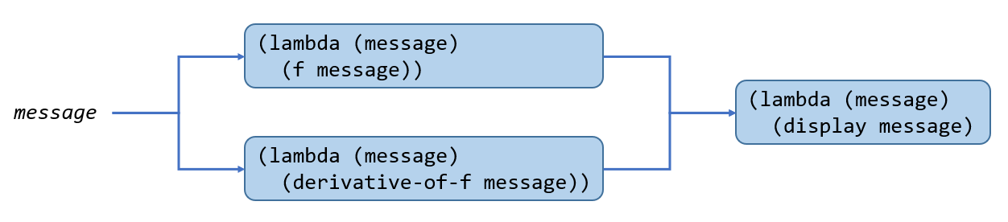

TBD: Clean this up and add explanation for the code and document the API. See also the codebase.

