Binocular summation in macaque V1 gives way within tens of milliseconds to normalization set by the other eye's contrast
Blake A. Mitchell, Brock M. Carlson, Alexander Maier
Draft V4 · 11 November 2026

About this draft
Draft V4 (11 November 2026). The figures were rebuilt around one result each, and the text rewritten to match: response onset follows drive, and the second eye counts as drive (Fig 1d); the eyes' contrasts add at onset and then fall short of summation in proportion to the other eye's contrast, shown across the full 6 × 6 design (Fig 2); normalization is strongest in and above the input layers (Fig 3); a delayed pool weighted toward the other eye accounts for the responses at every depth (Fig 4). All depth results use the final laminar alignment, referenced to the input/deep boundary from spike–LFP phase coupling. Every number comes from a script in the v1-laminar-binocular repository (analysis record: docs/09_paper_design.md; figures: scripts/figures/).
- Solid: onset follows drive and the second eye advances it, in both monkeys and at every depth; summation at onset and a shortfall graded with the other eye's contrast afterwards (hierarchical model, both halves of the data, each monkey); the sustained shortfall when the other eye is stronger, replicated in held-out recordings; weaker normalization below the input/deep boundary, for four depth references; a delayed pool weighted toward the other eye at every depth.
- Modest: the grading with the other eye's contrast in the held-out recordings (p = 0.054 and 0.20); the gains of the conductance and two-stage models (0.5–4.5%); the shorter superficial pool delay (not interpreted).
- Removed since V3: the linearity index, equivalent contrast and iso-response contours (replaced by the summation prediction in response units and by the additivity index); "at 45% the binocular response matches the dominant eye alone" (true only from about 30 to 100 ms, after which the other eye's contribution partly returns); depth below the top of cortex as the depth axis; the earliest sink summing the eyes at onset (in contrast units its current follows the spiking rule; Supplementary Fig S2).
Items in [square brackets] are facts to fill in or decisions to make. The last section lists what needs work.

Abstract
Binocular vision begins in primary visual cortex (V1), where signals from the two eyes converge. Their combination is usually described by divisive normalization, but when normalization takes hold, how it depends on each eye's contrast, and where in the cortical column it is strongest are unknown. We recorded laminar multi-unit activity in V1 of two awake macaques while each eye viewed a grating at one of six contrasts, chosen independently, and compared each binocular response, on each site's own response clock, with the response that summation of the two eyes' contrasts predicts. Across all 35 stimulus conditions, responses began sooner the stronger they were, and adding the second eye advanced the onset by 1.5–1.9 ms. For about 20 ms after onset, binocular responses were at or above summation in every combination of contrasts. Thereafter they fell short of summation in proportion to the other eye's contrast, and stayed short through 200 ms when the other eye's contrast exceeded the dominant eye's, a result replicated in held-out recordings. This normalization was strongest in and above the input layers and weaker below them, where responses began as early as in the input layers. A dynamic normalization model accounted for the responses at every depth only if the normalization pool was delayed and weighted the other eye more than the excitatory drive did. Binocular combination in V1 thus changes from summation to normalization by the other eye within tens of milliseconds, a possible basis for the larger binocular summation of brief stimuli.

Significance Statement
How the brain combines the images of the two eyes begins in primary visual cortex. We resolved this combination in time, at every depth of the cortex, for every pairing of the two eyes' contrasts. The eyes' signals add as soon as cortical neurons respond, but within tens of milliseconds the response falls short of their sum, by an amount set by the other eye's contrast. A model in which a delayed normalization signal weights the other eye more than the excitatory input does accounts for this sequence at every depth. Binocular combination is therefore not a fixed rule but a process that unfolds during each glance, which may explain why binocular summation in perception is largest for brief stimuli.

Introduction
The two eyes view the world from slightly different positions, and primary visual cortex (V1) is the first stage at which their signals converge on single neurons. How V1 combines them determines what later stages of the visual system receive. The combination is usually described by divisive normalization, in which each neuron's excitatory drive is divided by the pooled activity of a population of neurons (Carandini & Heeger 2012).
Which form of normalization operates between the eyes remains disputed. In anesthetized cat simple cells, each eye's signal is gain-controlled before the two are combined (Truchard, Ohzawa & Freeman 2000). Human fMRI and steady-state EEG instead point to a binocular pool, which makes responses to one eye and to two nearly equal, a property called ocularity invariance (Moradi & Heeger 2009; Baker & Wade 2017). Psychophysical contrast matching (Legge & Rubin 1981; Baker, Meese & Georgeson 2007) requires either two stages of gain control (Meese, Georgeson & Baker 2006) or mutual gain control between the eyes (Ding & Sperling 2006). In macaque V1, the two eyes' contrasts combine linearly near threshold (Smith et al. 1997a), and ocular dominance shapes how binocular responses are normalized (Mitchell et al. 2023; Zhang et al. 2024).
These accounts describe the combination once it has settled, yet several observations suggest that it changes during the response. In awake macaque V1, stimulating both eyes enhances the early, transient response but not the sustained response (Cox et al. 2019). When both eyes view the same grating, this enhancement persists at low contrast but turns into suppression at medium and high contrast by 150–250 ms after stimulus onset (Mitchell et al. 2022). In neurons driven by one eye only, binocular facilitation appears at response onset and suppression about 12 ms later (Dougherty et al. 2019), and suppression tuned to binocular disparity lags excitation by about 7 ms (Tanabe & Cumming 2014). Perception depends on time in a similar way: binocular summation is largest for brief stimuli (Bearse & Freeman 1994), and binocular contrast combination is more linear for brief, low-contrast stimuli than for long, high-contrast ones (Ding, Klein & Levi 2013). The neural studies used response windows of 50–100 ms or longer, a single contrast pair or equal contrasts in the two eyes, and differences in spike counts rather than a test of a combination rule; time-averaged responses from the recordings analysed here showed that the other eye's contribution depends on ocular dominance (Mitchell et al. 2023). When the rule changes, how the change depends on each eye's contrast, where in the cortical column it is strongest and what form of normalization produces it are therefore unknown. Normalization itself may take time: in human visual cortex it lags the response it divides (Zhou et al. 2019), and in recurrent circuit models it builds up over tens of milliseconds (Heeger & Zemlianova 2020).
Measuring how the rule changes on this time scale requires separating it from response latency. Stronger stimuli evoke responses with shorter latencies: in V1, latency shortens as contrast increases (Gawne, Kjaer & Richmond 1996; Albrecht et al. 2002), which normalization models attribute to the faster dynamics of a more strongly driven circuit (Carandini, Heeger & Movshon 1997). Stimulating both eyes acts as a stronger stimulus than stimulating one. In humans, binocular visual evoked potentials peak about 3 ms earlier than monocular ones (Plainis et al. 2011); in macaque V1, the latency of binocular responses is set largely by the dominant eye (Romero et al. 2007). If binocular responses begin even slightly earlier, comparing them with monocular responses at the same moment after stimulus onset shows a binocular excess on the rising edge of the response, whether or not the rule by which the eyes combine changes. A test of the combination rule must therefore account for these differences in latency, on a stimulus clock accurate to the millisecond.
We recorded laminar multi-unit activity (MUA), current-source density (CSD) and single units in V1 of two awake macaques while each eye viewed a grating at one of six contrasts, chosen independently for each eye, so that every combination of the two eyes' contrasts was tested. Across all conditions, response onset followed the strength of the response, and the second eye counted as drive (Fig 1). We compared each binocular response with the response of the dominant eye alone at the summed contrast, which also begins earlier, on each site's own response clock. For about 20 ms after onset, the two eyes' contrasts added in every combination; afterwards the binocular response fell short of summation in proportion to the other eye's contrast, and stayed short when the other eye was the stronger one (Fig 2). This normalization was strongest in and above the input layers (Fig 3). A dynamic normalization model accounted for the responses at every depth only with a delayed pool that weighted the other eye more than the excitatory drive did (Fig 4).

Results

Binocular combination measured with millisecond and laminar resolution
We recorded from 26 V1 penetrations in two macaques (monkey B: 8; monkey J: 18; 22 sessions) with linear arrays of 32 contacts spaced 100 µm apart. The monkeys viewed a single monitor through a mirror stereoscope that presented each eye with its own half of the screen (Fig 1a). Each eye saw the same static grating, matched to the receptive fields, at 0, 5.5, 11, 22.5, 45 or 90% contrast. All 36 combinations of the two eyes' contrasts were presented in random order, about 30 times each (Fig 1b). We analysed 570 MUA channels whose responses varied with the contrast of at least one eye.
Depth was referenced to the boundary between the input layers and the deep layers. In each penetration we located it from the laminar profile of spike–LFP phase coupling, where the preferred phase of spikes relative to the alpha/beta LFP reverses (Vinck et al. 2010; Davis et al. 2023), if the earliest current sink evoked by the gratings or the depth at which alpha/beta and gamma LFP power cross (Mendoza-Halliday et al. 2024) lay within 0.4 mm of it, and otherwise from the sink and the crossing where these two agreed (Methods). This gave a reference in 22 of 26 penetrations. The top of cortex, the most superficial contact with an evoked MUA response, lay a median 1.25 mm above it (interquartile range 0.80–1.52 mm). We grouped channels as superficial (from the top of cortex to 0.5 mm above the boundary), input (the 0.5 mm above the boundary) and deep (the 0.7 mm below it; 424 channels in all). Stimulus onsets were measured with a photodiode on the display.
The basic observation is visible in single penetrations (Fig 1c). At 45% contrast in each eye, the binocular response rose earlier and higher than the response to either eye alone and then, within about 30 ms of its peak, fell to the response of the dominant eye alone. The other eye drove weaker responses than the dominant eye at every contrast (Supplementary Fig S1a). We summarized each channel's balance between the eyes by an eye weight, the factor that maps the other eye's contrast onto the dominant eye's contrast–response function (median over penetrations 0.70, interquartile range 0.55–0.78). Most MUA channels were driven by both eyes (Supplementary Fig S1b).

Response onset follows drive, and the second eye counts as drive
Comparing binocular and monocular responses moment by moment requires knowing when each begins. Across the 35 stimulus conditions, the stronger the response, the earlier it began (Fig 1d). The rank correlation between the peak of a condition's response and its onset, the time at which the response reached half that peak, was −0.98 over the population medians of the 35 conditions; within penetrations it was negative in 24 of 26 (hierarchical estimate −0.48, p < 0.001; weaker in monkey B, p < 0.001). Raising the contrast in the dominant eye from 11 to 90% advanced the onset by 6.8 ms, to 32.8 ms after stimulus onset. Adding the other eye advanced it further, by 1.9, 1.6 and 1.5 ms with both eyes at 11, 22.5 and 45% (earlier than the dominant eye alone in 23, 25 and 23 of 26 penetrations; p < 0.001 at each contrast; hierarchical estimate at 45%, −1.55 ms, p = 0.013), and by 1.8 ms at 90%. Binocular responses began 1.5 ms earlier than the sum of the two monocular responses would have (25 of 26 penetrations, p < 0.001), so the advance reflects a stronger combined drive, not the addition of two responses. They also began 0.9 ms earlier than a single eye driving a response of the same peak (p = 0.002): with 45% in each eye, responses began before the response to the dominant eye at 90% in 17 of 26 penetrations. At their peaks, binocular responses did not differ from what summation of the two eyes' contrasts predicts (p ≥ 0.17 at 11, 22.5 and 45%).
Because onsets differ by several milliseconds between conditions and between channels, we aligned each channel to its own response onset, that of its response to the dominant eye at 90%. We then compared the binocular response with the response predicted if the two eyes' contrasts add: the dominant eye's response to the summed contrast c_D + a·c_O, where c_D and c_O are the contrasts of the dominant and the other eye and a is the eye weight (Methods). The prediction is itself a response to a stronger stimulus, so it also begins earlier than the dominant eye's response to c_D alone.
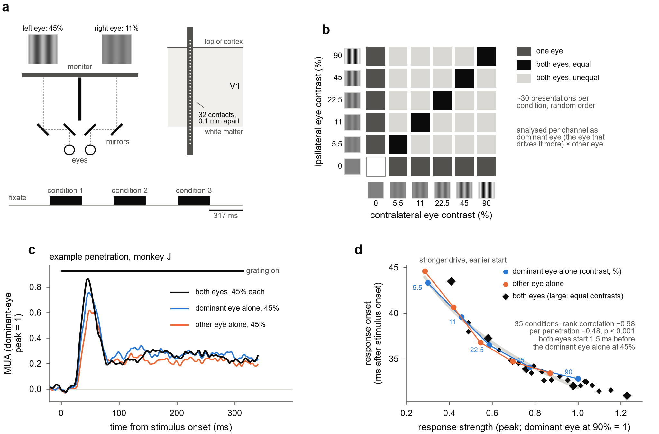
Figure 1. The experiment, an example penetration, and response onset follows drive. (a) Each eye viewed its own half of one monitor through a mirror stereoscope (top view): two mirrors per eye shift each eye's line of sight onto its own half, and a black septum divides the halves. A 32-contact laminar probe (0.1 mm spacing) spanned the depth of V1. Each trial presented three conditions in random order, each for about 317 ms with 317 ms between them. (b) The 6 × 6 dichoptic design: each eye saw a grating at 0, 5.5, 11, 22.5, 45 or 90% contrast (swatches), giving 36 conditions: one eye alone (dark grey), both eyes at equal contrast (black) and both eyes at unequal contrast (light grey), each shown about 30 times. Each channel was analysed with its axes reoriented to its dominant and other eye. (c) Multi-unit activity in one penetration of monkey J: mean of 28 channels, each scaled to its dominant-eye peak at 90% contrast, for both eyes at 45% and each eye alone at 45%. (d) Response onset (the time at which a condition's response reached half its own peak) against response strength (that peak), for all 35 stimulus conditions: each eye alone (circles; numbers, the dominant eye's contrast in %) and both eyes (diamonds; large, equal contrasts). Medians over channels in each penetration, then over 26 penetrations; onsets are relative to each channel's onset for the dominant eye at 90%, plus that onset's population median. Grey band, least-squares line of onset on log peak through the monocular conditions, drawn over their range.

The eyes' contrasts add at onset; afterwards the other eye's contrast sets the shortfall from summation
Because each eye's contrast was varied independently, we could ask how the combination changes over time across the whole design. The summation prediction can be made wherever both contrasts are at least 11% and the summed contrast does not exceed the highest contrast tested, 90%: up to 12 cells of the design in each penetration. Fig 2a shows one of them, the dominant eye at 22.5% and the other eye at 90%. In the first 20 ms after onset, the binocular response exceeded the summation prediction, by 4.8% of the dominant-eye peak. From about 25 ms it fell below the prediction and stayed below through 200 ms, by 5.6% from 30 to 100 ms and by 5.3% from 130 to 200 ms (mean over the 18 penetrations in which this prediction could be made). The shortfall is small relative to the response itself, which at its peak was twice the response to the dominant eye alone.
The same sequence ran through the design (Fig 2b, c). In the first 20 ms after onset, the binocular response was at or above summation in nearly every cell, and a stronger other eye added, if anything, slightly more (+1.1% of the dominant-eye peak per doubling of the other eye's contrast; linear mixed model with penetrations nested in sessions, Methods). From 30 to 100 ms the binocular response fell short of summation in every cell, and more so the higher the other eye's contrast (−1.3% per doubling, p < 0.001). From 130 to 200 ms the shortfall persisted where the other eye's contrast was high (−1.1% per doubling, p < 0.001). Both slopes were more negative than at onset (p < 0.001). Where the other eye's contrast exceeded the dominant eye's, the binocular response remained 2.6% of the dominant-eye peak below summation from 130 to 200 ms (p < 0.001; monkey B −1.6%, monkey J −3.6%), whereas on the diagonal of matched contrasts it had largely returned to summation (−1.0%). Every estimate had the same sign in odd and in even presentations and in each monkey alone. The shortfall therefore followed the other eye's contrast, along the columns of the design (Fig 2c), rather than the match between the two eyes' contrasts.
Two observations limit how the early surplus should be read. Binocular responses began about 1.5 ms earlier than responses to the dominant eye alone (Fig 1d), slightly earlier than the summation prediction. Shifting the prediction 1 ms earlier halved the surplus in the first 20 ms (averaged over the cells, from +3.1% to +1.7% of the dominant-eye peak) and left a shortfall of 3.7% from 30 to 100 ms (23 of 26 penetrations). We therefore describe the onset as at or above summation rather than as more than additive. Second, with matched contrasts the shortfall was transient: at 45% in each eye, the other eye added less than summation predicts from 30 to 100 ms (23 of 26 penetrations, p < 0.001; hierarchical estimate −4.1%, p < 0.001), and its contribution partly returned by 130–200 ms (21 of 26, p < 0.001).
On the dual-probe days, each probe was also recorded while the grating was centred on the receptive fields of the other probe. These eight recordings (monkey J) were not used to identify the effect, and their responses were weaker because the grating was off-centre. In them, the sustained shortfall with the stronger other eye replicated (−2.4% of the dominant-eye peak from 130 to 200 ms, p = 0.032), but its grading with the other eye's contrast did not reach significance (−0.6% per doubling from 130 to 200 ms, p = 0.20; −1.1% from 30 to 100 ms, p = 0.054).
The result did not depend on the measure or on pooling over neurons. In the additivity index, the binocular response divided by the sum of the two monocular responses, which we use for the depth analyses below, both eyes at 45% gave 0.54 from 30 to 100 ms against 0.62 predicted by summation (23 of 25 penetrations, p < 0.001), and with the other eye stronger the index stayed at 0.59 against 0.65 from 130 to 200 ms (24 of 25, p < 0.001). Isolated single units also fell short of summation from 30 to 100 ms (65 units in 20 penetrations; −7.6% of their dominant-eye peak, p < 0.001), including the more monocular half of the units (−7.7%, p = 0.003). Their summation at onset was not resolved (+7.2%, p = 0.20), so whether the eyes add within single neurons at onset, rather than across the neurons that make up the MUA, remains open.
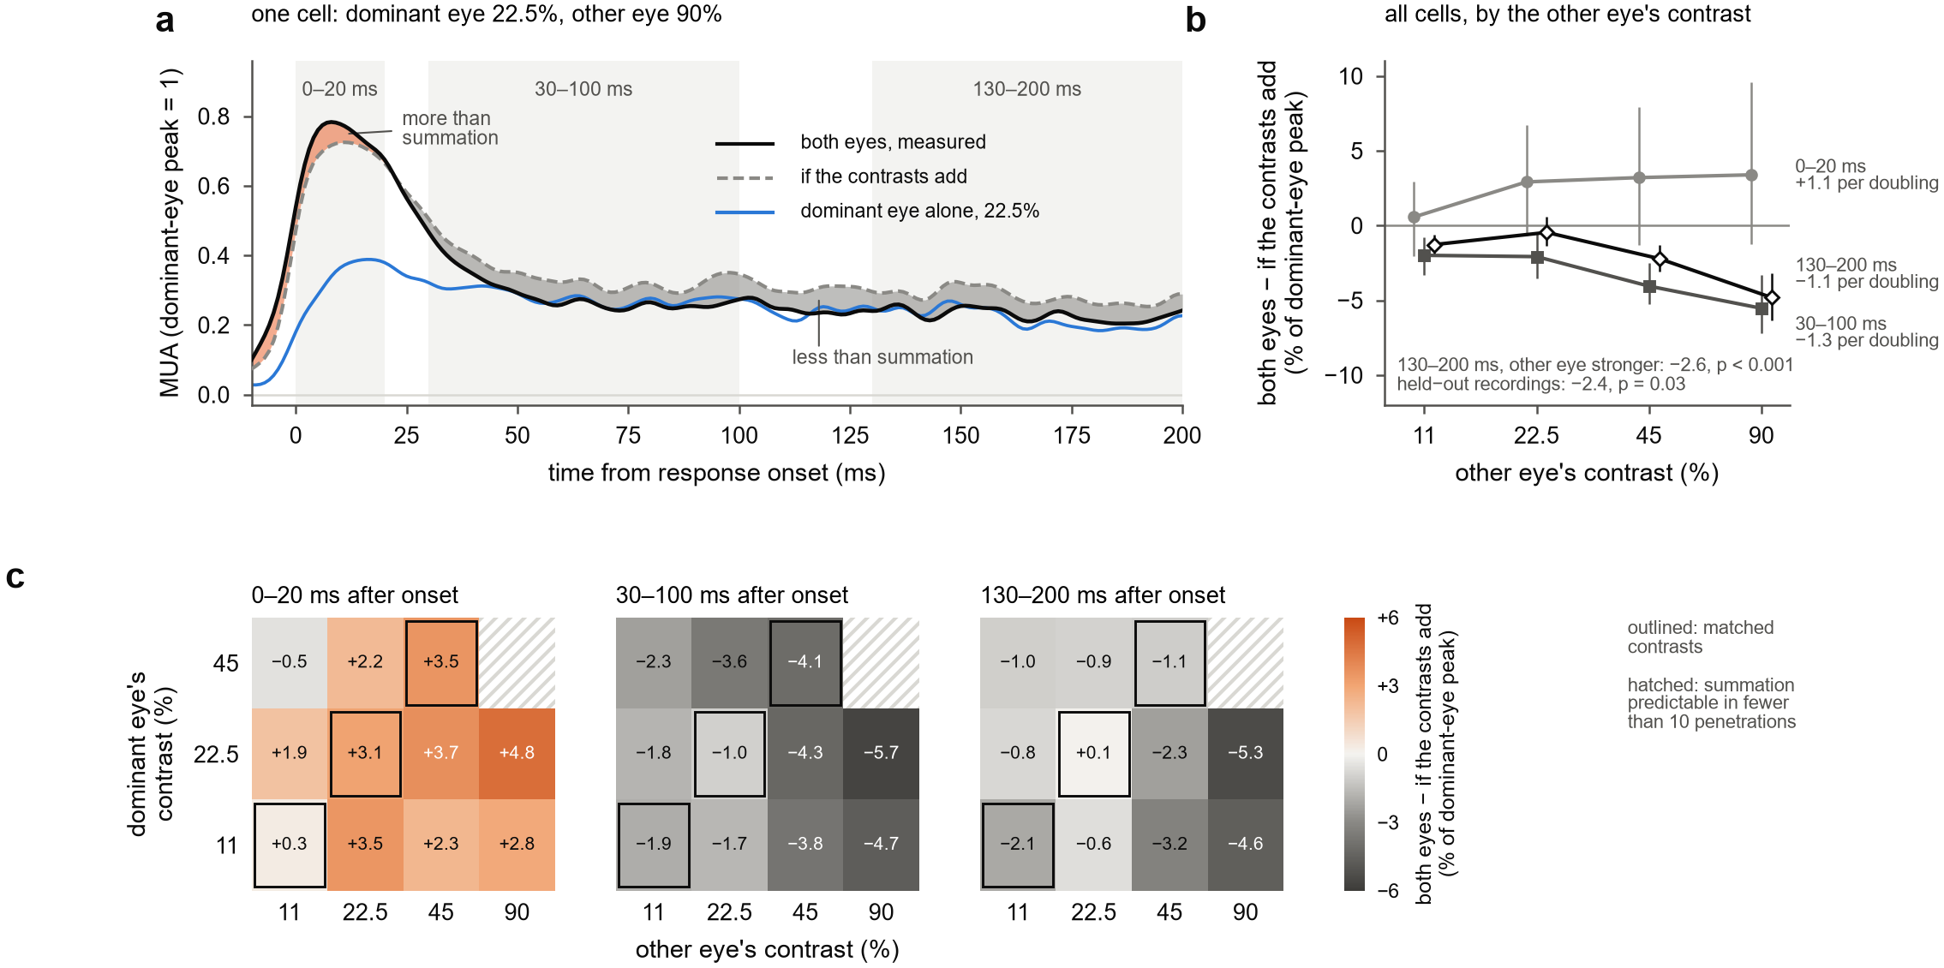
Figure 2. The eyes' contrasts add at response onset; afterwards the binocular response falls short of summation in proportion to the other eye's contrast. Each channel is aligned to its own response onset and scaled to its dominant-eye peak at 90%; penetration means of channel means. "If the contrasts add": the dominant eye's response at the summed contrast c_D + a·c_O, with the penetration's eye weight a. (a) One cell of the design, dominant eye 22.5% and other eye 90%: both eyes (black), the summation prediction (dashed) and the dominant eye alone at 22.5% (blue); orange, both eyes above the prediction; grey, below it. Mean over the 18 penetrations in which the prediction could be made (c_D + a·c_O ≤ 90%); 5 ms running mean. Grey bands, the three analysis windows. (b) Both eyes minus the summation prediction in each window, against the other eye's contrast, averaged over the dominant eye's contrasts (11–45%) in each penetration; mean and 95% bootstrap confidence interval over 26 penetrations (23 at 90%). Labels give the slope per doubling of the other eye's contrast from the linear mixed model; the inset text gives the 130–200 ms shortfall over the cells in which the other eye's contrast was higher, for all penetrations and for the eight held-out recordings. (c) The same measure for every cell, one matrix per window: rows, the dominant eye's contrast; columns, the other eye's; values in % of the dominant-eye peak, means over penetrations (26 per cell; 23 and 18 with the other eye at 90% and the dominant eye at 11 and 22.5%). Outlined, matched contrasts; hatched, cells in which summation could be predicted in fewer than 10 penetrations.

Normalization is strongest in and above the input layers
We then asked where in the column this normalization occurs. At 45% in each eye, the additivity index fell below its summation reference within about 30 ms of onset at every depth, but the gap was larger in and above the input layers than below them (Fig 3a). From 30 to 100 ms after onset, the index fell 0.17 below summation within 0.5 mm above the boundary and about 0.05 below it in the 0.7 mm beneath. By group, the index was 0.51 against 0.67 predicted superficially, 0.49 against 0.66 in the input group and 0.55 against 0.60 in the deep group (Fig 3b). The deep group fell short of summation by 0.11 less than the input group (18 of 21 penetrations, p < 0.001), and it still fell short of summation (15 of 21, p = 0.010). The superficial and input groups did not differ (p = 0.31).
In response units, the shortfall at 45% from 30 to 100 ms was 5.2% of the dominant-eye peak smaller in the deep group than in the input group (18 of 22 penetrations, p < 0.001; hierarchical estimate 4.8%, p < 0.001, with no difference between monkeys, p = 0.52), and per channel it shrank by 3.0% per mm of depth (424 channels, p < 0.001). The deep difference held with three alternative depth references: with the deep group limited to 0.5 mm, with the earliest current sink as the reference, and in the 15 penetrations referenced by the phase reversal alone (3.1–4.1%, p ≤ 0.006).
The laminar profile of onset differed from that of normalization (Fig 3c). Responses began earliest 0.1–0.5 mm below the boundary, 29–30 ms after stimulus onset for both eyes at 45%, and progressively later above it, reaching 37–39 ms 0.9–1.3 mm above. Superficial channels began 5.3 ms later than input channels (dominant eye at 90%; 18 of 21 penetrations, p < 0.001), whereas deep channels began no later than input channels (1.4 ms earlier, in 14 of 22 penetrations; not significant). Adding the other eye advanced the onset in every group (superficial 2.0 ms, 20 of 21 penetrations; input 1.5 ms, 20 of 22; deep 1.1 ms, 17 of 22; p ≤ 0.005). Deep channels thus responded as early as the input layers but normalized less. In the current at the earliest sink, the response to both eyes matched the dominant eye's current at the summed contrast from onset, as for spiking, and spiking on the sink channels began 2–3 ms before the sink current, so the current at this depth does not isolate an input that precedes the spikes (Supplementary Fig S2).
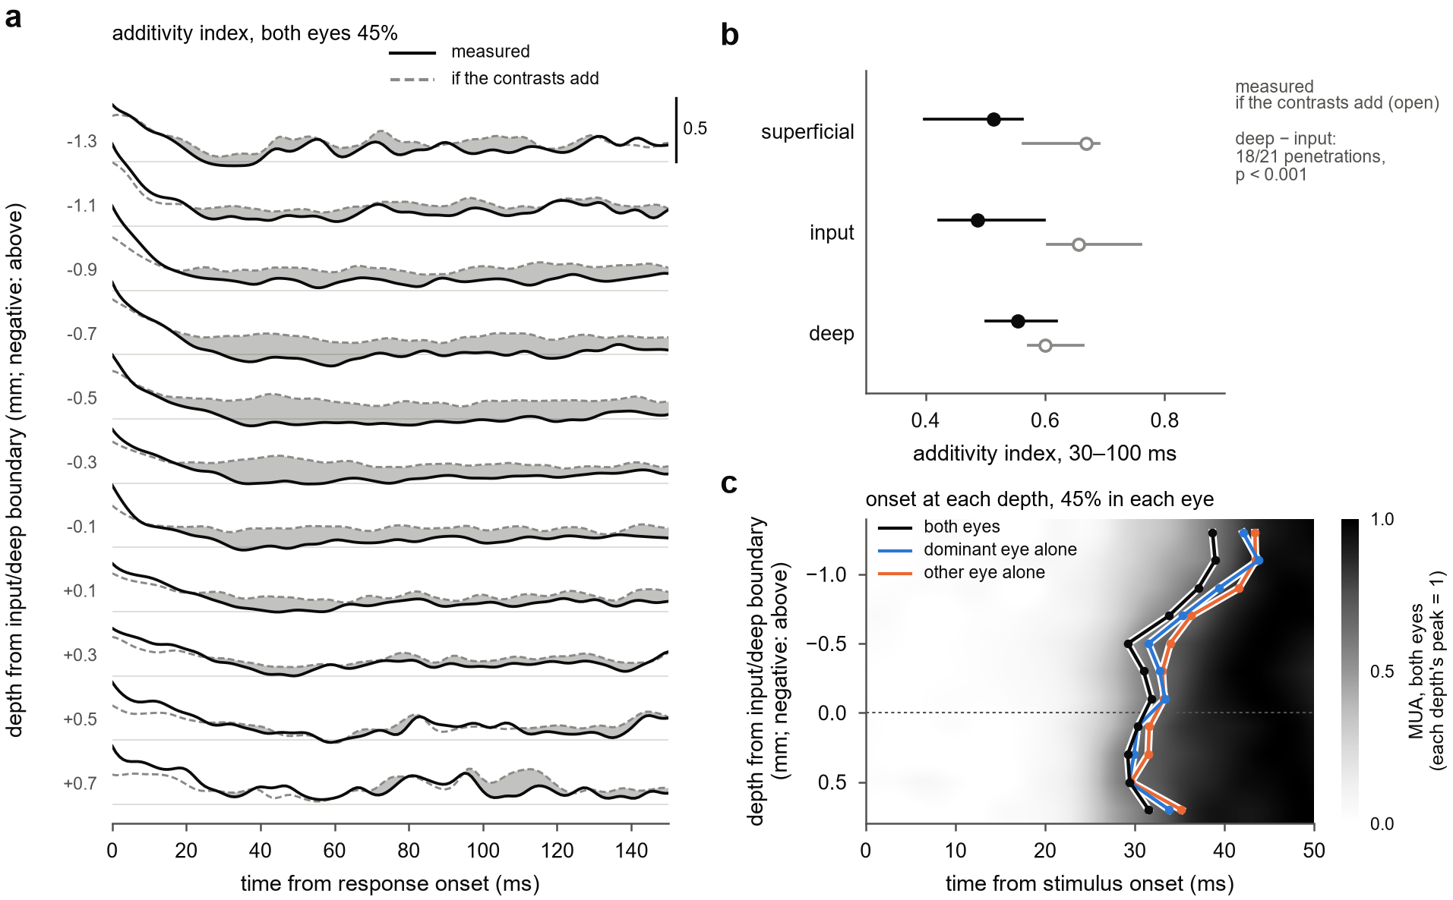
Figure 3. Normalization is strongest in and above the input layers; deep channels respond as early but normalize less. Depth from each penetration's input/deep boundary (Methods); negative values lie above it. (a) Additivity index (both eyes divided by the sum of the two monocular responses) at 45% in each eye over time from response onset, one trace per 0.2 mm depth bin with at least 10 penetrations: measured (solid) and the index that summation of the two eyes' contrasts predicts (dashed); grey where the measured index falls below the prediction; thin rules, index 0.5; 5 ms running mean; ratio of the population means of channel means over 22 penetrations. (b) The index 30–100 ms after onset in the superficial (top of cortex to 0.5 mm above the boundary), input (0.5 mm above the boundary to the boundary) and deep (the boundary to 0.7 mm below) groups: measured (filled) and predicted by summation (open); medians and interquartile ranges over penetrations; one-sided Wilcoxon signed-rank test of the deep-minus-input difference in the shortfall. (c) The first 50 ms at each depth: MUA for both eyes at 45%, each depth bin scaled to its own peak, with the median onset at each depth for both eyes, the dominant eye alone and the other eye alone at 45%; time from stimulus onset.

A delayed normalization pool weighted toward the other eye accounts for the responses at every depth
We next asked what form of normalization produces summation at onset followed by a shortfall that grows with the other eye's contrast. We extended the delayed normalization model of Zhou et al. (2019) to two eyes (Fig 4a). The excitatory drive sums the two eyes' contrasts, with a drive weight on the other eye. The normalization pool sums them with a separate pool weight and divides the drive after a low-pass delay. We fitted the model to the full 6 × 6 set of time courses of each depth group in each penetration (21 penetrations, 57 groups) and scored it on held-out presentations, in both directions of a split into odd and even presentations. With the median fitted parameters, the model produces the sequence of Fig 2: the drive adds the two eyes at once, the pool catches up over tens of milliseconds, and the binocular response falls toward that of the dominant eye alone (Fig 4a).
A delay was needed at every depth. Compared with a static pool, which divides the drive without delay, the delayed pool reduced held-out error by a median 50% superficially, 72% in the input group and 63% in the deep group (16 of 16, 19 of 20 and 20 of 21 penetrations; p < 0.001 in each; Fig 4b). The fitted pool time constant was 46 ms in the input group and 44 ms in the deep group. Superficially it was shorter (27 ms), but fits to single channels, which are not blurred by the later and more variable superficial onsets, showed a much smaller difference (4.8 ms), so we do not interpret it.
The pool weighted the other eye more than the drive did, at every depth (Fig 4c). The other eye's drive weight was 0.77, 0.86 and 0.86 of the dominant eye's in the superficial, input and deep groups, and its pool weight 1.01, 1.06 and 1.05 (excess pool weight in the hierarchical model 0.18, 0.27 and 0.19; p < 0.001 in each group). Freeing the pool weight from the drive weight improved held-out predictions in every group (p < 0.001). This asymmetry lets the binocular response fall toward the response of the dominant eye alone, and it makes the shortfall grow with the other eye's contrast, which enters the pool more strongly than the drive. The excess weight was smaller in the deep group than in the input group, but not significantly (−0.13, p = 0.076), and it was lower in monkey B superficially (p = 0.009).
Two variants improved the fits slightly. Letting the pool also shorten the response's time constant, as inhibition that increases membrane conductance would (Carandini, Heeger & Movshon 1997), reduced held-out error by 2.0% superficially and 0.5% in the input group, with a negligible gain in the deep group. A two-stage form, in which each eye is first gain-controlled by the other before the binocular pool (Meese, Georgeson & Baker 2006), reduced it below the fixed-delay model by 4.5%, 3.4% and 1.5% (p ≤ 0.009 in each group). A recurrent normalization circuit (a binocular version of the model of Heeger & Zemlianova 2020) did not improve on the conductance form at any depth. All models reproduced the shortening of latency with contrast and the earlier onset of binocular responses, because a stronger drive reaches half its peak sooner, so these features do not distinguish them. Fitted at each depth, the model did not reproduce the weaker normalization of the deep group [descriptive comparison to be rerun on the final alignment], and the pool weights did not differ reliably between depths; the laminar difference of Fig 3 therefore rests on the data, not on the model.
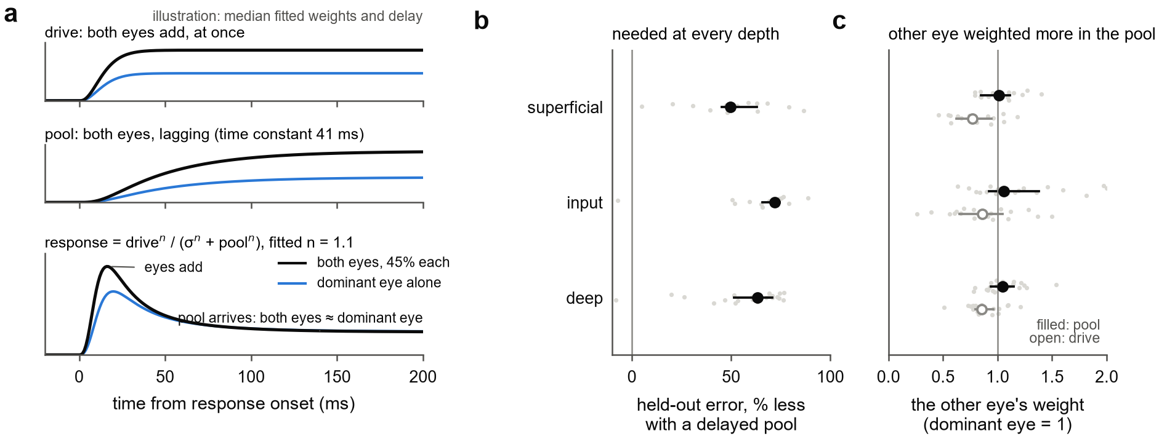
Figure 4. A delayed normalization pool that weights the other eye more than the drive does, at every depth. (a) The model, drawn with the median fitted weights, exponent and pool time constant of the conductance fits; both eyes at 45% (black) and the dominant eye alone at 45% (blue). Top, the excitatory drive: the two eyes' contrasts add at once. Middle, the normalization pool, which sums the two eyes with its own weight and lags the drive. Bottom, the response, drive^n / (σ^n + pool^n): both eyes exceed the dominant eye alone at first, then approach it as the pool arrives. (b) Held-out error, % less with a delayed pool than with a static pool, per penetration and depth group (grey dots), with medians and interquartile ranges; 16 superficial, 20 input and 21 deep groups; both cross-validation directions summed. (c) The other eye's weight in the drive (open) and in the pool (filled), conductance fits, relative to the dominant eye's (vertical line, 1); grey dots, penetrations; medians and interquartile ranges.

Discussion
In awake macaque V1, the two eyes' contrasts add at the onset of the response. Within about 30 ms, the binocular response falls short of summation by an amount set by the other eye's contrast, and when the other eye's contrast exceeds the dominant eye's, the shortfall persists through at least 200 ms. Response onsets follow the combined drive of the two eyes. Normalization is strongest in and above the input layers and weaker in the deep layers, which begin to respond as early as the input layers. A normalization pool that acts with a delay of about 45 ms and weights the other eye more than the drive does accounts for these responses at every depth.

Relation to earlier measurements
Earlier recordings in awake macaque V1 found binocular facilitation in an early window and its loss or reversal in a later one (Cox et al. 2019; Dougherty et al. 2019; Mitchell et al. 2022; Carlson et al. 2023), with equal contrasts in the two eyes or a single pair of contrasts. Time-averaged responses from the recordings analysed here showed that ocular dominance shapes how the other eye's contrast is combined (Mitchell et al. 2023). Our results resolve the combination in time across the full dichoptic design, on each site's own response clock. They show that the early phase is summation of the two eyes' contrasts in every combination tested; that the later shortfall depends on the other eye's contrast rather than on whether the contrasts match; and that it persists when the other eye is the stronger one, whereas with matched contrasts it is largely transient. A brief summation phase is compatible with the sublinear combination reported over longer windows (Mitchell et al. 2022), because the normalized state dominates any average over hundreds of milliseconds. Measurements that integrate over seconds, such as fMRI and steady-state EEG, report near ocularity invariance (Moradi & Heeger 2009; Baker & Wade 2017), the state our responses approached within about 50 ms of onset.

The second eye as drive
Onset latency fell with response strength across all 35 conditions, and adding the second eye advanced the onset by 1.5–1.9 ms at every contrast and every depth. In humans, binocular visual evoked potentials peak about 3 ms earlier than monocular ones (Plainis et al. 2011), whereas in macaque V1 the latency of binocular responses has been reported to follow the dominant eye (Romero et al. 2007). Measured at sub-millisecond resolution across the layers, the advance is present at every depth. Binocular responses also began about 1 ms earlier than a single eye driving a response of the same peak, and within one eye the onset gained little between 45 and 90% contrast. One reading, which we did not test, is that the latency of a monocular signal is limited before the cortex, whereas a second eye adds drive through a separate pathway. Because binocular responses begin earlier, comparisons with monocular responses at fixed times after stimulus onset overstate the binocular gain on the rising edge. Comparing with the response to the summed contrast, which also begins earlier, reduces this bias, but part of the surplus in the first 20 ms remains a matter of timing.

What the normalization requires
Two features of the data constrain models of binocular normalization. First, the pool must act with a delay: a static pool cannot produce summation at onset followed by a shortfall, and the delay reduced held-out error by 50–72% at every depth. Second, the pool must weight the other eye more than the drive does, or binocular responses could not fall toward the level of the dominant eye alone. The same asymmetry explains why the shortfall grows with the other eye's contrast and persists when that eye is the stronger one: a stronger other eye adds more to the pool than to the drive. A pool close to balanced between the eyes, with ocular dominance acting mainly on the drive, agrees with earlier time-averaged analyses of these recordings (Mitchell et al. 2023) and with the dependence of binocular combination on ocular dominance in superficial V1 (Zhang et al. 2024); our results show that this weighting acts with a delay of tens of milliseconds, at every depth.
Monocular contrast normalization has been reported to be fully expressed within 10 ms of response onset in anesthetized V1 (Albrecht et al. 2002), whereas interocular normalization in our data took hold 20–30 ms after onset, with a fitted pool time constant of about 45 ms. The difference may reflect the preparation, the measure (the shape of the contrast–response function, rather than a comparison with summation), or both; our data do not decide between these. Other forms of suppression in V1 also differ in speed: cross-orientation suppression is fast (Smith, Bair & Movshon 2006), whereas surround suppression is delayed (Bair, Cavanaugh & Movshon 2003). Interocular normalization resembles surround suppression in this respect, consistent with evidence that interocular suppression depends on cortical inhibition (Sengpiel & Vorobyov 2005).
Among the model forms, a conductance pool, which both divides the response and shortens its time constant, and a two-stage form, in which each eye is first gain-controlled by the other (Meese, Georgeson & Baker 2006; Ding & Sperling 2006), improved predictions slightly. The gains were 0.5–4.5%, so we read them as preferences rather than demonstrations. The conductance form agrees with the view that normalization in V1 is implemented partly by shunting inhibition (Carandini, Heeger & Movshon 1997). A recurrent circuit in which normalization is computed from the responses themselves (Heeger & Zemlianova 2020) did not improve on the conductance form at any depth.

The laminar profile
Normalization was strongest in and above the input layers and weaker in the 0.7 mm below the input/deep boundary, for every depth reference we tried. Deep channels nevertheless began to respond as early as input channels, the earliest 0.1–0.5 mm below the boundary, which would fit direct geniculate input to the deep layers [citation]; we did not test this. The fitted pool weights did not differ reliably between depths, and the model fitted at each depth did not reproduce the weaker deep normalization, so the difference is not explained by a single parameter of this model family. It could reflect a different balance of the two eyes in the deep layers' pool, a different time course of their inhibition, or a mixture of signals arriving early from the thalamus and later from the superficial layers. The current at the earliest sink followed the same contrast rule as the spikes at onset, but spiking on the sink channels led the current by 2–3 ms, so CSD at this resolution did not separate input from output.

Alternative explanations
Three alternatives deserve comment. First, the measure: the summation prediction depends on the eye weight and on interpolation between the contrasts tested, but the shortfall's dependence on the other eye's contrast, the comparison between time windows and the comparison between depths use the same prediction throughout, and the result held in odd and even presentations, in each monkey, in held-out recordings and in the additivity index. Second, eye movements: presentations with saccades were excluded [pupil-size control to be rerun on the new measures]. Third, small errors of vergence change the interocular phase of the gratings and could turn facilitation into suppression in cells selective for binocular phase. We could not measure vergence, because the position of only one eye was recorded in most sessions, but four arguments make this explanation unlikely. Vergence in fixating macaques varies by 1 arcmin or less (Read & Cumming 2003), which shifts the interocular phase of a 1–4 cycle/deg grating by only 6–24°. Binocular phase tuning in macaque V1 changes little with contrast (Smith et al. 1997b), so a phase error would scale binocular responses by a factor independent of contrast rather than produce a shortfall that grows with the other eye's contrast. MUA pools many neurons, including complex cells with little phase selectivity. And the sequence occurred in all 26 penetrations, whose receptive fields and gratings differed.
The conclusions have limits. The gratings were static and identical in the two eyes apart from contrast, so the results do not address disparity, orientation conflict or masking. The results rest mainly on MUA at 100 µm spacing; isolated units were few, and they confirm the later shortfall but not summation at onset within single neurons. Two monkeys contributed unequal numbers of penetrations (8 and 18), and the held-out recordings came from one monkey and replicated the sustained shortfall but not, significantly, its grading with the other eye's contrast. The depth reference is uncertain by a few hundred micrometres in individual penetrations, although the deep difference held for each reference we tried.

A prediction
Binocular combination in V1 is therefore not a fixed rule but a sequence that unfolds within tens of milliseconds. This predicts that the binocular signal V1 sends onward depends on stimulus duration: for presentations of a few tens of milliseconds, it approximates summation of the two eyes' contrasts, and for longer presentations it reflects the normalized state, in which the other eye's contrast reduces the binocular response. Perceptual binocular summation behaves in this way. It is largest for presentations of about 50 ms and absent at 100 ms or more (Bearse & Freeman 1994), and binocular combination is more linear for brief, low-contrast stimuli than for long, high-contrast ones (Ding, Klein & Levi 2013). Recording V1 responses to dichoptic stimuli of varied duration, together with perceptual reports, would test whether the time course measured here sets the duration dependence of binocular perception.

Methods

Animals
Two adult macaques [species, sex, ages, weights] were implanted with a head post and a recording chamber over V1 [procedures, anaesthesia, IACUC protocol]. Monkey B was recorded in right V1 (October–December 2021) and monkey J in left V1 (October–December 2022).

Task and stimuli
The task ran in NIMH MonkeyLogic 2. The monkeys fixated [fixation window, duration] while viewing a single monitor through a mirror stereoscope [display model, viewing distance, mean luminance; 120 Hz refresh]. Two mirrors in front of each eye directed its line of sight to its own half of the screen, and a black septum between the halves kept each eye from seeing the other half. Because the two eyes' gratings occupied the same rows of the display, both were drawn at the same time in each frame. Each trial showed three gratings, each for about 317 ms with about 317 ms between them, followed by a juice reward. In one penetration, gratings lasted about 217 ms.
Gratings were static sinusoids matched to the multi-unit receptive field in orientation, spatial frequency (1–4 cycles/deg), size and position [mapping procedure], and identical in the two eyes apart from contrast. Each eye's Michelson contrast was 0, 0.055, 0.11, 0.225, 0.45 or 0.9, chosen independently, giving 36 conditions in random order with about 30 presentations each.

Recording
We recorded with 32-contact linear arrays (Plexon, 100 µm spacing) and a Blackrock Cerebus system. Wideband signals were sampled at 30 kHz and LFP at 1 kHz. On seven days in monkey J, two arrays were recorded at once in separate columns; on these days each array was also recorded while the grating was centred on the receptive fields of the other array (held-out recordings). Stimulus onsets were taken from a photodiode on the display, and the 3.4 ms offset between the 30 kHz and 1 kHz file clocks was corrected.
MUA was the envelope of the wideband signal: band-pass 500–5000 Hz (4th-order Butterworth, zero phase), full-wave rectification, low-pass 200 Hz, resampled to 1 kHz. CSD was −σ∂²V/∂z² of the LFP (σ = 0.4 S/m, 0.1 mm spacing). Before differentiation, contacts with evoked amplitude outside 0.6–1.6 times the median of their neighbours were interpolated, and a three-point Hamming filter was applied across depth.
Single units came from curated Kilosort sorts, with a spike-time offset corrected, and from Kilosort 4 (Pachitariu et al. 2024) for five penetrations without a sort. Units were included if refractory-period contamination (Hill et al. 2011) was below 0.5 and signal-to-noise ratio was at least 3. A strict set also required contamination below 0.1, amplitude cutoff below 0.1 and presence ratio of at least 0.9.

Eye position and presentation selection
The position of one eye was recorded as analog gaze signals, calibrated in MonkeyLogic. Saccades were detected with a velocity threshold (Engbert & Kliegl 2003; λ = 6, minimum 6 ms). We analysed completed presentations with no saccade of 1° or more between 200 ms before and 500 ms after onset.
We also excluded presentations with large MUA artifacts: a peak MUA between −50 and 450 ms more than 20 robust standard deviations (median absolute deviation × 1.4826) above the median for that channel, on any channel in cortex. Visual responses reach 6–11 such units in penetrations without artifacts. The rule removed 0.6% of presentations, mostly in monkey J.

Laminar alignment
The input/deep boundary was estimated in three ways: the depth at which the preferred phase of spikes relative to the alpha/beta LFP reverses (spike–LFP phase coupling; Vinck et al. 2010; Davis et al. 2023), if the step in phase was at least 0.5 rad; the earliest current sink evoked by either eye alone, plus 0.3 mm; and the depth at which alpha/beta (10–19 Hz) and gamma (75–150 Hz) LFP power cross (Mendoza-Halliday et al. 2024), plus 0.1 mm. The offsets are the median differences from the phase reversal in the 14 penetrations with a clear reversal. The boundary was the phase reversal if the sink or the crossing lay within 0.4 mm of it, and otherwise the mean of the sink and the crossing if these lay within 0.4 mm of each other (15 and 7 penetrations); in 4 penetrations no two estimates agreed and depth was not analysed. The top of cortex was the most superficial contact with an evoked MUA response. Channels more than 0.7 mm below the boundary were excluded from depth analyses, which covers layers 5 and 6 with a margin for oblique penetrations and excludes any second sheet of cortex. All markers were set from laminar recordings and monocular responses, before any binocular measure was computed by depth.

Responses
A channel was analysed if it lay in cortex and its response varied with the contrast of at least one eye shown alone (one-way ANOVA over the six contrasts, p < 0.01, 40–140 or 150–250 ms after onset, peak above baseline). Condition means were computed over clean presentations, blank-subtracted and smoothed with a Gaussian (σ = 2 ms).
The dominant eye was the eye with the larger mean response at 90%, 40–250 ms. Each channel was scaled by its dominant-eye peak at 90%. The onset of a condition was the first time between 10 and 250 ms after stimulus onset at which the response reached half its own peak, interpolated linearly between samples; it was not defined if that peak was below 0.2 of the dominant-eye peak at 90%. A channel's response onset, used to align its responses, was the onset of its response to the dominant eye at 90%. Onsets were summarized as medians over channels in each penetration (and depth group), then over penetrations.

The summation prediction and the additivity index
The eye weight a was the contrast scale, between 0.05 and 1, that best mapped the dominant eye's monocular contrast–response function (mean response 40–250 ms) onto the other eye's (least squares over the five non-zero contrasts); each penetration's median over channels was used. The response predicted if the two eyes' contrasts add was the dominant eye's response at the summed contrast c_D + a·c_O, interpolated at each time point linearly in log contrast between the measured contrasts. It was computed where both contrasts were at least 11% and c_D + a·c_O did not exceed 90%. The shortfall from summation was the binocular response minus this prediction, from channel means aligned to response onset, in units of the dominant-eye peak at 90%, averaged 0–20, 30–100 and 130–200 ms after onset.
The additivity index was the binocular response divided by the sum of the two monocular responses, as a ratio of window means of channel means, computed where the denominator exceeded 0.12 of the dominant-eye peak. Its summation reference was the summation prediction divided by the same denominator, with each channel's own eye weight in depth analyses. For the onset of the summation prediction, the dominant eye's onset at c(1 + a) was interpolated linearly in log contrast between its onsets at the measured contrasts.

Single units and held-out recordings
Isolated units (lenient criteria below) were analysed as MUA channels, with each unit's own dominant eye, scale, onset and eye weight; for each eye at 45%, the other eye's contribution was compared with its summation prediction 0–20 and 30–100 ms after the unit's onset. For the held-out recordings, channels were included if their response varied with the dominant eye's contrast (one-way ANOVA, 40–250 ms, p < 0.01); the eight recordings with at least five such channels were analysed with the same measure as the main data, with a random intercept per recording.

Current-source density at the earliest sink
The earliest sink was found in the current evoked by either eye alone: among channels whose sink 20–70 ms after stimulus onset reached at least 40% of the strongest, the one whose sink first reached 25% of its own peak. Its current was the mean over that channel and its two neighbours. Additivity and the summation prediction were computed for the current as for MUA, with the current's own contrast response and eye weight, in windows after sink onset. For timing, the 0.9 ms delay of the amplifier's causal LFP filter, measured by comparing the 30 kHz and 1 kHz streams, was corrected.

Statistics
The penetration is the unit of replication, because neighbouring channels share signal. The main claims were tested with linear mixed models (statsmodels, restricted maximum likelihood) with a random intercept per session (two arrays were recorded in one session on dual-probe days) and monkey as a sum-coded fixed effect, reported two-sided. Over the dichoptic design, the shortfall was modelled as S ~ window × (x_O + x_D) + monkey, with x = log2(c / 22.5%), a random intercept per session and a variance component per penetration. Depth-group differences were tested with one-sided Wilcoxon signed-rank tests over penetrations for directional predictions, and two-sided tests otherwise; the per-channel depth profile with a linear mixed model with a random intercept per penetration. Each directional effect was also required to have the same sign in odd and in even presentations. Confidence intervals are bootstrap intervals with 2000 resamples of penetrations.

Models
In the fixed-delay normalization model, after Zhou et al. (2019), the drive is E(t) = (c_D + a·c_O)·u(t) and the pool P(t) = (c_D + w·c_O)·v(t), with response R = g·E^n / (σ^n + P^n). Here a and w are the drive and pool weights of the other eye, u(t) is the step response of a gamma filter (shape 3, time constant τ1) delayed by δ, and v(t) is u(t) passed through an exponential low-pass filter with time constant τ2. Static normalization sets v = u; the equal-weight version sets w = a. The fitted drive weight a is the model's counterpart of the measured eye weight.
In the conductance model, the response relaxes toward the fixed-delay value with an effective time constant τ_m / (1 + (P/σ)^n): τ_m·dR/dt = g·E^n/σ^n − (1 + (P/σ)^n)·R, so the pool both divides the response and shortens its time constant. As τ_m approaches 0, the model reduces to the fixed-delay model. In the recurrent model, a binocular version of ORGaNICs (Heeger & Zemlianova 2020), the normalization signal is computed recurrently from the responses. In the two-stage model, each eye is first divided by a delayed sum of its own and the other eye's contrast before the fixed-delay stage (after Meese, Georgeson & Baker 2006).
Models were fitted by least squares, with several starting points, to the full 6 × 6 time courses 0–219 ms after stimulus onset of the channel mean of each depth group in each penetration (groups with at least three channels), and, for comparison, of single channels. Held-out error was the summed squared error on even presentations for fits to odd presentations and vice versa, summed over both directions. One penetration, with 217 ms stimuli and few presentations, had no condition with enough presentations in its even half and was excluded. Model comparisons used one-sided Wilcoxon signed-rank tests on the log ratio of held-out errors, and required the median of each direction to favour the same model.

Code and data
All analyses are in the v1-laminar-binocular repository [link or availability statement]. Each figure is produced by one script from saved analysis outputs.

References
- Albrecht DG, Geisler WS, Frazor RA, Crane AM (2002). Visual cortex neurons of monkeys and cats: temporal dynamics of the contrast response function. J Neurophysiol 88:888–913.
- Bair W, Cavanaugh JR, Movshon JA (2003). Time course and time-distance relationships for surround suppression in macaque V1 neurons. J Neurosci 23:7690–7701.
- Baker DH, Meese TS, Georgeson MA (2007). Binocular interaction: contrast matching and contrast discrimination are predicted by the same model. Spat Vis 20:397–413.
- Baker DH, Wade AR (2017). Evidence for an optimal algorithm underlying signal combination in human visual cortex. Cereb Cortex 27:254–264.
- Bearse MA Jr, Freeman RD (1994). Binocular summation in orientation discrimination depends on stimulus contrast and duration. Vision Res 34:19–29.
- Carandini M, Heeger DJ (2012). Normalization as a canonical neural computation. Nat Rev Neurosci 13:51–62.
- Carandini M, Heeger DJ, Movshon JA (1997). Linearity and normalization in simple cells of the macaque primary visual cortex. J Neurosci 17:8621–8644.
- Carlson BM, Mitchell BA, Dougherty K, Westerberg JA, Cox MA, Maier A (2023). Does V1 response suppression initiate binocular rivalry? iScience 26:107359.
- Cox MA, Dougherty K, Westerberg JA, Schall MS, Maier A (2019). Temporal dynamics of binocular integration in primary visual cortex. J Vis 19(12):13.
- Davis ZW, Dotson NM, Franken TP, Muller L, Reynolds JH (2023). Spike-phase coupling patterns reveal laminar identity in primate cortex. eLife 12:e84512.
- Ding J, Klein SA, Levi DM (2013). Binocular combination of phase and contrast explained by a gain-control and gain-enhancement model. J Vis 13(2):13.
- Ding J, Sperling G (2006). A gain-control theory of binocular combination. Proc Natl Acad Sci USA 103:1141–1146.
- Dougherty K, Cox MA, Westerberg JA, Maier A (2019). Binocular modulation of monocular V1 neurons. Curr Biol 29:381–391.
- Engbert R, Kliegl R (2003). Microsaccades uncover the orientation of covert attention. Vision Res 43:1035–1045.
- Gawne TJ, Kjaer TW, Richmond BJ (1996). Latency: another potential code for feature binding in striate cortex. J Neurophysiol 76:1356–1360.
- Heeger DJ, Zemlianova KO (2020). A recurrent circuit implements normalization, simulating the dynamics of V1 activity. Proc Natl Acad Sci USA 117:22494–22505.
- Hill DN, Mehta SB, Kleinfeld D (2011). Quality metrics to accompany spike sorting of extracellular signals. J Neurosci 31:8699–8705.
- Legge GE, Rubin GS (1981). Binocular interactions in suprathreshold contrast perception. Percept Psychophys 30:49–61.
Mendoza-Halliday D, Major AJ, Lee N, Lichtenfeld MJ, Carlson B, Mitchell B, et al. (2024). A ubiquitous spectrolaminar motif of local field potential power across the primate cortex. Nat Neurosci 27:547–560.
- Meese TS, Georgeson MA, Baker DH (2006). Binocular contrast vision at and above threshold. J Vis 6(11):7.
- Mitchell BA, Dougherty K, Westerberg JA, Carlson BM, Daumail L, Maier A, Cox MA (2022). Stimulating both eyes with matching stimuli enhances V1 responses. iScience 25:104182.
- Mitchell BA, Carlson BM, Westerberg JA, Cox MA, Maier A (2023). A role for ocular dominance in binocular integration. Curr Biol 33:3884–3895.
- Moradi F, Heeger DJ (2009). Inter-ocular contrast normalization in human visual cortex. J Vis 9(3):13.
- Pachitariu M, Sridhar S, Pennington J, Stringer C (2024). Spike sorting with Kilosort4. Nat Methods 21:914–921.
- Plainis S, Petratou D, Giannakopoulou T, Atchison DA, Tsilimbaris MK (2011). Binocular summation improves performance to defocus-induced blur. Invest Ophthalmol Vis Sci 52:2784–2789.
- Read JCA, Cumming BG (2003). Measuring V1 receptive fields despite eye movements in awake monkeys. J Neurophysiol 90:946–960.
- Romero MC, Castro AF, Bermudez MA, Perez R, Gonzalez F (2007). Eye dominance and response latency in area V1 of the monkey. Vis Neurosci 24:757–761.
- Sengpiel F, Vorobyov V (2005). Intracortical origins of interocular suppression in the visual cortex. J Neurosci 25:6394–6400.
- Smith EL 3rd, Chino Y, Ni J, Cheng H (1997a). Binocular combination of contrast signals by striate cortical neurons in the monkey. J Neurophysiol 78:366–382.
- Smith EL 3rd, Chino YM, Ni J, Ridder WH 3rd, Crawford MLJ (1997b). Binocular spatial phase tuning characteristics of neurons in the macaque striate cortex. J Neurophysiol 78:351–365.
- Smith MA, Bair W, Movshon JA (2006). Dynamics of suppression in macaque primary visual cortex. J Neurosci 26:4826–4834.
- Tanabe S, Cumming BG (2014). Delayed suppression shapes disparity selective responses in monkey V1. J Neurophysiol 111:1759–1769.
- Truchard AM, Ohzawa I, Freeman RD (2000). Contrast gain control in the visual cortex: monocular versus binocular mechanisms. J Neurosci 20:3017–3032.
- Vinck M, van Wingerden M, Womelsdorf T, Fries P, Pennartz CMA (2010). The pairwise phase consistency: a bias-free measure of rhythmic neuronal synchronization. NeuroImage 51:112–122.
- Zhang SH, Zhao XN, Jiang DQ, Tang SM, Yu C (2024). Ocular dominance-dependent binocular combination of monocular neuronal responses in macaque V1. eLife 13:RP92839.
- Zhou J, Benson NC, Kay K, Winawer J (2019). Predicting neuronal dynamics with a delayed gain control model. PLoS Comput Biol 15:e1007484.

Supplementary figures and tables
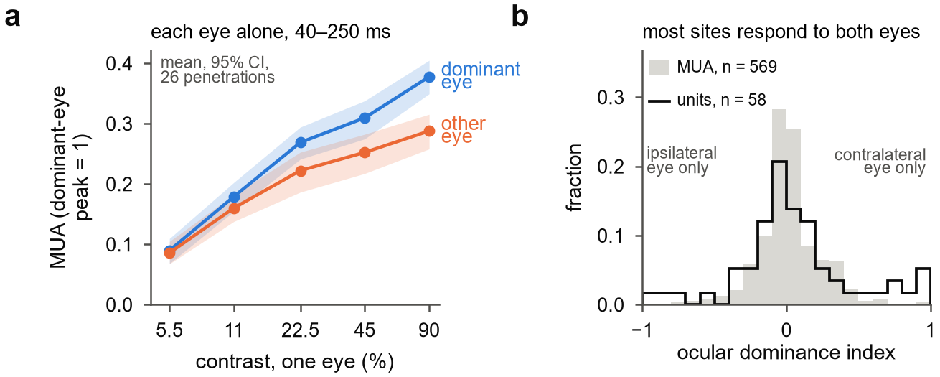
Supplementary Figure S1. Each eye alone. (a) Mean response 40–250 ms after stimulus onset to each eye alone, against contrast, in units of each channel's dominant-eye peak at 90%; mean and 95% bootstrap confidence interval over 26 penetrations. (b) Ocular dominance index at 90% contrast, the difference between the contralateral and ipsilateral responses divided by the sum of their magnitudes, for 569 driven multi-unit channels (grey) and 58 isolated single units (outline; contamination below 0.5, signal-to-noise ratio of at least 3).
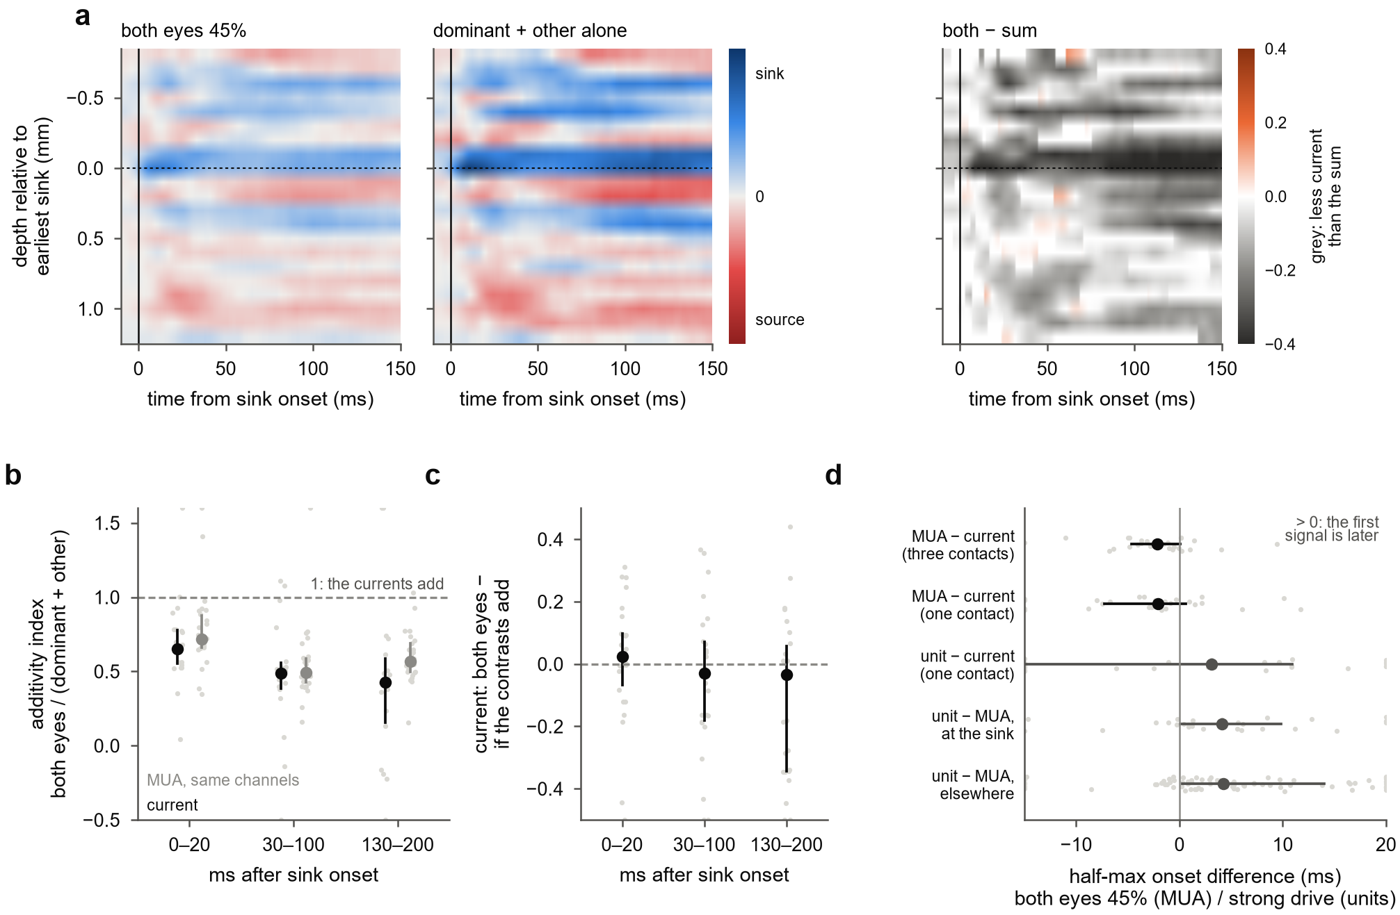
Supplementary Figure S2. The synaptic current at the earliest sink. (a) Current-source density at 45% in each eye, by depth relative to the earliest sink and time from sink onset: both eyes, the sum of the two monocular currents, and both eyes minus that sum (grey, less current than the sum; shown where the summed current exceeds 8% of the sink's peak); each penetration scaled by its sink's peak current, then averaged. (b) Additivity index of the sink current (the sink channel and its two neighbours) and of MUA on the same channels, in windows after sink onset, at 45%; medians and interquartile ranges over penetrations. (c) The sink current, both eyes minus the summation prediction from the current's own contrast response and eye weight, same windows. (d) Half-maximum onset differences at the earliest sink: MUA minus current (three-contact current, corrected for the 0.9 ms LFP filter delay; and the single-contact current), isolated units minus current, and isolated units minus MUA on their own contact, at the sink and elsewhere; medians and interquartile ranges. Depth here is relative to the earliest sink, not to the input/deep boundary.
[Supplementary figures still to be rebuilt on the V4 measures and the final alignment: the laminar markers and the depth reference in every penetration; the fixed-rule null passed through the shortfall readout; single units by ocular dominance; the model variants by depth (fixed delay, equal weights, conductance, two-stage, recurrent); Table S1, the main estimates with monkey effects.]

Open items for revision
- Fill in the bracketed Methods facts: species, sex, surgery and protocol, display, fixation window, receptive-field mapping.
- Affiliations, and whether Kacie Dougherty and Michele Cox join as authors.
- Confirm that Mitchell et al. 2023 analysed these recordings (the text says so in the Introduction and Discussion).
- Title: V4 proposes a new one that names the main result (summation gives way to normalization set by the other eye's contrast); the V3 and V2 titles are still options.
The 2024 dissertation reports normalization weakest in the geniculate input layers and strengthening through the circuit; here it is strongest in and above the input layers and weakest below them. Which measure and depth reference did the dissertation use? The Discussion should reconcile the two before submission, and should say what the SfN 2023 abstract (normalization across condition, depth and time) already reported.
Supplement: the V3 supplementary figures and tables used the linearity index and the earlier laminar alignment and are removed; the items listed in brackets after Supplementary Fig S2 need rebuilding. The model's failure to reproduce the laminar difference is still from the earlier depth groups and needs rerunning on the final alignment; so do the pupil-size and saccade controls on the new measures.
Check the new reference (Mendoza-Halliday et al. 2024) and add a citation for geniculate input to the deep layers (Discussion, The laminar profile), or drop that sentence.
- Remaining controls: receptive-field position, crosstalk between the eyes' images.

