The two eyes add first and normalize later in macaque V1
[Authors and affiliations]
Draft V1 · 29 October 2026

About this draft
This is a first full draft, written to be read and argued with, not submitted. Every number comes from a script in the v1-laminar-binocular repository (commit 74f1e2b, 2026-10-29). The analysis record is docs/09_paper_design.md, and the figures are built by scripts/figures/.
- Solid: linear summation at onset followed by interocular normalization (Fig 2); a stronger collapse at higher contrast in every penetration (Fig 3, discovery data); a delayed pool that weights the other eye more than excitation does (Fig 5).
- Candidate: the held-out confirmation of the contrast effect failed as registered and passes only after a later data-cleaning step (Fig 3c); the laminar timing statistics are modest (Fig 4).
- Open: what produces the full strength of the late collapse and the slow rise at low contrast (Figs 5–6).
Items in [square brackets] are facts to fill in or decisions to make. The last section lists what needs work.

Abstract
How the two eyes' signals combine in primary visual cortex (V1) is usually described by one static rule. We recorded laminar activity in V1 of two awake macaques while each eye saw a grating at one of six contrasts, chosen independently for each eye (a full 6 × 6 dichoptic design, 26 penetrations).
We used an equivalent-contrast measure that is not biased by the earlier onset of binocular responses. With it, the two eyes summed almost linearly for the first ~20 ms of the response. Interocular normalization then took over, 20–35 ms after response onset.
The collapse of binocular summation was deeper at higher contrast in all 26 penetrations. At 45% contrast, binocular responses fell to the level of the dominant eye alone. The same sequence ran at every depth and in the earliest current sink. Normalization reached the input layer first, about 63 ms after stimulus onset, and the layers above and below it 6–7 ms later.
A delayed normalization model fitted the full time courses. In it, the normalization pool weighted the non-dominant eye more than excitation did. It predicted held-out responses better than static normalization, and early interocular gain control added a small, consistent improvement. No fitted model captured the full strength of the late collapse, or the slow rise of low-contrast responses.
Binocular normalization in V1 takes time. Disagreements between static accounts of binocular combination may partly reflect when responses are measured.

Introduction
The two eyes see the world from slightly different positions, and V1 is the first place where their signals meet. How V1 combines them sets what the rest of the visual system receives. Divisive normalization is the standard description: each neuron's drive is divided by the pooled activity of its neighbours (Carandini & Heeger 2012).
Which normalization rule applies to the two eyes is still disputed. In anesthetized cat simple cells, each eye's input is gain-controlled before the two are summed (Truchard, Ohzawa & Freeman 2000). Human fMRI and steady-state EEG instead point to a binocular pool, in which responses barely change between one eye and two (Moradi & Heeger 2009; Baker & Wade 2017). Psychophysics needs either two stages of gain control (Meese, Georgeson & Baker 2006) or each eye controlling the other's gain (Ding & Sperling 2006).
Recordings in awake macaque V1 add a further split. Binocular stimulation boosts the early, transient response, and the boost is gone in the sustained response (Cox et al. 2019). Monocular neurons are suppressed by the other eye (Dougherty et al. 2019), and population calcium responses are about the same for one eye or two (Zhang et al. 2024). In this dataset, pooled over 50–200 ms, ocular dominance weighted the excitatory drive but not the normalization pool (Mitchell et al. 2023).
Most of these accounts treat binocular combination as fixed in time. Yet normalization takes time. In human visual cortex it lags the response it divides (Zhou et al. 2019), and recurrent circuit models make it build up over tens of milliseconds (Heeger & Zemlianova 2020). Monocular contrast normalization, by contrast, is in place within the first 10 ms of the response in anesthetized V1 (Albrecht et al. 2002). If interocular normalization is slower, the combination rule depends on when one looks, and studies that averaged over different windows could disagree for that reason alone.
Measuring when the eyes combine is harder than it looks. Two eyes act like a higher contrast, so binocular responses start a few milliseconds earlier. An earlier rising edge alone creates a brief binocular excess, even if the combination rule never changes. Separating timing from rule therefore needs a measure that compares binocular and monocular responses at matched response levels, and a stimulus clock accurate to a millisecond.
We recorded laminar multi-unit activity (MUA), current-source density (CSD) and single units in V1 of two awake macaques. Each eye saw a grating at one of six contrasts, chosen independently, so every combination of the two eyes' contrasts was tested. We measured the combination rule as an equivalent contrast: how much the dominant eye's contrast must rise to match the binocular response at the same moment.
The eyes summed almost linearly at response onset and were normalized 20–35 ms later (Fig 2). The collapse was deeper at higher contrast (Fig 3). It ran at every depth, and normalization reached the input layer first (Fig 4). A delayed normalization pool, weighting the other eye more than excitation does, explained the direction of these effects but not their full strength (Fig 5). It also missed the slow rise of responses to low contrast (Fig 6).

Results

Binocular combination measured with millisecond and laminar precision
We recorded from 26 V1 penetrations in two macaques (monkey B: 8, monkey J: 18), using linear arrays with 32 contacts spaced 100 µm apart. A mirror stereoscope gave each eye its own monitor (Fig 1a). Each eye saw the same static grating, matched to the receptive field, at 0, 5.5, 11, 22.5, 45 or 90% contrast. All 36 combinations were shown in random order, about 30 times each (Fig 1b).
Depth was measured from the top of cortex, defined by the onset of spontaneous MUA along the array. A layer 4/5 boundary was placed below the dominant early sink of a flash-evoked CSD, recorded separately and registered to the grating recording (Fig 1c). It was accepted only when a second marker agreed, which held in 22 penetrations. Because laminar labels carry an uncertainty of roughly ±0.5–1 mm, depth below the top of cortex is our main axis.
Stimulus timing was taken from a photodiode on the screen. The event code sent by the task computer missed the true onset by one to three 120 Hz frames, varying from presentation to presentation (Fig 1d). Every analysis uses photodiode times; an error of one frame (8.3 ms) is larger than several effects reported below.
The basic phenomenon is visible in a single penetration (Fig 1e). At 45% contrast, the response to both eyes rose like the dominant eye at 90%, the level linear summation predicts, and then dropped to the level of the dominant eye alone. The other eye drove responses less than the dominant eye at every contrast (Fig 1f). We summarized each channel's eye balance as an eye weight a: the factor that maps the other eye's contrast onto the dominant eye's contrast response (median 0.70). Most MUA channels were binocular, and isolated units spanned the full range of ocular dominance (Fig 1g).
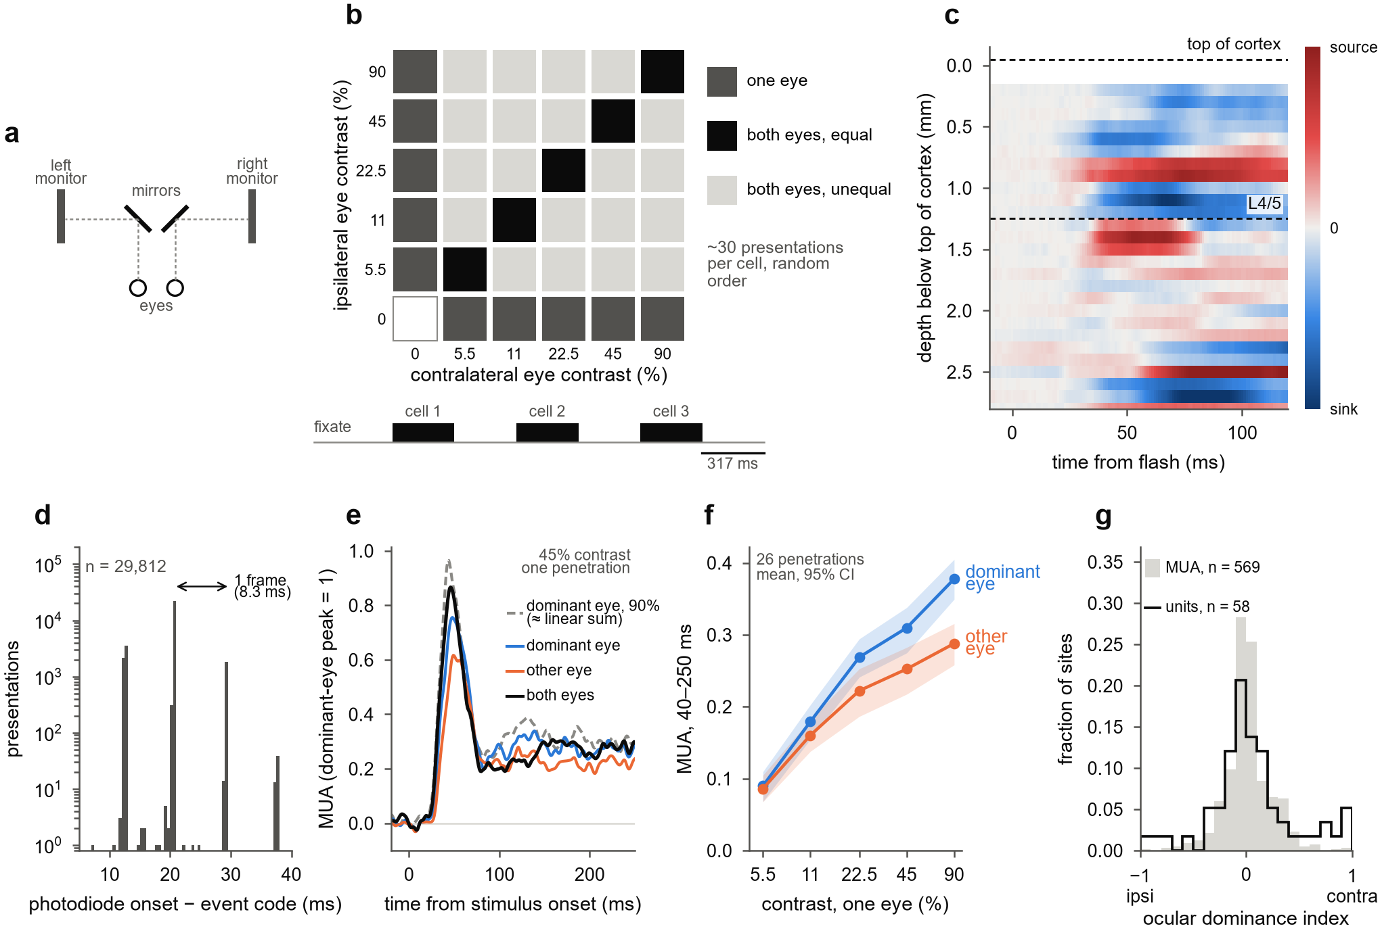
Figure 1. Binocular combination measured with millisecond and laminar precision. (a) Mirror stereoscope (top view). (b) The 6 × 6 dichoptic design: each eye's contrast was chosen independently, giving monocular cells (one eye at 0), dioptic cells (equal contrasts) and dichoptic cells (unequal contrasts); three cells per fixation trial, 317 ms on, 317 ms off. (c) Flash-evoked CSD in an example penetration (221212_J_eA), registered to the grating recording; dashed lines mark the top of cortex and the L4/5 boundary. (d) Photodiode onset minus event-code time, all presentations, log scale. (e) Example penetration, mean of 28 driven channels, each scaled to its dominant-eye peak at 90%; dashed grey, dominant eye at 90%, close to the linear-summation prediction (1 + a)·45%. (f) Monocular contrast responses of the dominant and the other eye (mean over 40–250 ms), mean and 95% bootstrap CI over 26 penetrations. (g) Ocular dominance index at 90% contrast, (contra − ipsi)/(|contra| + |ipsi|), for driven MUA channels (n = 569) and isolated single units (n = 58).

The two eyes add at response onset, then normalize within tens of milliseconds
Across penetrations, the 45% response to both eyes first tracked the linear-summation reference and then fell to the dominant eye's level (Fig 2a). We aligned each channel to its own response onset, the time its dominant-eye response at 90% reached half its peak, because onsets differ by several milliseconds across depths.
Comparing binocular and monocular responses at the same moment is confounded by latency: the binocular response starts earlier. We therefore measured the combination rule as an equivalent contrast (Fig 2b). In each time window, we found the dominant-eye contrast whose response matched the binocular response at contrast c, and divided it by c to obtain k.
Linear summation of contrast predicts k = 1 + a, where a is the other eye's weight. If the binocular response equals the dominant eye alone, k = 1. To compare channels with different eye balance, we used the linearity index L = (k − 1)/a. L = 1 means linear summation, L = 0 means the second eye adds nothing, and L < 0 means binocular responses fall below the dominant eye alone. In the population illustration of Fig 2b, k was 1.9 in the first 20 ms after onset, close to the linear prediction of 1.7, and 1.2 from 50 to 200 ms.
In the first 20 ms after onset, L was close to 1 at 11, 22.5 and 45% (penetration medians 1.19, 1.20 and 0.97; Fig 2c). It then fell. From 50 to 200 ms after onset, L was 0.61 at 11%, 0.47 at 22.5% and −0.12 at 45%. The drop held in 81%, 81% and 92% of penetrations (Wilcoxon signed-rank, p = 0.001, p < 0.001 and p < 0.001; Fig 2d).
The drop was not caused by the other eye's response fading faster. With the eye weight refitted in each window, it stayed at 0.64–0.70 and the drops were unchanged. The drop at 45% survived every control we applied: excluding presentations with any saccade, restricting to presentations within the interquartile range of pupil size, each half of the session, each monkey separately, and excluding the penetration with the fewest trials. At 11 and 22.5% it was weaker and depended on the window choice and subset (Supplementary Fig S1).
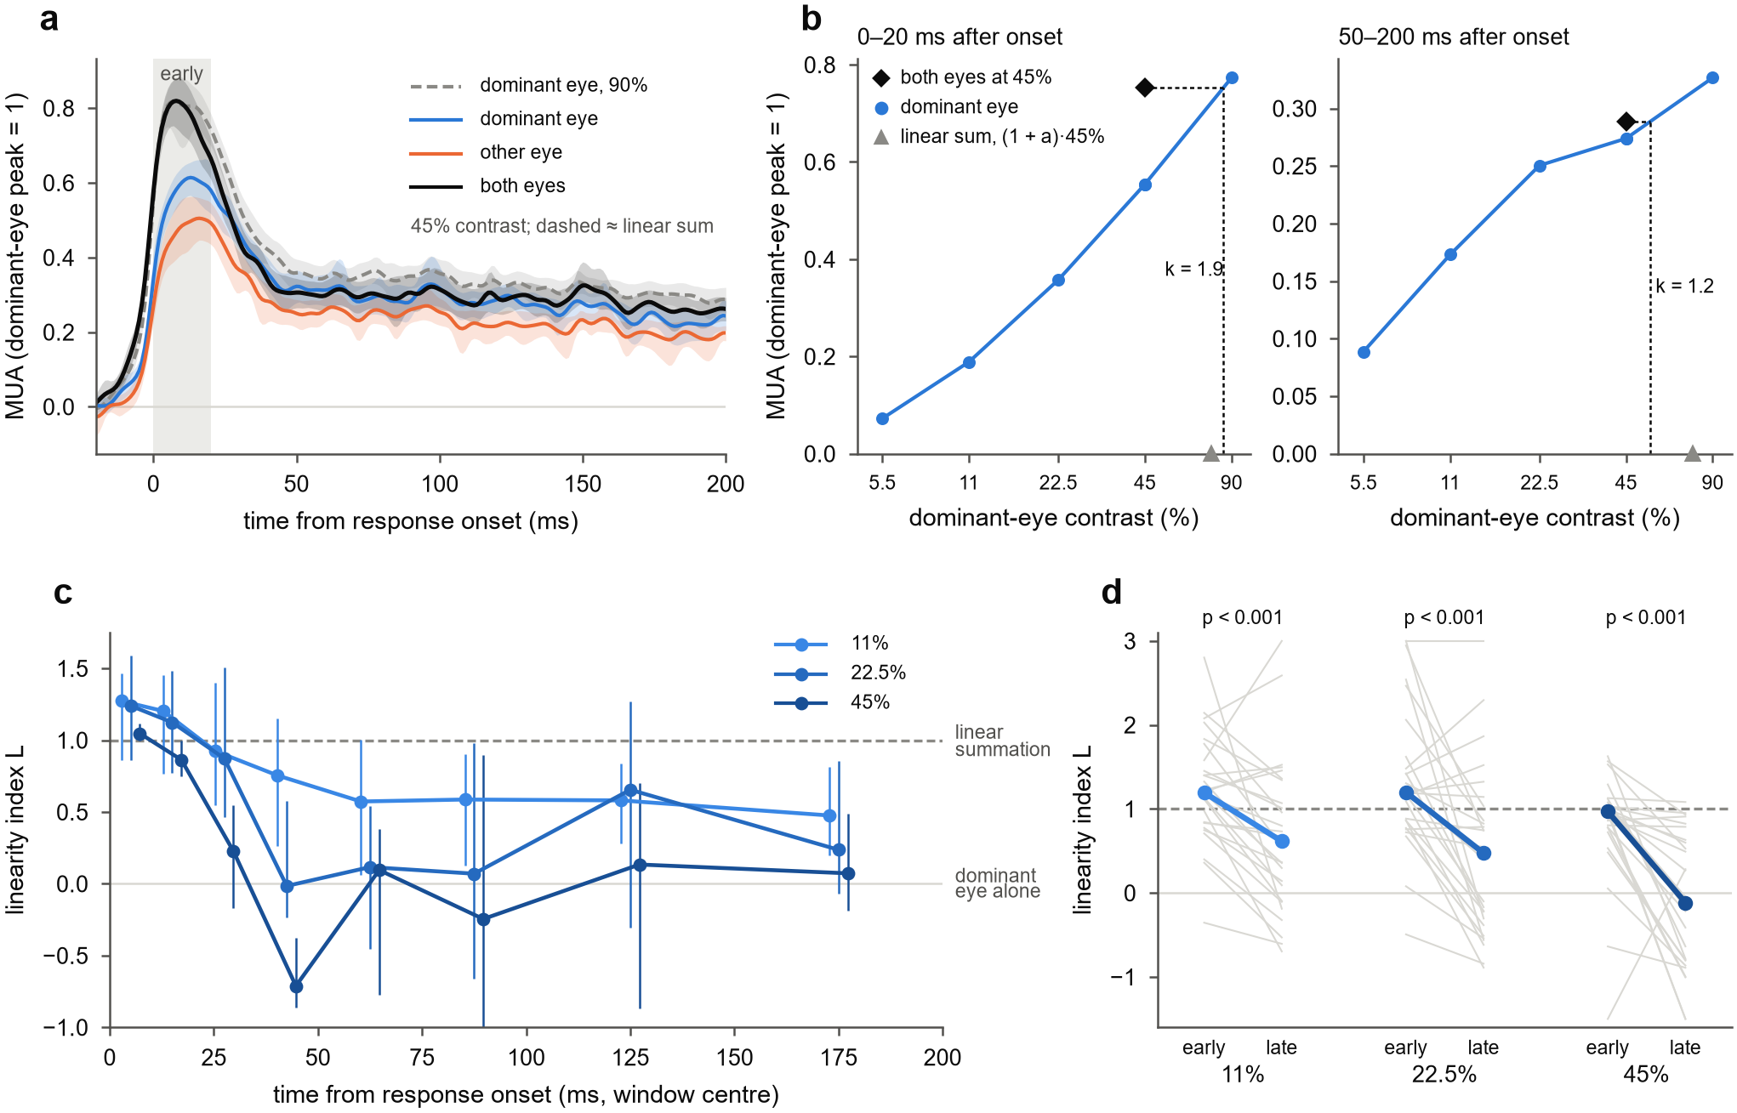
Figure 2. The two eyes add at response onset, then normalize within tens of milliseconds. (a) Population responses at 45%, aligned to each channel's response onset: each eye alone, both eyes, and the dominant eye at 90% (dashed; about the linear-summation prediction). Mean and 95% bootstrap CI over 26 penetrations; grey band, the first 20 ms. (b) Reading the equivalent contrast, on population means. The binocular response at 45% (diamond) is placed on the dominant eye's contrast response measured in the same window; k is the matching contrast divided by 45%. Early (left), it lies near the linear-summation prediction (1 + a)·45% (triangle); late (right), near 45%. (c) Linearity index L = (k − 1)/a in onset-aligned windows at 11, 22.5 and 45%, median over penetrations of channel medians, 95% bootstrap CI; points offset horizontally for visibility. (d) L early (0–20 ms after onset) and late (50–200 ms) per penetration (grey lines; values beyond the axis drawn at its edge) and the median (coloured); Wilcoxon signed-rank tests over 26 penetrations.

Contrast sets how far binocular summation collapses
The contrast dependence is visible in the raw responses, before any inversion (Fig 3a). The binocular gain, both eyes minus the dominant eye alone at the same contrast, peaked within about 10 ms of onset. It reached about 0.15 of the dominant-eye peak at 11% and about 0.3 at 90%. At 45 and 90% it was gone by about 25 ms after onset; at 11% it stayed positive for most of the first 100 ms.
In the window 20–50 ms after onset, L fell with contrast in every penetration: 26 of 26, 8 of 8 in monkey B and 18 of 18 in monkey J (median slope −0.95 per natural-log unit of contrast; Fig 3b, c). It also fell in each half of the data split by odd and even presentations (25 of 25 and 23 of 24 penetrations). It held under every control in Supplementary Fig S1 (88–100% of penetrations).
This effect was found while analysing the data, so we registered a confirmation test on held-out recordings before running it. On five dual-probe days with usable laminar alignment, each probe was also recorded while the grating sat on the other probe's receptive field; these recordings had not been analysed. The criterion was a negative slope in at least 80% of recordings and a one-sided sign test at p < 0.05.
As run, the test failed: the slope was negative in 6 of 7 recordings (86%), but p = 0.063. With seven recordings, only 7 of 7 could pass, so the test was underpowered by design. We later found and removed large MUA artifacts from all data (Methods), for a reason unrelated to this test. On the cleaned data, one more cross-recording had driven channels, and the same test gave 7 of 8 negative, p = 0.035 (Fig 3c). We report this as a sensitivity analysis, not as a confirmation.
Higher contrast made the collapse deeper but not reliably earlier. We timed each penetration's transition as the moment L had fallen halfway from its early to its late level. In the 15 penetrations with a clear drop at all three contrasts, this time did not differ between contrasts (Friedman p = 0.19; Fig 3d). At 45%, L fell below zero: the binocular response dropped beneath the dominant eye's own response. That is stronger than ocularity invariance, and it constrains the models in Fig 5.
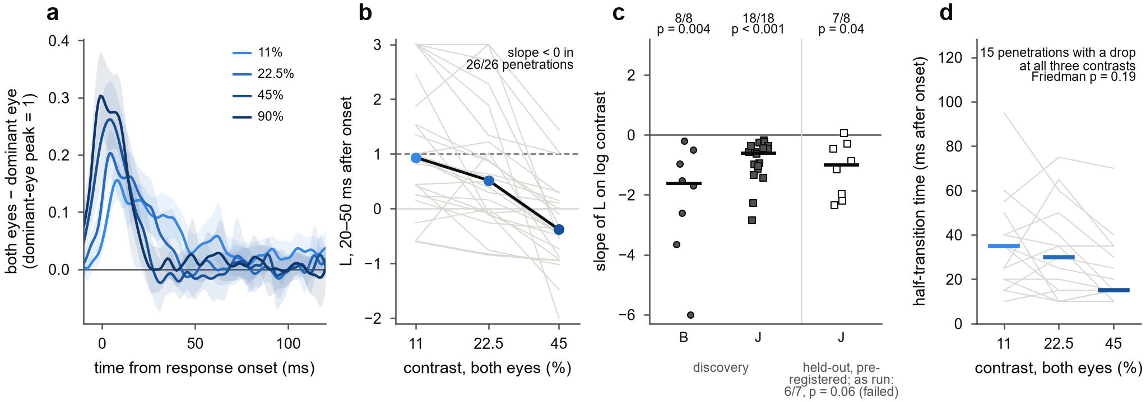
Figure 3. Contrast sets how far binocular summation collapses. (a) Raw binocular gain: both eyes minus the dominant eye alone at the same contrast, aligned to response onset, in units of the dominant-eye peak; mean and 95% bootstrap CI over 26 penetrations. (b) L 20–50 ms after onset per penetration (grey) and the median (black, coloured points); values beyond the axis drawn at its edge. (c) Slope of L against log contrast per recording, for the discovery penetrations of monkeys B and J and for the pre-registered held-out cross-recordings (monkey J); bars mark medians; counts are recordings with a negative slope, with one-sided sign tests. The held-out test as registered failed (6/7, p = 0.06); the counts shown are after MUA artifact rejection. (d) Half-transition time, the time at which L has fallen halfway from its early to its late level, for the 15 penetrations with a drop of at least 0.2 at all three contrasts; bars mark medians.

The same sequence runs at every depth and starts in the earliest synaptic input
The onset-then-collapse sequence appeared at every depth (Fig 4b). Early L was near 1 below about 0.8 mm and somewhat lower in the most superficial bins. Late L was lower than early L in every depth bin. A curved depth profile of late L, most linear in the middle depths, appeared in monkey J but not in monkey B, so we do not claim it.
We next asked whether the synaptic input to the column is already normalized. In every penetration we located the earliest grating-evoked current sink: the channel, among those with a strong sink, whose sink began first (Fig 4a). These sinks began 23–44 ms after stimulus onset and lay mostly in the upper 1.3 mm.
At sink onset, the input current added the two eyes almost linearly. Its equivalent contrast at 22.5 and 45% was about 2, against 1.78 predicted by linear summation with the sink's eye weight (0.78; Fig 4c). It then normalized, like the spiking at the same channels. Timed from sink onset, k for the current and for MUA did not differ consistently in any window. Normalization therefore does not arrive already formed in the earliest input; it appears in the currents and the spikes together.
We then grouped channels by their position relative to the earliest sink. Channels at the sink responded first: 30 ms after stimulus onset, against 35.5 ms above it (4 ms later, p = 0.02, 22 penetrations) and 35.5 ms below it (2 ms later, p = 0.012, 25 penetrations; Fig 4d). Each group normalized about 27.5 ms after its own onset. The groups above the sink and at it did not differ (p = 0.50), and the group below was slightly later (p = 0.045; Fig 4e).
On the stimulus clock, normalization therefore reached the input layer first, about 63 ms after stimulus onset. It reached the channels above 6 ms later (p = 0.016, 21 penetrations) and those below 7 ms later (p = 0.003, 23 penetrations; Fig 4f). These tests are uncorrected, and the 15 ms windows are coarse. A finer, pre-registered timing analysis is needed before this sequence is claimed firmly.
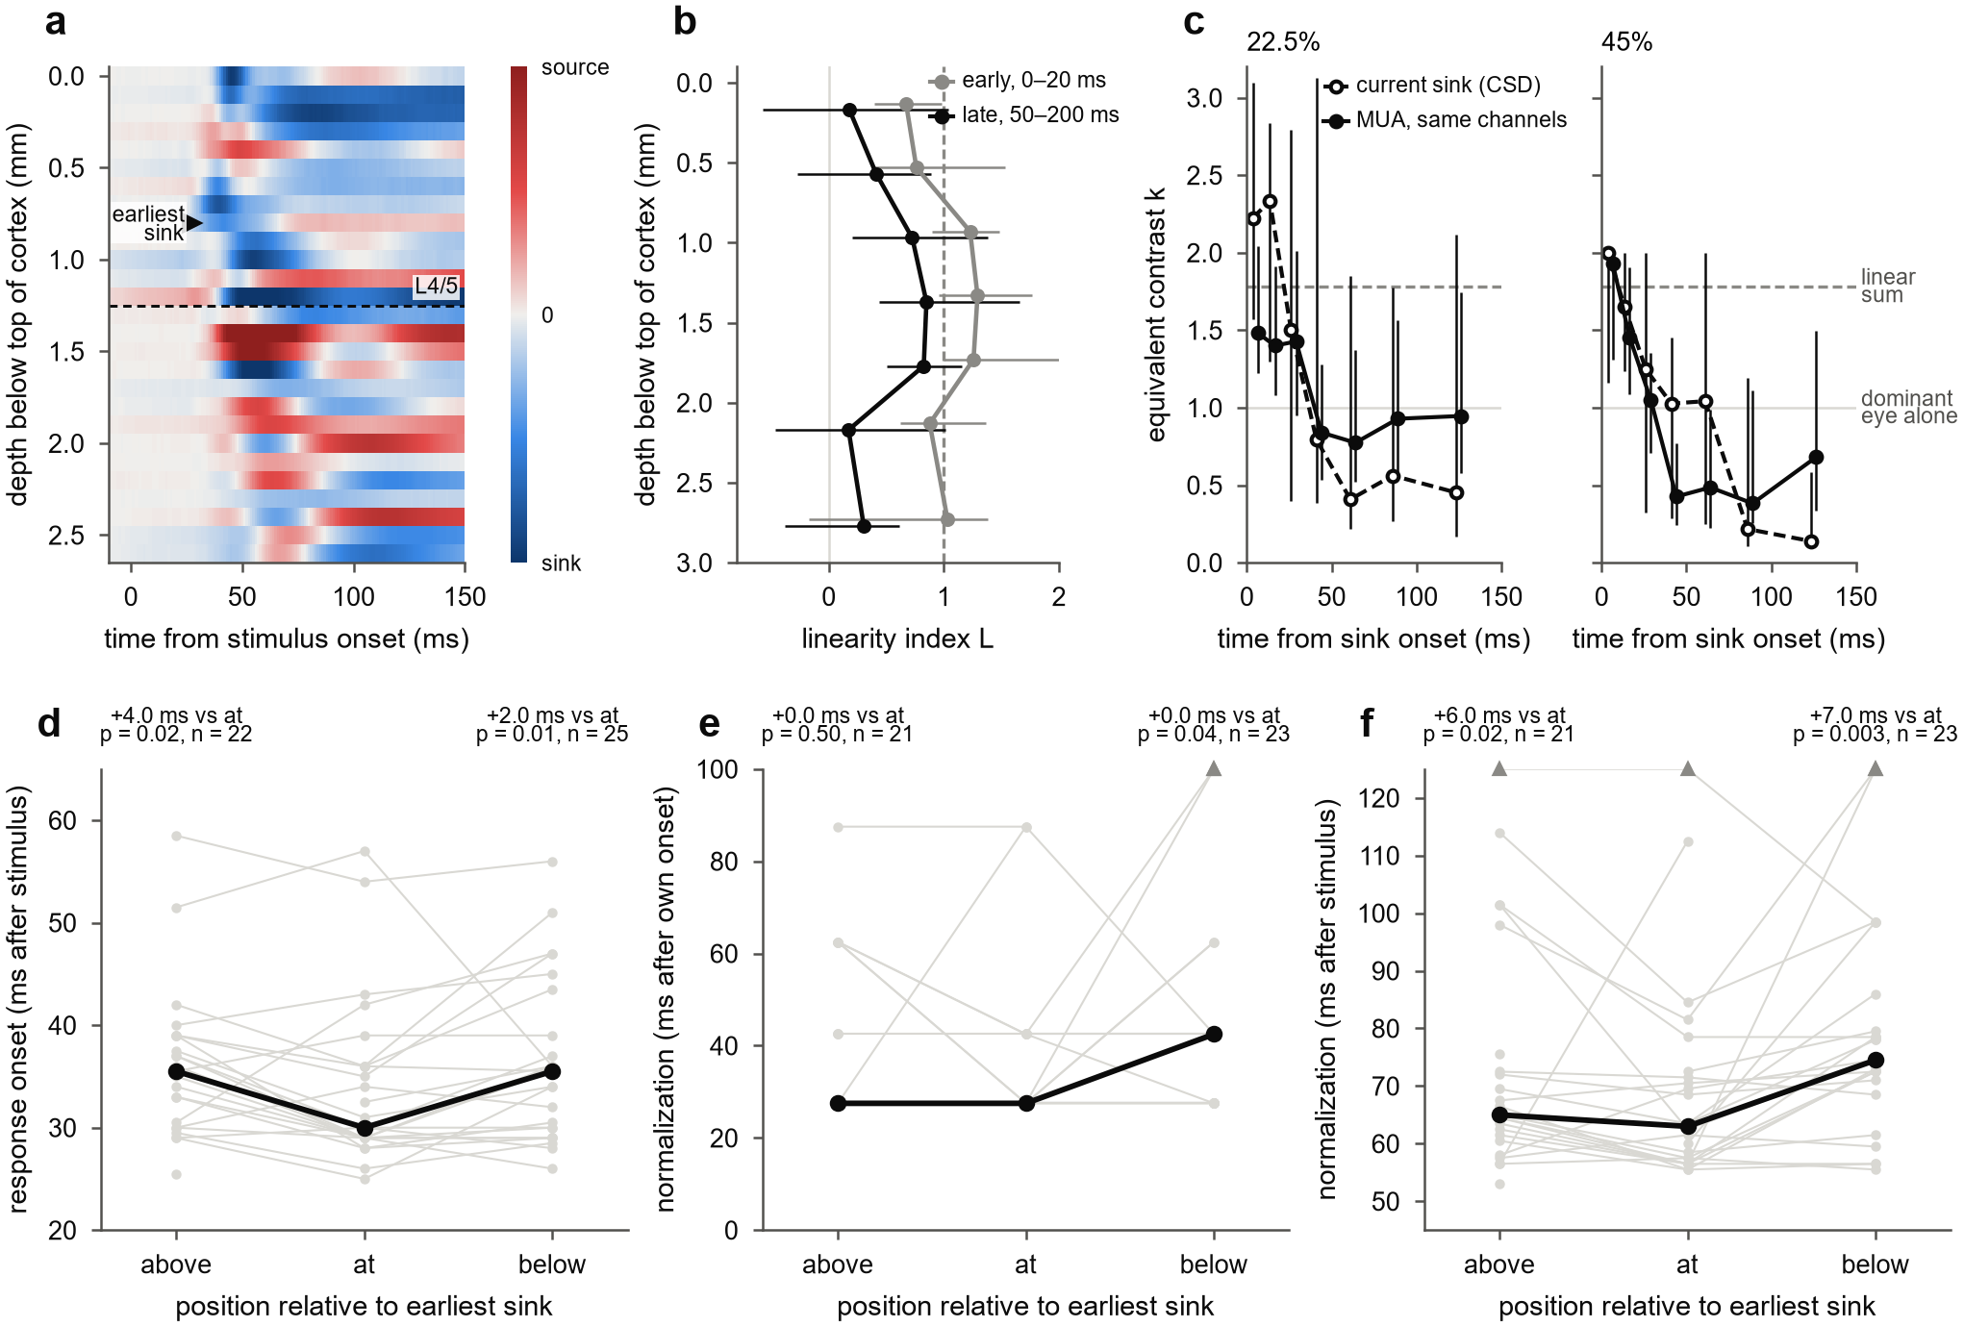
Figure 4. The same sequence runs at every depth and starts in the earliest synaptic input. (a) Grating-evoked CSD in the example penetration (presentations with either eye at ≥ 45%), with the earliest current sink (arrow) and the L4/5 boundary. (b) L by depth below the top of cortex, early (0–20 ms after each channel's onset) and late (50–200 ms), 11 and 22.5% pooled; median over penetrations, 95% bootstrap CI, bins with at least five penetrations. (c) Equivalent contrast k of the earliest sink (CSD, open symbols) and of MUA at the same channels (filled), in windows timed from sink onset, at 22.5 and 45%; dashed, linear summation with the sink's median eye weight; grey, binocular equal to the dominant eye alone. (d–f) Channels above, within two contacts of, and below the earliest sink, per penetration (grey) and median (black): (d) response onset after the stimulus; (e) time from each group's onset to the first 15 ms window with L < 0.5; (f) the same time on the stimulus clock. Values beyond the axis are drawn at its edge (triangles). Wilcoxon signed-rank tests against the sink group, uncorrected.

A delayed normalization pool explains the direction, but not the full strength, of the collapse
We asked what normalization circuit could produce linear summation at onset followed by a contrast-dependent collapse. We extended the delayed normalization model of Zhou et al. (2019) to two eyes (Fig 5a). The excitatory drive sums the eyes linearly, with weight a on the other eye. The normalization pool has its own weight w on the other eye and reaches the divisor through a low-pass filter with time constant τ2. The response is R = g·E^n / (σ^n + P^n).
We fitted the model to each penetration's full 6 × 6 time courses (0–219 ms after stimulus onset) and scored it on held-out presentations. Delayed normalization predicted held-out data better than static normalization (the same model with no filter) in 23 of 25 penetrations (p < 0.001), with 3.3 times lower median held-out error (Fig 5b). It explained a median 90% of the variance. The fitted pool delay τ2 was 30 ms (interquartile range 24–38 ms), close to the observed transition.
The pool weighted the other eye more than excitation did: w > a in 24 of 25 penetrations, with median w = 1.08 and a = 0.88 (Fig 5c). This is the condition under which binocular responses can fall below the dominant eye alone at high contrast, as they did at 45%. In this reading, ocular dominance shapes the excitatory drive while the pool stays close to eye-balanced, consistent with Mitchell et al. (2023).
The fitted model reproduced the direction and contrast ordering of the collapse but not its speed or depth. At low contrast its pool stayed below σ, so it predicted little normalization where the data showed it. A pool time constant that shortens with contrast did not help: it gave no meaningful gain in held-out error (median ratio 1.00), and its contrast factor fitted near zero.
The misfit at low contrast suggested an earlier stage of interocular gain control, as in the two-stage psychophysical model (Meese, Georgeson & Baker 2006). We tested a dynamic two-stage model in three registered tests. The first compared models fitted to channel averages and narrowly failed (17 of 25 penetrations against a criterion of 70%). We then found that it was flawed: the two-stage model lacked the free pool weight that the single-stage model had, and one criterion used L, which the models were not fitted to.
The corrected, nested test fitted each channel separately; the two-stage model reduces to the single-stage one when its first stage saturates. It passed: the two-stage model predicted held-out responses better in 23 of 24 penetrations, in both monkeys, from 538 channels (Fig 5d). The gain was small, a median 1.5% less held-out error. A third test, with a loss function that weighs the binocular interaction, gave the same answer (24 of 24 penetrations, p < 0.001). The fitted first stage had an interocular suppression weight of about 0.9 and a delay of about 30 ms.
No model captured the full strength of the late collapse. The registered capture test required each model's late L to match the data within ±0.25, with 90% confidence, at 11, 22.5 and 45% (Fig 5e). The single-stage model had no median bias but too little precision. The two-stage model stayed too linear late, by about 0.35 at 11 and 22.5%. A dynamic version of the Ding & Sperling (2006) gain-control model did no better than single-stage, and its parameters sat at their bounds.
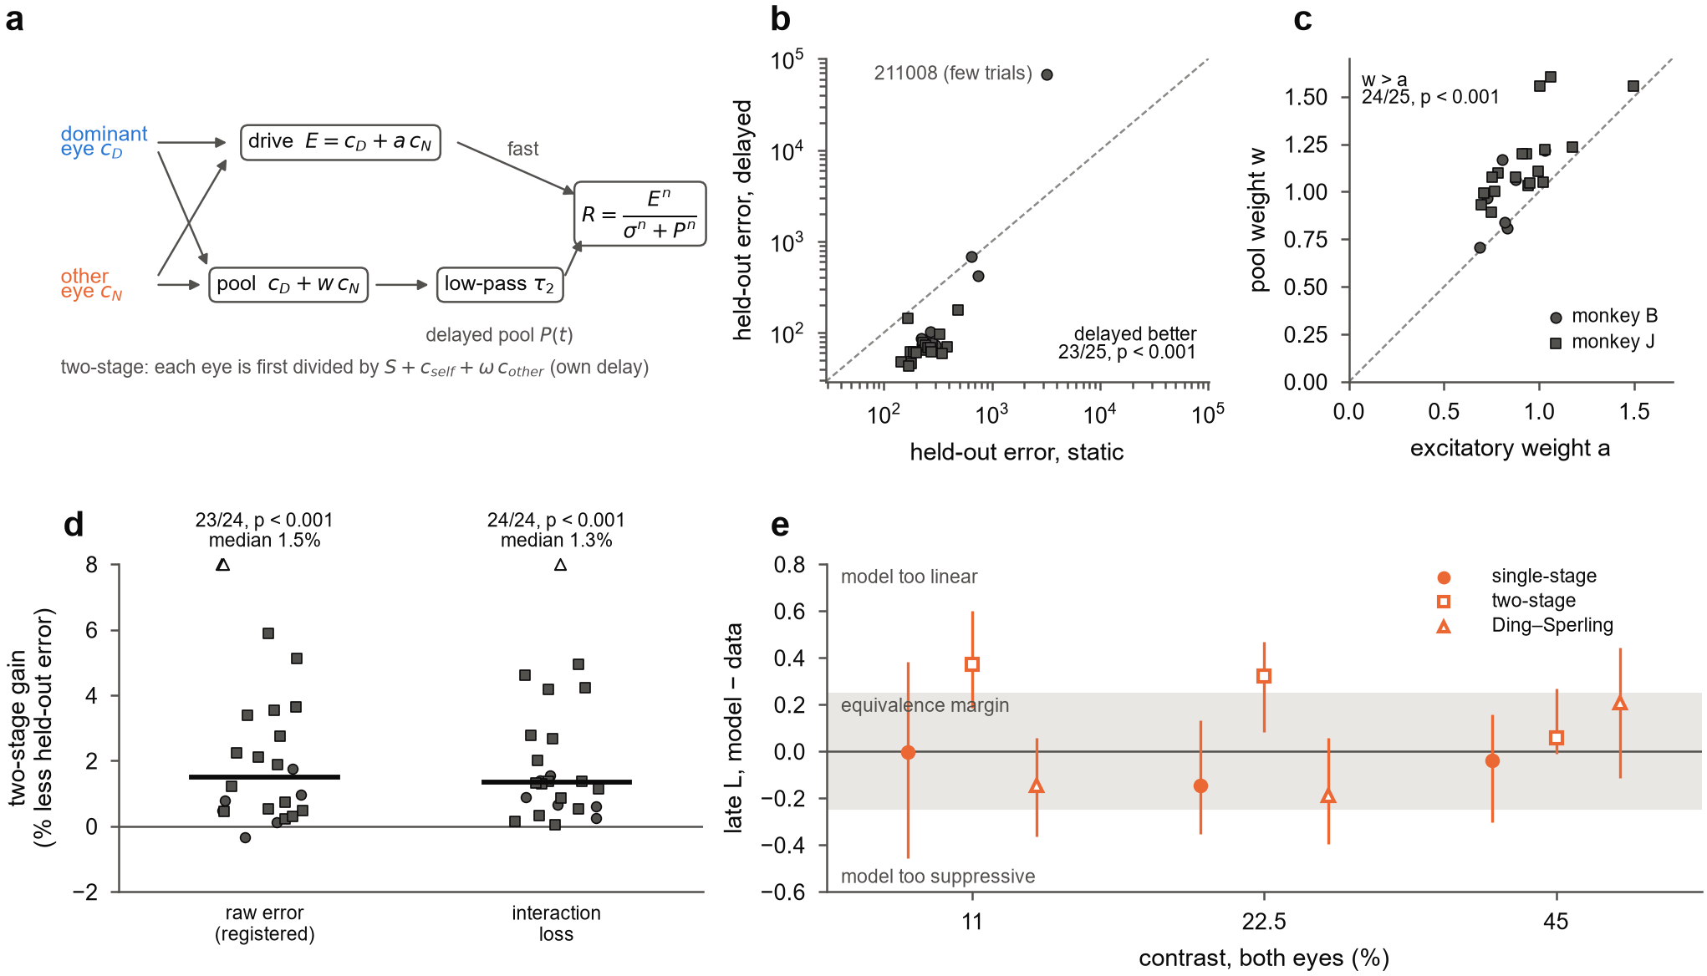
Figure 5. A delayed binocular normalization pool explains the direction, but not the full strength, of the collapse. (a) Single-stage delayed normalization: the drive E sums the two eyes with weight a on the other eye; the pool sums them with its own weight w and divides the response after a low-pass delay τ2. The two-stage variant first divides each eye by S plus both eyes' contrasts, with its own delay. (b) Held-out (odd/even) error of static against delayed normalization, per penetration; the outlier is the penetration with the fewest presentations. (c) Fitted pool weight w against excitatory weight a, per penetration; dashed, identity. (d) Two-stage against single-stage: per penetration, the median percentage reduction in held-out error over channels, for the registered raw-error test and the interaction-loss test; bars, medians; triangles, values above the axis; one-sided Wilcoxon tests over penetrations. (e) Registered capture test: late L (50–150 ms after onset) of each model's fit minus the data, median over penetrations with 90% bootstrap CI; grey band, the ±0.25 equivalence margin.

The fitted model rises too fast at low contrast and has no offset response
The delayed normalization model was fitted to the first 219 ms of the response, so its rise and its behaviour after the stimulus ends are predictions it was not fitted to. Responses rose more slowly at low contrast (Fig 6a). For the dominant eye alone, the 10–90% rise time, measured per channel, fell from 46.5 ms at 11% to 20 ms at 90% (penetration medians; Fig 6b).
The fitted model rose 2.3 times too fast at 11% (20 ms) and was too fast at every contrast (11 ms at 90%). In the model, normalization divides a response whose rise is set by a fixed input filter, so the rise shortens only modestly with contrast. In the data, low-contrast responses integrate more slowly.
After the stimulus ended, the data showed an offset response that the model cannot produce (Fig 6c). We aligned responses to the response offset, the stimulus duration plus each penetration's onset latency, and scaled them to the sustained level. The response rose to about 1.8 times its sustained level within about 10 ms, at every contrast, in 88–100% of penetrations, in both monkeys. The model, which has no drive at stimulus offset, simply decayed.
Two cautions follow. First, decay times measured after stimulus offset are dominated by this transient, so they cannot be used to compare normalization mechanisms. Second, a slower rise at low contrast is what models predict when normalization shortens the integration time constant, as in conductance-based (Carandini, Heeger & Movshon 1997) and recurrent (Heeger & Zemlianova 2020) circuits. Whether such a model fits these data, including the binocular collapse, is a separate test that we have specified but not yet run.
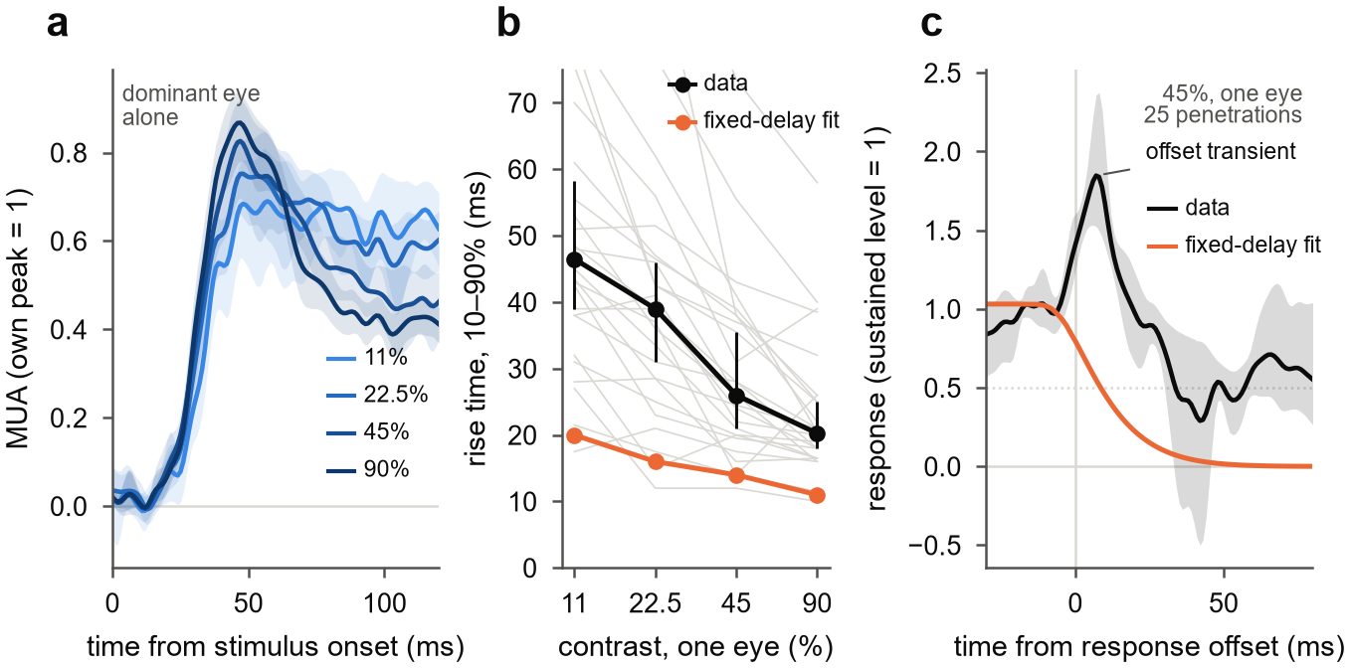
Figure 6. The fitted model rises too fast at low contrast and has no offset response. (a) Dominant eye alone at four contrasts, aligned to stimulus onset; each penetration scaled to its own peak; mean and 95% bootstrap CI over penetrations. (b) 10–90% rise time against contrast: data (grey, penetrations; black, median with 95% bootstrap CI) and the fitted delayed normalization model of Fig 5 (orange, median over penetrations), which was fitted to 0–219 ms only. (c) Response at 45% after the response offset (stimulus duration plus onset latency), scaled to the sustained level before it: data (mean, 95% bootstrap CI over 25 penetrations) and the fitted model (median).

Discussion
In awake macaque V1, the rule by which the two eyes combine changes within the first tens of milliseconds of the response. The eyes first sum almost linearly. Interocular normalization then takes over, 20–35 ms after response onset, and at high contrast it pushes binocular responses below those of the dominant eye alone.

Timing may reconcile static accounts
If the combination rule changes over time, studies that averaged over different windows should disagree. Methods that integrate over hundreds of milliseconds or seconds, such as fMRI and steady-state EEG, mostly see the late, normalized state, and they report near ocularity invariance (Moradi & Heeger 2009; Baker & Wade 2017). Spike counts split into transient and sustained windows see a binocular boost that vanishes later (Cox et al. 2019).
The same logic may apply to the disagreement about which neurons are suppressed (Dougherty et al. 2019; Zhang et al. 2024). In our data, isolated units were mostly net-suppressed by the second eye while MUA was mostly facilitated (Supplementary). Window choice, the signal recorded and ocular dominance therefore all shape the answer. We did not test these older paradigms directly, so this reconciliation is a hypothesis.

Interocular normalization is slower than monocular normalization
In anesthetized V1, monocular contrast normalization is fully in place within the first 10 ms of the response (Albrecht et al. 2002). Interocular normalization in our data needed 20–35 ms more. That difference suggests that the two eyes are normalized by a slower route than a single eye's contrast, plausibly a cortical one. In cat V1, interocular suppression is reduced by blocking GABA-A receptors (Sengpiel & Vorobyov 2005).
The CSD points the same way. The earliest current sink summed the two eyes almost linearly at onset, so normalization was not already present in the input it carries. Normalization then appeared in currents and spikes together, first in the input layer and a few milliseconds later above and below it. Each depth normalized a similar time after its own onset, as if a local circuit follows the feedforward wave with a fixed lag. That order differs from near-surround suppression, which reaches layer 4C last (Bijanzadeh et al. 2018).

What a model must contain
Two features of the data constrain models firmly. Normalization must be delayed relative to excitation; static normalization fitted held-out data far worse. And the normalization pool must weight the other eye more than excitation does (w > a), or binocular responses could never fall below the dominant eye alone. A pool close to eye-balanced, with ocular dominance acting on the drive, fits earlier results from this dataset (Mitchell et al. 2023).
Three features remain unexplained: the full depth of the late collapse, the slow rise at low contrast, and the offset response. A fixed delay in a feedforward pool cannot change how fast a response integrates. Conductance-based and recurrent normalization can (Carandini, Heeger & Movshon 1997; Heeger & Zemlianova 2020). A binocular version would also need eye-specific units, because a circuit driven only by the summed eye signal combines the eyes the same way at every moment. Testing such a model is the next step; we have not yet done it.

Limitations
- Stimulus. The gratings were static and identical in the two eyes. The design does not probe disparity, orientation conflict, temporal frequency or masking.
- Signals. The results rest mainly on MUA and CSD at 100 µm spacing. Isolated units were few (about 60 driven units in 20 penetrations), and layer labels are uncertain by roughly ±0.5–1 mm.
- Animals. Two monkeys contributed unequal numbers of penetrations (8 and 18), and their response latencies differed by about 8 ms.
- Confirmation. The registered held-out test of the contrast effect failed as run and passed only after artifact cleaning that came later. The laminar timing statistics are modest and uncorrected.
- Measure. L is a ratio and has heavy tails. Where the binocular response exceeds the dominant eye's response at 90%, k is censored and L is a lower bound; this happened in 45% of channels in the first window at 45%.

Methods

Animals
Two adult macaques [species, sex, ages, weights] were implanted with a head post and a recording chamber over V1 [procedures, anaesthesia, IACUC protocol]. Monkey B was recorded in right V1 (October–December 2021) and monkey J in left V1 (October–December 2022).

Task and stimuli
The task ran in NIMH MonkeyLogic 2. The monkeys fixated [fixation window, duration] while viewing two halves of one display through a mirror stereoscope, one half per eye [display model, viewing distance, mean luminance; 120 Hz refresh]. Each trial showed three gratings, each for about 317 ms with about 317 ms between them, followed by a juice reward. In one penetration (211008) gratings lasted about 217 ms.
Gratings were static sinusoids matched to the multi-unit receptive field in orientation, spatial frequency, size and position [mapping procedure], and identical in the two eyes apart from contrast. Each eye's Michelson contrast was 0, 0.055, 0.11, 0.225, 0.45 or 0.9, chosen independently, giving 36 conditions in random order with about 30 presentations each.

Recording
We recorded with 32-contact linear arrays (Plexon, 100 µm spacing) and a Blackrock Cerebus system. Wideband signals were sampled at 30 kHz and LFP at 1 kHz. On seven days in monkey J, two arrays were recorded at once in separate columns. Stimulus onsets were taken from a photodiode on the display, and the 3.4 ms offset between the 30 kHz and 1 kHz file clocks was corrected.
MUA was the envelope of the wideband signal: band-pass 500–5000 Hz (4th-order Butterworth, zero phase), full-wave rectification, low-pass 200 Hz, resampled to 1 kHz. CSD was −σ∂²V/∂z² of the LFP (σ = 0.4 S/m, 0.1 mm spacing). Before differentiation, contacts with evoked amplitude outside 0.6–1.6 times the median of their neighbours were interpolated, and a three-point Hamming filter was applied across depth.
Single units came from curated Kilosort sorts made in 2023, with a spike-time offset corrected, and from Kilosort 4 (Pachitariu et al. 2024) for five penetrations without a sort. Units were included if refractory-period contamination (Hill et al. 2011) was below 0.5 and signal-to-noise ratio was at least 3. A strict set also required contamination below 0.1, amplitude cutoff below 0.1 and presence ratio of at least 0.9.

Eye position and presentation selection
Eye position was recorded as analog gaze signals, calibrated against MonkeyLogic. Saccades were detected with a velocity threshold (Engbert & Kliegl 2003; λ = 6, minimum 6 ms). We analysed completed presentations with no saccade of 1° or more between 200 ms before and 500 ms after onset.
We also excluded presentations with large MUA artifacts: a peak MUA between −50 and 450 ms more than 20 robust standard deviations (median absolute deviation × 1.4826) above the median for that channel, on any channel in cortex. Visual responses reach 6–11 such units in penetrations without artifacts. The rule removed 0.6% of presentations, mostly in monkey J. It was set before we looked at its effect on any result, but after the registered tests had been run; all registered results are reported both as run and on the cleaned data (docs/09).

Laminar alignment
The top of cortex was the most superficial contact with spontaneous MUA. A layer 4/5 boundary was placed just below the dominant early sink (35–65 ms) of a flash-evoked CSD, recorded separately on the same day and registered to the grating recording by matching depth profiles of MUA and LFP power. It was accepted if it lay 0.5–1.7 mm below the top of cortex or agreed with a spectral marker; otherwise the spectral marker was used if its depth was plausible. This gave a boundary in 22 penetrations (16 from the flash CSD, 6 from the spectral marker); 26 penetrations had a usable top of cortex. Depth below the top of cortex is the primary depth axis.

Responses
A channel was analysed if it lay in cortex and its response varied with the contrast of at least one eye shown alone (one-way ANOVA over the six contrasts, p < 0.01, 40–140 or 150–250 ms after onset, peak above baseline). The contrast-timing analysis (Fig 3) used the same test on the dominant eye, 40–250 ms. Condition means were blank-subtracted and smoothed with a Gaussian (σ = 3 ms for equivalent contrast, 2 ms for figures and models).
The dominant eye was the eye with the larger mean response at 90%, 40–250 ms. Response onset was the first time after 10 ms at which the dominant-eye response at 90% reached half its peak. For display and model fitting, each channel was scaled by its dominant-eye peak at 90%.

Equivalent contrast and the linearity index
In each window, the binocular response at contrast c in both eyes was located on the dominant eye's monocular contrast response in the same window. We made that curve non-decreasing (running maximum) and interpolated it linearly between 0 and 5.5% and in log contrast above. The matching contrast divided by c is k. Where the binocular response exceeded the dominant-eye response at 90%, k was set to 0.9/c, a lower bound.
The eye weight a was the contrast scale, between 0.05 and 1, that best mapped the dominant eye's monocular contrast response onto the other eye's (least squares over the five non-zero contrasts). The linearity index is L = (k − 1)/a. Windows relative to onset were 0–10, 10–20, 20–35, 35–50, 50–75, 75–100, 100–150 and 150–200 ms. The contrast-timing analysis used sliding 15 ms windows starting every 5 ms. Robustness and timing analyses refitted a in each window.

Statistics
The penetration is the unit of replication, because neighbouring channels share signal. Statistics were computed on penetration medians over channels. We used two-sided Wilcoxon signed-rank tests for paired comparisons, one-sided sign tests for registered direction tests, Friedman tests across contrasts, and bootstrap confidence intervals with 2000 resamples of penetrations. Depth profiles were also tested with linear mixed models with a random intercept per penetration.

Models
In the single-stage delayed normalization model, after Zhou et al. (2019), E(t) = (c_D + a·c_N)·u(t) and P(t) = (c_D + w·c_N)·v(t), with R = g·E^n / (σ^n + P^n). Here u(t) is the step response of a gamma filter (shape 3, time constant τ1) delayed by δ, and v(t) is u(t) passed through an exponential low-pass filter with time constant τ2. Static normalization sets v = u.
In the two-stage model, each eye is first divided by S plus a delayed sum of its own and the other eye's contrast (weight ω, time constant τ_s). The two outputs are then summed and normalized as above, with their own pool weight w. As S grows, the model reduces to the single-stage model. The dynamic Ding–Sperling model replaces the first stage with mutual gain control driven by low-passed contrast energy (Ding & Sperling 2006).
Models were fitted by least squares, with several starting points, to the full 6 × 6 time courses 0–219 ms after stimulus onset. Fits were made either to each penetration's channel average or to each channel. Held-out error was the summed squared error on even presentations for fits to odd ones, and vice versa. The interaction loss weighted equally the monocular time courses and the binocular interaction, each binocular response minus the dominant eye alone at the same contrast.
The comparisons and pass criteria of the three model tests, and of the held-out test in Fig 3, were written into the project's design document before the corresponding fits or analyses were run. The record of each registration, including the flaws of the first two-stage test, is in docs/09 and docs/10 of the repository.

Response dynamics
For the dominant eye alone, rise time was the interval between 10% and 90% of the peak response within 150 ms of stimulus onset. Responses after the stimulus were aligned to the response offset, defined as the stimulus duration plus the half-maximum onset latency. They were scaled to the mean response over the 30 ms before that point.

Code and data
All analyses are in the v1-laminar-binocular repository [link or availability statement]. Each figure is produced by one script from saved analysis outputs.

References
Details marked [verify] still need checking against the source.
- Albrecht DG, Geisler WS, Frazor RA, Crane AM (2002). Visual cortex neurons of monkeys and cats: temporal dynamics of the contrast response function. J Neurophysiol 88:888–913. PubMed
- Baker DH, Wade AR (2017). Evidence for an optimal algorithm underlying signal combination in human visual cortex. Cereb Cortex 27:254–264. PMC
- Bijanzadeh M, Nurminen L, Merlin S, Clark AM, Angelucci A (2018). Distinct laminar processing of local and global context in primate primary visual cortex. Neuron 100:259–274. link
- Carandini M, Heeger DJ (2012). Normalization as a canonical neural computation. Nat Rev Neurosci 13:51–62.
- Carandini M, Heeger DJ, Movshon JA (1997). Linearity and normalization in simple cells of the macaque primary visual cortex. J Neurosci 17:8621–8644.
- Cox MA, Dougherty K, Westerberg JA, Schall MS, Maier A (2019). Temporal dynamics of binocular integration in primary visual cortex. J Vis 19(12):13. PMC
- Ding J, Sperling G (2006). A gain-control theory of binocular combination. Proc Natl Acad Sci USA 103:1141–1146. PMC
- Dougherty K, Cox MA, Westerberg JA, Maier A (2019). Binocular modulation of monocular V1 neurons. Curr Biol 29:381–391. doi
- Engbert R, Kliegl R (2003). Microsaccades uncover the orientation of covert attention. Vision Res 43:1035–1045.
- Heeger DJ, Zemlianova KO (2020). A recurrent circuit implements normalization, simulating the dynamics of V1 activity. Proc Natl Acad Sci USA 117:22494–22505. PMC
- Hill DN, Mehta SB, Kleinfeld D (2011). Quality metrics to accompany spike sorting of extracellular signals. J Neurosci 31:8699–8705.
- Meese TS, Georgeson MA, Baker DH (2006). Binocular contrast vision at and above threshold. J Vis 6(11):7. doi
- Mitchell BA, et al. (2023). [title, authors: verify]. Curr Biol. doi
- Moradi F, Heeger DJ (2009). Inter-ocular contrast normalization in human visual cortex. J Vis 9(3):13. PMC
- Pachitariu M, Sridhar S, Pennington J, Stringer C (2024). Spike sorting with Kilosort4. Nat Methods 21:914–921.
- Sengpiel F, Vorobyov V (2005). Intracortical origins of interocular suppression in the visual cortex. J Neurosci 25:6394–6400. doi
- Truchard AM, Ohzawa I, Freeman RD (2000). Contrast gain control in the visual cortex: monocular versus binocular mechanisms. J Neurosci 20:3017–3032. PMC
- Zhang et al. (2024). [title, authors: verify]. eLife. doi
- Zhou J, Benson NC, Kay K, Winawer J (2019). Predicting neuronal dynamics with a delayed gain control model. PLoS Comput Biol 15:e1007484. PMC

Open items for revision
- Decide whether the cleaned held-out result (7/8, p = 0.035) can count, or whether the contrast effect stays a candidate until new data confirm it.
- Fill in the bracketed Methods facts: species, sex, surgery and protocol, display, fixation window, receptive-field mapping, grating size and spatial frequency.
- Run the remaining controls for Supplementary Fig S1: vergence, receptive-field position, crosstalk between the eyes' images, trial selection.
- Build the supplementary figures: single units against MUA, results per monkey, results under each laminar marker, no supersaturation at any depth.
- Pre-register and run the recurrent normalization model test (Figs 5–6), with eye-specific units and an offset drive.
- Pre-register a finer laminar timing analysis before relying on Fig 4d–f.
- Use one driven-channel rule throughout (Fig 3 currently uses a dominant-eye test, the rest a test on either eye).
- Make the figures easier to read on their own: simplify Fig 2b, and consider merging Fig 4d–f into one panel.
- State the contribution relative to Mitchell et al. 2022 and 2023 (same dataset) and Cox et al. 2019; check overlap with the 2024 dissertation.
- Verify the references marked [verify] and choose a title.

