The two eyes add first and normalize later in macaque V1
[Authors and affiliations]
Draft V2 · 30 October 2026

About this draft
Draft V2 (30 October 2026), revised after Blake's comments on V1. Every number comes from a script in the v1-laminar-binocular repository; the analysis record is docs/09_paper_design.md, and the figures are built by scripts/figures/.
- Solid: linear summation at onset followed by interocular normalization (Fig 2); a stronger collapse at higher contrast in every penetration (Fig 3, discovery data); a delayed pool that weights the other eye more than excitation does (Fig 5).
- Candidate: the laminar timing statistics are modest and uncorrected (Fig 4d).
- Open: what produces the full strength of the late collapse and the slow rise at low contrast (Figs 5–6).
Items in [square brackets] are facts to fill in or decisions to make. The last section lists what needs work.

Abstract
Binocular vision begins in primary visual cortex (V1), where signals from the two eyes first converge on single neurons. Psychophysics, human neuroimaging and single-neuron recordings have described this convergence with gain-control models, in which each eye's signal is divided by a pool that includes the other eye, in one or two stages. These accounts describe the combination once it has settled; how it unfolds over the first tens of milliseconds of the cortical response is not known. Measuring it is complicated by a fact that is easily overlooked: two eyes act as a stronger stimulus than one, so binocular responses begin several milliseconds before monocular ones, and comparing the two at the same moment produces an apparent binocular boost at response onset even if the rule of combination never changes.
We recorded laminar multi-unit activity and current-source density in V1 of two awake macaques viewing gratings whose contrast was set independently in each eye. To separate the combination rule from response latency, we expressed each binocular response as an equivalent contrast: the contrast at which the dominant eye alone produced the same response in the same time window. For the first ~20 ms after response onset, the two eyes' contrasts summed almost linearly. Interocular normalization then took hold over the next 20–35 ms, more strongly at higher contrast, until at 45% contrast the binocular response matched, and in about half of the penetrations fell below, the response of the dominant eye alone. The same sequence occurred at every cortical depth and in the earliest current sink, where normalization appeared first.

A delayed normalization model fitted the full time courses. In it, the normalization pool weighted the non-dominant eye more than excitation did. It predicted held-out responses better than static normalization, and early interocular gain control added a small, consistent improvement. No fitted model captured the full strength of the late collapse, or the slow rise of low-contrast responses.
Binocular combination in V1 is thus not a fixed rule but a sequence, from summation to normalization, that unfolds within the first tens of milliseconds of the response. Accounting for the earlier onset of binocular responses is essential to measuring it, and static accounts that disagree may have sampled different moments of this sequence.

Introduction
The two eyes see the world from slightly different positions, and V1 is the first place where their signals meet. How V1 combines them sets what the rest of the visual system receives. Divisive normalization is the standard description: each neuron's drive is divided by the pooled activity of its neighbours (Carandini & Heeger 2012).
Which normalization rule applies to the two eyes is still disputed. In anesthetized cat simple cells, each eye's input is gain-controlled before the two are summed (Truchard, Ohzawa & Freeman 2000). Human fMRI and steady-state EEG instead point to a binocular pool, in which responses barely change between one eye and two (Moradi & Heeger 2009; Baker & Wade 2017). Psychophysics needs either two stages of gain control (Meese, Georgeson & Baker 2006) or each eye controlling the other's gain (Ding & Sperling 2006).
Neurophysiological recordings in awake macaque V1 have yielded a similarly mixed picture. Stimulating both eyes enhances the early, transient response, but the enhancement is absent from the sustained response (Cox et al. 2019). Monocular neurons are suppressed by stimulation of the other eye (Dougherty et al. 2019), whereas population calcium signals are similar for monocular and binocular viewing (Zhang et al. 2024). In earlier analyses of the present dataset, which pooled responses over 50–200 ms, ocular dominance weighted the excitatory drive but not the normalization pool (Mitchell et al. 2023).
Most of these accounts treat binocular combination as fixed in time. Yet normalization takes time. In human visual cortex it lags the response it divides (Zhou et al. 2019), and recurrent circuit models make it build up over tens of milliseconds (Heeger & Zemlianova 2020). Monocular contrast normalization, by contrast, is in place within the first 10 ms of the response in anesthetized V1 (Albrecht et al. 2002). If interocular normalization is slower, the combination rule depends on when one looks, and studies that averaged over different windows could disagree for that reason alone.
Measuring how binocular combination unfolds in time requires care, because binocular and monocular responses do not begin together. Response latency in V1 shortens as contrast increases (Albrecht et al. 2002), and stimulating both eyes acts as a stronger stimulus than stimulating either eye alone. Binocular responses therefore begin a few milliseconds earlier than monocular ones. Compared at the same moment after stimulus onset, they appear enhanced at response onset even if the rule by which the eyes combine never changes. Separating a change in the combination rule from this shift in latency requires comparing binocular and monocular responses at matched response levels within each time window, on a stimulus clock accurate to the millisecond.
We recorded laminar multi-unit activity (MUA), current-source density (CSD) and single units in V1 of two awake macaques. Each eye saw a grating at one of six contrasts, chosen independently, so every combination of the two eyes' contrasts was tested. We measured the combination rule as an equivalent contrast: how much the dominant eye's contrast must rise to match the binocular response at the same moment.
The eyes summed almost linearly at response onset and were normalized 20–35 ms later (Fig 2). The collapse was deeper at higher contrast (Fig 3). It ran at every depth, and normalization reached the input layer first (Fig 4). A delayed normalization pool, weighting the other eye more than excitation does, explained the direction of these effects but not their full strength (Fig 5). It also missed the slow rise of responses to low contrast (Fig 6).

Results

Binocular combination measured with millisecond and laminar precision
We recorded from 26 V1 penetrations in two macaques (monkey B: 8, monkey J: 18), using linear arrays with 32 contacts spaced 100 µm apart. A mirror stereoscope gave each eye its own monitor (Fig 1a). Each eye saw the same static grating, matched to the receptive field, at 0, 5.5, 11, 22.5, 45 or 90% contrast. All 36 combinations were shown in random order, about 30 times each (Fig 1b).
We measured cortical depth from the top of cortex, identified in each penetration as the most superficial contact with spontaneous MUA. To locate the boundary between layers 4 and 5, we used the lower edge of the earliest current sink evoked by a full-field flash (Fig 1c). Because the flash recordings were made earlier in each session, we first matched their depth to the grating recording using the laminar profiles of MUA and LFP power. Where the flash-evoked sink could not be resolved, or disagreed with other markers, we determined the boundary from the laminar profile of spike–LFP phase coupling (spike-phase index and pairwise phase consistency; Vinck et al. 2010; Davis et al. 2023). A layer 4/5 boundary could be assigned in 22 penetrations. Because laminar assignments carry an uncertainty of roughly ±0.5–1 mm, we used depth below the top of cortex as the primary depth axis.
Stimulus onsets were measured with a photodiode on the display, and all analyses are aligned to these measured onsets.
The basic phenomenon is visible in a single penetration (Fig 1d). At 45% contrast, the response to both eyes rose like the dominant eye at 90%, the level linear summation predicts, and then dropped to the level of the dominant eye alone. The other eye drove responses less than the dominant eye at every contrast (Fig 1e). We summarized each channel's eye balance as an eye weight a: the factor that maps the other eye's contrast onto the dominant eye's contrast response (median 0.70). Most MUA channels were binocular, and isolated units spanned the full range of ocular dominance (Fig 1f).
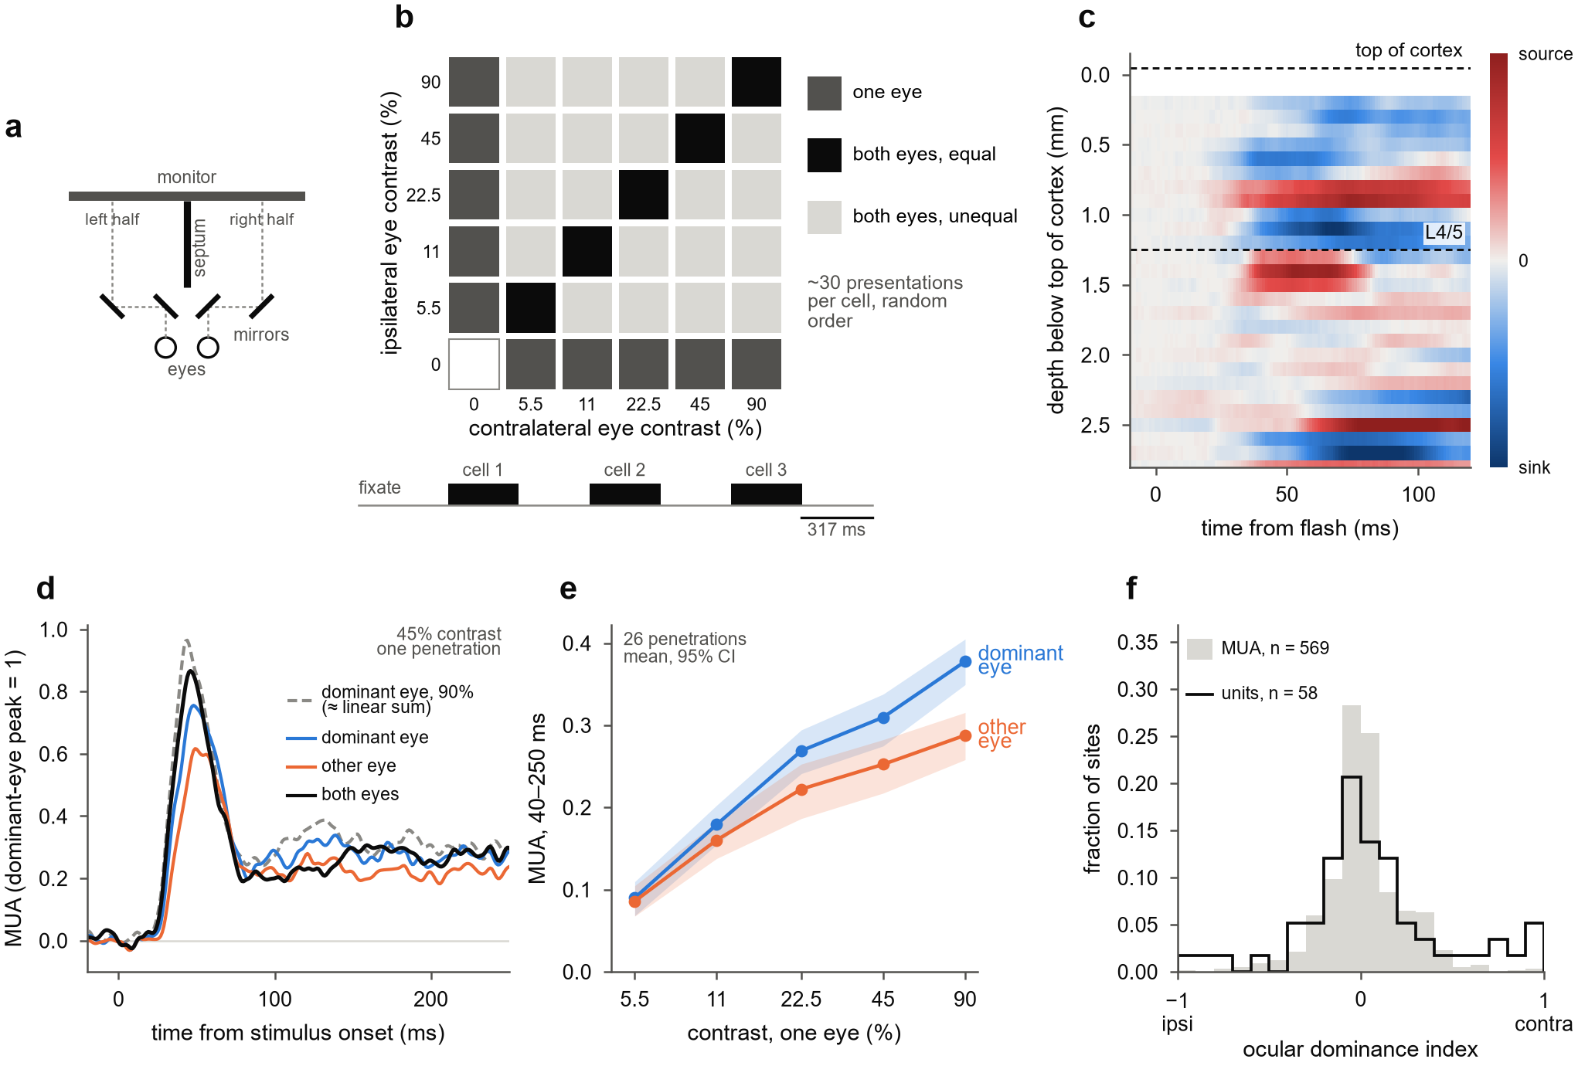
Figure 1. Binocular combination measured with millisecond and laminar precision. (a) Mirror stereoscope (top view). Two mirrors per eye shift each eye's line of sight onto its own half of a single monitor, and a black septum separates the two halves. (b) The 6 × 6 dichoptic design. Each eye's contrast was chosen independently, giving monocular cells (one eye at 0), dioptic cells (equal contrasts) and dichoptic cells (unequal contrasts); three cells were shown per fixation trial, each for 317 ms with 317 ms between them. (c) Flash-evoked CSD in an example penetration (221212_J_eA), depth-matched to the grating recording; dashed lines mark the top of cortex and the layer 4/5 boundary. (d) Example penetration, mean of 28 driven channels, each scaled to its dominant-eye peak at 90%. The dominant eye at 90% (dashed) approximates the linear-summation prediction (1 + a)·45%, where a is the weight of the other eye. (e) Monocular contrast responses of the dominant and the other eye (mean over 40–250 ms); mean and 95% bootstrap confidence interval (CI) over 26 penetrations. (f) Ocular dominance index at 90% contrast, (contra − ipsi)/(|contra| + |ipsi|), for driven MUA channels (n = 569) and isolated single units (n = 58).

The two eyes add at response onset, then normalize within tens of milliseconds
We first asked whether the rule by which the two eyes combine changes during the response. Fig 2a shows the population response to a grating of 45% contrast, aligned to each channel's response onset (the time at which its dominant-eye response to 90% contrast reached half its peak), because onsets differ by several milliseconds across depths. During the first ~20 ms after onset, the response to both eyes rose as steeply as the response of the dominant eye to 90% contrast, which approximates linear summation of the two eyes' contrasts. Within a further 20–30 ms, it had fallen to the level of the dominant eye viewing alone.
Because binocular responses begin earlier than monocular ones, comparing them at fixed times would exaggerate the binocular excess at onset. We therefore expressed each binocular response in units of contrast. In each time window, we asked what contrast the dominant eye alone would need to produce the same response as both eyes viewing contrast c (Fig 2b). During the first 20 ms after onset, both eyes viewing 45% produced the same response as the dominant eye viewing 84%, close to the 77% predicted by linear summation of the two eyes' contrasts weighted by their relative strength. From 50 to 200 ms, they produced the response of the dominant eye viewing only 55%.
To compare channels with different ocular balance, we converted the equivalent contrast into a linearity index (Methods). The index equals 1 when the binocular response matches linear summation of the two eyes' weighted contrasts, and 0 when it matches the dominant eye alone; negative values mean that adding the second eye reduced the response below that of the dominant eye alone.
At every contrast tested, the linearity index was close to 1 shortly after onset and then declined, and it declined further at higher contrast (Fig 2c). Across penetrations, it fell from 1.19 in the first 20 ms to 0.61 at 50–200 ms for 11% contrast, from 1.20 to 0.47 for 22.5%, and from 0.97 to −0.12 for 45% (Wilcoxon signed-rank tests, p ≤ 0.001, 26 penetrations; Fig 2d). At 45%, the late index was below zero in 14 of the 26 penetrations. At 5.5%, responses were weak and the decline (from 1.02 to 0.50) was not significant (p = 0.15). The index cannot be computed at 90%, because the dominant eye has no higher contrast with which to match the binocular response; the raw binocular gain at 90% is shown in Fig 3a.
The decline was not caused by the other eye's response fading faster. With the eye weight refitted in each window, it stayed at 0.64–0.70 and the drops were unchanged. The drop at 45% survived every control we applied: excluding presentations with any saccade, restricting to presentations within the interquartile range of pupil size, each half of the session, each monkey separately, and excluding the penetration with the fewest trials. At 11 and 22.5% it was weaker and depended on the window choice and subset (Supplementary Fig S1).
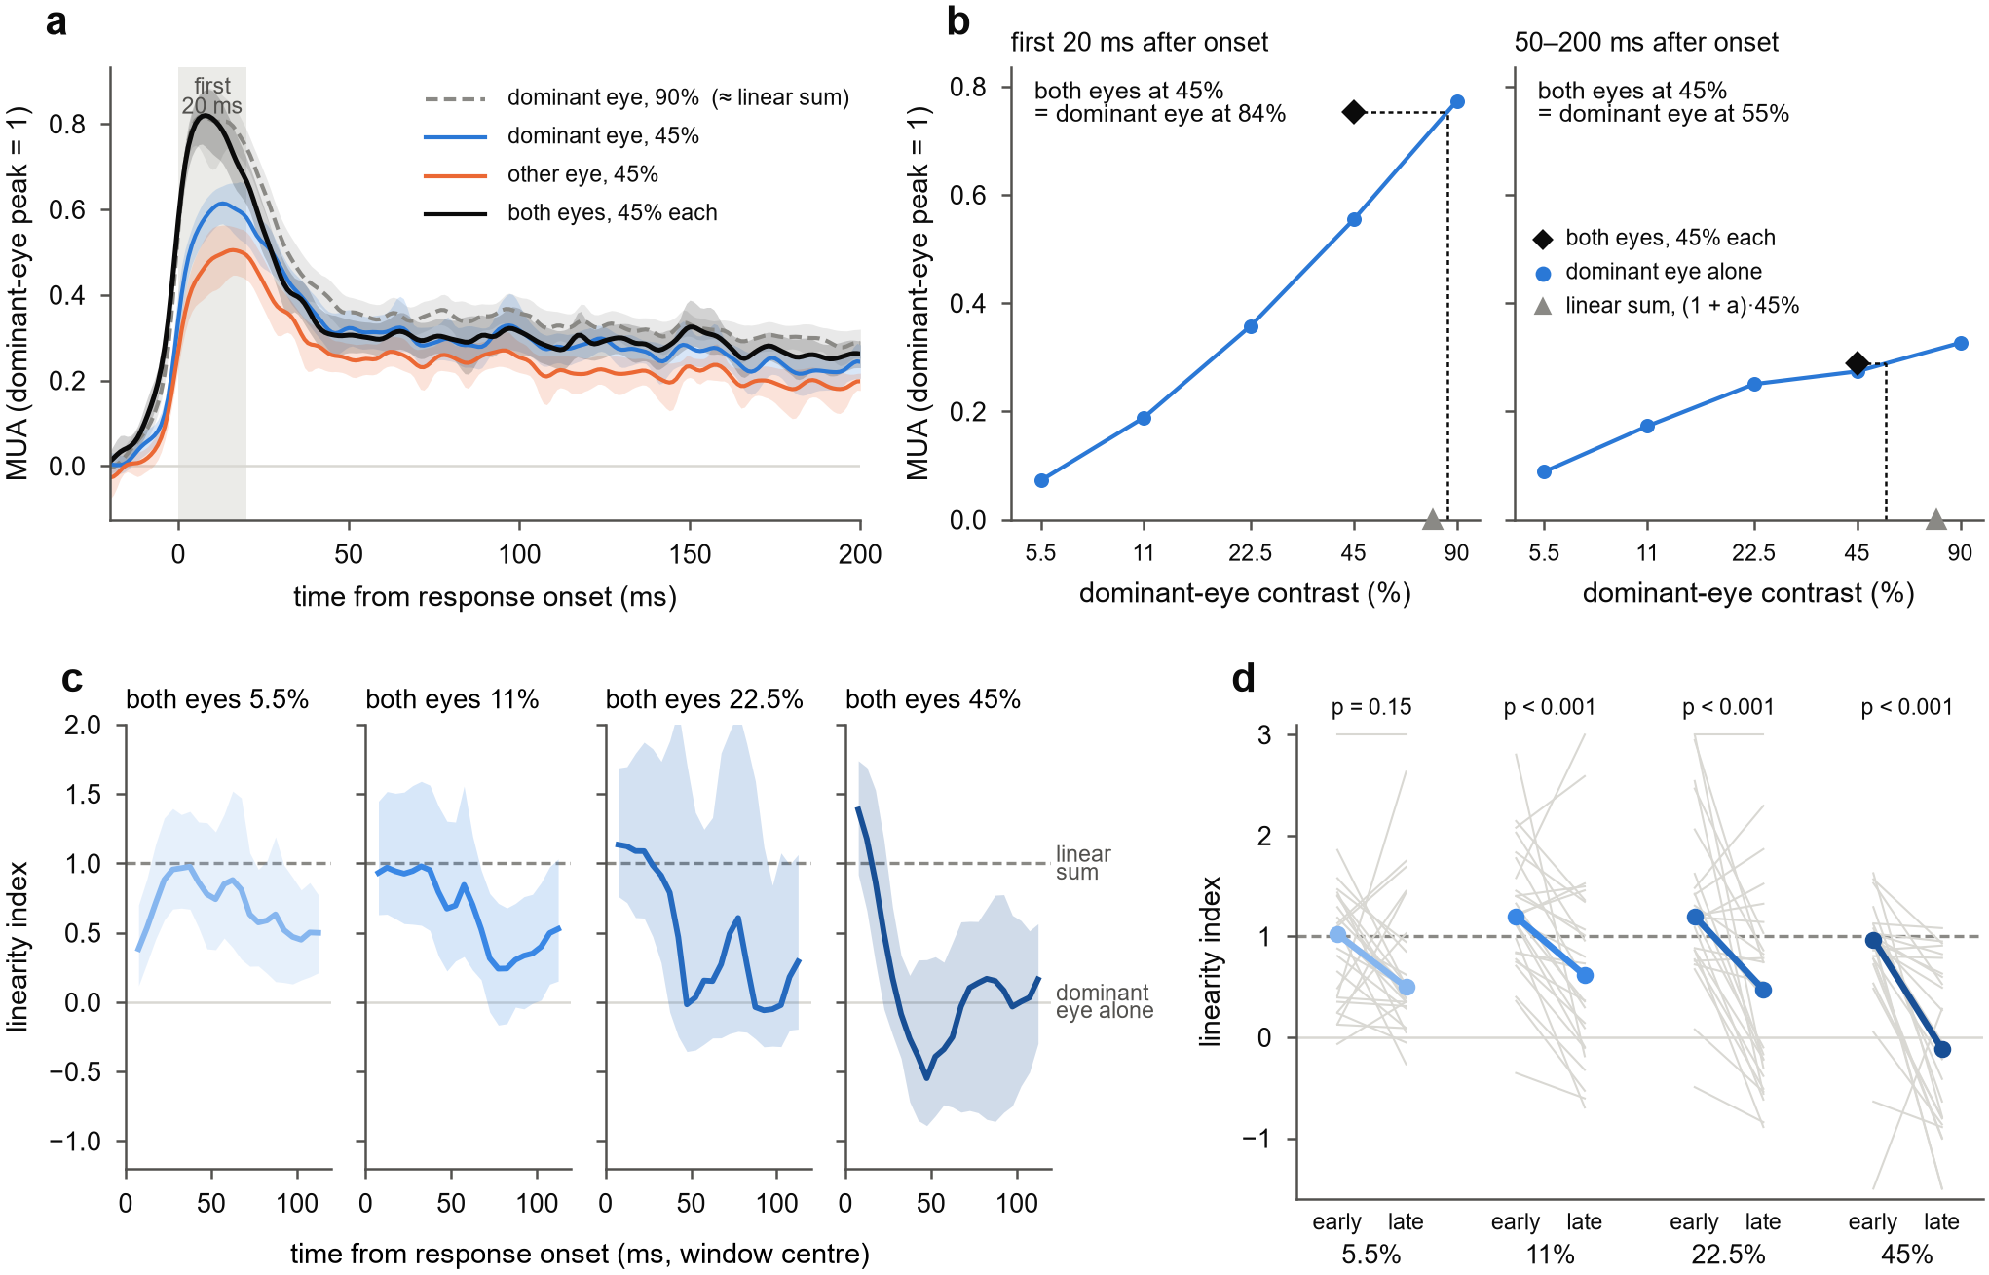
Figure 2. The two eyes add at response onset, then normalize within tens of milliseconds. (a) Population responses at 45% contrast, aligned to each channel's response onset: the dominant eye alone, the other eye alone, both eyes, and the dominant eye at 90% (dashed), which approximates linear summation. Mean and 95% bootstrap CI over 26 penetrations; grey band, the first 20 ms. (b) Reading the equivalent contrast from population means, on a common response axis. The response to both eyes at 45% (diamond) is located on the dominant eye's contrast-response function measured in the same window and read off as the dominant-eye contrast that gives the same response; triangles mark the linear-summation prediction (1 + a)·45%. (c) Linearity index of the population-average response in sliding 15 ms windows (plotted at window centres), one panel per contrast; 1 = linear summation, 0 = binocular response equal to the dominant eye alone. Shading, 95% CI from bootstrap resampling of penetrations. (d) Linearity index early (0–20 ms after onset) and late (50–200 ms) for each penetration (grey lines; values beyond the axis are drawn at its edge) and the median (coloured), with Wilcoxon signed-rank tests over 26 penetrations.

Contrast sets how far binocular summation collapses
The decline of the linearity index was steeper at higher contrast (Fig 2c, d). We next asked whether this contrast dependence is already visible in the raw responses, before they are converted into equivalent contrast. Fig 3a shows the binocular gain, the response to both eyes minus the response to the dominant eye alone at the same contrast, over time. At every contrast, the gain was largest within about 10 ms of response onset and then declined. The higher the contrast, the larger the initial gain and the sooner it disappeared: at 45 and 90% it was gone within about 25 ms of onset, whereas at 11% it remained positive for most of the first 100 ms.
The same contrast dependence held in every penetration. In the window 20–50 ms after onset, the linearity index decreased with contrast in all 26 penetrations (8 of 8 in monkey B and 18 of 18 in monkey J; median slope −0.95 per natural-log unit of contrast; Fig 3b, c). It did so in each half of the data when presentations were split into odd and even trials (25 of 25 and 23 of 24 penetrations), and under every control in Supplementary Fig S1 (88–100% of penetrations).
The effect also held in independent recordings. On five dual-probe days, each probe was additionally recorded while the grating was centred on the other probe's receptive field; these recordings were not used to identify the effect. In 7 of the 8 such recordings with at least five driven channels, the linearity index decreased with contrast (one-sided sign test, p = 0.035; Fig 3c).

Higher contrast made the collapse deeper, but not reliably earlier. We timed each penetration's transition as the moment its linearity index had fallen halfway from its early to its late value. Among the 15 penetrations with a clear decline at all three contrasts, this time did not differ between contrasts (Friedman test, p = 0.19; Fig 3d). At 45%, the linearity index fell below zero: the binocular response dropped beneath the dominant eye's own response. This is stronger suppression than ocularity invariance (equal responses to one eye and to two) predicts, and it constrains the models in Fig 5.
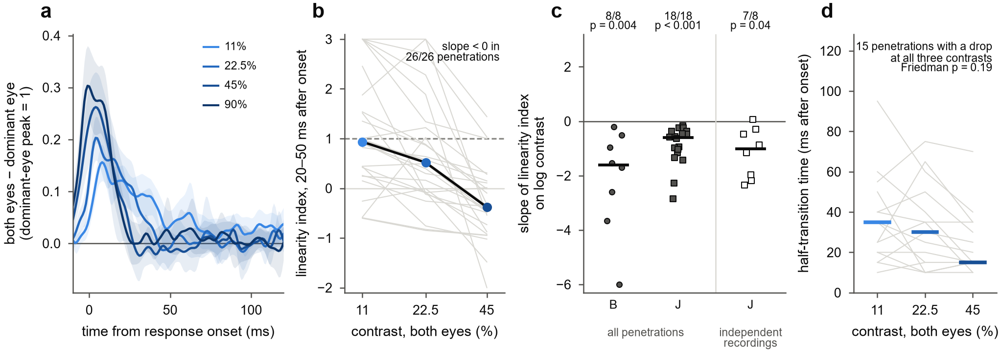
Figure 3. Contrast sets how far binocular summation collapses. (a) Binocular gain: the response to both eyes minus the response to the dominant eye alone at the same contrast, aligned to response onset, in units of the dominant-eye peak; mean and 95% bootstrap CI over 26 penetrations. (b) Linearity index 20–50 ms after onset for each penetration (grey) and the median (black, coloured points); values beyond the axis are drawn at its edge. (c) Slope of the linearity index against log contrast for each penetration of monkeys B and J, and for independent cross-recordings from dual-probe days (monkey J). Bars mark medians; counts give recordings with a negative slope, with one-sided sign tests. (d) Half-transition time, at which the linearity index has fallen halfway from its early to its late value, for the 15 penetrations with a decline of at least 0.2 at all three contrasts; bars mark medians.

The same sequence runs at every depth and starts in the earliest synaptic input
We next asked whether this sequence differs across cortical depth. It did not (Fig 4b). Early in the response, the linearity index was near or above 1 at depths below about 0.8 mm and somewhat lower in the most superficial bins; late in the response, it was lower than early at every depth. A curved depth profile of the late index, most linear at intermediate depths, appeared in monkey J but not in monkey B, and we do not interpret it further.
We then asked whether the synaptic input to the column already carries the normalization. In each penetration we located the earliest current sink evoked by the gratings: among channels with a strong sink, the one whose sink began first. These sinks began a median 30.5 ms after stimulus onset (interquartile range 27–35 ms). Averaged across penetrations after aligning each to its earliest sink (Fig 4a), the sink lay a median 0.3 mm above the layer 4/5 boundary and was followed within about 10 ms by sinks above and below it.
At its onset, the input current combined the two eyes much as the spiking output did. The binocular gain of the sink current and that of MUA on the same channels rose together after sink onset and then declined (Fig 4c). The gain of the current outlasted that of the spikes by about 10–15 ms at both contrasts, and late in the response the current was, if anything, more strongly normalized. Window-by-window comparisons of equivalent contrast between current and spikes were mixed, and none survived correction for multiple comparisons. Normalization was therefore absent from the earliest input at onset, and it appeared in the currents and in the spikes within milliseconds of each other.
To ask where normalization begins, we grouped channels by position relative to the earliest sink and measured, for each group, when it began to respond and when its linearity index first fell below 0.5 (Fig 4d). Channels at the sink responded first, 30 ms after stimulus onset; channels above and below it followed 4 ms (p = 0.020, 22 penetrations) and 2 ms (p = 0.012, 25 penetrations) later. Each group then normalized about 27.5 ms after its own onset.
Normalization therefore reached the channels at the sink first, about 63 ms after stimulus onset, and the channels above and below it 6 ms (p = 0.016, 21 penetrations) and 7 ms (p = 0.003, 23 penetrations) later. These comparisons are uncorrected and limited by the 15 ms resolution of the windows; a finer analysis is needed before this sequence can be stated firmly.
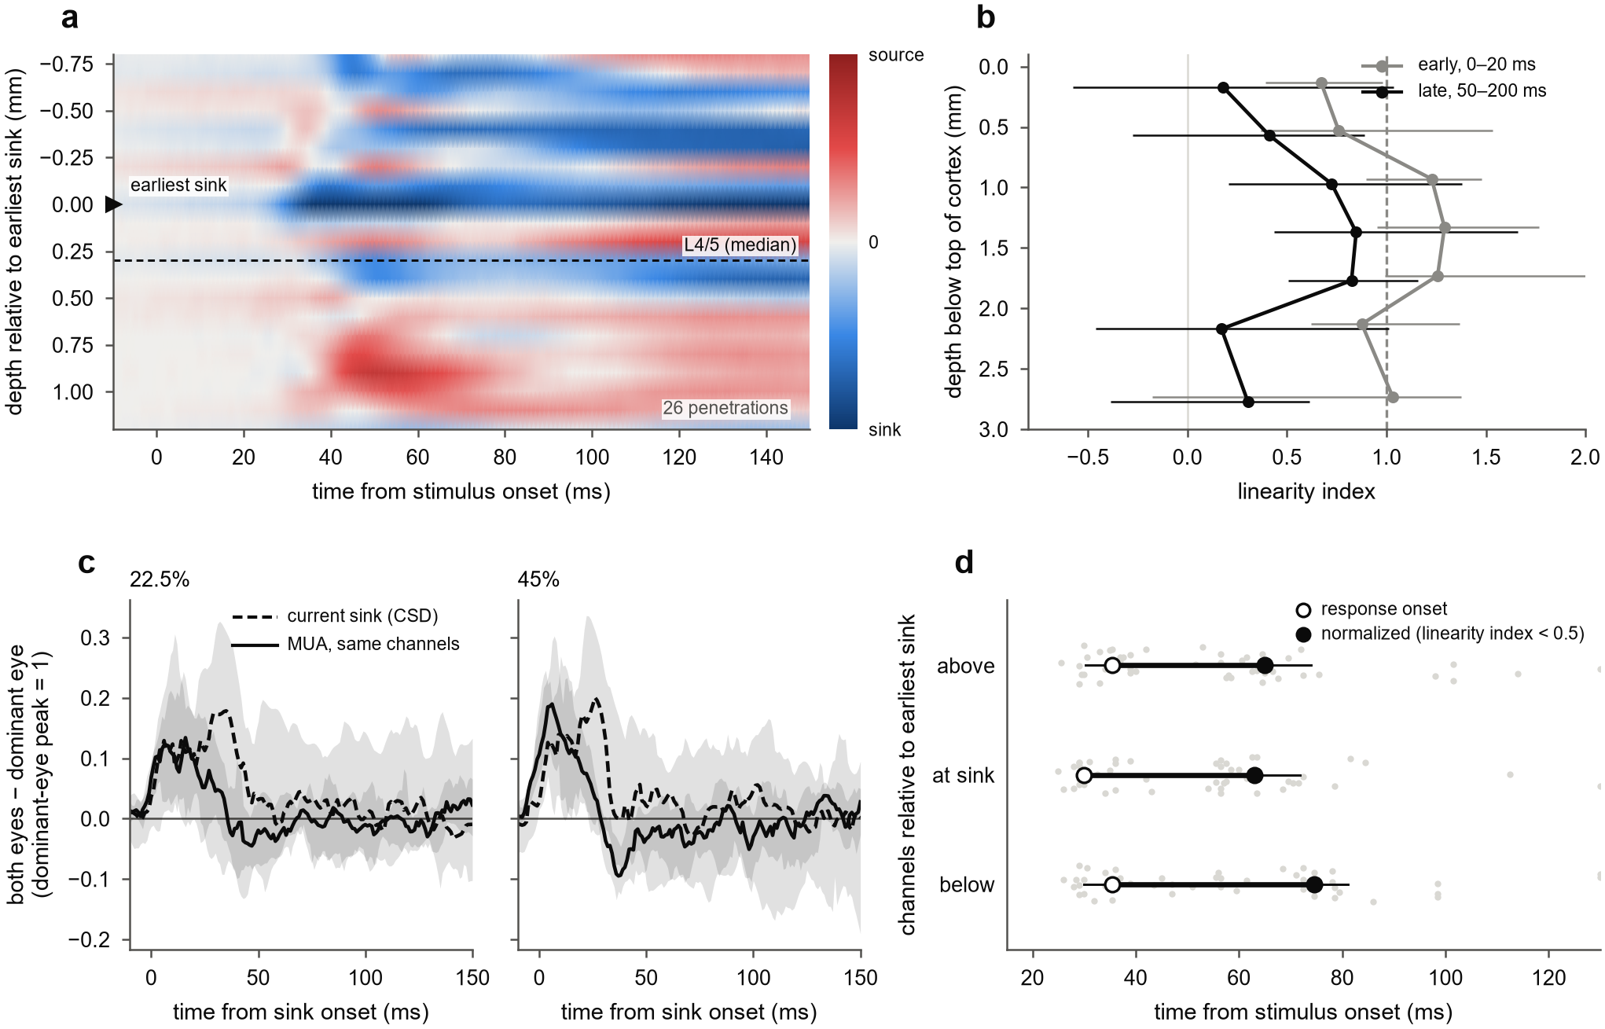
Figure 4. The same sequence runs at every depth and starts in the earliest synaptic input. (a) Population CSD for presentations with either eye at 45% or more, aligned to each penetration's earliest current sink (depth 0) and scaled by that sink's peak before averaging over 26 penetrations; the dashed line marks the median position of the layer 4/5 boundary. Colours are interpolated for display. (b) Linearity index by depth below the top of cortex, early (0–20 ms after each channel's onset) and late (50–200 ms), 11 and 22.5% pooled; median over penetrations with 95% bootstrap CI, for depth bins with at least five penetrations. (c) Binocular gain (both eyes minus the dominant eye alone) of the earliest sink's current (dashed) and of MUA on the same channels (solid), timed from sink onset, at 22.5 and 45%; each signal scaled to its dominant-eye peak at 90%; median and 95% bootstrap CI over penetrations. (d) Laminar sequence: for channels above, within two contacts of, and below the earliest sink, the response onset (open circles) and the time at which the linearity index first fell below 0.5 (filled circles), on the stimulus clock; medians with interquartile ranges, grey dots for single penetrations. Wilcoxon signed-rank tests against the sink group, uncorrected.

A delayed normalization pool explains the direction, but not the full strength, of the collapse
We asked what normalization circuit could produce linear summation at onset followed by a contrast-dependent collapse. We extended the delayed normalization model of Zhou et al. (2019) to two eyes (Fig 5a). The excitatory drive sums the eyes linearly, with weight a on the other eye. The normalization pool has its own weight w on the other eye and reaches the divisor through a low-pass filter with time constant τ2. The response is R = g·E^n / (σ^n + P^n).
We fitted the model to each penetration's full 6 × 6 time courses (0–219 ms after stimulus onset) and scored it on held-out presentations. Delayed normalization predicted held-out data better than static normalization (the same model with no filter) in 23 of 25 penetrations (p < 0.001), with 3.3 times lower median held-out error (Fig 5b). It explained a median 90% of the variance. The fitted pool delay τ2 was 30 ms (interquartile range 24–38 ms), close to the observed transition.
The pool weighted the other eye more than excitation did: w > a in 24 of 25 penetrations, with median w = 1.08 and a = 0.88 (Fig 5c). This is the condition under which binocular responses can fall below the dominant eye alone at high contrast, as they did at 45%. In this reading, ocular dominance shapes the excitatory drive while the pool stays close to eye-balanced, consistent with Mitchell et al. (2023).
The fitted model reproduced the direction and contrast ordering of the collapse but not its speed or depth. At low contrast its pool stayed below σ, so it predicted little normalization where the data showed it. A pool time constant that shortens with contrast did not help: it gave no meaningful gain in held-out error (median ratio 1.00), and its contrast factor fitted near zero.
The misfit at low contrast suggested an earlier stage of interocular gain control, as in the two-stage model of binocular contrast vision (Meese, Georgeson & Baker 2006). We therefore fitted a dynamic two-stage model, in which each eye's signal is first divided by a delayed sum of both eyes' contrasts before the two are summed and normalized as above. The single-stage model is a special case of this model, reached when the first stage saturates.
Fitted to each channel separately, the two-stage model predicted held-out responses better than the single-stage model in 23 of 24 penetrations, in both monkeys (538 channels; Fig 5d). The improvement was consistent but small, a median 1.5% reduction in held-out error. It was the same when the models were fitted with a loss function that emphasizes the binocular interaction (24 of 24 penetrations, p < 0.001). The fitted first stage had an interocular suppression weight of about 0.9 and a delay of about 30 ms.
No model captured the full strength of the late collapse. We required each model's late linearity index to match the data within ±0.25, with 90% confidence, at 11, 22.5 and 45% (Fig 5e). The single-stage model had no median bias, but its predictions were too imprecise to meet this criterion. The two-stage model remained too linear late in the response, by about 0.35 at 11 and 22.5%. A dynamic version of the Ding & Sperling (2006) gain-control model did no better than the single-stage model, and its parameters settled at their bounds.
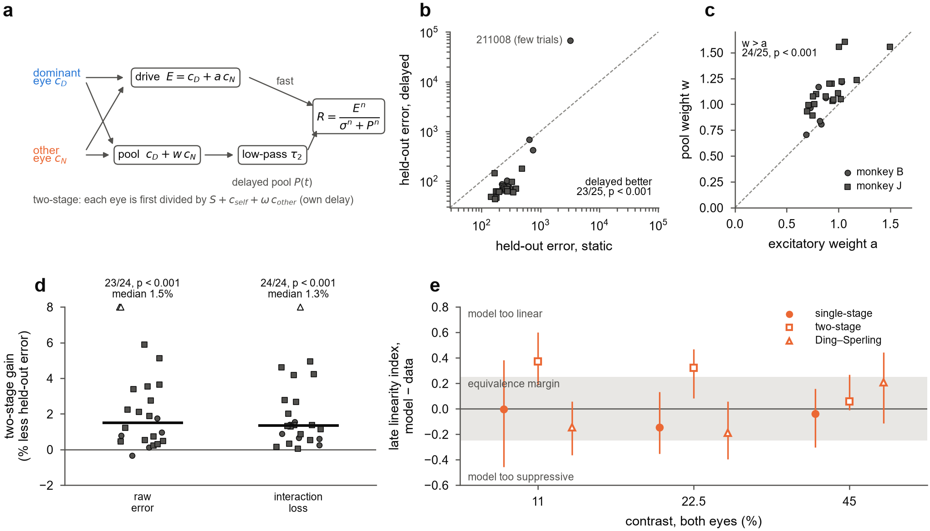
Figure 5. A delayed binocular normalization pool explains the direction, but not the full strength, of the collapse. (a) Single-stage delayed normalization: the drive E sums the two eyes with weight a on the other eye; the pool sums them with its own weight w and divides the response after a low-pass delay τ2. The two-stage variant first divides each eye by S plus both eyes' contrasts, with its own delay. (b) Held-out (odd/even) error of static against delayed normalization, per penetration; the outlier is the penetration with the fewest presentations. (c) Fitted pool weight w against excitatory weight a, per penetration; dashed, identity. (d) Two-stage against single-stage: for each penetration, the median percentage reduction in held-out error over channels, for fits to the raw time courses and for fits with the interaction loss; bars, medians; triangles, values above the axis; one-sided Wilcoxon tests over penetrations. (e) Capture of the late collapse: late linearity index (50–150 ms after onset) of each model's fit minus that of the data; median over penetrations with 90% bootstrap CI; grey band, the ±0.25 equivalence margin.

The fitted model rises too fast at low contrast and has no offset response
The delayed normalization model was fitted to the first 219 ms of the response, so its rise and its behaviour after the stimulus ends are predictions it was not fitted to. Responses rose more slowly at low contrast (Fig 6a). For the dominant eye alone, the 10–90% rise time, measured per channel, fell from 46.5 ms at 11% to 20 ms at 90% (penetration medians; Fig 6b).
The fitted model rose 2.3 times too fast at 11% (20 ms) and was too fast at every contrast (11 ms at 90%). In the model, normalization divides a response whose rise is set by a fixed input filter, so the rise shortens only modestly with contrast. In the data, low-contrast responses integrate more slowly.
After the stimulus ended, the data showed an offset response that the model cannot produce (Fig 6c). We aligned responses to the response offset, the stimulus duration plus each penetration's onset latency, and scaled them to the sustained level. The response rose to about 1.8 times its sustained level within about 10 ms, at every contrast, in 88–100% of penetrations, in both monkeys. The model, which has no drive at stimulus offset, simply decayed.
Two cautions follow. First, decay times measured after stimulus offset are dominated by this transient, so they cannot be used to compare normalization mechanisms. Second, a slower rise at low contrast is what models predict when normalization shortens the integration time constant, as in conductance-based (Carandini, Heeger & Movshon 1997) and recurrent (Heeger & Zemlianova 2020) circuits. Whether such a model fits these data, including the binocular collapse, is a separate test that we have specified but not yet run.
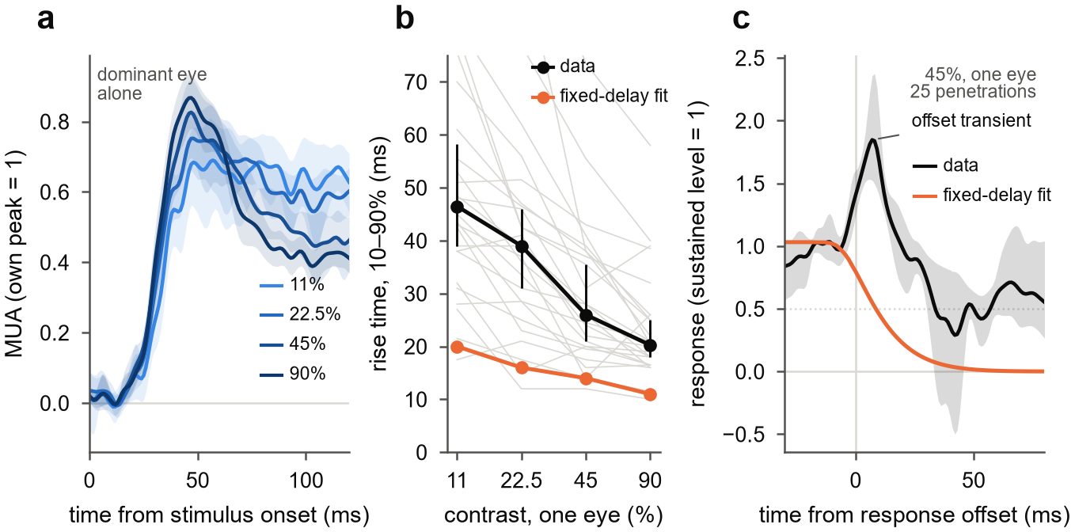
Figure 6. The fitted model rises too fast at low contrast and has no offset response. (a) Dominant eye alone at four contrasts, aligned to stimulus onset; each penetration scaled to its own peak; mean and 95% bootstrap CI over penetrations. (b) 10–90% rise time against contrast: data (grey, penetrations; black, median with 95% bootstrap CI) and the fitted delayed normalization model of Fig 5 (orange, median over penetrations), which was fitted to 0–219 ms only. (c) Response at 45% after the response offset (stimulus duration plus onset latency), scaled to the sustained level before it: data (mean, 95% bootstrap CI over 25 penetrations) and the fitted model (median).

Discussion
In awake macaque V1, the rule by which the two eyes combine changes within the first tens of milliseconds of the response. The eyes first sum almost linearly. Interocular normalization then takes over, 20–35 ms after response onset, and at high contrast it pushes binocular responses below those of the dominant eye alone.

Timing may reconcile static accounts
If the combination rule changes over time, studies that averaged over different windows should disagree. Methods that integrate over hundreds of milliseconds or seconds, such as fMRI and steady-state EEG, mostly see the late, normalized state, and they report near ocularity invariance (Moradi & Heeger 2009; Baker & Wade 2017). Spike counts split into transient and sustained windows see a binocular boost that vanishes later (Cox et al. 2019).
The same logic may apply to the disagreement about which neurons are suppressed (Dougherty et al. 2019; Zhang et al. 2024). In our data, isolated units were mostly net-suppressed by the second eye while MUA was mostly facilitated (Supplementary). Window choice, the signal recorded and ocular dominance therefore all shape the answer. We did not test these older paradigms directly, so this reconciliation is a hypothesis.

Interocular normalization is slower than monocular normalization
In anesthetized V1, monocular contrast normalization is fully in place within the first 10 ms of the response (Albrecht et al. 2002). Interocular normalization in our data needed 20–35 ms more. That difference suggests that the two eyes are normalized by a slower route than a single eye's contrast, plausibly a cortical one. In cat V1, interocular suppression is reduced by blocking GABA-A receptors (Sengpiel & Vorobyov 2005).
The CSD points the same way. The earliest current sink summed the two eyes almost linearly at onset, so normalization was not already present in the input it carries. Normalization then appeared in both currents and spikes, first in the input layer and a few milliseconds later above and below it. Each depth normalized a similar time after its own onset, as if a local circuit follows the feedforward wave with a fixed lag. That order differs from near-surround suppression, which reaches layer 4C last (Bijanzadeh et al. 2018).

Implications for models of binocular normalization
Two features of the data constrain models firmly. Normalization must be delayed relative to excitation; static normalization fitted held-out data far worse. And the normalization pool must weight the other eye more than excitation does (w > a), or binocular responses could never fall below the dominant eye alone. A pool close to eye-balanced, with ocular dominance acting on the drive, fits earlier results from this dataset (Mitchell et al. 2023).
Three features remain unexplained: the full depth of the late collapse, the slow rise at low contrast, and the offset response. A fixed delay in a feedforward pool cannot change how fast a response integrates. Conductance-based and recurrent normalization can (Carandini, Heeger & Movshon 1997; Heeger & Zemlianova 2020). A binocular version would also need eye-specific units, because a circuit driven only by the summed eye signal combines the eyes the same way at every moment. Testing such a model is the next step; we have not yet done it.

Limitations
- Stimulus. The gratings were static and identical in the two eyes. The design does not probe disparity, orientation conflict, temporal frequency or masking.
- Signals. The results rest mainly on MUA and CSD at 100 µm spacing. Isolated units were few (about 60 driven units in 20 penetrations), and layer labels are uncertain by roughly ±0.5–1 mm.
- Animals. Two monkeys contributed unequal numbers of penetrations (8 and 18), and their response latencies differed by about 8 ms.
- Replication. The independent recordings came from one monkey (J). The laminar timing statistics are modest and uncorrected.
- Measure. The linearity index is a ratio and has heavy tails. Where the binocular response exceeds the dominant eye's response at 90%, the equivalent contrast is censored and the index is a lower bound; this happened in 45% of channels in the first window at 45%.

Methods

Animals
Two adult macaques [species, sex, ages, weights] were implanted with a head post and a recording chamber over V1 [procedures, anaesthesia, IACUC protocol]. Monkey B was recorded in right V1 (October–December 2021) and monkey J in left V1 (October–December 2022).

Task and stimuli
The task ran in NIMH MonkeyLogic 2. The monkeys fixated [fixation window, duration] while viewing two halves of one display through a mirror stereoscope, one half per eye [display model, viewing distance, mean luminance; 120 Hz refresh]. Each trial showed three gratings, each for about 317 ms with about 317 ms between them, followed by a juice reward. In one penetration (211008) gratings lasted about 217 ms.
Gratings were static sinusoids matched to the multi-unit receptive field in orientation, spatial frequency, size and position [mapping procedure], and identical in the two eyes apart from contrast. Each eye's Michelson contrast was 0, 0.055, 0.11, 0.225, 0.45 or 0.9, chosen independently, giving 36 conditions in random order with about 30 presentations each.

Recording
We recorded with 32-contact linear arrays (Plexon, 100 µm spacing) and a Blackrock Cerebus system. Wideband signals were sampled at 30 kHz and LFP at 1 kHz. On seven days in monkey J, two arrays were recorded at once in separate columns. Stimulus onsets were taken from a photodiode on the display, and the 3.4 ms offset between the 30 kHz and 1 kHz file clocks was corrected.
MUA was the envelope of the wideband signal: band-pass 500–5000 Hz (4th-order Butterworth, zero phase), full-wave rectification, low-pass 200 Hz, resampled to 1 kHz. CSD was −σ∂²V/∂z² of the LFP (σ = 0.4 S/m, 0.1 mm spacing). Before differentiation, contacts with evoked amplitude outside 0.6–1.6 times the median of their neighbours were interpolated, and a three-point Hamming filter was applied across depth.
Single units came from curated Kilosort sorts made in 2023, with a spike-time offset corrected, and from Kilosort 4 (Pachitariu et al. 2024) for five penetrations without a sort. Units were included if refractory-period contamination (Hill et al. 2011) was below 0.5 and signal-to-noise ratio was at least 3. A strict set also required contamination below 0.1, amplitude cutoff below 0.1 and presence ratio of at least 0.9.

Eye position and presentation selection
Eye position was recorded as analog gaze signals, calibrated against MonkeyLogic. Saccades were detected with a velocity threshold (Engbert & Kliegl 2003; λ = 6, minimum 6 ms). We analysed completed presentations with no saccade of 1° or more between 200 ms before and 500 ms after onset.
We also excluded presentations with large MUA artifacts: a peak MUA between −50 and 450 ms more than 20 robust standard deviations (median absolute deviation × 1.4826) above the median for that channel, on any channel in cortex. Visual responses reach 6–11 such units in penetrations without artifacts. The rule removed 0.6% of presentations, mostly in monkey J. The rule was fixed before its effect on any result was examined.

Laminar alignment
The top of cortex was the most superficial contact with spontaneous MUA. A layer 4/5 boundary was placed just below the dominant early sink (35–65 ms) of a flash-evoked CSD, recorded separately on the same day and registered to the grating recording by matching depth profiles of MUA and LFP power. It was accepted if it lay 0.5–1.7 mm below the top of cortex or agreed with the laminar profile of spike–LFP phase coupling (spike-phase index and pairwise phase consistency; Vinck et al. 2010; Davis et al. 2023); otherwise the phase-coupling marker was used if its depth was plausible. This gave a boundary in 22 penetrations (16 from the flash CSD, 6 from phase coupling); 26 penetrations had a usable top of cortex. Depth below the top of cortex is the primary depth axis.

Responses
A channel was analysed if it lay in cortex and its response varied with the contrast of at least one eye shown alone (one-way ANOVA over the six contrasts, p < 0.01, 40–140 or 150–250 ms after onset, peak above baseline). The contrast-timing analysis (Fig 3) used the same test on the dominant eye, 40–250 ms. Condition means were blank-subtracted and smoothed with a Gaussian (σ = 3 ms for equivalent contrast, 2 ms for figures and models).
The dominant eye was the eye with the larger mean response at 90%, 40–250 ms. Response onset was the first time after 10 ms at which the dominant-eye response at 90% reached half its peak. For display and model fitting, each channel was scaled by its dominant-eye peak at 90%.

Equivalent contrast and the linearity index
In each window, the binocular response at contrast c in both eyes was located on the dominant eye's monocular contrast response in the same window. We made that curve non-decreasing (running maximum) and interpolated it linearly between 0 and 5.5% and in log contrast above. The matching contrast divided by c is k. Where the binocular response exceeded the dominant-eye response at 90%, k was set to 0.9/c, a lower bound.
The eye weight a was the contrast scale, between 0.05 and 1, that best mapped the dominant eye's monocular contrast response onto the other eye's (least squares over the five non-zero contrasts). The linearity index is (k − 1)/a. Windows relative to onset were 0–10, 10–20, 20–35, 35–50, 50–75, 75–100, 100–150 and 150–200 ms. The contrast-timing analysis used sliding 15 ms windows starting every 5 ms. Robustness and timing analyses refitted a in each window.

Statistics
The penetration is the unit of replication, because neighbouring channels share signal. Statistics were computed on penetration medians over channels. We used two-sided Wilcoxon signed-rank tests for paired comparisons, one-sided sign tests for registered direction tests, Friedman tests across contrasts, and bootstrap confidence intervals with 2000 resamples of penetrations. Depth profiles were also tested with linear mixed models with a random intercept per penetration.

Models
In the single-stage delayed normalization model, after Zhou et al. (2019), E(t) = (c_D + a·c_N)·u(t) and P(t) = (c_D + w·c_N)·v(t), with R = g·E^n / (σ^n + P^n). Here u(t) is the step response of a gamma filter (shape 3, time constant τ1) delayed by δ, and v(t) is u(t) passed through an exponential low-pass filter with time constant τ2. Static normalization sets v = u.
In the two-stage model, each eye is first divided by S plus a delayed sum of its own and the other eye's contrast (weight ω, time constant τ_s). The two outputs are then summed and normalized as above, with their own pool weight w. As S grows, the model reduces to the single-stage model. The dynamic Ding–Sperling model replaces the first stage with mutual gain control driven by low-passed contrast energy (Ding & Sperling 2006).
Models were fitted by least squares, with several starting points, to the full 6 × 6 time courses 0–219 ms after stimulus onset. Fits were made either to each penetration's channel average or to each channel. Held-out error was the summed squared error on even presentations for fits to odd ones, and vice versa. The interaction loss weighted equally the monocular time courses and the binocular interaction, each binocular response minus the dominant eye alone at the same contrast.

Response dynamics
For the dominant eye alone, rise time was the interval between 10% and 90% of the peak response within 150 ms of stimulus onset. Responses after the stimulus were aligned to the response offset, defined as the stimulus duration plus the half-maximum onset latency. They were scaled to the mean response over the 30 ms before that point.

Code and data
All analyses are in the v1-laminar-binocular repository [link or availability statement]. Each figure is produced by one script from saved analysis outputs.

References
Details marked [verify] still need checking against the source.
- Albrecht DG, Geisler WS, Frazor RA, Crane AM (2002). Visual cortex neurons of monkeys and cats: temporal dynamics of the contrast response function. J Neurophysiol 88:888–913. PubMed
- Baker DH, Wade AR (2017). Evidence for an optimal algorithm underlying signal combination in human visual cortex. Cereb Cortex 27:254–264. PMC
- Bijanzadeh M, Nurminen L, Merlin S, Clark AM, Angelucci A (2018). Distinct laminar processing of local and global context in primate primary visual cortex. Neuron 100:259–274. link
- Carandini M, Heeger DJ (2012). Normalization as a canonical neural computation. Nat Rev Neurosci 13:51–62.
- Carandini M, Heeger DJ, Movshon JA (1997). Linearity and normalization in simple cells of the macaque primary visual cortex. J Neurosci 17:8621–8644.
- Cox MA, Dougherty K, Westerberg JA, Schall MS, Maier A (2019). Temporal dynamics of binocular integration in primary visual cortex. J Vis 19(12):13. PMC
- Davis ZW, Dotson NM, Franken TP, Muller L, Reynolds JH (2023). Spike-phase coupling patterns reveal laminar identity in primate cortex. eLife 12:e84512. [verify]
- Ding J, Sperling G (2006). A gain-control theory of binocular combination. Proc Natl Acad Sci USA 103:1141–1146. PMC
- Dougherty K, Cox MA, Westerberg JA, Maier A (2019). Binocular modulation of monocular V1 neurons. Curr Biol 29:381–391. doi
- Engbert R, Kliegl R (2003). Microsaccades uncover the orientation of covert attention. Vision Res 43:1035–1045.
- Heeger DJ, Zemlianova KO (2020). A recurrent circuit implements normalization, simulating the dynamics of V1 activity. Proc Natl Acad Sci USA 117:22494–22505. PMC
- Hill DN, Mehta SB, Kleinfeld D (2011). Quality metrics to accompany spike sorting of extracellular signals. J Neurosci 31:8699–8705.
- Meese TS, Georgeson MA, Baker DH (2006). Binocular contrast vision at and above threshold. J Vis 6(11):7. doi
- Mitchell BA, et al. (2023). [title, authors: verify]. Curr Biol. doi
- Moradi F, Heeger DJ (2009). Inter-ocular contrast normalization in human visual cortex. J Vis 9(3):13. PMC
- Pachitariu M, Sridhar S, Pennington J, Stringer C (2024). Spike sorting with Kilosort4. Nat Methods 21:914–921.
- Sengpiel F, Vorobyov V (2005). Intracortical origins of interocular suppression in the visual cortex. J Neurosci 25:6394–6400. doi
- Truchard AM, Ohzawa I, Freeman RD (2000). Contrast gain control in the visual cortex: monocular versus binocular mechanisms. J Neurosci 20:3017–3032. PMC
- Vinck M, van Wingerden M, Womelsdorf T, Fries P, Pennartz CMA (2010). The pairwise phase consistency: a bias-free measure of rhythmic neuronal synchronization. NeuroImage 51:112–122. [verify]
- Zhang et al. (2024). [title, authors: verify]. eLife. doi
- Zhou J, Benson NC, Kay K, Winawer J (2019). Predicting neuronal dynamics with a delayed gain control model. PLoS Comput Biol 15:e1007484. PMC

Open items for revision

- Fill in the bracketed Methods facts: species, sex, surgery and protocol, display, fixation window, receptive-field mapping, grating size and spatial frequency.
- Run the remaining controls for Supplementary Fig S1: vergence, receptive-field position, crosstalk between the eyes' images, trial selection.
- Build the supplementary figures: single units against MUA, results per monkey, results under each laminar marker, no supersaturation at any depth.
- Run the recurrent normalization model test (Figs 5–6), with eye-specific units and an offset drive.
- Run a finer laminar timing analysis before relying on Fig 4d.
- Use one driven-channel rule throughout (Fig 3 currently uses a dominant-eye test, the rest a test on either eye).
- Check that Figs 2 and 4 now read on their own (Fig 2 rebuilt; Fig 4 now shows a population CSD and a single laminar-sequence panel).
- State the contribution relative to Mitchell et al. 2022 and 2023 (same dataset) and Cox et al. 2019; check overlap with the 2024 dissertation.
- Verify the references marked [verify] and choose a title.

