Binocular contrast summation in macaque V1 gives way within tens of milliseconds to normalization set by the other eye's contrast
Blake A. Mitchell, Brock M. Carlson, Alexander Maier

Abstract
Binocular vision begins in primary visual cortex (V1), where signals from the two eyes converge. Their combination is usually described by divisive normalization, but when normalization takes hold, how it depends on each eye's contrast, and where in the cortical column it is strongest are unknown. We recorded laminar multi-unit activity in V1 of two awake macaques while each eye viewed a grating at one of six contrasts, chosen independently for each eye. Timing each response from its own onset, we compared binocular responses with contrast summation, the response predicted if the two eyes' contrasts add. Across all 35 stimulus conditions, responses began sooner the stronger they were, and adding the second eye advanced the onset by 1.5–1.9 ms. For about 20 ms after onset, binocular responses were at or above contrast summation in every combination. Thereafter they fell short of it in proportion to the other eye's contrast, and stayed short through 200 ms when the other eye's contrast exceeded the dominant eye's. This normalization was strongest in and above layer 4 and weaker in layers 5 and 6. A dynamic normalization model reproduced this sequence only if the normalization pool was delayed and weighted the other eye more than the excitatory drive did; fitted in each compartment, it also reproduced the weaker normalization in layers 5 and 6. Binocular combination in V1 thus changes from contrast summation to normalization by the other eye within tens of milliseconds, a possible basis for the larger binocular summation of brief stimuli.

Significance Statement
How the brain combines the images of the two eyes begins in primary visual cortex. We resolved this combination in time, at every cortical depth, for every pairing of the two eyes' contrasts. The eyes' contrasts add as soon as cortical neurons respond, but within tens of milliseconds the response falls short of what that addition predicts, by an amount set by the other eye's contrast. A model in which a delayed normalization signal weights the other eye more than the excitatory input does accounts for this sequence. Binocular combination is therefore not a fixed rule but a process that unfolds during each glance, which may explain why binocular summation in perception is largest for brief stimuli.

Introduction
The two eyes view the world from slightly different positions, and primary visual cortex (V1) is the first stage at which their signals converge on single neurons. How V1 combines them determines what later stages of the visual system receive. In anesthetized cat V1, the combination has been described as two stages of gain control: each eye's signal is gain-controlled before the eyes converge, and the summed binocular signal is gain-controlled again after they do (Truchard, Ohzawa & Freeman 2000). Each stage is a form of divisive normalization, in which a neuron's excitatory drive is divided by the pooled activity of a population of neurons (Carandini & Heeger 2012); the two stages differ in whether that pool carries the signal of one eye or of both.
Which form of normalization operates between the eyes remains disputed. In cat simple cells, most of the change in gain occurs at the monocular stage (Truchard, Ohzawa & Freeman 2000). Human fMRI and steady-state EEG instead point to a binocular pool, which makes responses to one eye and to two nearly equal, a property called ocularity invariance (Moradi & Heeger 2009; Baker & Wade 2017). Psychophysical contrast matching (Legge & Rubin 1981; Baker, Meese & Georgeson 2007) requires either two stages of gain control (Meese, Georgeson & Baker 2006) or mutual gain control between the eyes (Ding & Sperling 2006). In macaque V1, the two eyes' contrasts combine linearly near threshold (Smith et al. 1997a), and ocular dominance shapes how binocular responses are normalized (Mitchell et al. 2023; Zhang et al. 2024).
These accounts describe the combination once it has settled, yet several observations suggest that it changes during the response. In awake macaque V1, stimulating both eyes enhances the early, transient response but not the sustained response (Cox et al. 2019). When both eyes view the same grating, this enhancement persists at low contrast but turns into suppression at medium and high contrast by 150–250 ms after stimulus onset (Mitchell et al. 2022). In neurons driven by one eye only, binocular facilitation appears at response onset and suppression about 12 ms later (Dougherty et al. 2019), and suppression tuned to binocular disparity lags excitation by about 7 ms (Tanabe & Cumming 2014). Perception depends on time in a similar way: binocular summation is largest for brief stimuli (Bearse & Freeman 1994), and binocular contrast combination is more linear for brief, low-contrast stimuli than for long, high-contrast ones (Ding, Klein & Levi 2013). The neural studies used response windows of 50–100 ms or longer, a single contrast pair or equal contrasts in the two eyes, and differences in spike counts rather than a test of a combination rule; time-averaged responses from the recordings analyzed here showed that the other eye's contribution depends on ocular dominance (Mitchell et al. 2023). When the rule changes, how the change depends on each eye's contrast, where in the cortical column it is strongest and what form of normalization produces it are therefore unknown. Normalization itself may take time: in human visual cortex it lags the response it divides (Zhou et al. 2019), and in recurrent circuit models it builds up over tens of milliseconds (Heeger & Zemlianova 2020).
Measuring how the rule changes on this time scale requires separating it from response latency. Stronger stimuli evoke responses with shorter latencies: in V1, latency shortens as contrast increases (Gawne, Kjaer & Richmond 1996; Albrecht et al. 2002), which normalization models attribute to the faster dynamics of a more strongly driven circuit (Carandini, Heeger & Movshon 1997). Stimulating both eyes acts as a stronger stimulus than stimulating one. In humans, binocular visual evoked potentials peak about 3 ms earlier than monocular ones (Plainis et al. 2011); in macaque V1, the latency of binocular responses is set largely by the dominant eye (Romero et al. 2007). If binocular responses begin even slightly earlier, comparing them with monocular responses at the same moment after stimulus onset shows a binocular excess on the rising edge of the response, whether or not the rule by which the eyes combine changes. A test of the combination rule must therefore account for these differences in latency, on a stimulus clock accurate to the millisecond.
We recorded laminar multi-unit activity (MUA), current-source density (CSD) and single units in V1 of two awake macaques while each eye viewed a grating at one of six contrasts, chosen independently for each eye, so that every combination of the two eyes' contrasts was tested. Across all conditions, response onset followed the strength of the response, and the second eye counted as drive (Fig 1). We compared each binocular response with the response of the dominant eye alone at the summed contrast (contrast summation), which also begins earlier, on each site's own response clock. For about 20 ms after onset, the two eyes' contrasts added in every combination; afterwards the binocular response fell short of contrast summation in proportion to the other eye's contrast, and stayed short when the other eye was the stronger one (Fig 2). This normalization was strongest in and above layer 4 and weaker in layers 5 and 6 (Fig 3). A dynamic normalization model reproduced this sequence only with a delayed pool that weighted the other eye more than the excitatory drive did; fitted in each compartment, the model also reproduced the weaker normalization in layers 5 and 6 (Fig 4).

Results

Binocular combination measured with millisecond and laminar resolution
We recorded from 26 V1 penetrations in two macaques (monkey B: 8; monkey J: 18; 22 sessions) with linear arrays of 32 contacts spaced 100 µm apart. The monkeys viewed a single monitor through a mirror stereoscope that presented each eye with its own half of the screen (Fig 1a). Each eye saw the same static grating, matched to the receptive fields, at 0, 5.5, 11, 22.5, 45 or 90% contrast. All 36 combinations of the two eyes' contrasts were presented in random order, about 30 times each per electrode penetration (Fig 1b). We analyzed 570 MUA channels whose responses varied with the contrast of at least one eye.
Depth was referenced to the border between layer 4C and layer 5. In each penetration we estimated it from the laminar profile of spike–LFP phase coupling, where the preferred phase of spikes relative to the alpha/beta LFP reverses (Vinck et al. 2010; Davis et al. 2023), from the earliest current sink evoked by the gratings, and from the depth at which alpha/beta and gamma LFP power cross (Mendoza-Halliday et al. 2024), and accepted it where these agreed (22 of 26 penetrations; Methods). Because the markers can disagree, and because the array can compress or stretch the cortex by a different amount on each day, we then checked each reference against the thickness of the layers above it: about 1.24 mm from the top of layer 2 to the bottom of layer 4C (Zhu et al. 2026). The depth analyses used the 12 penetrations (3 in monkey B, 9 in monkey J) in which the top of cortex lay within about 30% of that distance above the reference, or beyond the end of the array at a consistent distance, and in which two estimates of the reference agreed within 0.3 mm (Supplementary Fig S3a). Heights were scaled by each penetration's ratio of measured to expected thickness, and channels were labelled supragranular (layers 2/3), granular (layer 4) or infragranular (layers 5 and 6; 237 channels in all). Stimulus onsets were measured with a photodiode on the display.
The basic observation is visible in single penetrations (Fig 1c). At 45% contrast in each eye, the binocular response rose earlier and higher than the response to either eye alone and then, within about 30 ms of its peak, fell to the response of the dominant eye alone. The other eye drove weaker responses than the dominant eye at every contrast (Supplementary Fig S1a). We summarized each channel's balance between the eyes by an eye weight, the factor that maps the other eye's contrast onto the dominant eye's contrast–response function (median over penetrations 0.70, interquartile range 0.55–0.78). Most MUA channels were driven by both eyes (Supplementary Fig S1b).

Response onset follows drive, and the second eye counts as drive
Comparing binocular and monocular responses moment by moment requires knowing when each begins. Across the 35 stimulus conditions, the stronger the response, the earlier it began (Fig 1d). The rank correlation between the peak of a condition's response and its onset, the time at which the response reached half that peak, was −0.98 over the population medians of the 35 conditions; within penetrations it was negative in 24 of 26 (hierarchical estimate −0.48, p < 0.001; weaker in monkey B, p < 0.001). Raising the contrast in the dominant eye from 11 to 90% advanced the onset by 6.8 ms, to 32.8 ms after stimulus onset. Adding the other eye advanced it further, by 1.9, 1.6 and 1.5 ms with both eyes at 11, 22.5 and 45% (earlier than the dominant eye alone in 23, 25 and 23 of 26 penetrations; p < 0.001 at each contrast; hierarchical estimate at 45%, −1.55 ms, p = 0.013), and by 1.8 ms at 90%. Binocular responses began 1.5 ms earlier than the sum of the two monocular responses would have (25 of 26 penetrations, p < 0.001), so the advance reflects a stronger combined drive, not the addition of two responses. They also began 0.9 ms earlier than a single eye driving a response of the same peak (p = 0.002): with 45% in each eye, responses began before the response to the dominant eye at 90% in 17 of 26 penetrations. At their peaks, binocular responses did not differ from the response predicted if the two eyes' contrasts add (below; p ≥ 0.17 at 11, 22.5 and 45%).
Because onsets differ by several milliseconds between conditions and between channels, we aligned each channel to its own response onset, that of its response to the dominant eye at 90%. We then compared the binocular response with the response predicted if the two eyes' contrasts add: the dominant eye's response to the summed contrast c_D + a·c_O, where c_D and c_O are the contrasts of the dominant and the other eye and a is the eye weight (Methods). We call this prediction contrast summation. It is not linear summation of the two monocular responses, which ignores the compressive contrast–response function and predicts a much larger binocular response: with both eyes at 45%, 30 to 100 ms after onset, linear summation corresponds to an additivity index (the binocular response divided by the sum of the monocular responses) of 1, and contrast summation to 0.62. The prediction is itself a response to a stronger stimulus, so it also begins earlier than the dominant eye's response to c_D alone.
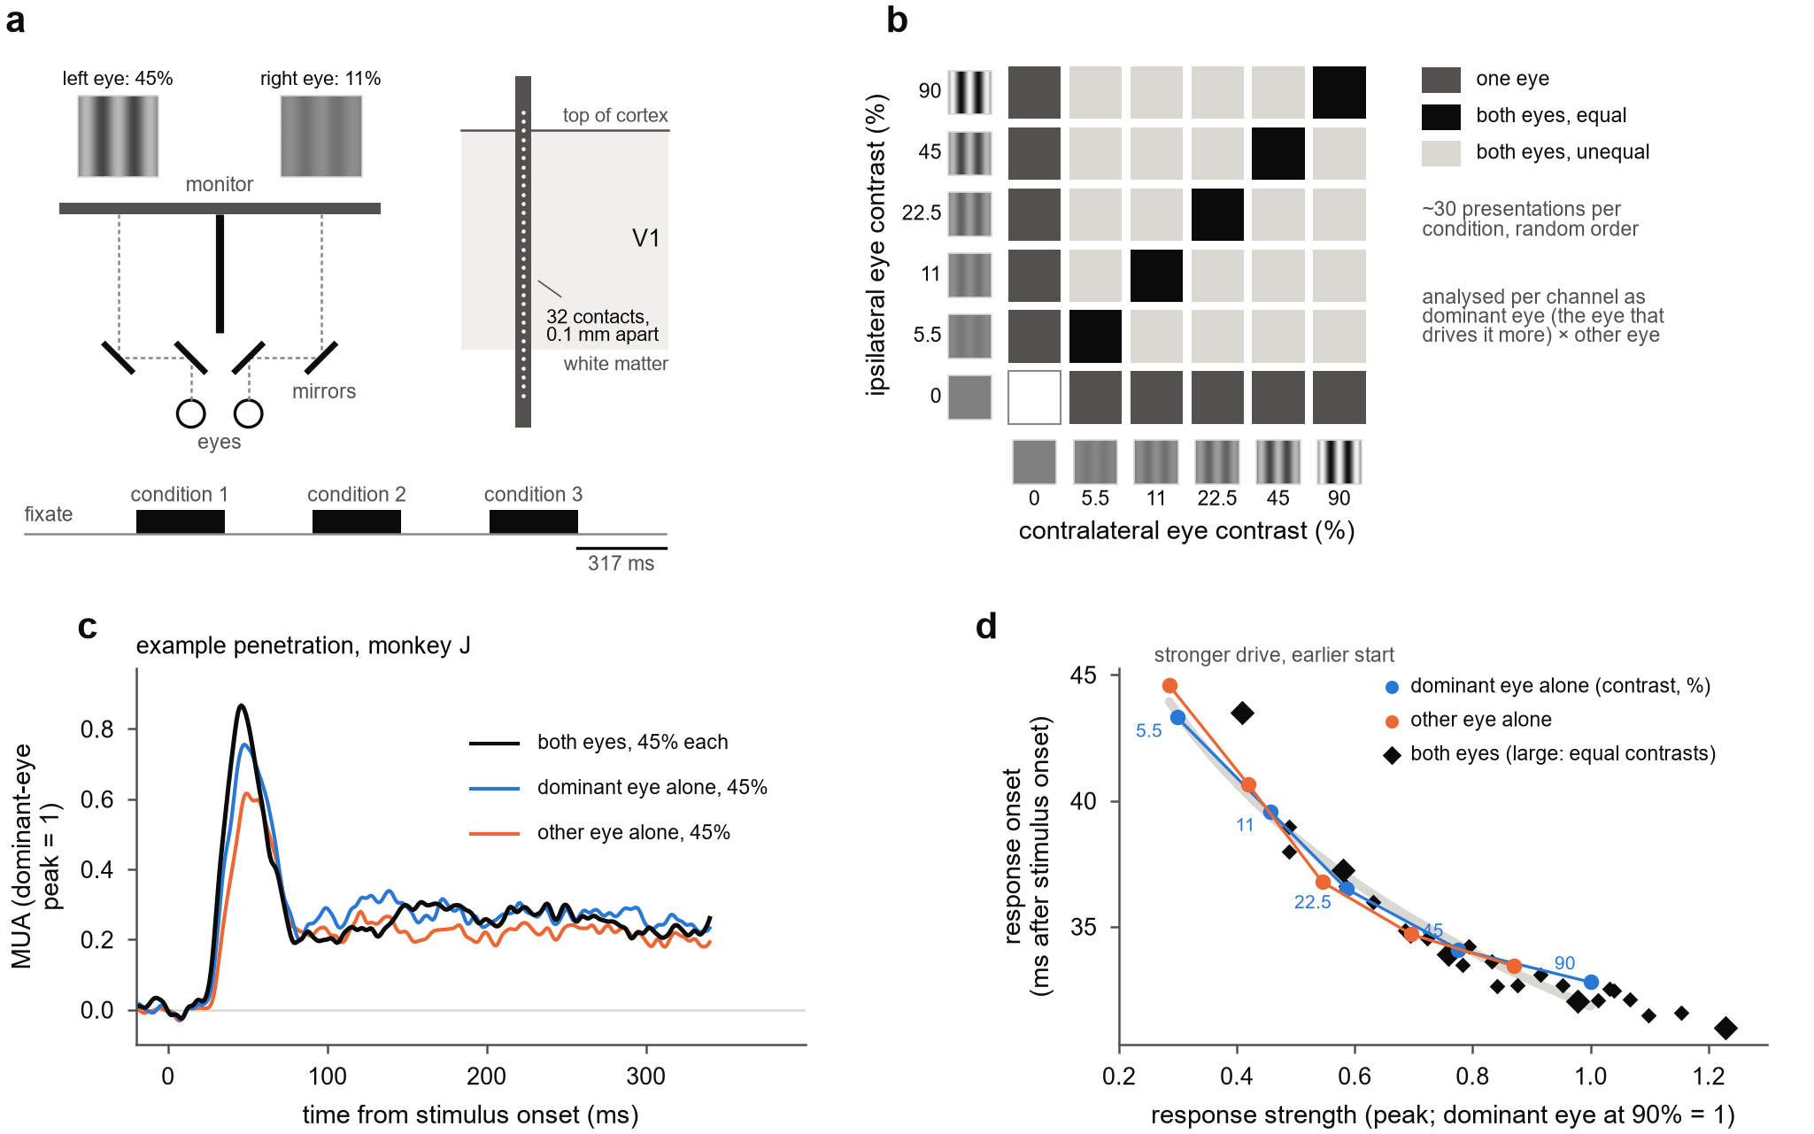
Figure 1. The experiment, an example penetration, and response onset follows drive. (a) Each eye viewed its own half of one monitor through a mirror stereoscope (top view): two mirrors per eye shift each eye's line of sight onto its own half, and a black septum divides the halves. A 32-contact laminar probe spanned the depth of V1. Below, one trial: after fixation, three conditions in random order, each for about 317 ms with 317 ms between them. (b) The 6 × 6 dichoptic design: each eye saw a grating at 0, 5.5, 11, 22.5, 45 or 90% contrast (swatches), giving 36 conditions: one eye alone (dark grey), both eyes at equal contrast (black) and both eyes at unequal contrast (light grey), each shown about 30 times. Each channel was analysed with its axes reoriented to its dominant and other eye. (c) Multi-unit activity in one penetration of monkey J: mean of 28 channels, each scaled to its dominant-eye peak at 90% contrast, for both eyes at 45% and each eye alone at 45%. (d) Response onset (the time at which a condition's response reached half its own peak) against response strength (that peak), for all 35 stimulus conditions: each eye alone (circles; numbers, the dominant eye's contrast in %) and both eyes (diamonds; large, equal contrasts). Medians over channels in each penetration, then over 26 penetrations; onsets are relative to each channel's onset for the dominant eye at 90%, plus that onset's population median. Grey band, least-squares line of onset on log peak through the monocular conditions, drawn over their range.

The eyes' contrasts add at onset; afterwards the other eye's contrast sets the shortfall from contrast summation
Because each eye's contrast was varied independently, we could ask how the combination changes over time across the whole design. Contrast summation can be predicted wherever both contrasts are at least 11% and the summed contrast does not exceed the highest contrast tested, 90%: up to 12 cells of the design in each penetration. Fig 2a shows one of them, the dominant eye at 22.5% and the other eye at 90%. In the first 20 ms after onset, the binocular response exceeded contrast summation, by 4.8% of the dominant-eye peak. From about 25 ms it fell below the prediction and stayed below through 200 ms, by 5.6% from 30 to 100 ms and by 5.3% from 130 to 200 ms (mean over the 18 penetrations in which this prediction could be made). The shortfall is small relative to the response itself, which at its peak was twice the response to the dominant eye alone.
The same sequence ran through the design (Fig 2b, c). In the first 20 ms after onset, the binocular response was at or above contrast summation in nearly every cell, and a stronger other eye added, if anything, slightly more (+1.1% of the dominant-eye peak per doubling of the other eye's contrast; linear mixed model with penetrations nested in sessions, Methods). From 30 to 100 ms the binocular response fell short of contrast summation in every cell, and more so the higher the other eye's contrast (−1.3% per doubling, p < 0.001). From 130 to 200 ms the shortfall persisted where the other eye's contrast was high (−1.1% per doubling, p < 0.001). Both slopes were more negative than at onset (p < 0.001). Where the other eye's contrast exceeded the dominant eye's, the binocular response remained 2.6% of the dominant-eye peak below contrast summation from 130 to 200 ms (p < 0.001; monkey B −1.6%, monkey J −3.6%), whereas on the diagonal of matched contrasts it had largely returned to contrast summation (−1.0%). Every estimate had the same sign in odd and in even presentations and in each monkey alone. The shortfall therefore followed the other eye's contrast, along the columns of the design (Fig 2c), rather than the match between the two eyes' contrasts.
Two observations limit how the early surplus should be read. Binocular responses began about 1.5 ms earlier than responses to the dominant eye alone (Fig 1d), slightly earlier than the contrast-summation prediction. Shifting the prediction 1 ms earlier halved the surplus in the first 20 ms (averaged over the cells, from +3.1% to +1.7% of the dominant-eye peak) and left a shortfall of 3.7% from 30 to 100 ms (23 of 26 penetrations). We therefore describe the onset as at or above contrast summation rather than as more than additive. Second, with matched contrasts the shortfall was transient: at 45% in each eye, the other eye added less than contrast summation predicts from 30 to 100 ms (23 of 26 penetrations, p < 0.001; hierarchical estimate −4.1%, p < 0.001), and its contribution partly returned by 130–200 ms (21 of 26, p < 0.001).
On the dual-probe days, each probe was also recorded while the grating was centered on the receptive fields of the other probe. These eight recordings (monkey J) were not used to identify the effect, and their responses were weaker because the grating was off-center. In them, the sustained shortfall with the stronger other eye replicated (−2.4% of the dominant-eye peak from 130 to 200 ms, p = 0.032), but its grading with the other eye's contrast did not reach significance (−0.6% per doubling from 130 to 200 ms, p = 0.20; −1.1% from 30 to 100 ms, p = 0.054).
The result did not depend on the measure or on pooling over neurons. In the additivity index, which we use for the depth analyses below, both eyes at 45% gave 0.54 from 30 to 100 ms against 0.62 predicted by contrast summation (and 1 by linear summation of the responses) (23 of 25 penetrations, p < 0.001), and with the other eye stronger the index stayed at 0.59 against 0.65 from 130 to 200 ms (24 of 25, p < 0.001). Isolated single units also fell short of contrast summation from 30 to 100 ms (65 units in 20 penetrations; −7.6% of their dominant-eye peak, p < 0.001), including the more monocular half of the units (−7.7%, p = 0.003). Their surplus over contrast summation at onset was not significant (+7.2%, p = 0.20), so whether the eyes add within single neurons at onset, rather than across the neurons that make up the MUA, remains open.
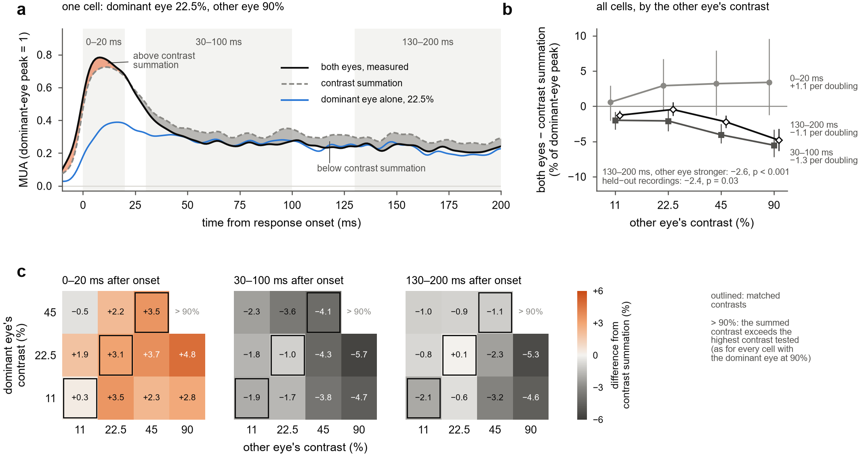
Figure 2. The eyes' contrasts add at response onset; afterwards the binocular response falls short of contrast summation in proportion to the other eye's contrast. Each channel is aligned to its own response onset and scaled to its dominant-eye peak at 90%; penetration means of channel means. Contrast summation: the dominant eye's response at the summed contrast c_D + a·c_O, with the penetration's eye weight a. (a) One cell of the design, dominant eye 22.5% and other eye 90%: both eyes (black), contrast summation (dashed) and the dominant eye alone at 22.5% (blue); orange, both eyes above the prediction; grey, below it. Mean over the 18 penetrations in which the prediction could be made (c_D + a·c_O ≤ 90%); 5 ms running mean. Grey bands, the three analysis windows. (b) Both eyes minus contrast summation in each window, against the other eye's contrast, averaged over the dominant eye's contrasts (11–45%) in each penetration; mean and 95% bootstrap confidence interval over 26 penetrations (23 at 90%). Labels give the slope per doubling of the other eye's contrast from the linear mixed model; the inset text gives the 130–200 ms shortfall over the cells in which the other eye's contrast was higher, for all penetrations and for the eight held-out recordings. (c) The same measure for every cell, one matrix per window: rows, the dominant eye's contrast; columns, the other eye's; values in % of the dominant-eye peak, means over penetrations (26 per cell; 23 and 18 with the other eye at 90% and the dominant eye at 11 and 22.5%). Outlined, matched contrasts. “> 90%”: cells in which the summed contrast c_D + a·c_O exceeded 90%, the highest contrast tested, in most penetrations (in 20 of 26 for this cell), so that contrast summation could not be predicted; for the same reason no cell is shown with the dominant eye at 90%.

Normalization is strongest in and above layer 4
We then asked where in the column this normalization occurs. At 45% in each eye, the additivity index fell below its contrast-summation reference within about 30 ms of onset in every compartment, but the gap was larger in and above layer 4 than in layers 5 and 6 (Fig 3a; every depth in Supplementary Fig S2). From 30 to 100 ms after onset, the index was 0.54 against 0.68 predicted in layers 2/3, 0.56 against 0.72 in layer 4 and 0.58 against 0.61 in layers 5 and 6 (medians over 12 penetrations; Fig 3b). Layers 5 and 6 fell short of contrast summation by 0.11 less than layer 4 (9 of 12 penetrations, p = 0.006). Layers 2/3 and layer 4 did not differ (p = 0.34).
In response units, the shortfall at 45% from 30 to 100 ms was 2.9% of the dominant-eye peak smaller in layers 5 and 6 than in layer 4 (9 of 12 penetrations, p = 0.017, with the same sign in odd and in even presentations), and per channel it shrank by 3.5% per mm of depth (237 channels, p < 0.001). The difference held in the 9 penetrations whose top of cortex was on the array (4.2%, p = 0.020) and in all 22 penetrations with a depth reference (4.3%, 19 of 22, p < 0.001). With finer labels, which place three or fewer channels in each compartment, layer 5 and layer 6 each normalized less than layer 4C by similar amounts (2.3% and 2.4%; p = 0.12 and 0.065; Supplementary Fig S3).
The laminar profile of onset differed from that of normalization (Fig 3c). Responses began in layer 4 and in layers 5 and 6 within about 3 ms of each other (29–32 ms after stimulus onset for both eyes at 45%), and progressively later above layer 4, reaching about 41 ms 1.2 mm above the layer 4C/5 boundary. Layers 2/3 began 7.8 ms later than layer 4 (dominant eye at 90%; 12 of 12 penetrations, p < 0.001), whereas layers 5 and 6 did not differ reliably from layer 4 (1.9 ms earlier, 8 of 12 penetrations, p = 0.42). Adding the other eye advanced the onset in layers 2/3 (2.4 ms, 11 of 12 penetrations, p < 0.001) and in layer 4 (1.1 ms, 10 of 12, p = 0.013), but only slightly in layers 5 and 6 (0.3 ms, 8 of 12, p = 0.10).
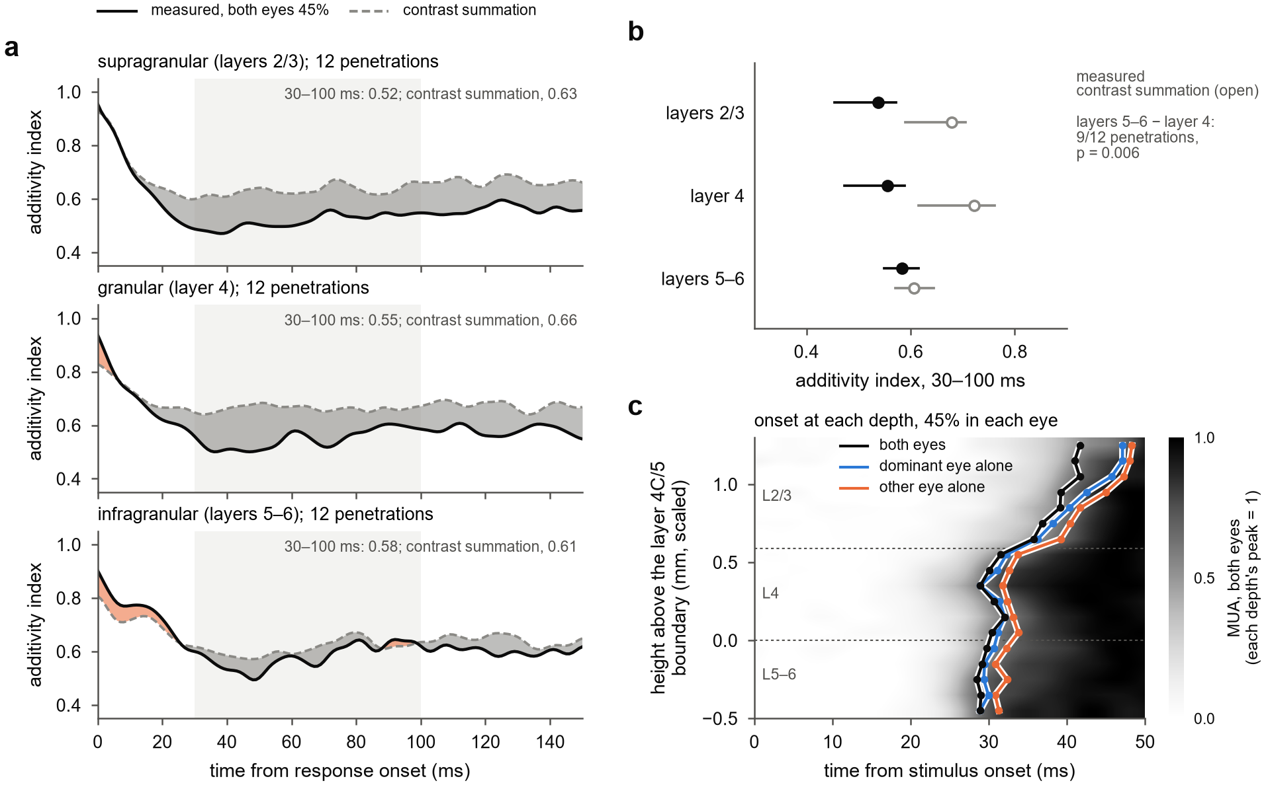
Figure 3. Normalization is strongest in and above layer 4. Main laminar set: 12 penetrations (both monkeys) whose depth reference passed the thickness checks (Methods). Height above each penetration's layer 4C/5 boundary, scaled by the ratio of the measured to the expected thickness of the layers above it: layers 2/3, more than 0.59 mm above; layer 4, the 0.59 mm above; layers 5 and 6, the 0.49 mm below. (a) Additivity index (both eyes divided by the sum of the two monocular responses) at 45% in each eye over time from response onset, in each compartment. Measured (solid) and contrast summation (dashed, the index predicted if the two eyes' contrasts add); orange where the measured index exceeds contrast summation, grey where it falls below; light band, 30–100 ms; values, means over 30–100 ms. Ratio of the population means of channel means over the penetrations with at least two channels in the compartment; 5 ms running mean. The index at every 0.2 mm is in Supplementary Fig S2. (b) The index 30–100 ms after onset in each compartment: measured (filled) and contrast summation (open); medians and interquartile ranges over penetrations; one-sided Wilcoxon signed-rank test of the difference between layers 5–6 and layer 4 in the gap to contrast summation. (c) The first 50 ms at each height (0.1 mm bins with at least 8 penetrations): MUA for both eyes at 45%, each bin scaled to its own peak, with the median onset for both eyes, the dominant eye alone and the other eye alone at 45%; time from stimulus onset; dashed lines, the compartment boundaries.

A delayed normalization pool weighted toward the other eye reproduces the sequence
We next asked what form of normalization produces contrast summation at onset followed by a shortfall that grows with the other eye's contrast. We extended the delayed normalization model of Zhou et al. (2019) to two eyes (Fig 4a). The excitatory drive sums the two eyes' contrasts, with a drive weight on the other eye. The normalization pool sums them with a separate pool weight and divides the drive after a low-pass delay. We fitted the model to the full 6 × 6 set of time courses of three depth groups in each penetration (21 penetrations, 57 groups) and, for the laminar comparison, of each compartment of the main laminar set (11 penetrations, 33 compartments) and scored it on held-out presentations, in both directions of a split into odd and even presentations. With the median fitted parameters, the model produces the sequence of Fig 2: the drive adds the two eyes at once, the pool catches up over tens of milliseconds, and the binocular response falls toward that of the dominant eye alone (Fig 4a). The fits reproduced both phases, at about half their size: at 45% in each eye, the fitted binocular response exceeded contrast summation by 1.2% of the dominant-eye peak in the first 20 ms after onset (data, 4.8%) and fell short of it by 2.7% from 30 to 100 ms (data, 5.5%; medians over 21 penetrations; Fig 4b).
A delay was needed in every compartment. Without it, the fitted binocular response fell short of contrast summation from onset (by 2.2% in the first 20 ms; Fig 4b), because a pool that divides at once cannot let the eyes add first. Fitted to each compartment of the main laminar set (11 penetrations; one had too few presentations to fit, Methods), the delayed pool reduced held-out error compared with a static pool by a median 48% in layers 2/3, 75% in layer 4 and 67% in layers 5 and 6 (11 of 11 penetrations in each; p < 0.001). The fitted pool time constant was 50 ms in layer 4 and 41 ms in layers 5 and 6. In layers 2/3 it was shorter (16 ms), which may reflect the later and more variable superficial onsets blurring the compartment average; we do not interpret it.
The pool weighted the other eye more than the drive did, in every compartment (Fig 4d). The other eye's drive weight was 0.76, 0.69 and 0.82 of the dominant eye's in layers 2/3, layer 4 and layers 5 and 6, and its pool weight 0.94, 1.09 and 0.98 (excess pool weight 0.22, 0.43 and 0.11; 10, 10 and 11 of 11 penetrations; p ≤ 0.002 in each). Freeing the pool weight from the drive weight improved held-out predictions in every compartment (10, 10 and 9 of 11 penetrations; p ≤ 0.003). This asymmetry lets the binocular response fall toward the response of the dominant eye alone, and it makes the shortfall grow with the other eye's contrast, which enters the pool more strongly than the drive. With equal weights in drive and pool, the fitted binocular response stayed at contrast summation for every contrast of the other eye, whereas the data fell short by 1.9% at 11% and 7.0% at 90%, and the conductance fits by 0.5% and 5.8% (30–100 ms; Fig 4c). The excess weight was smaller in layers 5 and 6 than in layer 4, but not significantly (−0.21; 8 of 11 penetrations, p = 0.054).
Two variants improved the fits slightly. Letting the pool also shorten the response's time constant, as inhibition that increases membrane conductance would (Carandini, Heeger & Movshon 1997), reduced held-out error by 3.8% in layers 2/3 and 1.5% in layer 4, with no gain in layers 5 and 6. A two-stage form, in which each eye is first gain-controlled by the other before the binocular pool (Meese, Georgeson & Baker 2006), reduced it below the fixed-delay model by 5.0%, 2.5% and 1.3% (p = 0.074, 0.009 and 0.034). A recurrent normalization circuit (a binocular version of the model of Heeger & Zemlianova 2020) did not improve on the conductance form in any compartment. All models reproduced the shortening of latency with contrast and the earlier onset of binocular responses, because a stronger drive reaches half its peak sooner, so these features do not distinguish them. Fitted in each compartment, the conductance model reproduced the weaker normalization of layers 5 and 6 (Fig 4e): the shortfall at 45% from 30 to 100 ms was 2.6% of the dominant-eye peak smaller in layers 5 and 6 than in layer 4 in the data (9 of 11 penetrations, p = 0.021) and 2.5% smaller in the conductance fits (8 of 11, p = 0.021), consistent with the smaller excess pool weight in layers 5 and 6. The two-stage form gave a larger but more variable difference (4.3%, p = 0.10). In an earlier analysis with depth groups from all 21 penetrations with a depth reference, before the thickness checks, the conductance fits had reproduced less of the difference (0.8% against 4.5%) and the two-stage form most of it.
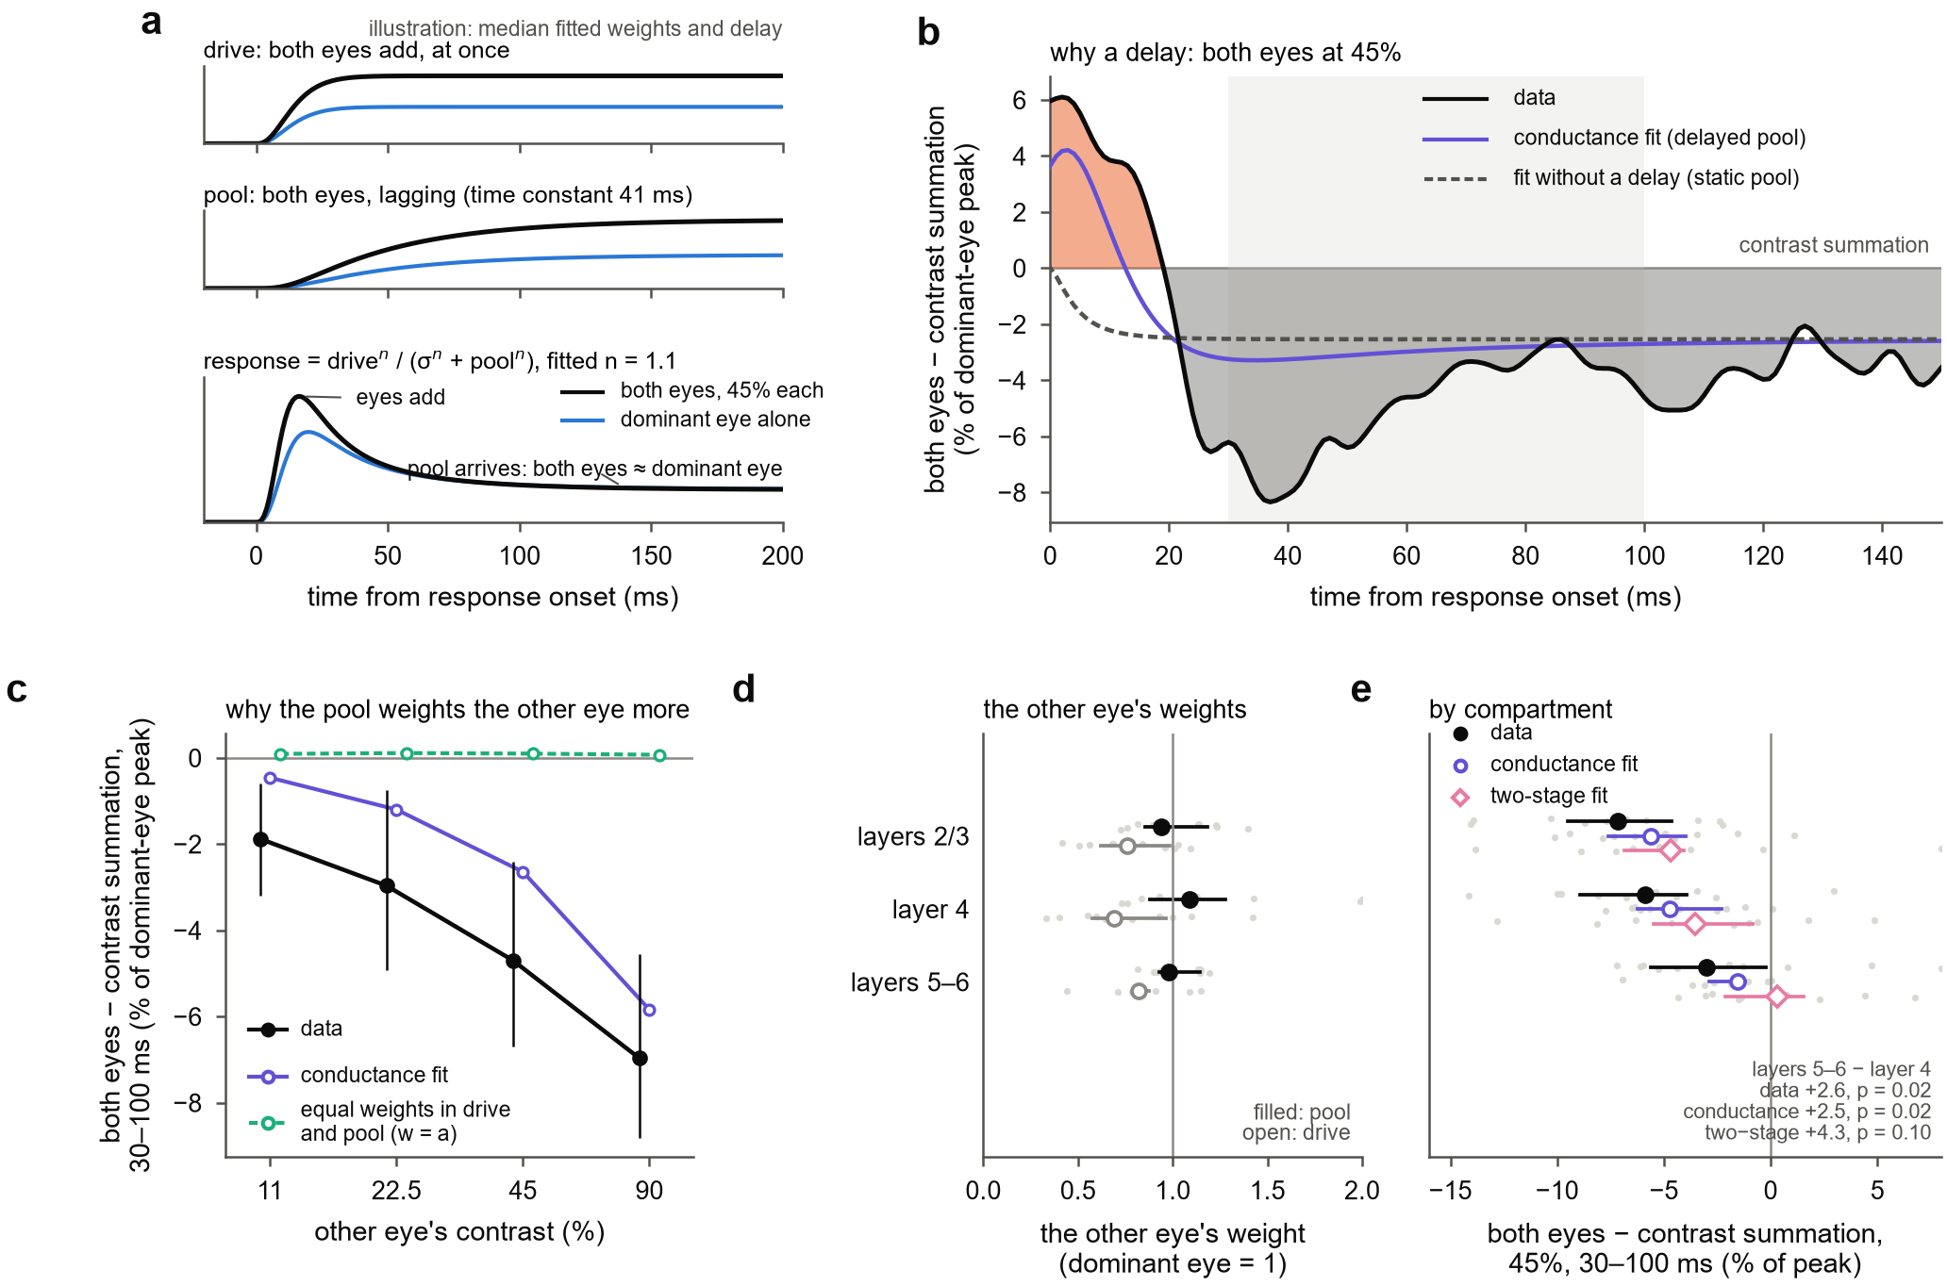
Figure 4. A delayed normalization pool that weights the other eye more than the drive does reproduces the sequence and, fitted in each compartment, its laminar difference. (a) The model, drawn with the median fitted weights, exponent and pool time constant of the conductance fits; both eyes at 45% (black) and the dominant eye alone at 45% (blue). Top, the excitatory drive: the two eyes' contrasts add at once. Middle, the normalization pool, which sums the two eyes with its own weight and lags the drive. Bottom, the response, drive^n / (σ^n + pool^n): both eyes exceed the dominant eye alone at first, then approach it as the pool arrives. (b) Both eyes minus contrast summation at 45% in each eye, in % of the dominant-eye peak, over time from response onset: data (orange where above contrast summation, grey where below), conductance fits, and fits without a delay (static pool: the fixed-delay model with the pool undelayed). Each trace is computed from its own response onset, eye weight and contrast-summation prediction; means over 21 penetrations of the mean over each penetration's depth groups; 5 ms running mean; light band, 30–100 ms. (c) The same difference 30–100 ms after onset against the other eye's contrast, averaged over dominant-eye contrasts of 11, 22.5 and 45% where contrast summation can be predicted: data (means and 95% bootstrap confidence intervals over penetrations), conductance fits, and fits with equal weights for the other eye in drive and pool (the fixed-delay model with w = a). (d) The other eye's weight in the drive (open) and in the pool (filled), conductance fits, relative to the dominant eye's (vertical line, 1), in each compartment of the main laminar set (11 penetrations); grey dots, penetrations; medians and interquartile ranges. (e) Both eyes minus contrast summation at 45%, 30–100 ms, in each compartment: data, conductance fits and two-stage fits; grey dots, penetrations; medians and interquartile ranges; one-sided Wilcoxon signed-rank tests of the difference between layers 5–6 and layer 4.

Discussion
In awake macaque V1, the two eyes' contrasts add at the onset of the response. Within about 30 ms, the binocular response falls short of contrast summation by an amount set by the other eye's contrast, and when the other eye's contrast exceeds the dominant eye's, the shortfall persists through at least 200 ms. Response onsets follow the combined drive of the two eyes. Normalization is strongest in and above layer 4 and weaker in layers 5 and 6. A normalization pool that acts with a delay of about 45 ms and weights the other eye more than the drive does reproduces this sequence in every compartment and, fitted in each, the weaker normalization of layers 5 and 6.

Relation to earlier measurements
Earlier recordings in awake macaque V1 found binocular facilitation in an early window and its loss or reversal in a later one (Cox et al. 2019; Dougherty et al. 2019; Mitchell et al. 2022; Carlson et al. 2023), with equal contrasts in the two eyes or a single pair of contrasts. Time-averaged responses from the recordings analysed here showed that ocular dominance shapes how the other eye's contrast is combined (Mitchell et al. 2023). Our results resolve the combination in time across the full dichoptic design, on each site's own response clock. They show that the early phase is summation of the two eyes' contrasts in every combination tested; that the later shortfall depends on the other eye's contrast rather than on whether the contrasts match; and that it persists when the other eye is the stronger one, whereas with matched contrasts it is largely transient. A brief phase of contrast summation is compatible with the sublinear combination reported over longer windows (Mitchell et al. 2022), because the normalized state dominates any average over hundreds of milliseconds. Measurements that integrate over seconds, such as fMRI and steady-state EEG, report near ocularity invariance (Moradi & Heeger 2009; Baker & Wade 2017), the state our responses approached within about 50 ms of onset.

The second eye as drive
Onset latency fell with response strength across all 35 conditions, and adding the second eye advanced the onset by 1.5–1.9 ms at every contrast, and in and above layer 4. In humans, binocular visual evoked potentials peak about 3 ms earlier than monocular ones (Plainis et al. 2011), whereas in macaque V1 the latency of binocular responses has been reported to follow the dominant eye (Romero et al. 2007). Measured at sub-millisecond resolution across the layers, the advance is clear in and above layer 4 and small below it. Binocular responses also began about 1 ms earlier than a single eye driving a response of the same peak, and within one eye the onset gained little between 45 and 90% contrast. One reading, which we did not test, is that the latency of a monocular signal is limited before the cortex, whereas a second eye adds drive through a separate pathway. Because binocular responses begin earlier, comparisons with monocular responses at fixed times after stimulus onset overstate the binocular gain on the rising edge. Comparing with the response to the summed contrast, which also begins earlier, reduces this bias, but part of the surplus in the first 20 ms remains a matter of timing.

What the normalization requires
Two features of the data constrain models of binocular normalization. First, the pool must act with a delay: a static pool cannot produce contrast summation at onset followed by a shortfall, and the delay reduced held-out error by 48–75% in every compartment. Second, the pool must weight the other eye more than the drive does, or binocular responses could not fall toward the level of the dominant eye alone. The same asymmetry explains why the shortfall grows with the other eye's contrast and persists when that eye is the stronger one: a stronger other eye adds more to the pool than to the drive. A pool close to balanced between the eyes, with ocular dominance acting mainly on the drive, agrees with earlier time-averaged analyses of these recordings (Mitchell et al. 2023) and with the dependence of binocular combination on ocular dominance in superficial V1 (Zhang et al. 2024); our results show that this weighting acts with a delay of tens of milliseconds, in every compartment.
Monocular contrast normalization has been reported to be fully expressed within 10 ms of response onset in anesthetized V1 (Albrecht et al. 2002), whereas interocular normalization in our data took hold 20–30 ms after onset, with a fitted pool time constant of about 45 ms. The difference may reflect the preparation, the measure (the shape of the contrast–response function, rather than a comparison with contrast summation), or both; our data do not decide between these. Other forms of suppression in V1 also differ in speed: cross-orientation suppression is fast (Smith, Bair & Movshon 2006), whereas surround suppression is delayed (Bair, Cavanaugh & Movshon 2003). Interocular normalization resembles surround suppression in this respect, consistent with evidence that interocular suppression depends on cortical inhibition (Sengpiel & Vorobyov 2005).
Among the model forms, a conductance pool, which both divides the response and shortens its time constant, and a two-stage form, in which each eye is first gain-controlled by the other (Meese, Georgeson & Baker 2006; Ding & Sperling 2006), improved predictions slightly. The gains were 0–5%, so we read them as preferences rather than demonstrations. The conductance form agrees with the view that normalization in V1 is implemented partly by shunting inhibition (Carandini, Heeger & Movshon 1997). A recurrent circuit in which normalization is computed from the responses themselves (Heeger & Zemlianova 2020) did not improve on the conductance form in any compartment.

The laminar profile
Normalization was strongest in and above layer 4 and weaker in layers 5 and 6. Fitted in each compartment, the delayed pool reproduced this difference, with a smaller excess weight of the other eye in the pool in layers 5 and 6, although that difference in weight was not significant. When depth groups were drawn from every penetration, before the thickness checks, the single-stage pool reproduced less of the difference and a two-stage form, in which each eye is first gain-controlled by the other, reproduced more of it; which form underlies the laminar difference therefore remains open. The weaker deep normalization could also reflect a different time course of inhibition in the deep layers, or a mixture of signals arriving early from the thalamus, which projects to layer 6 as well as to layer 4C (Hubel & Wiesel 1972; Blasdel & Lund 1983), and later from the superficial layers.

Alternative explanations
Three alternatives deserve comment. First, the measure: the contrast-summation prediction depends on the eye weight and on interpolation between the contrasts tested, but the shortfall's dependence on the other eye's contrast, the comparison between time windows and the comparison between depths use the same prediction throughout, and the result held in odd and even presentations, in each monkey, in held-out recordings and in the additivity index. Second, eye movements and arousal: presentations with saccades were excluded, and every result held separately for presentations with smaller and with larger pupils before stimulus onset; only the shortfall at matched 45% contrasts differed between them, slightly larger with larger pupils (by 1.5% of the dominant-eye peak, p = 0.038). Third, small errors of vergence change the interocular phase of the gratings and could turn facilitation into suppression in cells selective for binocular phase. We could not measure vergence, because the position of only one eye was recorded in most sessions, but four arguments make this explanation unlikely. Vergence in fixating macaques varies by 1 arcmin or less (Read & Cumming 2003), which shifts the interocular phase of a 1–4 cycle/deg grating by only 6–24°. Binocular phase tuning in macaque V1 changes little with contrast (Smith et al. 1997b), so a phase error would scale binocular responses by a factor independent of contrast rather than produce a shortfall that grows with the other eye's contrast. MUA pools many neurons, including complex cells with little phase selectivity. And the sequence occurred in all 26 penetrations, whose receptive fields and gratings differed.
The conclusions have limits. The gratings were static and identical in the two eyes apart from contrast, so the results do not address disparity, orientation conflict or masking. The results rest mainly on MUA at 100 µm spacing (50 µm in three early sessions of monkey B); isolated units were few, and they confirm the later shortfall but not contrast summation at onset within single neurons. Two monkeys contributed unequal numbers of penetrations (8 and 18), and the held-out recordings came from one monkey and replicated the sustained shortfall but not, significantly, its grading with the other eye's contrast. The electrophysiological markers of depth disagreed by more than the thickness of layer 4C in some penetrations; we therefore based the depth analyses on the 12 penetrations in which the reference was consistent with the thickness of the layers above it, and the difference between layer 4 and layers 5 and 6 held in all penetrations with a reference. Labels within layer 4 and between layers 5 and 6 are less certain than the three-way division.

A prediction
Binocular combination in V1 is therefore not a fixed rule but a sequence that unfolds within tens of milliseconds. This predicts that the binocular signal V1 sends onward depends on stimulus duration: for presentations of a few tens of milliseconds, it approximates summation of the two eyes' contrasts, and for longer presentations it reflects the normalized state, in which the other eye's contrast reduces the binocular response. Perceptual binocular summation behaves in this way. It is largest for presentations of about 50 ms and absent at 100 ms or more (Bearse & Freeman 1994), and binocular combination is more linear for brief, low-contrast stimuli than for long, high-contrast ones (Ding, Klein & Levi 2013). Recording V1 responses to dichoptic stimuli of varied duration, together with perceptual reports, would test whether the time course measured here sets the duration dependence of binocular perception.

Methods

Animals
Two adult male macaques were used: a bonnet macaque (Macaca radiata; monkey B) and a rhesus macaque (Macaca mulatta; monkey J). In two surgeries under isoflurane anaesthesia (1.5–2.0%) and sterile conditions, each was implanted with a plastic head holder and a recording chamber (Crist Instruments), fixed to the skull with ceramic screws (Thomas Recording) and dental acrylic, and a craniotomy was made over the parafoveal representation of V1. Analgesics and antibiotics were given after surgery. All procedures followed National Institutes of Health guidelines and were approved by the Vanderbilt University Institutional Animal Care and Use Committee. Monkey B was recorded in right V1 (October–December 2021) and monkey J in left V1 (October–December 2022). Time-averaged responses from these recordings were reported by Mitchell et al. (2023), who describe the procedures in more detail; the selection of penetrations and channels here is our own.

Task and stimuli
The task ran in NIMH MonkeyLogic 2. The monkeys viewed a ViewPixx display (VPixx Technologies; 1920 × 1080 pixels, 120 Hz) through a mirror stereoscope at a viewing distance of 60 cm (monkey B) or 73 cm (monkey J; 67 cm in one session). Each trial began once the monkey had held its gaze for 200 ms within 1° of a central fixation cross shown to both eyes, and fixation had to be held within that window throughout the trial. Two mirrors in front of each eye directed its line of sight to its own half of the screen, and a black septum between the halves kept each eye from seeing the other half. Because the two eyes' gratings occupied the same rows of the display, both were drawn at the same time in each frame. Each trial showed three gratings, each for about 317 ms with about 317 ms between them, followed by a juice reward. In one penetration, gratings lasted about 217 ms.
Gratings were static sinusoids matched to the multi-unit receptive field in orientation, spatial frequency (1–4 cycles/deg), size and position, and identical in the two eyes apart from contrast. Receptive fields were mapped with brief static random-noise patches presented at grid positions to each eye and to both eyes, and orientation and spatial frequency were chosen from tuning runs with gratings (Mitchell et al. 2023). Each eye's Michelson contrast was 0, 0.055, 0.11, 0.225, 0.45 or 0.9, chosen independently, giving 36 conditions in random order with about 30 presentations each.

Recording
We recorded with 32-contact linear arrays (Plexon, 100 µm spacing; in three early sessions of monkey B, NeuroNexus, 50 µm spacing) and a Blackrock Cerebus system. Each array was lowered through the intact dura with a chamber-mounted microdrive (Narishige) until its contacts spanned the cortical thickness, and its shaft served as the reference. Wideband signals were sampled at 30 kHz and LFP at 1 kHz. On seven days in monkey J, two arrays were recorded at once in separate columns; on these days each array was also recorded while the grating was centred on the receptive fields of the other array (held-out recordings). Stimulus onsets were taken from a photodiode on the display, and the 3.4 ms offset between the 30 kHz and 1 kHz file clocks was corrected.
MUA was the envelope of the wideband signal: band-pass 500–5000 Hz (4th-order Butterworth, zero phase), full-wave rectification, low-pass 200 Hz, resampled to 1 kHz. CSD was −σ∂²V/∂z² of the LFP (σ = 0.4 S/m, with each array's contact spacing). Before differentiation, contacts with evoked amplitude outside 0.6–1.6 times the median of their neighbours were interpolated, and a three-point Hamming filter was applied across depth.
Single units came from curated Kilosort sorts, with a spike-time offset corrected, and from Kilosort 4 (Pachitariu et al. 2024) for five penetrations without a sort. Units were included if refractory-period contamination (Hill et al. 2011) was below 0.5 and signal-to-noise ratio was at least 3. A strict set also required contamination below 0.1, amplitude cutoff below 0.1 and presence ratio of at least 0.9.

Eye position and presentation selection
The position of one eye was recorded with an infrared eye tracker (EyeLink II, SR Research) through the infrared-transparent mirrors of the stereoscope, as analog gaze signals calibrated in MonkeyLogic. Saccades were detected with a velocity threshold (Engbert & Kliegl 2003; λ = 6, minimum 6 ms). We analysed completed presentations with no saccade of 1° or more between 200 ms before and 500 ms after onset. As a control for arousal, the presentations of each penetration were split at the median of the pupil signal 200 ms before stimulus onset, and the main analyses were repeated in each half.
We also excluded presentations with large MUA artifacts: a peak MUA between −50 and 450 ms more than 20 robust standard deviations (median absolute deviation × 1.4826) above the median for that channel, on any channel in cortex. Visual responses reach 6–11 such units in penetrations without artifacts. The rule removed 0.6% of presentations, mostly in monkey J.

Laminar alignment
The layer 4C/5 boundary was estimated in three ways: the depth at which the preferred phase of spikes relative to the alpha/beta LFP reverses (spike–LFP phase coupling; Vinck et al. 2010; Davis et al. 2023), if the step in phase was at least 0.5 rad; the earliest current sink evoked by either eye alone, plus 0.3 mm; and the depth at which alpha/beta (10–19 Hz) and gamma (75–150 Hz) LFP power cross (Mendoza-Halliday et al. 2024), plus 0.1 mm. The offsets are the median differences from the phase reversal in the 14 penetrations with a clear reversal. The boundary was the phase reversal if the sink or the crossing lay within 0.4 mm of it, and otherwise the mean of the sink and the crossing if these lay within 0.4 mm of each other; in 4 of 26 penetrations no two estimates agreed. The top of cortex was the most superficial contact with an evoked MUA response. Because these markers disagreed by more than the thickness of layer 4C in some penetrations, and because the array may compress or stretch the cortex by a different amount on each day, each boundary was then checked against the thickness of the layers above it: about 1.24 mm from the top of layer 2 to the bottom of layer 4C (650, 311 and 281 µm for layers 2/3, 4A/B and 4C; Zhu et al. 2026). The ratio s of the measured to this expected distance had to lie between 0.75 and 1.35, two estimates of the boundary had to agree within 0.3 mm, and the array had to extend at least 0.49·s mm below the boundary (9 penetrations). Penetrations whose top of cortex lay beyond the end of the array were included if the distance from the boundary to the end of the array was consistent with these limits (3 penetrations). These 12 penetrations (3 in monkey B, 9 in monkey J) formed the main laminar set; the other 10 with a boundary were used only to check the results. Heights above the boundary were divided by s (s = 1 where the top lay beyond the array), and channels were labelled supragranular (layers 2/3; more than 0.59 mm above the boundary), granular (layer 4; 0–0.59 mm above) or infragranular (layers 5 and 6; 0–0.49 mm below); deeper channels were excluded. For finer labels, layer 4 was divided 0.28 mm above the boundary into 4A/B and 4C, and layers 5 and 6 were divided 0.22 mm below it. All markers, checks and labels were set from laminar recordings and monocular responses only.

Responses
A channel was analysed if it lay in cortex and its response varied with the contrast of at least one eye shown alone (one-way ANOVA over the six contrasts, p < 0.01, 40–140 or 150–250 ms after onset, peak above baseline). Condition means were computed over clean presentations, blank-subtracted and smoothed with a Gaussian (σ = 2 ms).
The dominant eye was the eye with the larger mean response at 90%, 40–250 ms. Each channel was scaled by its dominant-eye peak at 90%. The onset of a condition was the first time between 10 and 250 ms after stimulus onset at which the response reached half its own peak, interpolated linearly between samples; it was not defined if that peak was below 0.2 of the dominant-eye peak at 90%. A channel's response onset, used to align its responses, was the onset of its response to the dominant eye at 90%. Onsets were summarized as medians over channels in each penetration (and depth group), then over penetrations.

Contrast summation and the additivity index
The eye weight a was the contrast scale, between 0.05 and 1, that best mapped the dominant eye's monocular contrast–response function (mean response 40–250 ms) onto the other eye's (least squares over the five non-zero contrasts); each penetration's median over channels was used. The response predicted if the two eyes' contrasts add (contrast summation) was the dominant eye's response at the summed contrast c_D + a·c_O, interpolated at each time point linearly in log contrast between the measured contrasts. It was computed where both contrasts were at least 11% and c_D + a·c_O did not exceed 90%. The shortfall from contrast summation was the binocular response minus this prediction, from channel means aligned to response onset, in units of the dominant-eye peak at 90%, averaged 0–20, 30–100 and 130–200 ms after onset.
The additivity index was the binocular response divided by the sum of the two monocular responses, as a ratio of window means of channel means, computed where the denominator exceeded 0.12 of the dominant-eye peak. Its contrast-summation reference was the contrast-summation prediction divided by the same denominator, with each channel's own eye weight in depth analyses; linear summation of the monocular responses corresponds to an index of 1. For the onset of the contrast-summation prediction, the dominant eye's onset at c(1 + a) was interpolated linearly in log contrast between its onsets at the measured contrasts.

Single units and held-out recordings
Isolated units (lenient criteria below) were analysed as MUA channels, with each unit's own dominant eye, scale, onset and eye weight; for each eye at 45%, the other eye's contribution was compared with its contrast-summation prediction 0–20 and 30–100 ms after the unit's onset. For the held-out recordings, channels were included if their response varied with the dominant eye's contrast (one-way ANOVA, 40–250 ms, p < 0.01); the eight recordings with at least five such channels were analysed with the same measure as the main data, with a random intercept per recording.

The earliest current sink
The earliest sink was found in the current evoked by either eye alone: among channels whose sink 20–70 ms after stimulus onset reached at least 40% of the strongest, the one whose sink first reached 25% of its own peak.

Statistics
The penetration is the unit of replication, because neighbouring channels share signal. The main claims were tested with linear mixed models (statsmodels, restricted maximum likelihood) with a random intercept per session (two arrays were recorded in one session on dual-probe days) and monkey as a sum-coded fixed effect, reported two-sided. Over the dichoptic design, the shortfall was modelled as S ~ window × (x_O + x_D) + monkey, with x = log2(c / 22.5%), a random intercept per session and a variance component per penetration. Depth-group differences were tested with one-sided Wilcoxon signed-rank tests over penetrations for directional predictions, and two-sided tests otherwise; the per-channel depth profile with a linear mixed model with a random intercept per penetration. Each directional effect was also required to have the same sign in odd and in even presentations. Confidence intervals are bootstrap intervals with 2000 resamples of penetrations.

Models
In the fixed-delay normalization model, after Zhou et al. (2019), the drive is E(t) = (c_D + a·c_O)·u(t) and the pool P(t) = (c_D + w·c_O)·v(t), with response R = g·E^n / (σ^n + P^n). Here a and w are the drive and pool weights of the other eye, u(t) is the step response of a gamma filter (shape 3, time constant τ1) delayed by δ, and v(t) is u(t) passed through an exponential low-pass filter with time constant τ2. Static normalization sets v = u; the equal-weight version sets w = a. The fitted drive weight a is the model's counterpart of the measured eye weight.
In the conductance model, the response relaxes toward the fixed-delay value with an effective time constant τ_m / (1 + (P/σ)^n): τ_m·dR/dt = g·E^n/σ^n − (1 + (P/σ)^n)·R, so the pool both divides the response and shortens its time constant. As τ_m approaches 0, the model reduces to the fixed-delay model. In the recurrent model, a binocular version of ORGaNICs (Heeger & Zemlianova 2020), the normalization signal is computed recurrently from the responses. In the two-stage model, each eye is first divided by a delayed sum of its own and the other eye's contrast before the fixed-delay stage (after Meese, Georgeson & Baker 2006).
Models were fitted by least squares, with several starting points, to the full 6 × 6 time courses 0–219 ms after stimulus onset of the channel mean of each of three depth groups in each penetration (Fig 4b, c) and of each compartment of the main laminar set (Fig 4d, e; groups with at least three channels), and, for comparison, of single channels. Held-out error was the summed squared error on even presentations for fits to odd presentations and vice versa, summed over both directions. One penetration, with 217 ms stimuli and few presentations, had no condition with enough presentations in its even half and was excluded. Model comparisons used one-sided Wilcoxon signed-rank tests on the log ratio of held-out errors, and required the median of each direction to favour the same model.

Code and data
All analyses are in the v1-laminar-binocular repository, which will be made public on publication together with the processed data. Each figure is produced by one script from saved analysis outputs.

References
- Albrecht DG, Geisler WS, Frazor RA, Crane AM (2002). Visual cortex neurons of monkeys and cats: temporal dynamics of the contrast response function. J Neurophysiol 88:888–913.
- Bair W, Cavanaugh JR, Movshon JA (2003). Time course and time-distance relationships for surround suppression in macaque V1 neurons. J Neurosci 23:7690–7701.
- Baker DH, Meese TS, Georgeson MA (2007). Binocular interaction: contrast matching and contrast discrimination are predicted by the same model. Spat Vis 20:397–413.
- Baker DH, Wade AR (2017). Evidence for an optimal algorithm underlying signal combination in human visual cortex. Cereb Cortex 27:254–264.
- Bearse MA Jr, Freeman RD (1994). Binocular summation in orientation discrimination depends on stimulus contrast and duration. Vision Res 34:19–29.
- Blasdel GG, Lund JS (1983). Termination of afferent axons in macaque striate cortex. J Neurosci 3:1389–1413.
- Carandini M, Heeger DJ (2012). Normalization as a canonical neural computation. Nat Rev Neurosci 13:51–62.
- Carandini M, Heeger DJ, Movshon JA (1997). Linearity and normalization in simple cells of the macaque primary visual cortex. J Neurosci 17:8621–8644.
- Carlson BM, Mitchell BA, Dougherty K, Westerberg JA, Cox MA, Maier A (2023). Does V1 response suppression initiate binocular rivalry? iScience 26:107359.
- Cox MA, Dougherty K, Westerberg JA, Schall MS, Maier A (2019). Temporal dynamics of binocular integration in primary visual cortex. J Vis 19(12):13.
- Davis ZW, Dotson NM, Franken TP, Muller L, Reynolds JH (2023). Spike-phase coupling patterns reveal laminar identity in primate cortex. eLife 12:e84512.
- Ding J, Klein SA, Levi DM (2013). Binocular combination of phase and contrast explained by a gain-control and gain-enhancement model. J Vis 13(2):13.
- Ding J, Sperling G (2006). A gain-control theory of binocular combination. Proc Natl Acad Sci USA 103:1141–1146.
- Dougherty K, Cox MA, Westerberg JA, Maier A (2019). Binocular modulation of monocular V1 neurons. Curr Biol 29:381–391.
- Engbert R, Kliegl R (2003). Microsaccades uncover the orientation of covert attention. Vision Res 43:1035–1045.
- Gawne TJ, Kjaer TW, Richmond BJ (1996). Latency: another potential code for feature binding in striate cortex. J Neurophysiol 76:1356–1360.
- Heeger DJ, Zemlianova KO (2020). A recurrent circuit implements normalization, simulating the dynamics of V1 activity. Proc Natl Acad Sci USA 117:22494–22505.
- Hill DN, Mehta SB, Kleinfeld D (2011). Quality metrics to accompany spike sorting of extracellular signals. J Neurosci 31:8699–8705.
- Hubel DH, Wiesel TN (1972). Laminar and columnar distribution of geniculo-cortical fibers in the macaque monkey. J Comp Neurol 146:421–450.
- Legge GE, Rubin GS (1981). Binocular interactions in suprathreshold contrast perception. Percept Psychophys 30:49–61.
- Mendoza-Halliday D, Major AJ, Lee N, Lichtenfeld MJ, Carlson B, Mitchell B, et al. (2024). A ubiquitous spectrolaminar motif of local field potential power across the primate cortex. Nat Neurosci 27:547–560.
- Meese TS, Georgeson MA, Baker DH (2006). Binocular contrast vision at and above threshold. J Vis 6(11):7.
- Mitchell BA, Dougherty K, Westerberg JA, Carlson BM, Daumail L, Maier A, Cox MA (2022). Stimulating both eyes with matching stimuli enhances V1 responses. iScience 25:104182.
- Mitchell BA, Carlson BM, Westerberg JA, Cox MA, Maier A (2023). A role for ocular dominance in binocular integration. Curr Biol 33:3884–3895.
- Moradi F, Heeger DJ (2009). Inter-ocular contrast normalization in human visual cortex. J Vis 9(3):13.
- Pachitariu M, Sridhar S, Pennington J, Stringer C (2024). Spike sorting with Kilosort4. Nat Methods 21:914–921.
- Plainis S, Petratou D, Giannakopoulou T, Atchison DA, Tsilimbaris MK (2011). Binocular summation improves performance to defocus-induced blur. Invest Ophthalmol Vis Sci 52:2784–2789.
- Read JCA, Cumming BG (2003). Measuring V1 receptive fields despite eye movements in awake monkeys. J Neurophysiol 90:946–960.
- Romero MC, Castro AF, Bermudez MA, Perez R, Gonzalez F (2007). Eye dominance and response latency in area V1 of the monkey. Vis Neurosci 24:757–761.
- Sengpiel F, Vorobyov V (2005). Intracortical origins of interocular suppression in the visual cortex. J Neurosci 25:6394–6400.
- Smith EL 3rd, Chino Y, Ni J, Cheng H (1997a). Binocular combination of contrast signals by striate cortical neurons in the monkey. J Neurophysiol 78:366–382.
- Smith EL 3rd, Chino YM, Ni J, Ridder WH 3rd, Crawford MLJ (1997b). Binocular spatial phase tuning characteristics of neurons in the macaque striate cortex. J Neurophysiol 78:351–365.
- Smith MA, Bair W, Movshon JA (2006). Dynamics of suppression in macaque primary visual cortex. J Neurosci 26:4826–4834.
- Tanabe S, Cumming BG (2014). Delayed suppression shapes disparity selective responses in monkey V1. J Neurophysiol 111:1759–1769.
- Truchard AM, Ohzawa I, Freeman RD (2000). Contrast gain control in the visual cortex: monocular versus binocular mechanisms. J Neurosci 20:3017–3032.
- Vinck M, van Wingerden M, Womelsdorf T, Fries P, Pennartz CMA (2010). The pairwise phase consistency: a bias-free measure of rhythmic neuronal synchronization. NeuroImage 51:112–122.
- Zhang SH, Zhao XN, Jiang DQ, Tang SM, Yu C (2024). Ocular dominance-dependent binocular combination of monocular neuronal responses in macaque V1. eLife 13:RP92839.
- Zhou J, Benson NC, Kay K, Winawer J (2019). Predicting neuronal dynamics with a delayed gain control model. PLoS Comput Biol 15:e1007484.

Supplementary figures
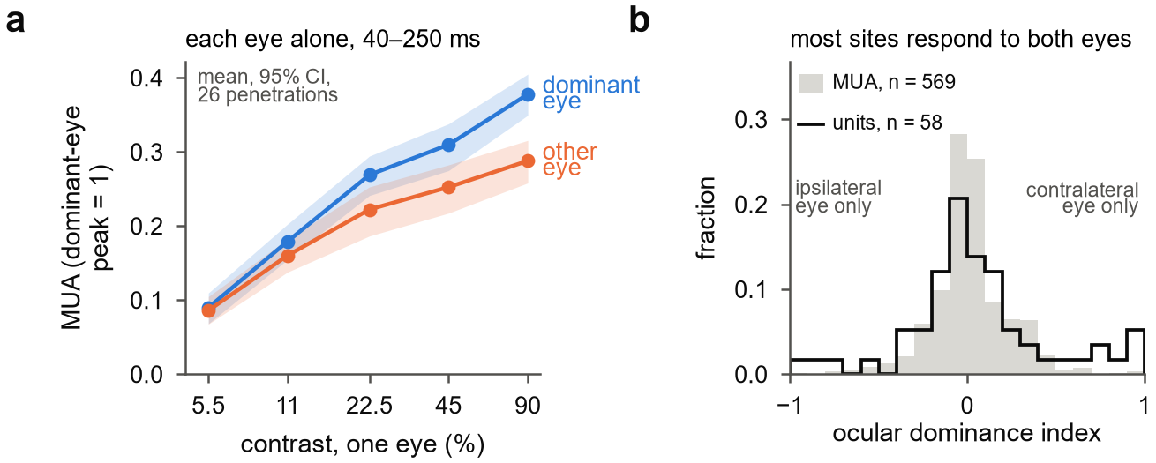
Supplementary Figure S1. Each eye alone. (a) Mean response 40–250 ms after stimulus onset to each eye alone, against contrast, in units of each channel's dominant-eye peak at 90%; mean and 95% bootstrap confidence interval over 26 penetrations. (b) Ocular dominance index at 90% contrast, the difference between the contralateral and ipsilateral responses divided by the sum of their magnitudes, for 569 driven multi-unit channels (grey) and 58 isolated single units (outline; contamination below 0.5, signal-to-noise ratio of at least 3).
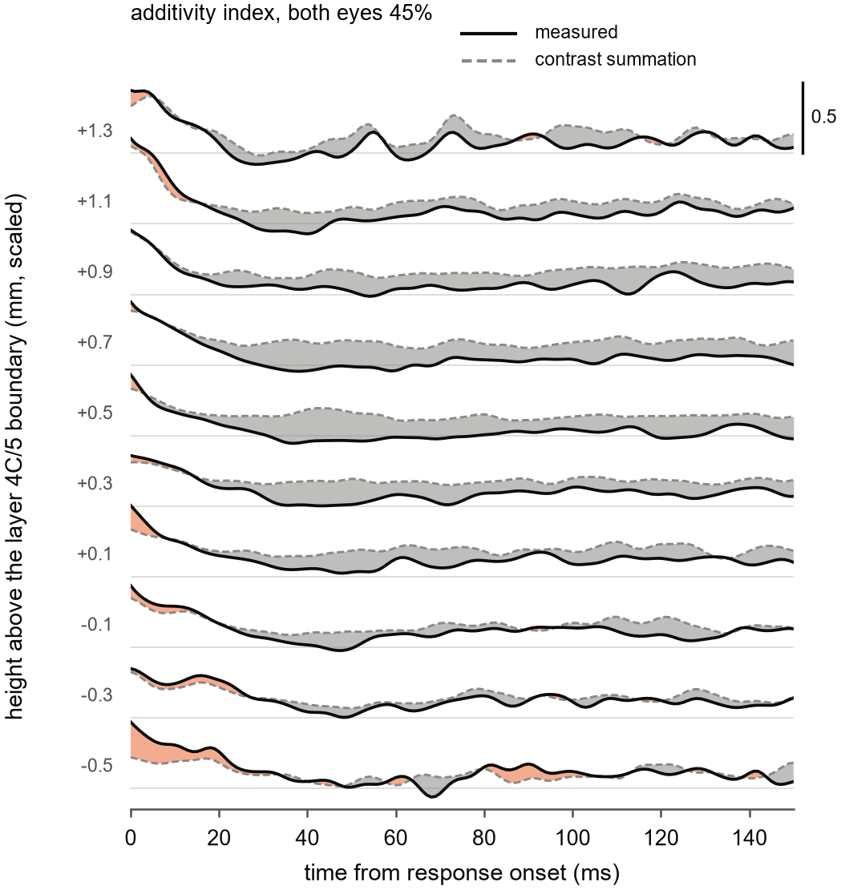
Supplementary Figure S2. The additivity index at every depth. Additivity index at 45% in each eye over time from response onset, one trace per 0.2 mm of height above the layer 4C/5 boundary (scaled as in Fig 3) with at least 10 penetrations: measured (solid) and contrast summation (dashed); orange where the measured index exceeds contrast summation, grey where it falls below; thin rules, index 0.5; 5 ms running mean; ratio of the population means of channel means over the 12 penetrations of the main laminar set. Fig 3a shows the same data pooled in three compartments.
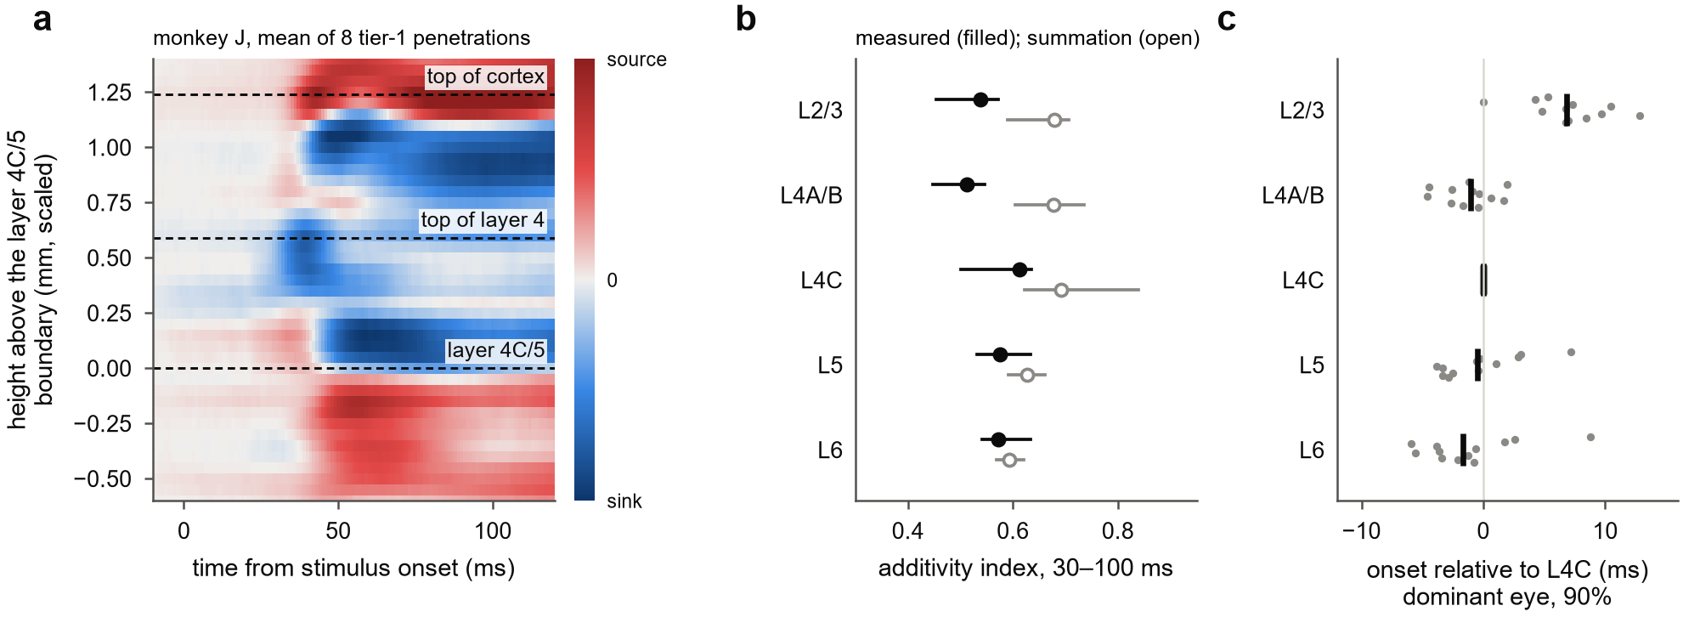
Supplementary Figure S3. The laminar compartments, and finer labels. (a) Current-source density evoked by either eye alone (45 or 90% contrast), averaged over the 8 penetrations of monkey J in which the depth reference passed every check, each aligned to its layer 4C/5 boundary, scaled by its thickness ratio and divided by its own peak before averaging; dashed lines, the top of cortex, the top of layer 4 and the layer 4C/5 boundary. The early sink in the upper part of layer 4 precedes a second sink just above the boundary by about 9 ms, and sinks give way to sources at the boundary. (b) Additivity index 30–100 ms after onset at 45% in each eye, with finer labels: layers 2/3, 4A/B (0.28–0.59 mm above the boundary), 4C (0–0.28 mm), 5 (0–0.22 mm below) and 6 (0.22–0.49 mm below); measured (filled) and contrast summation (open); medians and interquartile ranges over the 12 penetrations of the main laminar set. Layer 6 minus layer 4C in the gap to contrast summation: 8 of 12 penetrations, p = 0.065. (c) Onset for the dominant eye at 90% relative to layer 4C; grey dots, penetrations; bars, medians. With 100 µm contacts these compartments hold two or three channels each, and their boundaries are uncertain by about one contact.

