Binocular summation gives way to interocular normalization within tens of milliseconds in macaque V1
Blake A. Mitchell, Brock M. Carlson, Alexander Maier
Draft V3 · 1 November 2026

About this draft
Draft V3 (1 November 2026), revised after a reviewer's read of V2 and the analyses it prompted. The main text now has four figures; checks of the measure, model variants and timing analyses are in Supplementary Figs S1–S6 and Tables S1–S2. Every number comes from a script in the v1-laminar-binocular repository (analysis record: docs/09_paper_design.md; figures: scripts/figures/).
- Solid: linear summation for about 20 ms after onset, then interocular normalization that is stronger at higher contrast (Figs 2–3); the measure stays at linear summation for simulated responses with a fixed combination rule (Fig S2); the delay is needed for the binocular interaction itself, and the pool weights the other eye more than the drive does (Fig 4).
- Modest: the conductance model's advantage (small, mostly from monkey J); the depth profile of the late index.
- Removed since V2: normalization reaching the input layer first; interocular normalization slower than monocular; the slow rise of low-contrast responses (a noise artefact); single units mostly suppressed.

Items in [square brackets] are facts to fill in or decisions to make. The last section lists what needs work.

Abstract
Binocular vision begins in primary visual cortex (V1), where signals from the two eyes converge on single neurons. Their combination is usually described by divisive normalization, in which each eye's signal is divided by a pool that includes the other eye. Recordings in macaque V1 suggest that binocular responses are first enhanced and later suppressed, but when and how the combination rule changes is unknown. We recorded laminar multi-unit activity and current-source density in V1 of two awake macaques while each eye viewed a grating at one of six contrasts, chosen independently. We expressed each binocular response as an equivalent contrast, the dominant-eye contrast giving the same response in the same time window, a comparison unaffected by the earlier onset of binocular responses. For about 20 ms after response onset, the two eyes' contrasts summed linearly. Normalization then took hold within 15–30 ms, more strongly at higher contrast, until at 45% contrast the binocular response matched that of the dominant eye alone. Iso-response contours changed accordingly, from linear summation toward the dominant eye alone. The same sequence occurred at every cortical depth, and the earliest current sink summed the two eyes at onset. A dynamic normalization model reproduced it only if the pool was delayed and weighted the other eye more than the excitatory drive did. Binocular combination in V1 thus changes from summation to normalization within tens of milliseconds, in line with the larger binocular summation observed for brief stimuli.

Introduction
The two eyes view the world from slightly different positions, and primary visual cortex (V1) is the first stage at which their signals converge on single neurons. How V1 combines them determines what later stages of the visual system receive. The combination is usually described by divisive normalization, in which each neuron's excitatory drive is divided by the pooled activity of a population of neurons (Carandini & Heeger 2012).
Which form of normalization operates between the eyes remains disputed. In anesthetized cat simple cells, each eye's signal is gain-controlled before the two are combined (Truchard, Ohzawa & Freeman 2000). Human fMRI and steady-state EEG instead point to a binocular pool, which makes responses to one eye and to two nearly equal, a property called ocularity invariance (Moradi & Heeger 2009; Baker & Wade 2017). Psychophysical contrast matching (Legge & Rubin 1981; Baker, Meese & Georgeson 2007) requires either two stages of gain control (Meese, Georgeson & Baker 2006) or mutual gain control between the eyes (Ding & Sperling 2006). In macaque V1, the two eyes' contrasts combine linearly near threshold (Smith et al. 1997a), and ocular dominance shapes how binocular responses are normalized (Mitchell et al. 2023; Zhang et al. 2024).
These accounts describe the combination once it has settled, yet several observations suggest that it changes during the response. In awake macaque V1, stimulating both eyes enhances the early, transient response but not the sustained response (Cox et al. 2019). When both eyes view the same grating, this enhancement persists at low contrast but turns into suppression at medium and high contrast by 150–250 ms after stimulus onset (Mitchell et al. 2022). In neurons driven by one eye only, binocular facilitation appears at response onset and suppression about 12 ms later (Dougherty et al. 2019), and suppression tuned to binocular disparity lags excitation by about 7 ms (Tanabe & Cumming 2014). Perception depends on time in a similar way: binocular summation is largest for brief stimuli (Bearse & Freeman 1994), and binocular contrast combination is more linear for brief, low-contrast stimuli than for long, high-contrast ones (Ding, Klein & Levi 2013). The neural studies used response windows of 50–100 ms or longer, a single contrast pair or equal contrasts in the two eyes, and differences in spike counts rather than a test of a combination rule. When the rule changes, how the change depends on each eye's contrast, and what form of normalization produces it are therefore unknown. Normalization itself may take time: in human visual cortex it lags the response it divides (Zhou et al. 2019), and in recurrent circuit models it builds up over tens of milliseconds (Heeger & Zemlianova 2020).

Measuring how the rule changes on this time scale requires separating it from response latency. Stronger stimuli evoke responses with shorter latencies: in V1, latency shortens as contrast increases (Gawne, Kjaer & Richmond 1996; Albrecht et al. 2002), which normalization models attribute to the faster dynamics of a more strongly driven circuit (Carandini, Heeger & Movshon 1997). Stimulating both eyes acts as a stronger stimulus than stimulating one. In humans, binocular visual evoked potentials peak about 3 ms earlier than monocular ones (Plainis et al. 2011); in macaque V1, the latency of binocular responses is set largely by the dominant eye (Romero et al. 2007). If binocular responses begin even slightly earlier, comparing them with monocular responses at the same moment after stimulus onset shows a binocular excess on the rising edge of the response, whether or not the rule by which the eyes combine changes. A measure of the combination rule must therefore compare binocular and monocular responses at matched response levels within each time window, on a stimulus clock accurate to the millisecond.
We recorded laminar multi-unit activity (MUA), current-source density (CSD) and single units in V1 of two awake macaques while each eye viewed a grating at one of six contrasts, chosen independently for each eye, so that every combination of the two eyes' contrasts was tested. We expressed each binocular response as an equivalent contrast: the contrast at which the dominant eye alone produced the same response in the same time window. For about 20 ms after response onset, the two eyes' contrasts summed linearly; normalization then took hold, more strongly at higher contrast (Fig 2). The sequence occurred at every cortical depth, and the earliest synaptic current into the column summed the two eyes at onset (Fig 3). A dynamic normalization model reproduced it only with a delayed pool that weighted the other eye more than the excitatory drive did (Fig 4).

Results

Binocular combination measured with millisecond and laminar resolution
We recorded from 26 V1 penetrations in two macaques (monkey B: 8; monkey J: 18) with linear arrays of 32 contacts spaced 100 µm apart. The monkeys viewed a single monitor through a mirror stereoscope that presented each eye with its own half of the screen (Supplementary Fig S1a). Each eye saw the same static grating, matched to the receptive fields, at 0, 5.5, 11, 22.5, 45 or 90% contrast. All 36 combinations of the two eyes' contrasts were presented in random order, about 30 times each (Fig 1a).
We measured depth from the top of cortex, the most superficial contact with spontaneous MUA. The boundary between layers 4 and 5 was placed at the lower edge of the earliest current sink evoked by a full-field flash, recorded earlier in the session and matched in depth to the grating recording. Where this sink was unclear or implausibly placed, we used the laminar profile of spike–LFP phase coupling instead (Vinck et al. 2010; Davis et al. 2023; Supplementary Fig S1b; Methods). Because the two markers rarely agreed closely, we treat layer assignments as approximate and use depth below the top of cortex as the primary depth axis. Stimulus onsets were measured with a photodiode on the display.

The basic observation is visible in single penetrations (Fig 1b). At 45% contrast, the response to both eyes first rose with the response of the dominant eye to 90% contrast, about the level that linear summation of the two eyes' contrasts predicts, and then fell to the response of the dominant eye alone. The other eye drove weaker responses than the dominant eye at every contrast (Fig 1c). We summarized each channel's balance between the eyes by an eye weight, the factor that maps the other eye's contrast onto the dominant eye's contrast-response function (median 0.70). Most MUA channels were driven by both eyes, and isolated units spanned the full range of ocular dominance (Fig 1d).
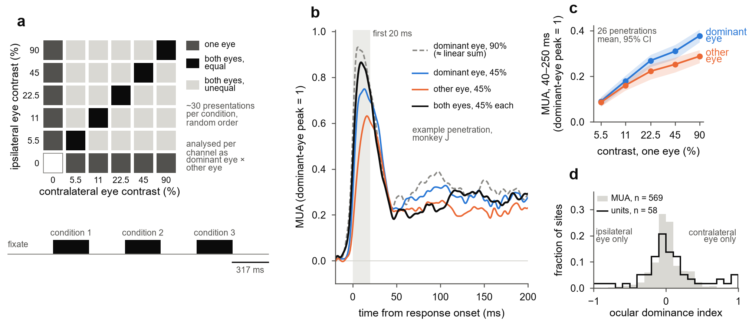
Figure 1. Dichoptic contrast design and an example penetration. (a) Each eye viewed its own half of one monitor through a mirror stereoscope (Supplementary Fig S1a) and saw a grating at 0, 5.5, 11, 22.5, 45 or 90% contrast, giving 36 conditions: one eye alone (dark grey), both eyes at equal contrast (black) and both eyes at unequal contrast (light grey). Each trial presented three conditions in random order, each for about 317 ms with 317 ms between them; each condition was shown about 30 times. Each channel was analysed with its axes reoriented to its dominant and other eye. (b) Multi-unit activity in one penetration of monkey J: mean of 28 channels, each aligned to its own response onset and scaled to its dominant-eye peak at 90% contrast. In the first 20 ms after onset (grey band), the response to both eyes at 45% approaches the response to the dominant eye at 90% (dashed), about what linear summation of the two eyes' contrasts predicts; from about 50 ms it falls to the response to the dominant eye alone at 45%. (c) Mean response 40–250 ms after stimulus onset to each eye alone, against contrast; mean and 95% bootstrap confidence interval (CI) over 26 penetrations. (d) Ocular dominance index at 90% contrast, the difference between the contralateral and ipsilateral responses divided by the sum of their magnitudes, for 569 driven multi-unit channels (grey) and 58 isolated single units (outline; contamination below 0.5, signal-to-noise ratio of at least 3).

The two eyes sum linearly at response onset, then normalize within tens of milliseconds
We first asked whether the rule by which the two eyes combine changes during the response. Fig 2a shows the population response to a grating of 45% contrast, with each channel aligned to its own response onset (the time at which its response to the dominant eye at 90% contrast reached half its peak), because onsets differ by several milliseconds across channels. For about 20 ms after onset, the response to both eyes rose as steeply as the response of the dominant eye to 90% contrast, which approximates linear summation of the two eyes' contrasts. Within a further 20–30 ms, it had fallen to the response of the dominant eye alone.
Binocular responses reached half their peak 1–2 ms before responses to the dominant eye alone at the same contrast (in 69–81% of penetrations; Methods), so comparing the two at fixed times would exaggerate the binocular excess at onset. We therefore expressed each binocular response in units of contrast. In each time window, we asked what contrast the dominant eye alone would need to produce the response evoked by both eyes (Fig 2b). A higher dominant-eye contrast also shortens latency, so this comparison absorbs the earlier onset of binocular responses instead of mistaking it for a change in the combination rule. In the first 20 ms after onset, both eyes at 45% produced the response of the dominant eye at 84%, close to the 77% predicted by linear summation of the two eyes' contrasts weighted by their strengths. From 50 to 200 ms, they produced the response of the dominant eye at only 55%.

To compare channels with different balance between the eyes, we converted the equivalent contrast into a linearity index (Methods). The index equals 1 when the binocular response matches linear summation of the two eyes' weighted contrasts and 0 when it matches the response of the dominant eye alone. Across penetrations, the index fell from 1.19 in the first 20 ms after onset to 0.61 at 50–200 ms for 11% contrast, from 1.20 to 0.47 for 22.5%, and from 0.97 to −0.11 for 45% (Wilcoxon signed-rank tests, p ≤ 0.001, 26 penetrations; Fig 2d). Late in the response at 45%, the binocular response thus matched that of the dominant eye alone. At 5.5%, responses were weak and the decline (from 1.02 to 0.50) was not significant (p = 0.15). The index cannot be computed at 90%, because no higher dominant-eye contrast exists to match the binocular response.
Three checks show that the decline reflects a change in how the eyes combine rather than a property of the measure. First, we passed simulated responses through the identical analysis. They were generated by each penetration's fitted normalization model with a fixed combination rule (the other eye weighted equally in the drive and in the pool), which preserves realistic transients and latencies. Their index stayed between 0.96 and 1.03 in every window. With the data's own noise added, it fell from early to late by only 0.11–0.23 at 45%, compared with 1.25 in the data (Supplementary Fig S2a). Second, when the dominant eye and the eye weight were chosen from one half of the presentations and the index was measured on the other half, the decline at 45% was unchanged (from 0.99 to −0.32; Supplementary Fig S2b), so selecting the dominant eye on the same data did not create it. Third, the decline occurred both in channels driven equally by the two eyes and in channels dominated by one eye (p < 0.001 in each third of the ocular dominance distribution at 45%; Supplementary Fig S2c), and in isolated single units (at 22.5%, from 1.50 to 0.19; p < 0.001; Supplementary Fig S2d). The decline also persisted when presentations with any saccade were excluded, when presentations were restricted to the middle half of pupil sizes, and in each half of the session (Supplementary Table S2). In monkey J it occurred at every contrast; in monkey B it occurred at 22.5% (8 of 8 penetrations) and 45% (7 of 8) but not at 11% (4 of 8; Supplementary Table S1).
Because each eye's contrast was varied independently, the design also shows how the rule changes when the two eyes' contrasts differ. For a given target response, we found the combinations of the two eyes' contrasts that produced it: an iso-response contour (Fig 2c). Linear summation predicts a straight line, along which the other eye's weighted contrast substitutes for the dominant eye's. If the binocular response follows the dominant eye alone, the contour is instead a vertical line at the dominant eye's contrast. We summarized each contour by a Minkowski exponent, which is 1 for linear summation and grows as the contour approaches that of the dominant eye alone. Early in the response, contours for the responses to the dominant eye at 22.5% and 45% lay on the line of linear summation (median exponents 1.00 and 0.90 across penetrations). Late in the response, they bent toward the contour of the dominant eye alone (median exponents 2.17 and 2.39; higher than early in 21 and 19 of 25 penetrations, p < 0.001; Supplementary Fig S3). Where the other eye's contrast was low, the late response to both eyes needed more dominant-eye contrast than the target itself (up to 1.36 times the target), a sign of interocular suppression. Contours built from the population-average response showed the same change (exponents 1.00 early and 2.30 late at 22.5%), although at 45% the late population contour was uncertain (exponent 1.81, 95% confidence interval 0.96 to at least 20). The contour for the response to the dominant eye at 11% changed less (median exponents 1.15 early and 1.38 late, 15 of 25 penetrations).

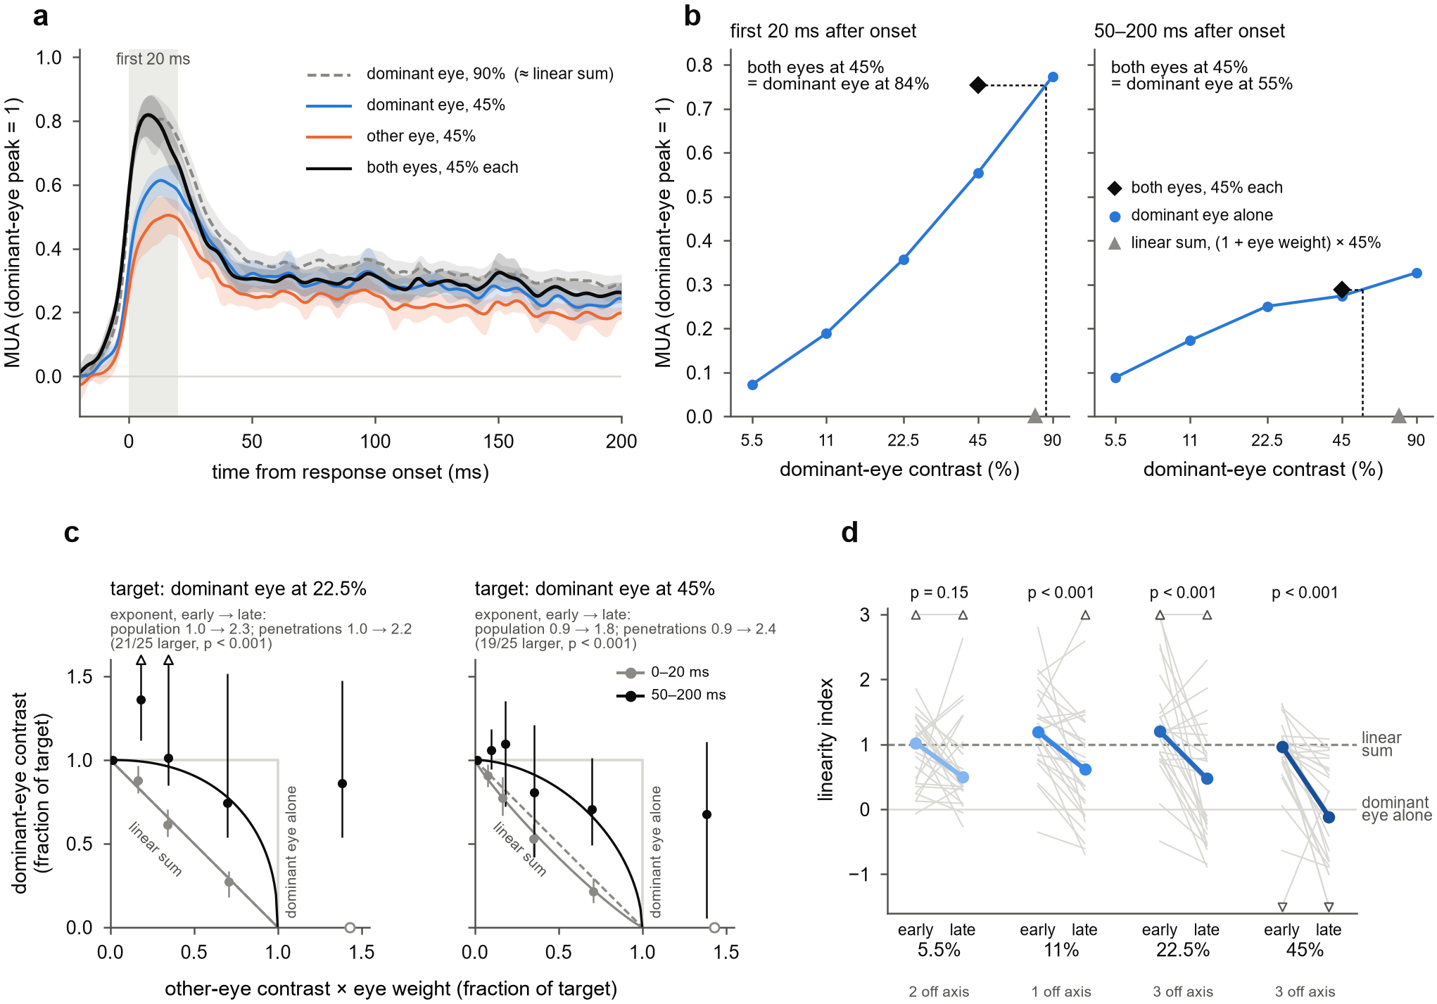
Figure 2. The two eyes sum linearly at response onset, then normalize. (a) Population responses at 45% contrast, each channel aligned to its own response onset and scaled to its dominant-eye peak at 90%: each eye alone, both eyes, and the dominant eye at 90% (dashed), which approximates linear summation of the two eyes' contrasts. Mean and 95% bootstrap CI over 26 penetrations; grey band, the first 20 ms. (b) Reading the equivalent contrast (population means, illustration). In each window, the response to both eyes at 45% (diamond) is located on the dominant eye's contrast-response function measured in the same window and read off as the dominant-eye contrast that gives the same response: 84% in the first 20 ms after onset, near the linear-summation prediction (triangle), and 55% at 50–200 ms. (c) Iso-response contours for target responses equal to the dominant eye's response at 22.5% and 45%. Each point is the dominant-eye contrast needed to reach the target at one contrast of the other eye, both as fractions of the target; the other eye's contrast is multiplied by its eye weight, so that linear summation lies on the diagonal and the dominant eye alone on the L-shaped line. Grey, 0–20 ms after onset; black, 50–200 ms. Points from population-average responses with 95% penetration-bootstrap CIs; curves, fitted Minkowski contours. Open circles mark contrasts at which the other eye alone already reaches the target. (d) Linearity index early (0–20 ms after onset) and late (50–200 ms) for each penetration (grey) and the median (colour); 1, linear summation; 0, the dominant eye alone. Wilcoxon signed-rank tests over 26 penetrations; values beyond the axis are drawn at its edge and counted.

Contrast sets how far summation collapses, at every depth

The collapse of summation was deeper at higher contrast (Fig 2d). To measure this contrast dependence in each penetration, we used the window 20–50 ms after onset, in which the transition took place. In this window, the median linearity index fell from 0.93 at 11% to 0.52 at 22.5% and −0.38 at 45%, and it fell with contrast in all 26 penetrations (8 of 8 in monkey B and 18 of 18 in monkey J; median slope −0.95 per natural-log unit of contrast; one-sided sign test, p < 0.001; Fig 3a, b). It also fell with contrast in each half of the data when presentations were split into odd and even trials (25 of 25 and 23 of 24 penetrations). On dual-probe days, each probe was also recorded while the grating was centred on the receptive fields of the other probe; these recordings were not used to identify the effect. The index fell with contrast in 7 of the 8 such recordings with at least five driven channels (one-sided sign test, p = 0.035; Fig 3b). Higher contrast made the collapse deeper, but not reliably earlier: the time at which the index had fallen halfway did not differ consistently between contrasts (Supplementary Fig S4b).
We next asked whether the sequence differed across cortical depth. At 45%, the linearity index fell from early to late at every depth (Fig 3c). At 11% and 22.5%, the size of the decline did not depend on depth (linear mixed model, p = 0.60), although it was not significant in two bins at intermediate depths. How far the late index fell did vary with depth in one monkey: in monkey J, the late index at 11% and 22.5% was highest about 1.9 mm below the top of cortex (quadratic term, p < 0.001), whereas monkey B showed no such profile (p = 0.34). The sequence of summation followed by normalization therefore occurred at every depth, and only its late strength varied with depth, in one of the two animals.

We then asked whether the synaptic input to the column shows the same sequence. In each penetration, we located the earliest current sink evoked by the gratings. These sinks began a median 30.5 ms after stimulus onset (interquartile range 27–35 ms) and lay a median 0.3 mm above the layer 4/5 boundary; sinks above and below them followed within about 10 ms (Fig 3d). In the first 20 ms after sink onset, the current at this sink was larger for both eyes at 45% than for the dominant eye alone (22 of 26 penetrations, p = 0.001) and close to the current evoked by the dominant eye at 90% (Fig 3e): the input current summed the two eyes at onset. Later, the sink current was too compressed to test the combination rule, because the dominant eye's currents at 45% and 90% no longer differed after 50 ms (p = 0.45). Channels at the earliest sink began to respond 2–4 ms before channels above and below it, and each group of channels normalized a similar time after its own onset (Supplementary Fig S4c). The transition therefore followed the feedforward sweep of activity through the column rather than starting in one compartment.

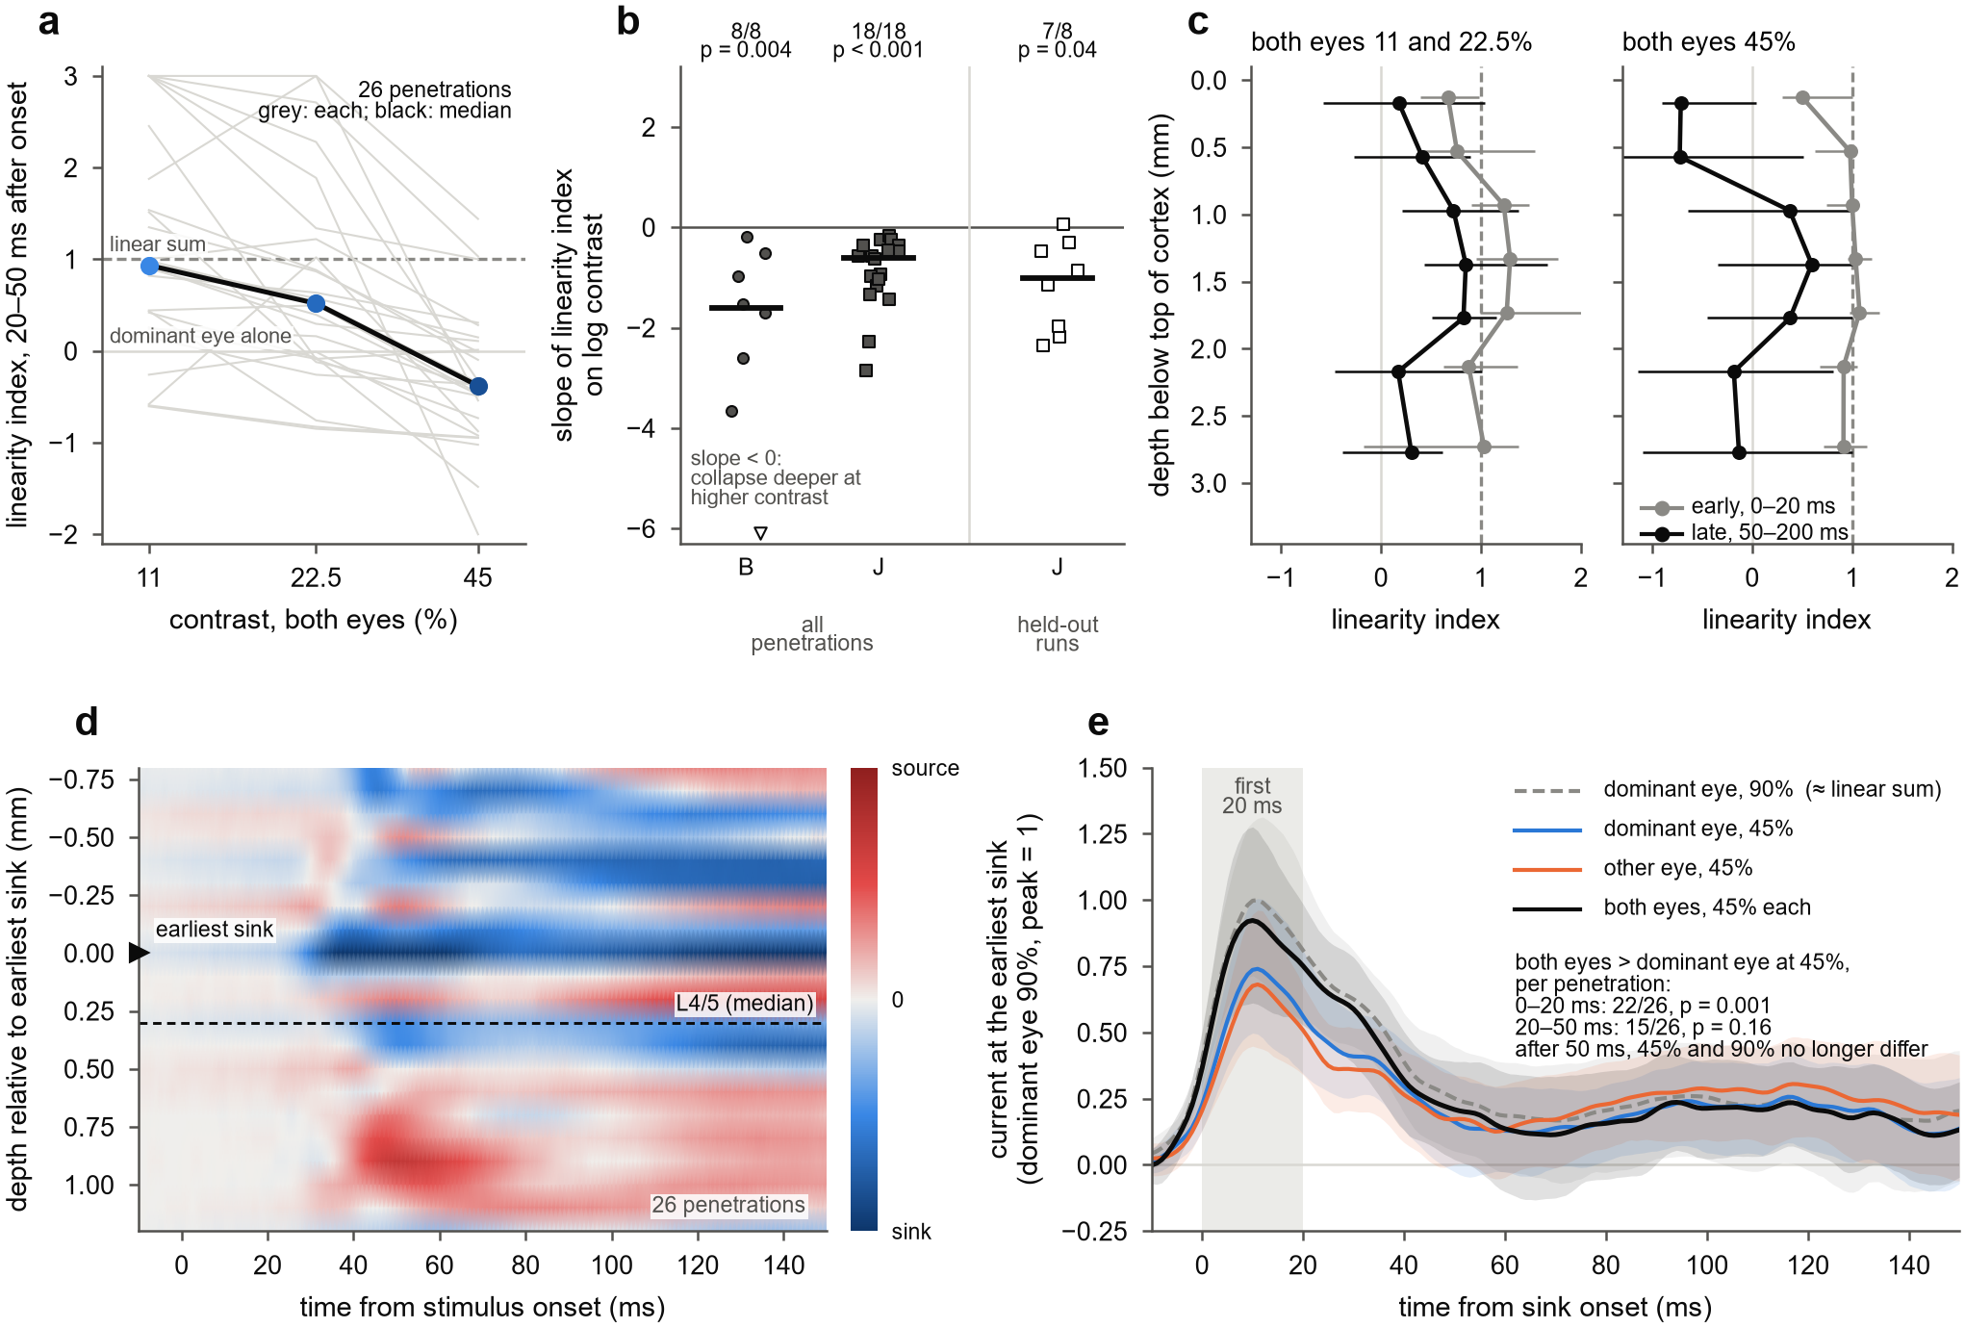
Figure 3. Contrast sets how far binocular summation collapses, at every depth. (a) Linearity index 20–50 ms after response onset, both eyes at the same contrast, for each penetration (grey) and the median (black; 26 penetrations); 1, linear summation; 0, the dominant eye alone. (b) Slope of this index on log contrast for each penetration, by monkey (filled), and for held-out recordings from the dual-probe days, in which the grating was centred on the other probe's receptive fields (monkey J, open squares). Bars, medians; counts give negative slopes, with one-sided sign tests; one value beyond the axis is drawn at its edge. (c) Linearity index early (0–20 ms after onset, grey) and late (50–200 ms, black) by depth below the top of cortex, for 11 and 22.5% pooled and for 45%; medians of penetration medians with 95% bootstrap CIs, for depth bins with at least five penetrations. (d) Population current-source density for presentations with either eye at 45% or more, aligned to each penetration's earliest current sink (depth 0) and scaled by that sink's peak before averaging over 26 penetrations; the dashed line marks the median layer 4/5 boundary. Colours are interpolated for display. (e) Current at the earliest sink at 45%, in the format of Fig 2a, timed from sink onset: each penetration scaled by its mean monocular sink current over 0–150 ms, then averaged and expressed relative to the peak of the mean response to the dominant eye at 90%; 95% bootstrap CIs over 26 penetrations. Counts compare both eyes with the dominant eye alone in each window (Wilcoxon signed-rank tests).

A delayed, conductance-like normalization pool best predicts binocular responses

We next asked what form of normalization produces linear summation at onset followed by a contrast-dependent collapse. We extended the delayed normalization model of Zhou et al. (2019) to two eyes (Fig 4a). The excitatory drive sums the two eyes' contrasts, with a drive weight on the other eye. The normalization pool sums them with a separate pool weight and divides the drive after a low-pass delay. We fitted the model to each penetration's full 6 × 6 set of time courses and scored it on held-out presentations. The fitted model reproduced the sequence of Fig 2a: the response to both eyes at 45% first approached the response to the dominant eye at 90% and later matched the response to the dominant eye at 45% (Fig 4b, which shows the conductance version described below). The fits underestimated the transient peaks by about 8%.
A static version of the model, in which the pool divides the drive without delay, also produced a collapse that deepened with contrast: its linearity index in the transition window fell with contrast in 25 of 25 penetrations. The contrast dependence of Fig 3a therefore does not by itself require a delay. What the static model could not produce was the change over time. Its linearity index was set within about 10 ms of onset and then stayed constant, whereas the index of the delayed model, like that of the data, started near linear summation and then declined (Fig 4c). The delayed model captured this decline at 22.5% and 45%, but not two features of the data: at 11% it stayed near linear summation while the data fell to 0.48, and at 45% it declined monotonically, whereas the data briefly fell below the dominant eye alone 35–50 ms after onset before partly recovering. To test whether the delay matters for the interaction between the eyes rather than only for the transient of monocular responses, we fitted both models with a loss that weights the binocular interaction (each binocular response minus the response to the dominant eye alone) equally with the monocular responses. The delayed model predicted the held-out interaction better in 23 of 24 penetrations, with a median 52% less error (p < 0.001; Fig 4d). The fitted pool delay was 30 ms (median; 38 ms in the conductance version). A separate delay for the other eye's contribution to the pool exceeded the dominant eye's by only 2 ms and did not improve held-out predictions (Supplementary Fig S5e), so monocular and interocular normalization shared one delay.

The pool weighted the other eye more than the drive did, in 24 of 25 penetrations (median pool weight 1.07, drive weight 0.88; p < 0.001; Fig 4e). This asymmetry allows the binocular response to fall to the response of the dominant eye alone at high contrast, as observed. It was not an artefact of fitting: refitting simulated responses generated with equal weights recovered a median difference of 0.000, compared with 0.19 in the data (Supplementary Fig S5d).
Normalization by a delayed divisor reduces the response but does not change how quickly it rises. In cortical neurons, inhibition acts partly by increasing membrane conductance, which both divides the response and shortens its time constant (Carandini, Heeger & Movshon 1997). We therefore compared the fixed-delay model with a conductance version, in which the pool also speeds the response, and with a recurrent normalization circuit (a binocular version of the model of Heeger & Zemlianova 2020). The conductance model predicted held-out responses better than the fixed-delay model in 20 of 24 penetrations (median 1.6% less error, p < 0.001), a small but consistent gain that came mostly from monkey J. The recurrent model was no better than the fixed-delay model (9 of 24 penetrations, p = 0.86) and worse than the conductance model (18 of 24 penetrations, p < 0.001; Fig 4f). One penetration was excluded from these comparisons because one half of its presentations was too small to fit (Methods). All three models reproduced the shortening of latency with contrast and the earlier onset of binocular responses, because a stronger drive reaches half its peak sooner, so these features do not distinguish them. The rise time of the mean response fell within the data's confidence interval for every model, except that the fixed-delay model rose 2–4 ms too fast at 45% and 90% (Supplementary Fig S6a, b). A second stage of interocular gain control before the pool improved held-out predictions by about 1.5% (Supplementary Fig S5a) but left late responses too close to linear summation at 11% and 22.5% (Supplementary Fig S5b).

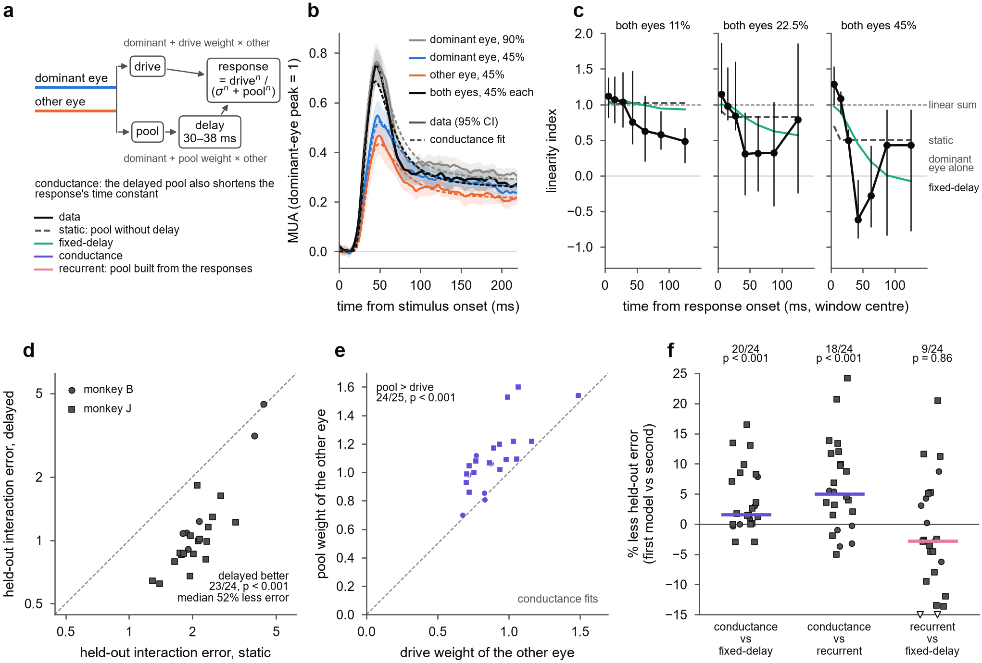
Figure 4. A delayed normalization pool that weights the other eye more than the drive does accounts for binocular combination. (a) The model. Each eye's contrast enters an excitatory drive, in which the other eye counts by its drive weight, and a normalization pool, in which it counts by its pool weight. The pool is low-pass filtered (median delay 30 ms in the fixed-delay fits, 38 ms in the conductance fits) and divides the drive. In the conductance version, the pool also shortens the response's time constant; the static version has no delay; in the recurrent version, the pool is computed from the responses. (b) Channel-averaged responses at 45% on the stimulus clock (solid; mean over 25 penetrations with 95% bootstrap CI) and the conductance fits (dashed), in the format of Fig 2a. (c) Linearity index over time for the data (median over penetrations with 95% bootstrap CI) and for the static and fixed-delay fits (medians), at 11, 22.5 and 45%. (d) Held-out error of the binocular interaction (each binocular response minus the dominant eye alone) for static and delayed normalization, each fitted with the interaction loss; dashed, identity. (e) Pool and drive weights of the other eye in the conductance fits; dashed, identity; two-sided Wilcoxon signed-rank test. (f) Reduction in held-out error for three pairings of models; bars, medians; open triangles, values beyond the axis. In (d) and (f), one-sided Wilcoxon signed-rank tests over 24 penetrations; one penetration had too few presentations for a held-out half. Circles, monkey B; squares, monkey J.

Discussion
In awake macaque V1, the rule by which the two eyes combine changes within tens of milliseconds of response onset. For about 20 ms, the eyes' contrasts sum linearly. Interocular normalization then takes hold, more strongly at higher contrast, until at 45% contrast the binocular response matches the response of the dominant eye alone. The sequence occurs at every cortical depth, the earliest synaptic current sums the two eyes at onset, and a normalization pool that acts with a delay of about 30 ms and weights the other eye more than the drive does reproduces it.

Relation to earlier measurements
Earlier recordings in awake macaque V1 found binocular facilitation in an early window and its loss or reversal in a later one (Cox et al. 2019; Dougherty et al. 2019; Mitchell et al. 2022; Carlson et al. 2023). Our results resolve this sequence on a millisecond scale, in units of contrast and across the full range of the two eyes' contrasts. They show that the early phase is linear summation of the two eyes' contrasts, rather than facilitation of unknown form; that normalization takes hold 20–35 ms after response onset, a transition that windows of 50–100 ms cannot resolve; and that the change appears in iso-response contours, the measure used in psychophysics (Legge & Rubin 1981; Baker, Meese & Georgeson 2007). A linear early phase is compatible with the sublinear combination reported over longer windows (Mitchell et al. 2022), because the normalized state dominates any average over hundreds of milliseconds. Measurements that integrate over seconds, such as fMRI and steady-state EEG, report near ocularity invariance (Moradi & Heeger 2009; Baker & Wade 2017), the state our responses reached within about 50 ms of onset.

What must be delayed

Two features of the data constrain models of binocular normalization. First, the pool must act with a delay. A static pool reproduced the dependence of the late state on contrast, but not the change over time, and the delay improved predictions of the binocular interaction itself, not only of the monocular transient. Second, the pool must weight the other eye more than the drive does, or binocular responses could not fall to the level of the dominant eye alone. A pool close to balanced between the eyes, with ocular dominance acting mainly on the drive, agrees with earlier time-averaged analyses of these recordings (Mitchell et al. 2023) and with the dependence of binocular combination on ocular dominance in superficial V1 (Zhang et al. 2024).
Monocular and interocular normalization shared one delay in our fits. Monocular contrast normalization has been reported to be fully expressed within 10 ms of response onset in anesthetized V1 (Albrecht et al. 2002), whereas interocular normalization in our data took 20–35 ms. The difference may reflect the preparation, the measure (the shape of the contrast-response function, rather than a comparison with linear summation), or both; our data do not decide between these. Other forms of suppression in V1 also differ in speed: cross-orientation suppression is fast (Smith, Bair & Movshon 2006), whereas surround suppression is delayed (Bair, Cavanaugh & Movshon 2003). Interocular normalization resembles surround suppression in this respect, consistent with evidence that interocular suppression depends on cortical inhibition (Sengpiel & Vorobyov 2005).
Among the dynamic models, a conductance version of the delayed pool, in which normalization both divides the response and shortens its time constant, predicted held-out responses best. The advantage was small and came mostly from one monkey, so we read it as a preference rather than a demonstration. It agrees with the view that normalization in V1 is implemented partly by shunting inhibition (Carandini, Heeger & Movshon 1997). A recurrent circuit in which normalization is computed from the responses themselves (Heeger & Zemlianova 2020) fitted no better than a fixed delay. Some features of the data remained unexplained: all three models stayed too close to linear summation late in the response at 11% (Supplementary Fig S5c), the fixed-delay model did not produce the brief undershoot at 45% (Fig 4c), and it lacked the transient that followed stimulus offset (Supplementary Fig S6c).

The sequence across depth
The sequence ran at every depth. Channels at the earliest sink began to respond first, and every depth normalized a similar time after its own onset, so the transition travelled with the feedforward sweep of activity through the column rather than starting in one compartment. The current at the earliest sink summed the two eyes at onset, so normalization was not already present in the first synaptic input to the column. Whether the same current later normalizes could not be tested, because its contrast response saturated. The late strength of normalization varied with depth in one monkey only, so we do not interpret its laminar profile further.

Alternative explanations
Three alternatives deserve comment. First, the measure: simulated responses with a fixed combination rule, realistic transients and latencies, and the data's own noise did not show the decline when passed through the identical analysis (Supplementary Fig S2a). Second, eye movements and arousal: excluding presentations with saccades, or restricting them to the middle half of pupil sizes, did not change the result (Supplementary Table S2). Third, small errors of vergence change the interocular phase of the gratings and could turn facilitation into suppression in cells selective for binocular phase. We could not measure vergence, because the position of only one eye was recorded in most sessions, but four arguments make this explanation unlikely. Vergence in fixating macaques varies by 1 arcmin or less (Read & Cumming 2003), which shifts the interocular phase of a 1–4 cycle/deg grating by only 6–24°. Binocular phase tuning in macaque V1 changes little with contrast (Smith et al. 1997b), so a phase error would scale binocular responses by a factor independent of contrast rather than produce a suppression that grows with contrast. MUA pools many neurons, including complex cells with little phase selectivity. And the sequence occurred in all 26 penetrations, whose receptive fields and gratings differed.
The conclusions have limits. The gratings were static and identical in the two eyes apart from contrast, so the results do not address disparity, orientation conflict or masking. The results rest mainly on MUA and CSD at 100 µm spacing; isolated units were few and support the population result only in aggregate. Two monkeys contributed unequal numbers of penetrations (8 and 18), and the recordings held out to test the contrast dependence came from one monkey.

A prediction
Binocular combination in V1 is therefore not a fixed rule but a sequence that unfolds within tens of milliseconds. This predicts that the binocular signal V1 sends onward depends on stimulus duration: for presentations of a few tens of milliseconds, it approximates linear summation of the two eyes' contrasts, and for longer presentations it reflects the normalized state. Perceptual binocular summation behaves in this way. It is largest for presentations of about 50 ms and absent at 100 ms or more (Bearse & Freeman 1994), and binocular combination is more linear for brief, low-contrast stimuli than for long, high-contrast ones (Ding, Klein & Levi 2013). Recording V1 responses to dichoptic stimuli of varied duration, together with perceptual reports, would test whether the time course measured here sets the duration dependence of binocular perception.

Methods

Animals
Two adult macaques [species, sex, ages, weights] were implanted with a head post and a recording chamber over V1 [procedures, anaesthesia, IACUC protocol]. Monkey B was recorded in right V1 (October–December 2021) and monkey J in left V1 (October–December 2022).

Task and stimuli
The task ran in NIMH MonkeyLogic 2. The monkeys fixated [fixation window, duration] while viewing a single monitor through a mirror stereoscope [display model, viewing distance, mean luminance; 120 Hz refresh]. Two mirrors in front of each eye directed its line of sight to its own half of the screen, and a black septum between the halves kept each eye from seeing the other half. Because the two eyes' gratings occupied the same rows of the display, both were drawn at the same time in each frame. Each trial showed three gratings, each for about 317 ms with about 317 ms between them, followed by a juice reward. In one penetration, gratings lasted about 217 ms.
Gratings were static sinusoids matched to the multi-unit receptive field in orientation, spatial frequency (1–4 cycles/deg), size and position [mapping procedure], and identical in the two eyes apart from contrast. Each eye's Michelson contrast was 0, 0.055, 0.11, 0.225, 0.45 or 0.9, chosen independently, giving 36 conditions in random order with about 30 presentations each.

Recording
We recorded with 32-contact linear arrays (Plexon, 100 µm spacing) and a Blackrock Cerebus system. Wideband signals were sampled at 30 kHz and LFP at 1 kHz. On seven days in monkey J, two arrays were recorded at once in separate columns. Stimulus onsets were taken from a photodiode on the display, and the 3.4 ms offset between the 30 kHz and 1 kHz file clocks was corrected.
MUA was the envelope of the wideband signal: band-pass 500–5000 Hz (4th-order Butterworth, zero phase), full-wave rectification, low-pass 200 Hz, resampled to 1 kHz. CSD was −σ∂²V/∂z² of the LFP (σ = 0.4 S/m, 0.1 mm spacing). Before differentiation, contacts with evoked amplitude outside 0.6–1.6 times the median of their neighbours were interpolated, and a three-point Hamming filter was applied across depth.
Single units came from curated Kilosort sorts, with a spike-time offset corrected, and from Kilosort 4 (Pachitariu et al. 2024) for five penetrations without a sort. Units were included if refractory-period contamination (Hill et al. 2011) was below 0.5 and signal-to-noise ratio was at least 3. A strict set also required contamination below 0.1, amplitude cutoff below 0.1 and presence ratio of at least 0.9.

Eye position and presentation selection
The position of one eye was recorded as analog gaze signals, calibrated in MonkeyLogic. Saccades were detected with a velocity threshold (Engbert & Kliegl 2003; λ = 6, minimum 6 ms). We analysed completed presentations with no saccade of 1° or more between 200 ms before and 500 ms after onset.
We also excluded presentations with large MUA artifacts: a peak MUA between −50 and 450 ms more than 20 robust standard deviations (median absolute deviation × 1.4826) above the median for that channel, on any channel in cortex. Visual responses reach 6–11 such units in penetrations without artifacts. The rule removed 0.6% of presentations, mostly in monkey J.

Laminar alignment
The top of cortex was the most superficial contact with spontaneous MUA. A layer 4/5 boundary was placed just below the dominant early sink (35–65 ms) of a flash-evoked CSD, recorded separately on the same day and matched in depth to the grating recording by the depth profiles of MUA and LFP power. It was accepted if it lay 0.5–1.7 mm below the top of cortex or agreed with the laminar profile of spike–LFP phase coupling (spike-phase index and pairwise phase consistency; Vinck et al. 2010; Davis et al. 2023); otherwise the phase-coupling marker was used if its depth was plausible. This gave a boundary in 22 penetrations (16 from the flash CSD, 6 from phase coupling); 26 penetrations had a usable top of cortex. The two markers agreed within 0.3 mm in only 4 penetrations, so layer assignments are uncertain by roughly 0.5–1 mm. Depth along the array can also exceed the thickness of V1 where the array is not perpendicular to the layers. Depth below the top of cortex is therefore the primary depth axis.

Responses
A channel was analysed if it lay in cortex and its response varied with the contrast of at least one eye shown alone (one-way ANOVA over the six contrasts, p < 0.01, 40–140 or 150–250 ms after onset, peak above baseline). Condition means were blank-subtracted and smoothed with a Gaussian (σ = 3 ms for equivalent contrast, 2 ms for figures and models).
The dominant eye was the eye with the larger mean response at 90%, 40–250 ms. Response onset was the first time after 10 ms at which the dominant-eye response at 90% reached half its peak. For display and model fitting, each channel was scaled by its dominant-eye peak at 90%. The binocular latency difference was the half-peak time of the response to both eyes minus that of the dominant eye alone, at the same contrast.

Equivalent contrast and the linearity index
In each window, the binocular response at contrast c in both eyes was located on the dominant eye's monocular contrast-response function in the same window. We made that function non-decreasing (running maximum) and interpolated it linearly between 0 and 5.5% and in log contrast above. The matching contrast divided by c is the equivalent contrast ratio k. Where the binocular response exceeded the dominant-eye response at 90%, k was set to 0.9/c, a lower bound.
The eye weight a was the contrast scale, between 0.05 and 1, that best mapped the dominant eye's monocular contrast-response function onto the other eye's (least squares over the five non-zero contrasts). The linearity index is (k − 1)/a: 1 for linear summation of the weighted contrasts, 0 for the dominant eye alone. Windows relative to onset were 0–10, 10–20, 20–35, 35–50, 50–75, 75–100, 100–150 and 150–200 ms; early was 0–20 ms and late 50–200 ms. The contrast-timing analysis used sliding 15 ms windows starting every 5 ms. Robustness and timing analyses refitted a in each window.

Checks of the measure
For the fixed-rule simulation, each penetration's fitted fixed-delay model was evaluated with the pool weight set equal to the drive weight, so that the binocular response equals the monocular response at the summed weighted contrast at every moment. The simulated time courses were analysed exactly as the data, without noise and with the data's noise added, estimated as half the difference between odd and even presentations and applied with both signs. For cross-validation, the dominant eye, the eye weight and the onset were estimated on odd presentations and the index on even presentations, and vice versa. Ocular dominance terciles were formed from the absolute ocular dominance index at 90%. Isolated units were analysed as MUA channels.

Iso-response contours
For a target contrast c_T (11, 22.5 or 45%), the target response was the dominant eye's response at c_T in the window. For each contrast of the other eye, the dominant-eye contrast giving the target response was found by inverting that row of the 6 × 6 matrix, as for the equivalent contrast; points beyond the dominant eye at 90% were set to 90% as lower bounds. Contours were fitted with a Minkowski sum, (c_D/c_T)^m + (a·c_N/c_T)^m = 1, where m = 1 is linear summation and large m approaches the dominant eye alone. Population contours used population-average responses with penetration-bootstrap confidence intervals.

Statistics
The penetration is the unit of replication, because neighbouring channels share signal. Statistics were computed on penetration medians over channels. We used two-sided Wilcoxon signed-rank tests for paired comparisons, one-sided sign tests and one-sided Wilcoxon tests for directional predictions, Friedman tests across contrasts, and bootstrap confidence intervals with 2000 resamples of penetrations. Depth profiles were also tested with linear mixed models with a random intercept per penetration.

Models
In the fixed-delay normalization model, after Zhou et al. (2019), the drive is E(t) = (c_D + w_E·c_N)·u(t) and the pool P(t) = (c_D + w_P·c_N)·v(t), with response R = g·E^n / (σ^n + P^n). Here w_E and w_P are the drive and pool weights of the other eye, u(t) is the step response of a gamma filter (shape 3, time constant τ1) delayed by δ, and v(t) is u(t) passed through an exponential low-pass filter with time constant τ2. Static normalization sets v = u. The drive weight is a model parameter and differs from the eye weight a of the linearity index, which is measured from monocular responses.
In the conductance model, the response relaxes toward the fixed-delay value with an effective time constant τ_m / (1 + (P/σ)^n): τ_m·dR/dt = g·E^n/σ^n − (1 + (P/σ)^n)·R, so the pool both divides the response and shortens its time constant. As τ_m approaches 0, the model reduces to the fixed-delay model. In the recurrent model, a binocular version of ORGaNICs (Heeger & Zemlianova 2020), the normalization signal is computed recurrently from the responses. In the two-stage model, each eye is first divided by a delayed sum of its own and the other eye's contrast before the fixed-delay stage (after Meese, Georgeson & Baker 2006). The dynamic Ding–Sperling model replaces the first stage with mutual gain control driven by low-passed contrast energy (Ding & Sperling 2006). In the separate-delay model, the other eye's term in the pool has its own time constant.

Models were fitted by least squares, with several starting points, to the full 6 × 6 time courses 0–219 ms after stimulus onset of each penetration's channel average (or of each channel, for the two-stage test). Held-out error was the summed squared error on even presentations for fits to odd presentations, and vice versa. One penetration, with 217 ms stimuli and few presentations, had no condition with enough presentations in its even half and was excluded from held-out comparisons. The interaction loss weighted equally the monocular time courses and the binocular interaction, each binocular response minus the dominant eye alone at the same contrast. Parameter recovery refitted 100 simulated data sets per penetration, generated with w_P = w_E and the data's noise.

Response dynamics
Rise time was the interval between 10% and 90% of the peak of the population-mean response to the dominant eye alone, within 150 ms of stimulus onset. Per-channel rise times at low contrast are dominated by noise: adding the data's own noise to a model's prediction lengthens its rise at 11% from 20 ms to 33–44 ms. Responses after the stimulus were aligned to the response offset, the stimulus duration plus the half-peak onset latency, and scaled to the mean response over the 30 ms before it.

Code and data
All analyses are in the v1-laminar-binocular repository [link or availability statement]. Each figure is produced by one script from saved analysis outputs.

References

- Albrecht DG, Geisler WS, Frazor RA, Crane AM (2002). Visual cortex neurons of monkeys and cats: temporal dynamics of the contrast response function. J Neurophysiol 88:888–913.
- Bair W, Cavanaugh JR, Movshon JA (2003). Time course and time-distance relationships for surround suppression in macaque V1 neurons. J Neurosci 23:7690–7701.
- Baker DH, Meese TS, Georgeson MA (2007). Binocular interaction: contrast matching and contrast discrimination are predicted by the same model. Spat Vis 20:397–413.
- Baker DH, Wade AR (2017). Evidence for an optimal algorithm underlying signal combination in human visual cortex. Cereb Cortex 27:254–264.
- Bearse MA Jr, Freeman RD (1994). Binocular summation in orientation discrimination depends on stimulus contrast and duration. Vision Res 34:19–29.

- Carandini M, Heeger DJ (2012). Normalization as a canonical neural computation. Nat Rev Neurosci 13:51–62.
- Carandini M, Heeger DJ, Movshon JA (1997). Linearity and normalization in simple cells of the macaque primary visual cortex. J Neurosci 17:8621–8644.
- Carlson BM, Mitchell BA, Dougherty K, Westerberg JA, Cox MA, Maier A (2023). Does V1 response suppression initiate binocular rivalry? iScience 26:107359.
- Cox MA, Dougherty K, Westerberg JA, Schall MS, Maier A (2019). Temporal dynamics of binocular integration in primary visual cortex. J Vis 19(12):13.
- Davis ZW, Dotson NM, Franken TP, Muller L, Reynolds JH (2023). Spike-phase coupling patterns reveal laminar identity in primate cortex. eLife 12:e84512.
- Ding J, Klein SA, Levi DM (2013). Binocular combination of phase and contrast explained by a gain-control and gain-enhancement model. J Vis 13(2):13.
- Ding J, Sperling G (2006). A gain-control theory of binocular combination. Proc Natl Acad Sci USA 103:1141–1146.
- Dougherty K, Cox MA, Westerberg JA, Maier A (2019). Binocular modulation of monocular V1 neurons. Curr Biol 29:381–391.
- Engbert R, Kliegl R (2003). Microsaccades uncover the orientation of covert attention. Vision Res 43:1035–1045.
- Gawne TJ, Kjaer TW, Richmond BJ (1996). Latency: another potential code for feature binding in striate cortex. J Neurophysiol 76:1356–1360.
- Heeger DJ, Zemlianova KO (2020). A recurrent circuit implements normalization, simulating the dynamics of V1 activity. Proc Natl Acad Sci USA 117:22494–22505.
- Hill DN, Mehta SB, Kleinfeld D (2011). Quality metrics to accompany spike sorting of extracellular signals. J Neurosci 31:8699–8705.
- Legge GE, Rubin GS (1981). Binocular interactions in suprathreshold contrast perception. Percept Psychophys 30:49–61.
- Meese TS, Georgeson MA, Baker DH (2006). Binocular contrast vision at and above threshold. J Vis 6(11):7.
- Mitchell BA, Dougherty K, Westerberg JA, Carlson BM, Daumail L, Maier A, Cox MA (2022). Stimulating both eyes with matching stimuli enhances V1 responses. iScience 25:104182.
- Mitchell BA, Carlson BM, Westerberg JA, Cox MA, Maier A (2023). A role for ocular dominance in binocular integration. Curr Biol 33:3884–3895.

- Moradi F, Heeger DJ (2009). Inter-ocular contrast normalization in human visual cortex. J Vis 9(3):13.
- Pachitariu M, Sridhar S, Pennington J, Stringer C (2024). Spike sorting with Kilosort4. Nat Methods 21:914–921.
- Plainis S, Petratou D, Giannakopoulou T, Atchison DA, Tsilimbaris MK (2011). Binocular summation improves performance to defocus-induced blur. Invest Ophthalmol Vis Sci 52:2784–2789.
- Read JCA, Cumming BG (2003). Measuring V1 receptive fields despite eye movements in awake monkeys. J Neurophysiol 90:946–960.
- Romero MC, Castro AF, Bermudez MA, Perez R, Gonzalez F (2007). Eye dominance and response latency in area V1 of the monkey. Vis Neurosci 24:757–761.
- Sengpiel F, Vorobyov V (2005). Intracortical origins of interocular suppression in the visual cortex. J Neurosci 25:6394–6400.
- Smith EL 3rd, Chino Y, Ni J, Cheng H (1997a). Binocular combination of contrast signals by striate cortical neurons in the monkey. J Neurophysiol 78:366–382.
- Smith EL 3rd, Chino YM, Ni J, Ridder WH 3rd, Crawford MLJ (1997b). Binocular spatial phase tuning characteristics of neurons in the macaque striate cortex. J Neurophysiol 78:351–365.
- Smith MA, Bair W, Movshon JA (2006). Dynamics of suppression in macaque primary visual cortex. J Neurosci 26:4826–4834.
- Tanabe S, Cumming BG (2014). Delayed suppression shapes disparity selective responses in monkey V1. J Neurophysiol 111:1759–1769.
- Truchard AM, Ohzawa I, Freeman RD (2000). Contrast gain control in the visual cortex: monocular versus binocular mechanisms. J Neurosci 20:3017–3032.
- Vinck M, van Wingerden M, Womelsdorf T, Fries P, Pennartz CMA (2010). The pairwise phase consistency: a bias-free measure of rhythmic neuronal synchronization. NeuroImage 51:112–122.
- Zhang SH, Zhao XN, Jiang DQ, Tang SM, Yu C (2024). Ocular dominance-dependent binocular combination of monocular neuronal responses in macaque V1. eLife 13:RP92839.

- Zhou J, Benson NC, Kay K, Winawer J (2019). Predicting neuronal dynamics with a delayed gain control model. PLoS Comput Biol 15:e1007484.

Supplementary figures and tables
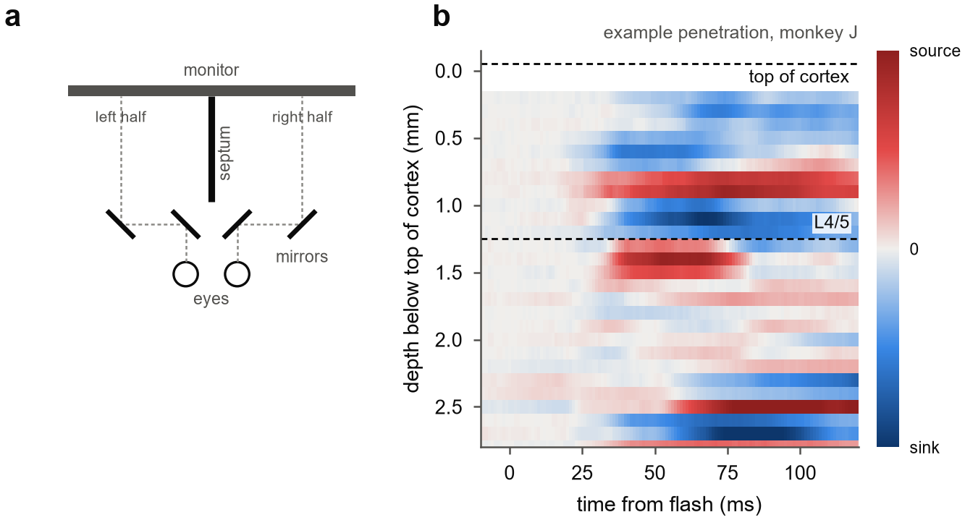
Supplementary Figure S1. Apparatus and laminar alignment. (a) Mirror stereoscope, top view. Two mirrors per eye shift each eye's line of sight onto its own half of one monitor, and a black septum divides the monitor between the eyes. (b) Current-source density evoked by a brief flash in the example penetration of Fig 1b, with sinks in blue and sources in red, smoothed across depth and matched in depth to the grating recording. Dashed lines mark the top of cortex and the boundary between layers 4 and 5, placed below the earliest flash-evoked sink.
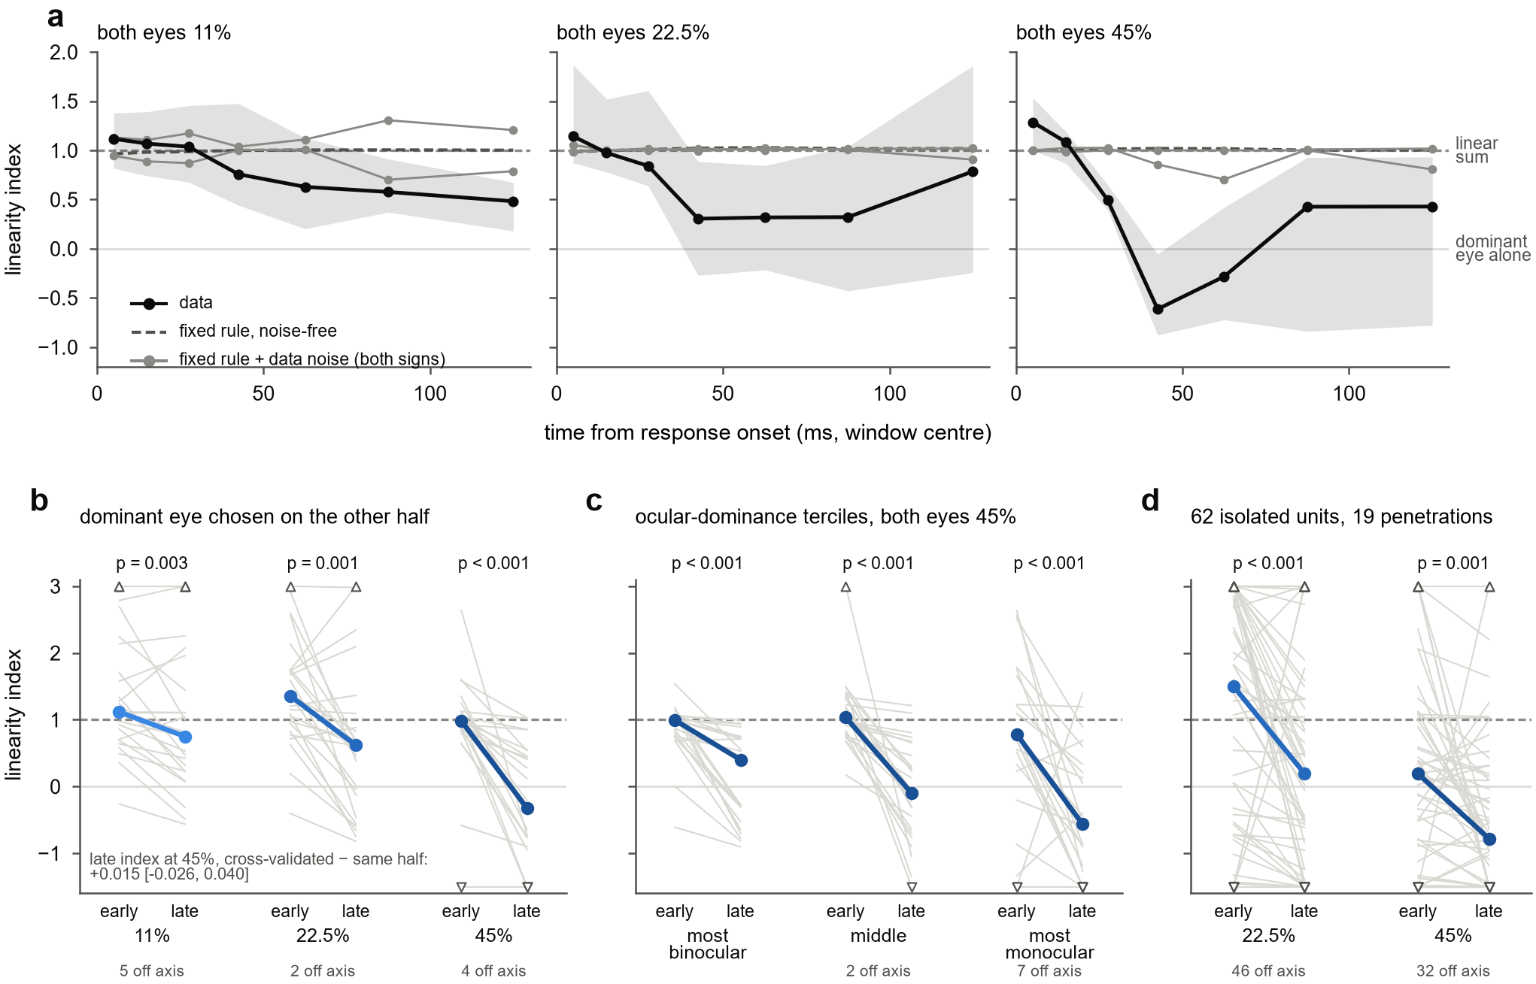
Supplementary Figure S2. The linearity index measures the combination rule without bias. (a) Fixed-rule simulation: each penetration's fitted model with the pool weight set equal to the drive weight, so that the binocular response always equals the dominant eye's response at the summed weighted contrast, read out exactly as the data, without noise (dashed) and with the data's own noise added with either sign (grey). Black, data in the same readout. Medians over 25 penetrations, with the 95% bootstrap CI of the data median. (b) Dominant eye, eye weight and onset chosen on one half of the presentations, with the index measured on the other half. (c) Channels split into terciles of the absolute ocular dominance index, at 45%. (d) Isolated single units (62 units in 19 penetrations). In b–d, thin lines are penetrations (units in d) and coloured lines medians; Wilcoxon signed-rank tests; values beyond the axis are drawn at its edge and counted.
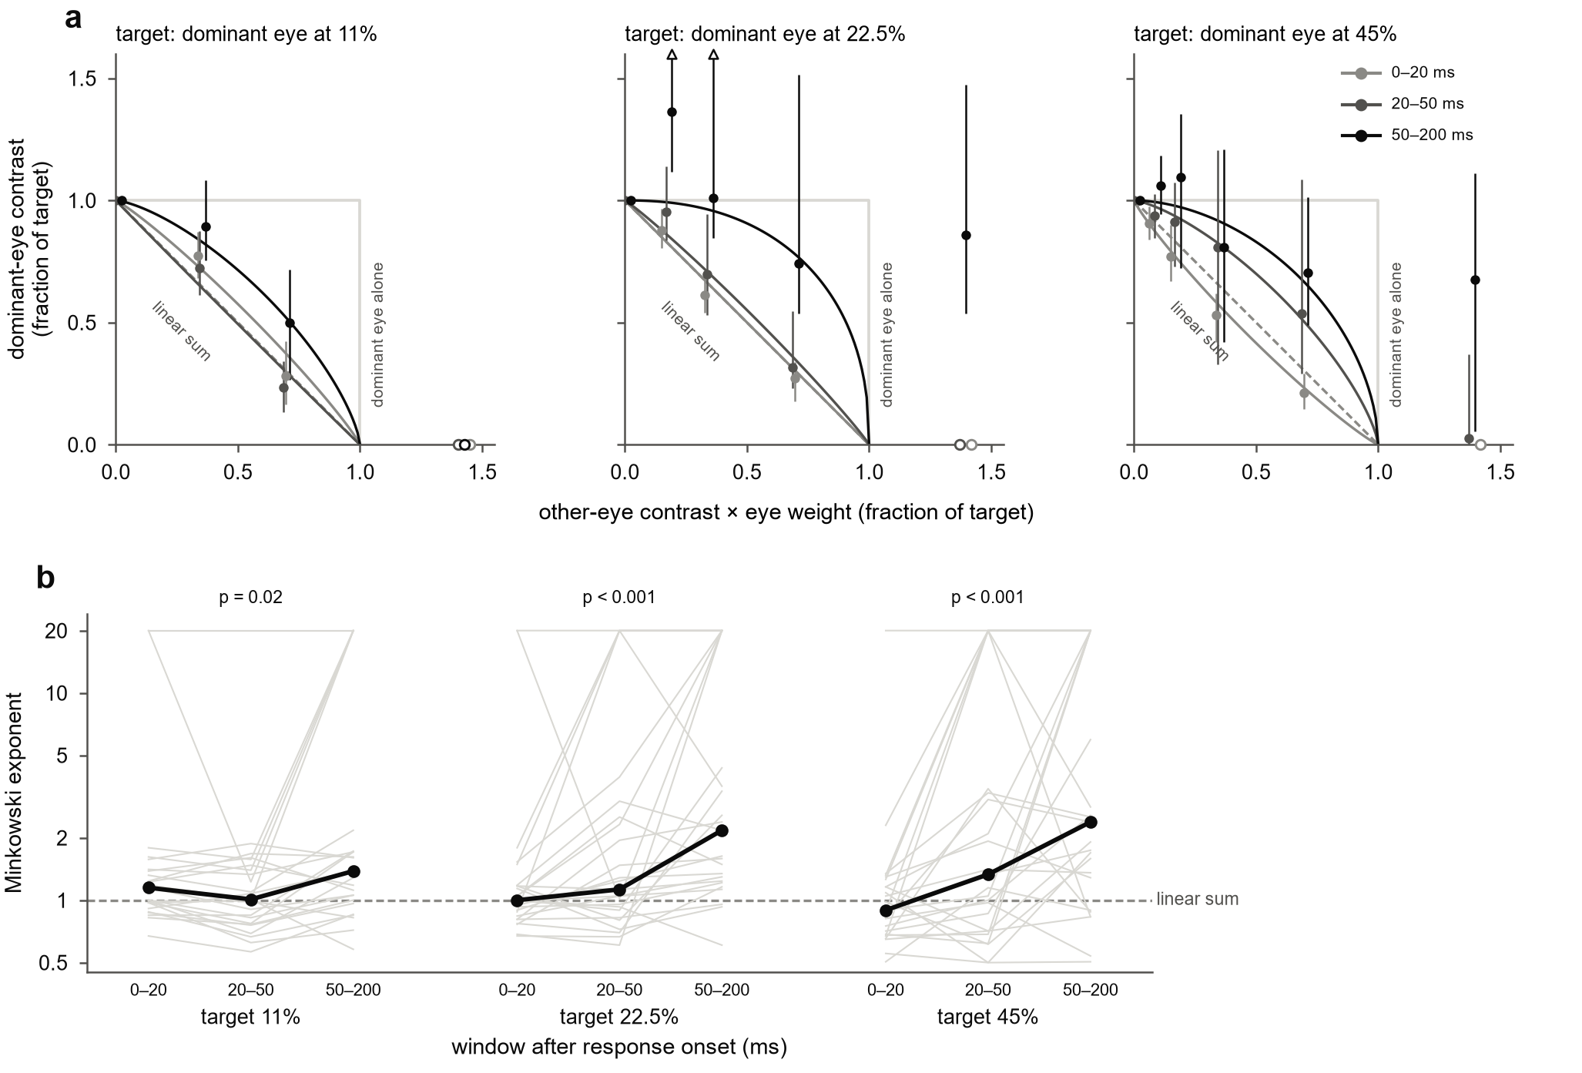
Supplementary Figure S3. Iso-response contours at every target contrast. (a) As Fig 2c, for target responses equal to the dominant eye's response at 11%, 22.5% and 45%, in three windows after response onset: 0–20 ms (light grey), 20–50 ms (dark grey) and 50–200 ms (black). Points from population-average responses with 95% penetration-bootstrap CIs; curves, fitted Minkowski contours. (b) Minkowski exponent fitted to each penetration's contours (grey; bounded at 0.5 and 20) and the median (black); 1 is linear summation, and larger values approach the dominant eye alone. Wilcoxon signed-rank tests, late against early window; 25 penetrations.
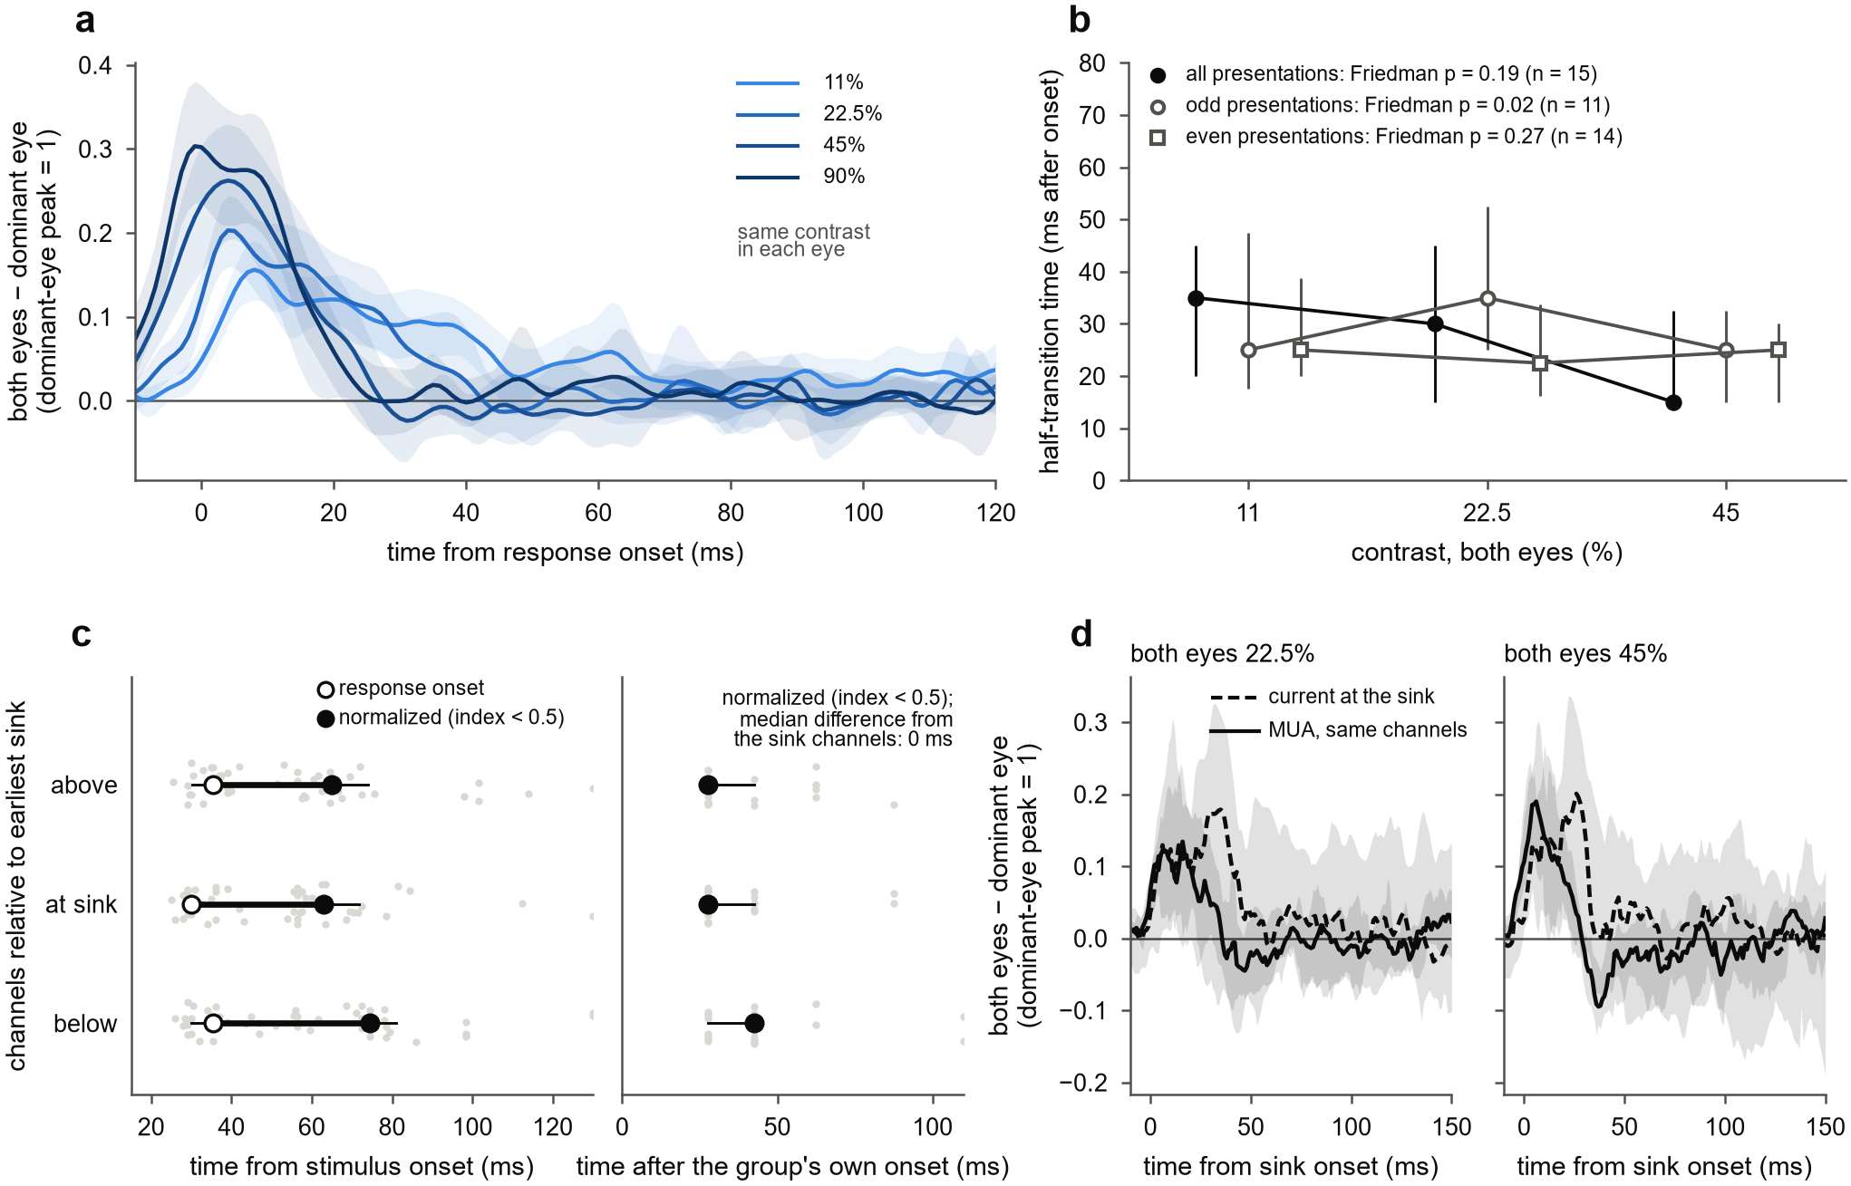
Supplementary Figure S4. Timing measures and their sensitivity to noise. (a) Binocular gain: response to both eyes minus the response to the dominant eye alone at the same contrast, aligned to each channel's response onset, in units of the dominant-eye peak; mean and 95% bootstrap CI over 26 penetrations. Because binocular responses begin 1–2 ms earlier, this raw difference overstates the gain on the rising edge. (b) Time at which the linearity index had fallen halfway from its early to its late value, for all presentations and for odd and even presentations separately; medians and interquartile ranges over penetrations with a decline at all three contrasts, with Friedman tests. The ordering across contrasts does not replicate between halves. (c) Response onset and the time at which the linearity index first fell below 0.5, for channels above, within two contacts of, and below the earliest sink: left, from stimulus onset; right, from each group's own onset. Wilcoxon signed-rank tests against the sink group. With 15 ms windows, most penetrations share the same values, so medians can sit at window edges. (d) Binocular gain of the current at the earliest sink (dashed) and of MUA on the same channels (solid), timed from sink onset, at 22.5 and 45%; each scaled to its dominant-eye peak at 90%; median and 95% bootstrap CI over penetrations.
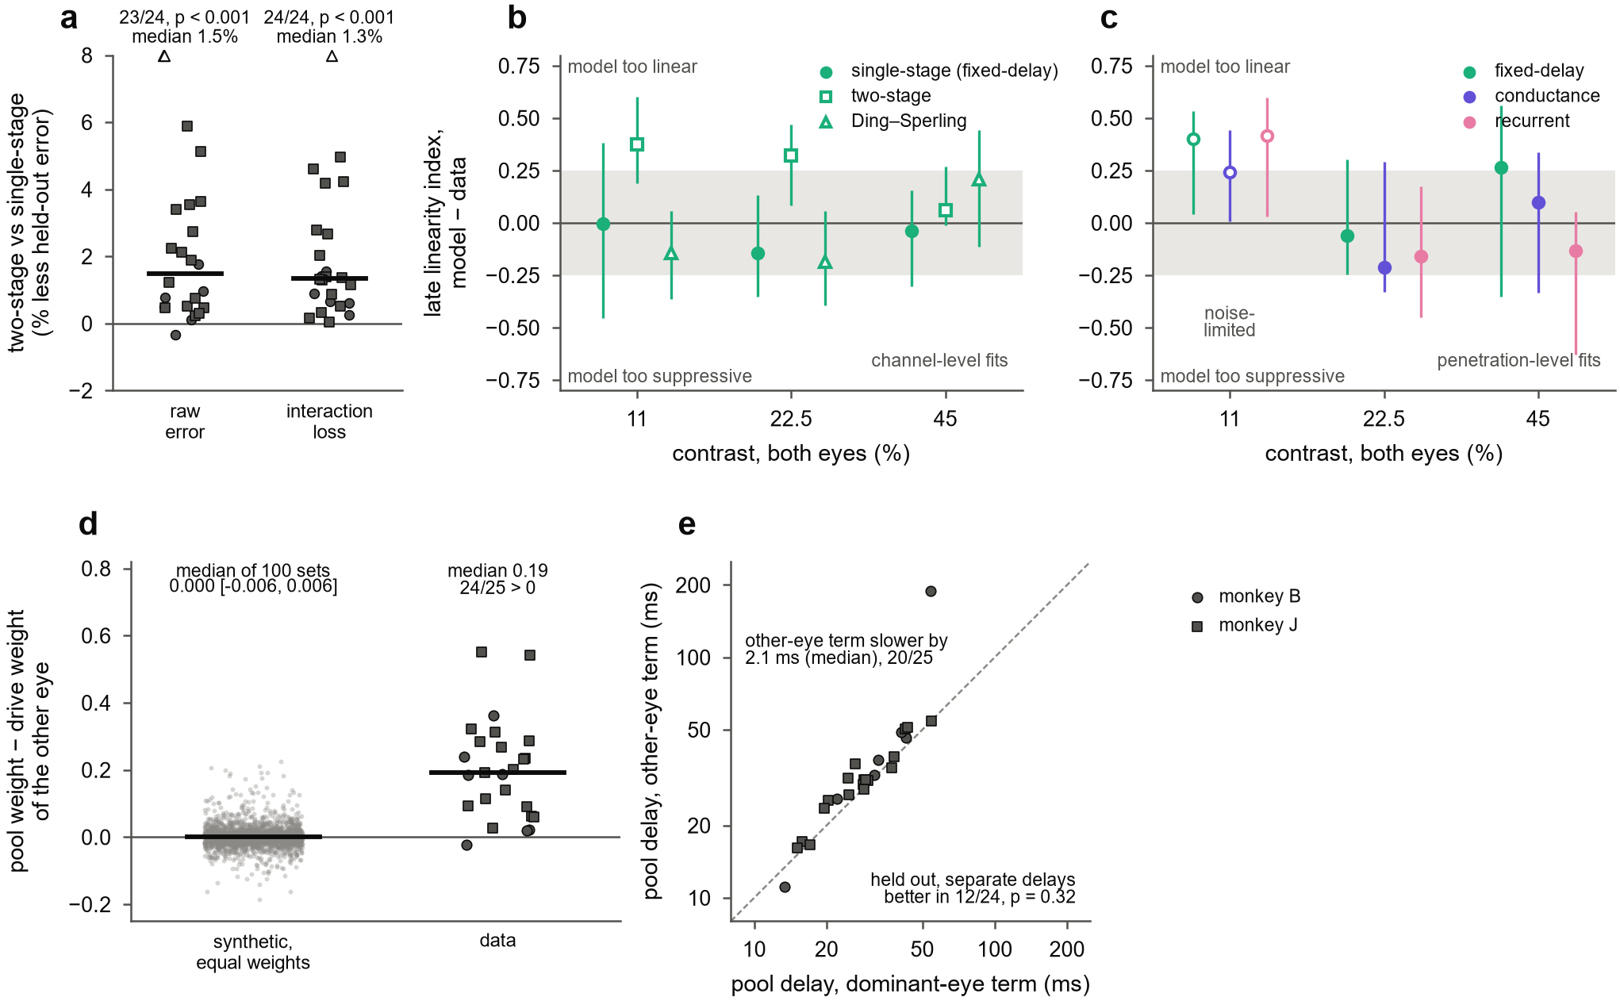
Supplementary Figure S5. Model checks. (a) Reduction in held-out error from adding interocular gain control before binocular normalization (two-stage model), per penetration, for fits to the raw time courses of each channel and for fits with the interaction loss; bars, medians; one-sided Wilcoxon signed-rank tests. (b, c) Late linearity index (50–150 ms after response onset) of each fit minus that of the data, median over penetrations with 90% bootstrap CI; grey band, ±0.25. (b) Channel-level fits of the single-stage, two-stage and dynamic Ding–Sperling models. (c) Penetration-level fits of the fixed-delay, conductance and recurrent models; at 11% (open symbols), noise in the data alone moves this index by 0.4–0.7. (d) Pool weight minus drive weight of the other eye, refitted from simulated data with equal weights and the data's noise (grey; 100 sets of 25 penetrations) and from the data (black); bars, medians. (e) Pool delays fitted separately for the dominant eye's and the other eye's terms; dashed, equality.
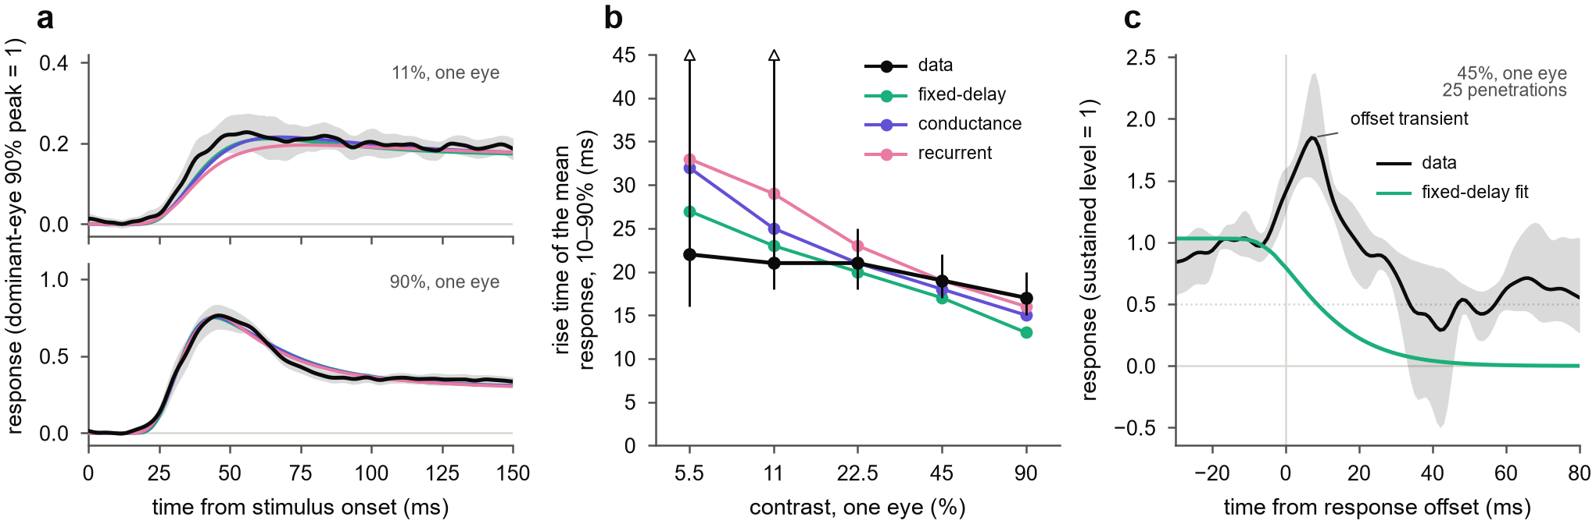
Supplementary Figure S6. Response dynamics. (a) Channel-averaged response to the dominant eye alone at 11% and 90% (black; mean over 25 penetrations with 95% bootstrap CI) and the mean fits of the fixed-delay (aqua), conductance (violet) and recurrent (magenta) models. (b) Rise time (10–90%) of the mean response: data with 95% penetration-bootstrap CIs (open triangles, upper ends beyond the axis) and the fits. Rise times of single penetrations are not shown, because at low contrast they are dominated by noise. (c) Response to the dominant eye alone at 45% after the stimulus was switched off, aligned to the response offset and scaled to the sustained level before it: data (mean with 95% CI) and the fixed-delay fit (median), which was fitted to the first 219 ms only.
Supplementary Table S1. Main statistics in each monkey. Medians over penetrations; counts give the penetrations with an effect in the stated direction; p, one-sided Wilcoxon signed-rank test (sign test for slopes). Penetrations: 26 for the linearity index and slopes, 25 for model fits and contours, 24 for held-out comparisons (Methods).
Statistic | Monkey B | Monkey J | Both monkeys
Linearity index, early → late, 11% | 1.52 → 1.41 (4/8, p = 0.37) | 1.12 → 0.36 (17/18, p < 0.001) | 1.19 → 0.61 (21/26, p < 0.001)
Linearity index, early → late, 22.5% | 1.40 → −0.19 (8/8, p = 0.0039) | 1.20 → 0.76 (13/18, p = 0.0052) | 1.20 → 0.47 (21/26, p < 0.001)
Linearity index, early → late, 45% | 0.93 → −0.71 (7/8, p = 0.10) | 0.97 → 0.51 (17/18, p < 0.001) | 0.97 → −0.11 (24/26, p < 0.001)
Slope of the index on log contrast, 20–50 ms | −1.61 (8/8, p = 0.0039) | −0.61 (18/18, p < 0.001) | −0.95 (26/26, p < 0.001)
Contour exponent, late − early, 11% | +0.06 (4/7, p = 0.42) | +0.24 (11/18, p = 0.0087) | +0.09 (15/25, p = 0.0093)
Contour exponent, late − early, 22.5% | +0.29 (4/7, p = 0.11) | +0.75 (17/18, p < 0.001) | +0.69 (21/25, p < 0.001)
Contour exponent, late − early, 45% | +5.25 (5/7, p = 0.04) | +1.00 (14/18, p = 0.0017) | +1.18 (19/25, p < 0.001)
Delayed vs static: less held-out interaction error | 41.1% (5/6, p = 0.03) | 52.1% (18/18, p < 0.001) | 51.6% (23/24, p < 0.001)
Pool weight − drive weight of the other eye | +0.19 (6/7, p = 0.02) | +0.22 (18/18, p < 0.001) | +0.19 (24/25, p < 0.001)
Conductance vs fixed-delay: less held-out error | 0.4% (5/6, p = 0.08) | 2.2% (15/18, p = 0.0014) | 1.6% (20/24, p < 0.001)
Supplementary Table S2. Robustness of the decline and of its contrast dependence. Early-minus-late drop of the linearity index (eye weight refitted in each window) and slope of the index on log contrast in the transition window, under each control; median over penetrations, fraction of penetrations in the stated direction, and p (two-sided Wilcoxon signed-rank test for drops, two-sided sign test for slopes).
Control (penetrations) | Drop, 11% | Drop, 22.5% | Drop, 45% | Slope, 20–50 ms
All presentations (26) | 0.41 (85%, p = 0.0043) | 0.60 (65%, p = 0.04) | 0.69 (81%, p < 0.001) | −0.77 (100%, p < 0.001)
No saccade of any size (25) | 0.74 (84%, p < 0.001) | 0.44 (56%, p = 0.15) | 0.79 (84%, p < 0.001) | −0.74 (96%, p < 0.001)
Pupil size within its interquartile range (24–25) | 0.41 (72%, p = 0.01) | 0.49 (80%, p = 0.02) | 0.93 (92%, p < 0.001) | −0.75 (96%, p < 0.001)
First half of the session (25) | 0.50 (80%, p = 0.0046) | 0.51 (68%, p = 0.05) | 0.65 (68%, p = 0.0029) | −0.92 (100%, p < 0.001)
Second half of the session (24) | 0.46 (71%, p = 0.11) | 1.14 (67%, p = 0.05) | 0.92 (88%, p < 0.001) | −0.70 (88%, p < 0.001)
Previous presentation absent or ≤ 11% (15–17) | 0.31 (60%, p = 0.80) | 0.64 (76%, p = 0.03) | 0.58 (75%, p = 0.02) | −1.26 (100%, p < 0.001)
Monkey B (8) | 0.39 (62%, p = 0.84) | 0.76 (75%, p = 0.38) | 1.39 (88%, p = 0.02) | −1.26 (100%, p = 0.0078)
Monkey J (18) | 0.41 (94%, p < 0.001) | 0.60 (61%, p = 0.07) | 0.50 (78%, p < 0.001) | −0.64 (100%, p < 0.001)
Without the penetration with 217 ms stimuli (25) | 0.31 (84%, p = 0.0067) | 0.66 (64%, p = 0.04) | 0.65 (80%, p < 0.001) | −0.78 (100%, p < 0.001)
Channels with eye weight ≥ 0.3 (25) | 0.34 (88%, p < 0.001) | 0.38 (60%, p = 0.18) | 0.43 (80%, p < 0.001) | −0.65 (100%, p < 0.001)

Open items for revision
- Fill in the bracketed Methods facts: species, sex, surgery and protocol, display, fixation window, receptive-field mapping.
- Affiliations, and whether Kacie Dougherty and Michele Cox join as authors.
- Confirm that Mitchell et al. 2023 analysed these recordings (the text says so in the Introduction and Discussion).
- Title: V3 proposes a new one, because "the two eyes normalize" was read as inexact; the V2 title is still an option.
- Remaining controls: receptive-field position, crosstalk between the eyes' images.
- Optional: whether the late recovery of the index at 45% after an undershoot (visible in Fig 4c) survives a noise check; not mentioned in the text.

