User guide to for pamfit an R package for the study of photosynthesis-light curve parameters spatial heterogeneity.

The objective of this guide is to help users in obtaining Imaging-PAM light-curve image parameters, e.g. alpha, E_{k}, rETR_{max} images, using the pamfit R package. It was originally written as supplementary material of the article “PAMFIT a new R package for the study of photosynthesis-light curve parameters spatial heterogeneity. ” by Jesus, B., Cartaxana, P., Williamson, C. (submitted) Limnology and Oceanography: methods.

1 - Installing the package

The package is stored on github and can be installed using the function install_github() from the package devtools.

The objective of this guide is to help users in obtaining Imaging-PAM light-curve image parameters, i.e. α, E_{k}, rETR_{max} and β images, using an ImageJ macro and the R functions available in the PAM-fit functions package. It was originally written as supplementary material of the article “Computer analysis of Imaging-PAM data for the study of photosynthesis-light curve parameters spatial heterogeneity” by Jesus, B., Cartaxana, P., Sanchez, G., Marques da Silva, J., Perkins, R.G. (2016) PlosOne (Details).

1- ImageJ macro

The first step of the process is to run a custom made ImageJ function that will transform the Imaging-PAM data in a format that can be analysed in R.

ImageJ is an open source software that can be downloaded at http://rsb.info.nih.gov/ij/. The ImageJ macro (Extract_data_ImagingPAM.ijm) can be run in ImageJ by going to the sub-menu Macros inside the menu Plugins (Figure 1) and selecting Run. You can also install the macro using the Install option in the same menu, this will add a item inside the sub-menu Macros called Calculate Fv/Fm files.

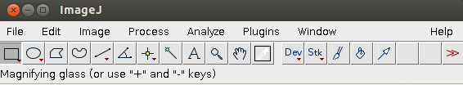

Figure 1 – ImageJ main menu (version 1.48k in Ubuntu 14.04)

The macro will ask the user for a Tiff file as input. This file is a multi-layered Tiff file exported from the ImagingWin software (Walz, ImagingWin v2.33) that contains information about F_{o}, F_{m} and F, F_{m}' data for each light step of the light curve and will be imported as a “stack” image in ImageJ. Please see the Walz ImagingWin software for more details about the Tiff file.

Once the Tiff file is selected the macro will ask for a smoothing radius (Figure 2). This is an optional but we strongly suggest that a minimum of 2 pixels is used to minimize image noise and improve the model fitting in R. The smoothing procedure smooths the image by replacing each pixel with the neighbourhood mean.
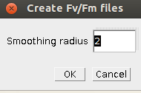

Figure 2 – Macro input box for the amount of pixels to be smoothed

The next step is to select the area that will be analysed (Figure 3). The macro accepts any type of selection (e.g. squares, circles, polygons, freehand, etc.) but a selection has to be made for the macro to continue. If the user wants to analyse the entire image a rectangle covering the entire image will have to drawn or the keyboard shortcut ctrl-A used to select the entire image. Pressing OK will initiate the image analysis.

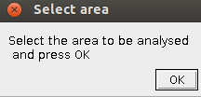

Figure 3 – Area of analysis selection menu.

Once the selection is done, the macro will calculates PSII quantum efficiency images for each step, i.e. F_{v}/F_{m} for the first light step (dark) or F_{q}’/F_{m}’ (or ΔF/Fm’) for the remaining light steps and export each image as a text file named accordingly to the light step (fv_fm01.txt for the 1st light step, fv_fm02.txt for the 2nd step, etc...). These text files will be used as input for the R functions. The macro also creates text files corresponding to the F_{o}, F_{m}, red and infra-red images. Expect a lot of windows opening and closing during the time the macro is running! In the end the user will be left with an image containing the area selected for analysis that can be saved for future reference.

2 – PAM-fit functions

Loading the R package (PAM-fit) adds all the necessary functions to the R workspace and loads two additional packages (“bigmemmory” and “doMC”). The PAM-fit R package includes the following functions: "test_OS()", "import_PAM_data(folder,ab)", "jassby_model(ncores,plots)" and "platt_model(ncores,plots)".
The "test_OS()" function has the sole purpose of helping the user to discover if they have access to parallel computing and inform the user of how many CPU cores are available in their system. Currently, only unix based systems allow parallel computing using doMC package (e.g. Linux and MacOS). Using parallel CPU processing will drastically decrease the time taken in processing large images.
The "import_PAM_data(folder,ab)" function requires the parameter folder which is the path to the “Fv_Fm0X.txt” files produced by the ImageJ macro. The function will search for these files inside R current working directory if no path is specified. It is essential that a plain text file named “light.txt” with the light curve levels exist in the same directory, the light levels should be separated by commas. Additionally, the parameter ab can be set to 1 when absorptivity data are available. If the function finds the “Fv_Fm0X.txt” files and their associated light levels in the “light.txt” file it will import all the “Fv_Fm0X.txt” and calculate the equivalent rETR images for each light level following equation 1:

rETR = 0.5 x ΔF/F_{m} x PAR x 0.84 (Equation 1)

Apparent rate of photosynthesis (PS) will be calculated when ab is set to 1 using equation 2:

PS = 0.5 x ΔF/F_{m} x PAR x Abs (Equation 2)

The "import_PAM_data(folder,ab)" function finishes by organizing and preparing the data matrix for the P-I light curve model fitting.

The next step is to chose which P-I model to fit to the dataset. Currently available, are the hyperbolic model described by Jassby & Platt (1976) (equation 3) and the model by Platt et al. (1980) (equation 4). Both, calculate images of PI curve parameters, i.e. α, E_{k}, rETR_{max} and produce another four images that can be used to estimate the goodness of fit, i.e. a weighted sum-of-squared-residuals (WSSR) image, a mean normalized bias (MNB) image, a residual mean square error (RMSE) image and a non-fitted pixels image. The Platt et al. (1980) calculates an extra image with the photoinhibition parameter (β).

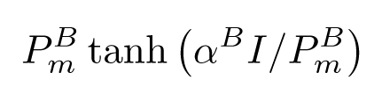
(Equation 3)

(Equation 4)

Both functions (jassby(ncores,plots) and platt(ncores,plots)) include a parameter that controls the number of CPU cores to be used (ncores), e.g. 4 in a quadcore CPU, and a parameter to control the visualization of the fitting process (plots). The plots parameters can only be activated if ncores=1. E.g. platt(1,plots=1) will process the image the using a single core and will plot a line with the model being fitted to each pixel; platt(4,plots=0) will process the image using 4 cores (if they are available in the machine) and will not plot anything during the analysis. Even if the user sets plots=1 no plot will be produced during an analysis with ncores>1.

Once the analysis is finished the user will find the following text files in the working directory:

alpha_platt_model.txt - contains all the pixels where α was calculated. Missing values are represented as NA.

etrmax_platt_model.txt - contains all the pixels where rETR_{max} was calculated. Missing values are represented as NA.

Ek_platt_model.txt - contains all the pixels where E_{k} was calculated. Missing values are represented as NA.

Beta_platt_model.txt - contains all the pixels where β was calculated. Missing values are represented as NA.

WWSR_platt_model.txt – contains the WWSR calculations for each pixel. Calculated as Σ(ETR_{obs}-ETR_{pred})²

MNB_platt_model.txt - contains the MNB calculations for each pixel. Calculated as
((ETR_{predicted}/ETR_{obs})/(n-1)) x 100

RMSE_platt_model.txt - contains the RMSE calculations for each pixel. Calculated as (Σ(ETR_{pred}-ETR_{obs})²/(n-3))^{1/2}

nonFit_platt_model.txt – contains a an images with coded pixels between 1 and 6 where each number correspond to the following code:

1- pixels excluded at the ImagingJ stage, i.e. outside the selection made by the user.
2- pixels excluded at the import_data() stage, i.e. pixels that were considered as noise by showing negative or >0.85 ΔF/F_{m} values.
3- pixels excluded because the fitting algorithm returned an error.
4- pixels excluded because the model did not converged to a solution.
5- pixels included and where everyhing was ok.
6- pixels where β equals zero or where the platt model was unable to return an estimation of rETR_{max}. This is only applicable when the Platt et al. (1980) model was used.

All the information present in the exported txt files can also be found in the R workspace in form of dataframes, i.e. alpha_platt, etr_max_platt, Ek_platt, Beta_platt, WSSR_platt, MNB_platt, RMSE_platt, nonFit_platt

Using the jassby() function will create similar files and dataframes as described above with the word jassby replacing the word platt.

All images produced are in simple text format and can be further processed, either in R using the datasets, or they can be imported with imagery software for more spatial analyses, e.g. ImageJ or GIS software. To open the images in ImageJ the user only needs to use “Import text image”. The dataframes can be visualized in R using the image function (see R documentation for more information on the image function).

3 - Visual example of the entire process

The example presented is from a microphytobenthic biofilm from the Tagus estuary (Lisbon, Portugal) (Vieira et al., 2013). The sediment surface was collected with circular corer of 20 mm diameter and a drop of dithiothreitol (DTT) was added in the centre of the core. Dithiothreitol is a strong inhibitor of the xanthophyll cycle, which is a main photoregulatory mechanism in diatoms.

3.1 -ImageJ macro

The first step is to run the macro Extract_data_ImagingPAM.ijm (Figure 4)
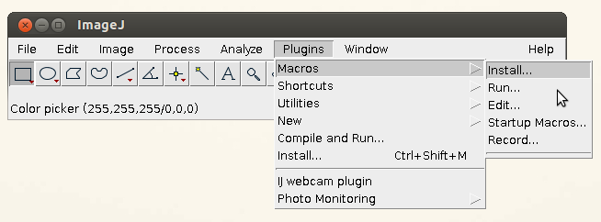

Figure 4 –Location of the menu Run macro in ImageJ

The macro will ask for your ImagingPAM tiff and when opened it will rename it to “Working copy”. This is to avoid making changes to your original image by mistake.

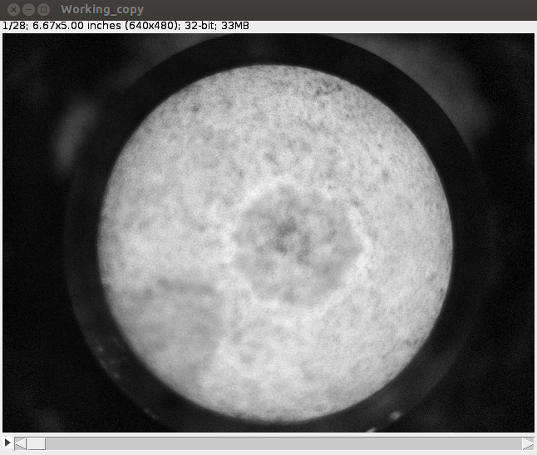

Figure 5 – The Tiff file open in ImageJ shows the corer with the biofilm at the surface. The area where DTT was added is clearly visible in stronger contrast. Notice that the image title is now called Working_copy.

The next step is to select the smoothing radius (Figure 2). In this example we chose 4 pixels. The smoothed result can be seen in Figure 6.

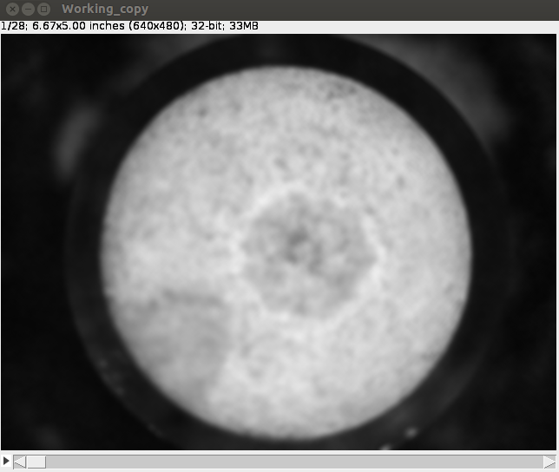

Figure 6 – The Tiff file after the 4 pixels smoothing step.

The macro then asks for a selection area to be analysed (Figure 3) and in this example we selected a small part of the image that includes the transition between the biofilm with and without DTT (Figure 7).

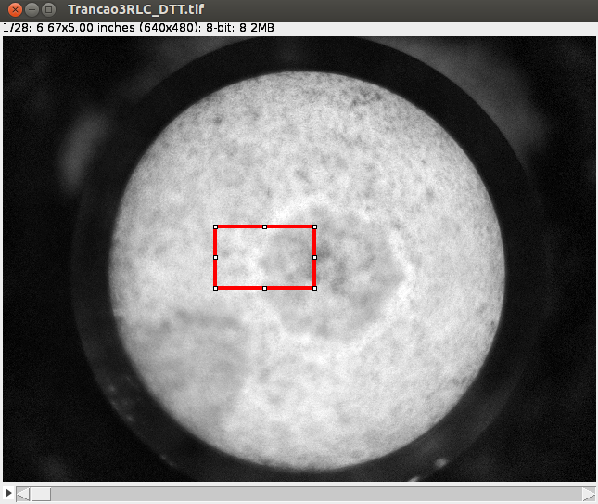

Figure 7 – The Tiff file with the selection area in red.

After the selection, the macro will calculate F_{m}'-F'/F_{m}'=ΔF/F_{m} for each light step (Figure 8) and you will see a lot of images opening and closing. This correspond to the macro extracting the F' and Fm' image from each light step and calculating the ΔF/F_{m} image.
F'
Fm'
-


ΔF/Fm
=
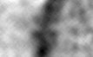
Fm'


Figure 8 – Calculation of the ΔF/F_{m} images.

When the ImageJ macro is finished you should see a list of text files named fv_fmX.txt in your working folder where X stands for the light step number.

The next step is to import and fit the P-I models in R.

3.2 – PAM-fit functions

Firstly, you need to open an R session, install the PAM-fit package [install.packages(“PAM-fit”)] and load it into the workspace [library(“PAM-fit”)].

Secondly, you need to import the data produced by ImageJ into R. If you are running R in the same directory and you have no absorbance measurements you just need to execute the function without changing any parameters, i.e. import_data(). This will check for the existence of a text file called light.txt with the corresponding light levels separated by a comma. If there is a discrepancy between the number of fv_fmX.txt and the number of light steps inside the file light.txt the function will abort and the user will get the following message: “The number of light steps does not match the number of PSII efficiency files. Please check the light.txt file to see if the number of light steps match the number of Fv/Fm files”.

If the light levels are ok the function will import all the files (printing the message: “files will be imported”). If the user used the parameter ab=1 then a message will appear saying “Calculating absorbance”. Once these two steps are done the function will calculate rETR images for each light level and print the message “Calculating rETR”. The final step is to organize the rETR data into a single matrix in a format that will allow parallel processing during the model fit, this step takes longer than the previous one and the function will print the message “Transforming the matrices" followed by the percentage of completeness (Figure 9).

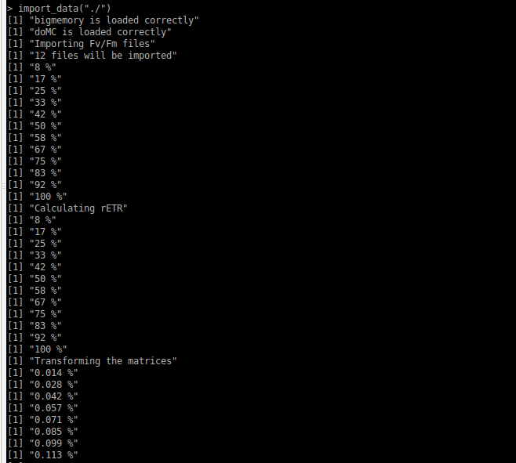

Figure 9 – R console showing the messages the user will see during the execution of the function import_data().

The user then needs to select which model to fit to the rETR data. In the example we used the DTT inhibitor added to the surface was likely to induce photo-inhibition during the light curve so we chose to use the Platt et al. (1980) model. If the user selects to visualize the model fit in “real-time” he can run the platt_model() function with the plots parameter active, i.e. platt_model(ncores=1, plots=1). This will lunch the analysis and a plot will be presented with the observed rETR and the fitted data for each pixel (Figure 9), simultaneously the percentage of completeness will be printed in the console.

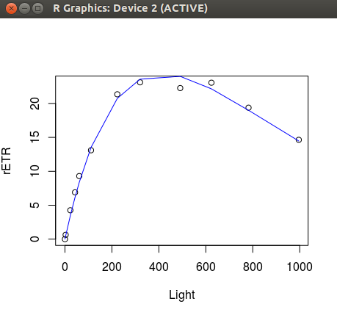

Figure 10 – Example of a plot that will appear if the user selects the parameter plots=1. Notice that in this dataset there was a clear photo-inhibition effect in higher light levels that will not be detected if the Jassby and Platt (1976) model is used.

When the analysis is finished the user will find in the workspace the objects described in section 2, as well as the corresponding text files in the working directory.

The images can then be used as input variables for any analysis the user wishes. For example, plotting alpha and rETRmax can achieved with the instruction: plot(alpha_platt,etr_max_platt) (Figure 10).
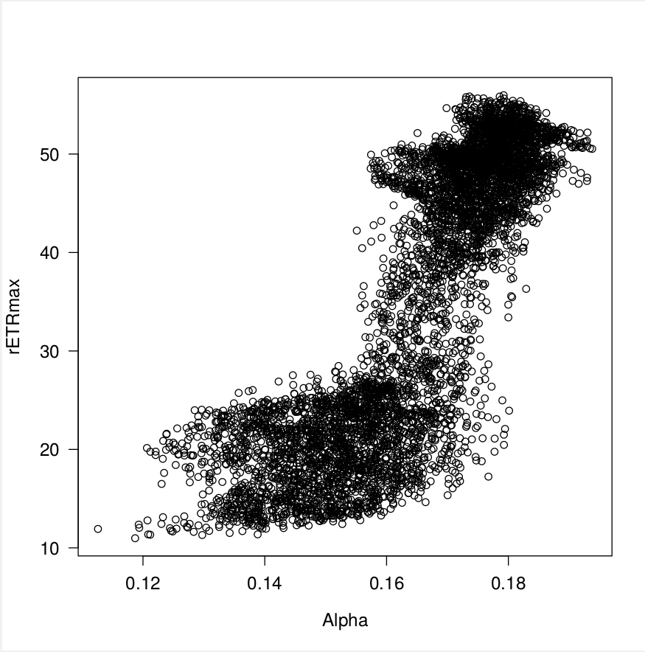

Figure 11 – Example of a plot between alpha and rETRmax.

To plot a parameter in the form of an image the user can use the R function image, e.g.
image(t(as.matrix(alpha_platt))) will create an image of the alpha parameter (Figure 12 ).
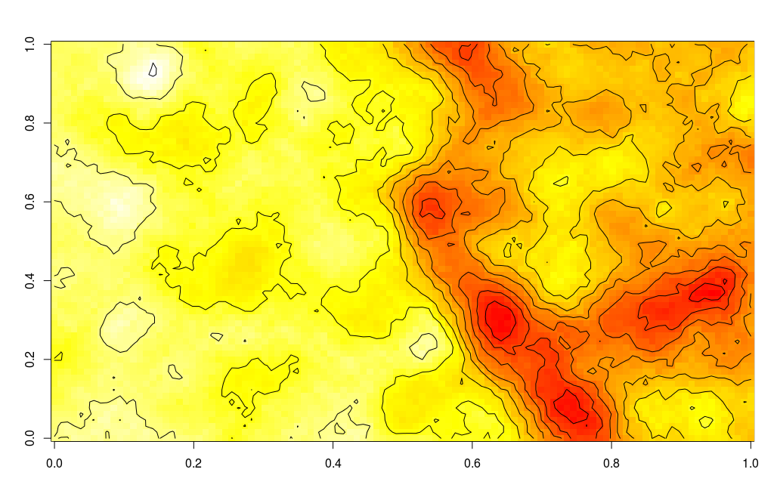

Figure 12 – Example of an alpha image with 10 contour levels.

The user can also visualize the PI parameters using 3D perspective, e.g using persp3D() from the package plot3D (Figure 13).
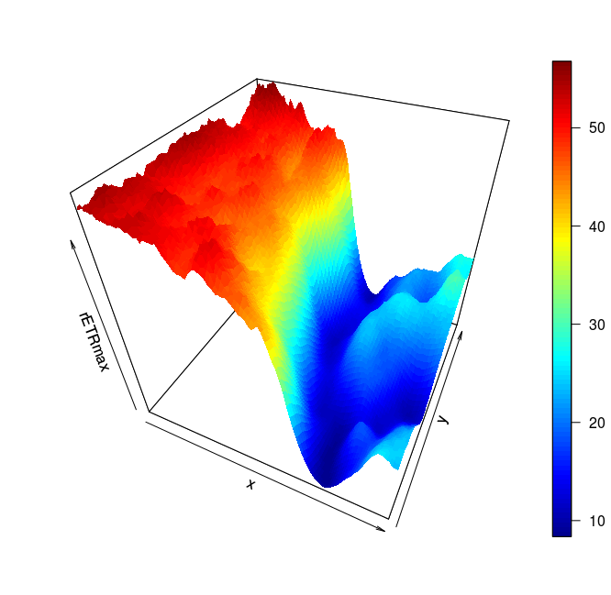

Figure 13 – Example of an rETRmax image using persp3d showing, very clearly, the decrease in rETRmax induced by the DTT inhibitor.

The text images produced by the PAM-fit package can be easily imported as text images in ImageJ (Figure 14). Operations between the images can then be made using the Image Calculator (Figure 15) or writing scripts for more complex operations.
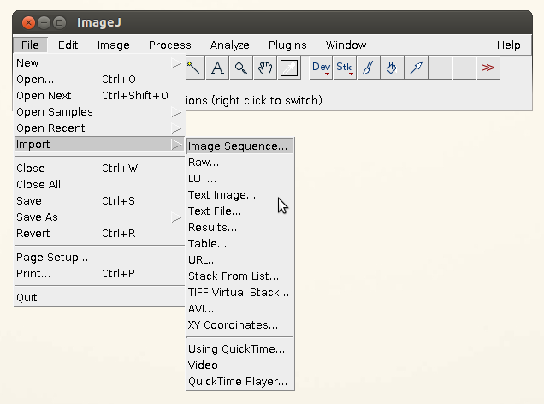

Figure 14 – Location of the menu to import Text images in ImageJ.

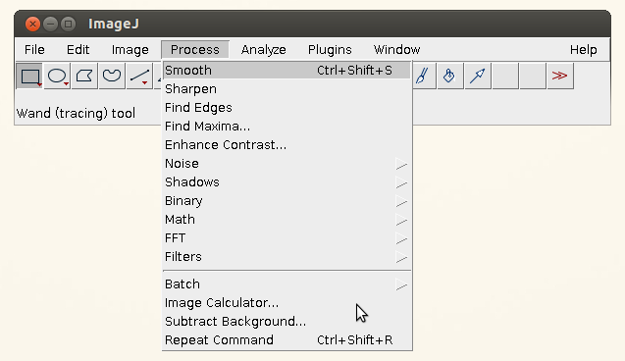

Figure 15 – Location of the menu to Image Calculations in ImageJ.

References
Jassby, A.D., Platt, T., (1976) Mathematical formulation of the relationship between photosynthesis and light for phytoplankton. Limnol. Oceanogr. 21: 540-547.
Platt, T., Gallegos, C.L., Harrison, W.G. (1980) Photoinhibition of photosynthesis in natural assemblages of marine phytoplankton. J. Mar. Res. 38, 687-701.
Vieira, S., Ribeiro, L., Jesus, B., Cartaxana, P., Marques da Silva, J (2013) Photosynthesis Assessment in Microphytobenthos with Conventional and Imaging Pulse Amplitude Modulation Fluorometry. Photochemistry and Photobiology. 89: 97-102.

This guide was written using ImageJ version 1.48k
If these two packages are not installed then PAM-fit tries to install them for you. If it fails installing, then the user needs to manually install “bigmemmory” and “doMC”.
The matrices are re-ordered in a way that allows the function mclapply to be used in parallel processing.
Model fitting uses the R optim function with the quasi-Newton method L-BFGS-B
Simultaneous parallel processing and visualization of the fitting plots will crash your computer, thus the code is written to prevent plotting if ncores>1.
Please notice that running the analysis and plotting the data at the same time will drastically increase the analysis time. Nevertheless, we recommend that the users visualize how the models fit their data by using a small sub-set of the entire image.

