**Steps to create web app in azure** :

1.Go to <https://portal.azure.com>

2.Go to app services menu and click the add button (+)

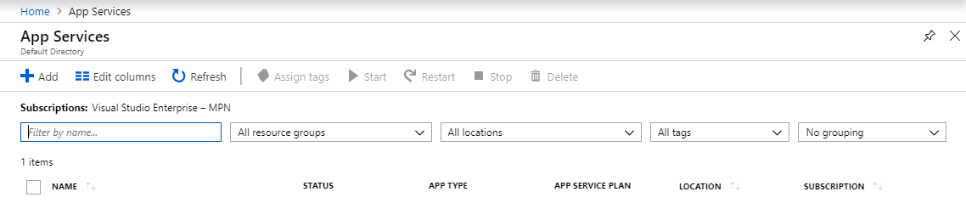

3.Select web app from the list of items and click the create button

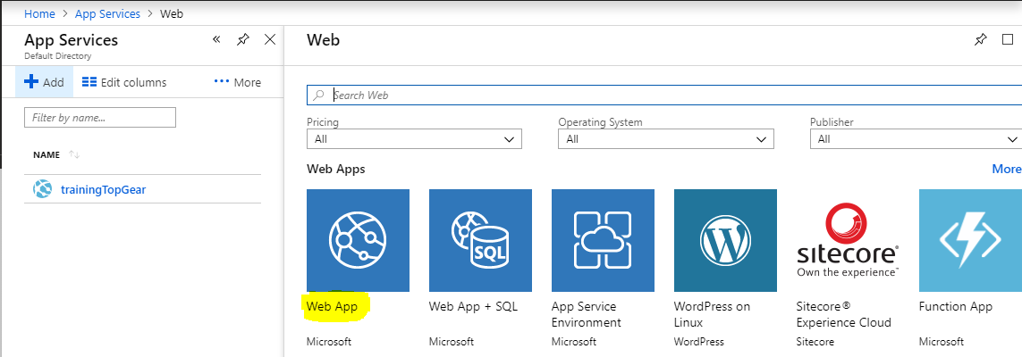

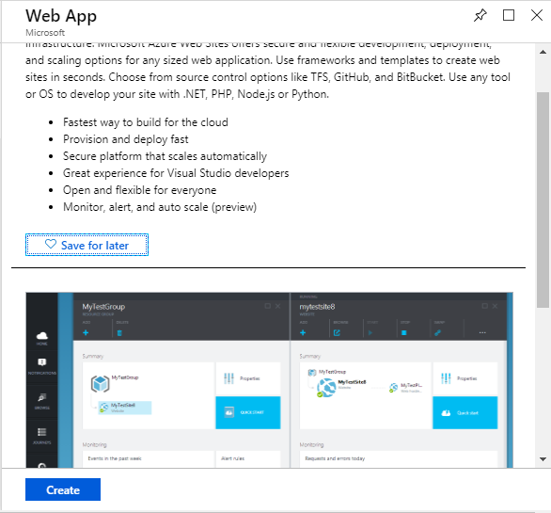

4.Finally you will get below screen, fill all the required information and it will create web app

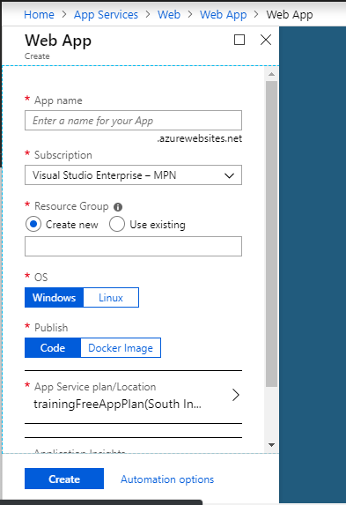

**Publish to azure web app using web deploy** :

1. Create a asp.net MVC project
2. Make your desired changes to the view
3. Right click on solution and select publish
4. It will open a publish window and select your subscription and the web app and click on OK.

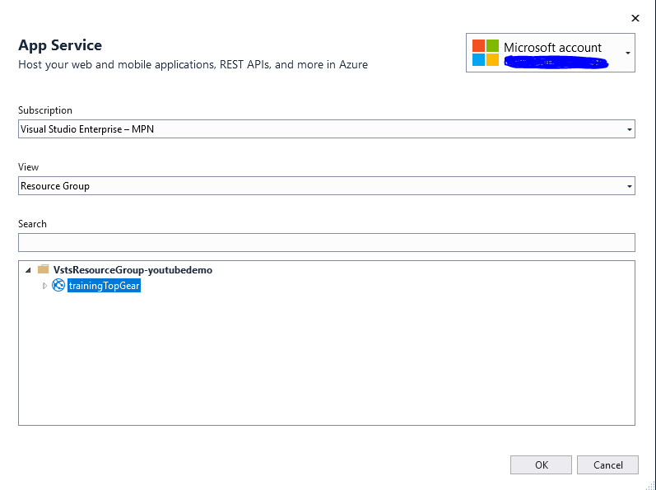

1. Once publish you can see you application is now hosted on azure <https://trainingtopgear.azurewebsites.net/>

**Create a Web Job** :

1. Create a simple console application with some logging
2. Build the application and add the created exe into a zip file
3. Go to azure portal and create a web job  
   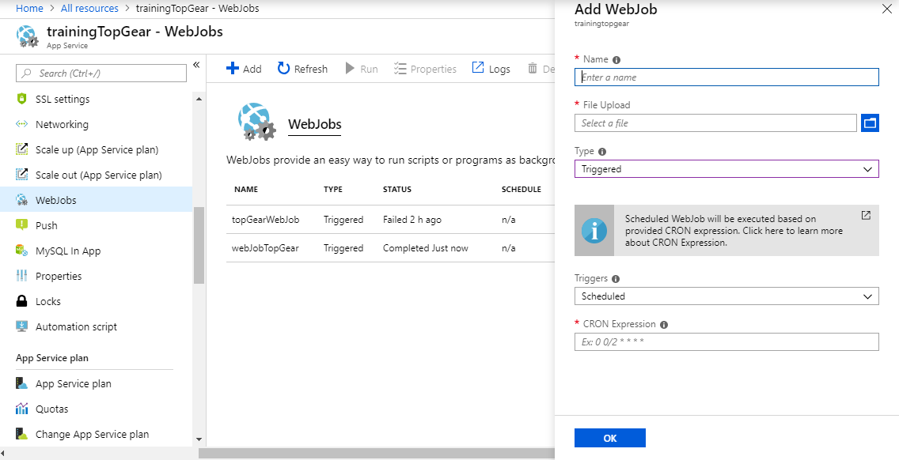
4. Fill the required information, upload the zip file and select the appropriate trigger and click ok
5. Once created select the run option to run the job or if it is scheduled then it will run on the specified schedule
6. See the logs  
   