# Answers bioinformatics 2 Primer Design

Update: 2021-12-24

1. 240 bp
2. Acc65I – SacI
3. NotI, XhoI  (DrdI cuts twice in the plasmid and outside the MCS, HincII cuts in the insert, PciI does not cut in the plasmid, TatI cuts in the insert and cuts outside the MCS)
4. NotI: GCGGCCGC

XhoI: CTCGAG

1. 5’ end: NotI
2. 3’ end: XhoI
3. 65.01 °C
4. 57.69%
5. Forward: 28 bp
6. Reverse: 26 bp
7. 254 bp
8. 3138 bp
9. Yes, same sequence and 240 bp in length
10. Enzyme pair 1: NotI x XhoI (i.e. the enzymes that you used for cloning)
11. Enzyme pair 2: Multiple answers possible. Search for an enzyme that cuts once in the plasmid and an enzyme that cuts once in the insert. For example: HincII and XmnI
12. Enzyme pair 1 (NotI x NcoI): 247 bp + 2891 bp
13. Enzyme pair 2: multiple answers possible. For HincII x XmnI: 2033 bp + 1105 bp

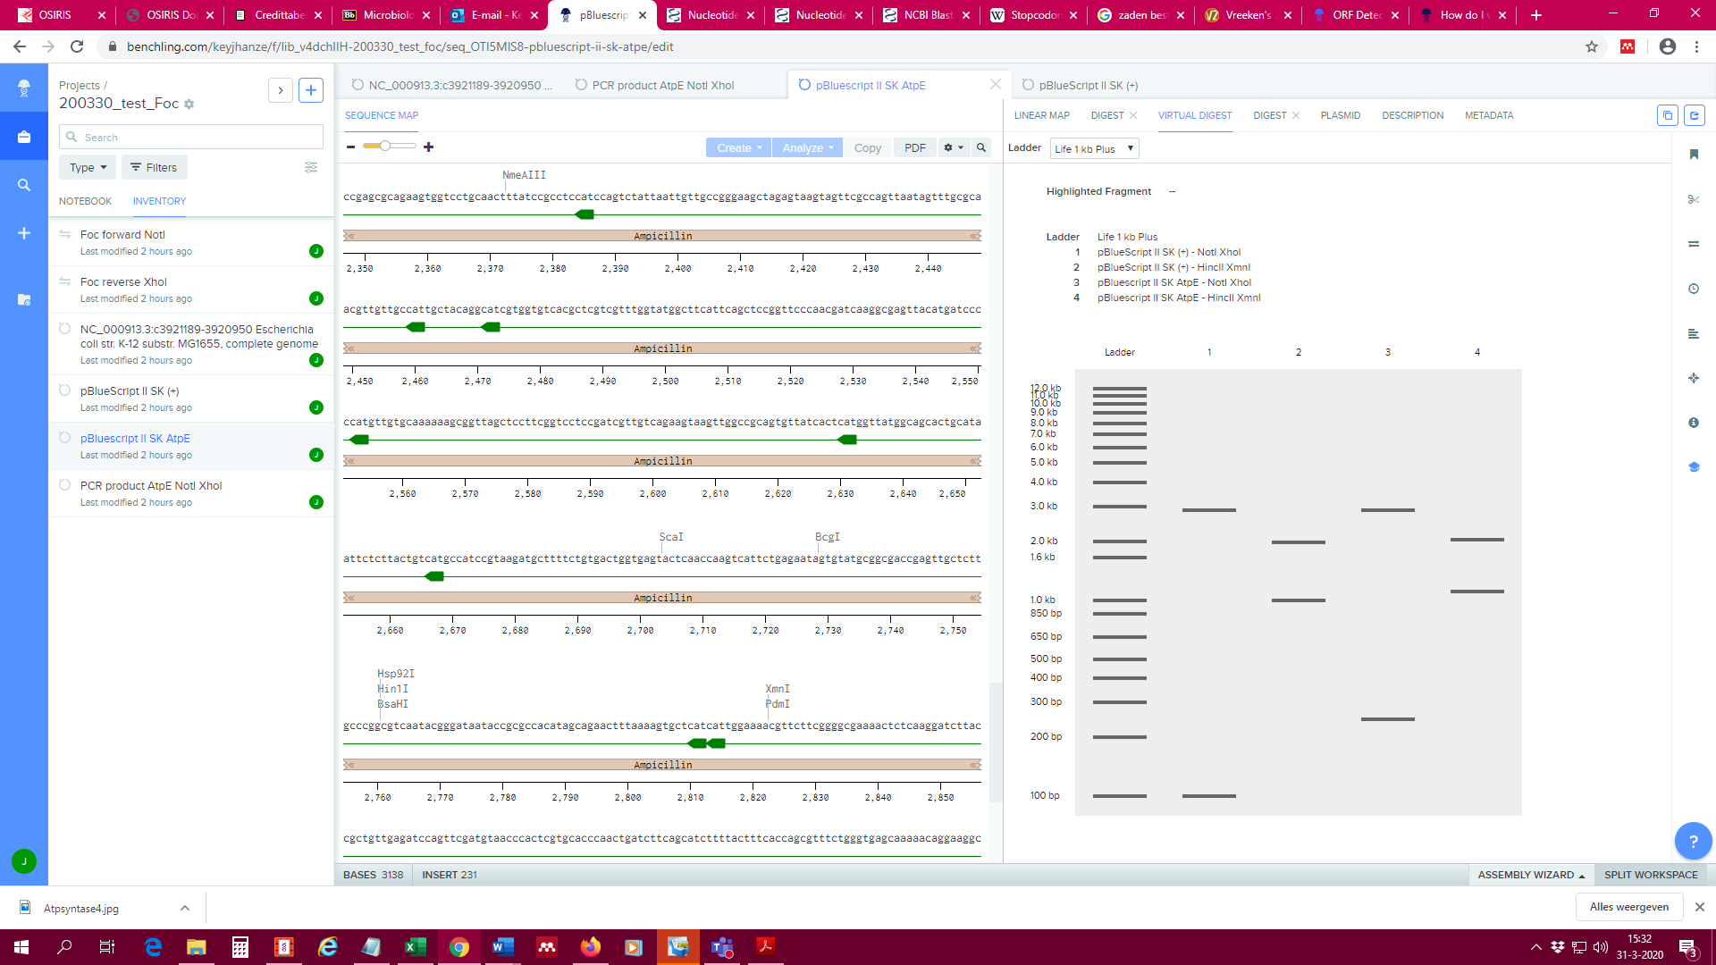

1. The ‘-‘ indicates that the primer binds on the complementary strand.
2. Primer 1 and Primer 4 (primers 2 and 3 do not bind at all to the construct, primer 5 can bind, but binds inside the sequence of *atpE*).

The end…