Excel Exercise Solution

Exercise 1

Introduction
The Comet Goldfish Lifespan Prediction Dataset offers a structured approach to analysing the environmental and biological variables that influence the longevity of Carassius auratus. Through targeted data visualizations, such as pivot charts, box plots, and scatter plots, we can uncover how specific factors—ranging from habitat types to water pH levels—impact the lifespan of comet goldfish.

Dataset
The following data set was used: Predict lifespan of a comet goldfish. It is a fictional data set.

Aim
The aim of this study is to utilize Excel and Power Query to clean, transform, and visually analyze the environmental and biological factors influencing the lifespan of comet goldfish.

Data import
Data was inspected in PowerQuery:

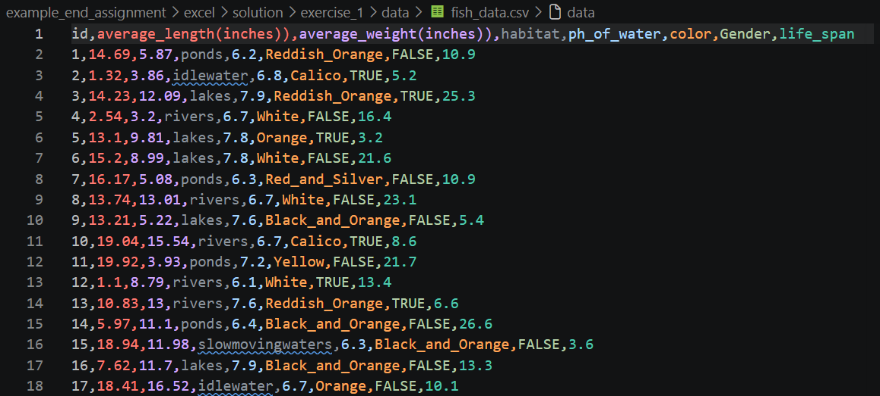

Comma separated. Decimal separator is a dot.
Load using PowerQuery:
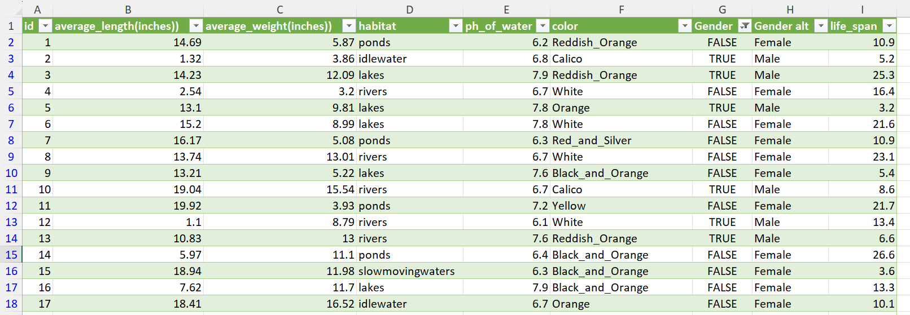

- Data import: how did you import the data (screenshot)
- Cleaning: did you clean the dataset? If so, how?
- Results: show your plots together with a short result description.
- Conclusion: a brief conclusion (one or two sentences).

