PSG6&9Voices Card for HITACHI BASIC MASTER LEVEL3
Designed by Sasaji 2021 Rev. 0.2
Parts List

The main board
Parts Number | Parts Name | Qty. | Description
C1~C16 | Ceramic Capacitor | 16 | 0.1uF (Bypass)
C19 | Electrolytic Capacitor | 1 | 1uF, 10V~
C100 | Electrolytic Capacitor | 1 | 100uF, 16V~ (Bypass)
C101~C103 | Electrolytic Capacitor | 3 | 22uF, 10V~ (Coupling)
C104 | Electrolytic Capacitor | 1 | 100uF, 10V~ (Coupling)
R1 | Carbon Resistor | 1 | 4.7KΩ, 1/4W~ (Pullup)
R3~R5 | Carbon Resistor | 3 | 4.7KΩ, 1/4W~ (Pulldown)
R6~R10 | Carbon Resistor | 5 | 3.3KΩ, 1/4W~ (Pulldown)
R11~R19 | Carbon Resistor | 9 | 470Ω, 1/4W~ (Analog sound)
R21~R24 | Carbon Resistor | 4 | 1KΩ, 1/4W~ (Analog sound)
R31~R32 | Carbon Resistor | 2 | 10KΩ, 1/4W~ (Pullup)
U1~U3 | PSG (or compatible IC) | 3 | AY-3-8910, AY-3-8913 or YM2149  DIP40pin or 24pin 600mil  * Use the same type IC on U1~U3.
U4 | PIA | 1 | HD6821P or MC6821, DIP40pin 600mil
U5 | VIA | 1 | MCS6522 or R6522, DIP40pin 600mil
U6~U7 | CMOS Logic IC | 2 | 74CBT3257C, SOIC16pin
U8 | CMOS Logic IC | 1 | 74HC244, SOIC20pin
U9 | CMOS Logic IC | 1 | 74HC74, SOIC14pin
U10 | CMOS Logic IC | 1 | 74HC139, SOIC16pin
U11 | CMOS Logic IC | 1 | 74HC04, SOIC14pin
U12,U14 | CMOS Logic IC | 2 | 74HC02, SOIC14pin
U13 | CMOS Logic IC | 1 | 74HC00, SOIC14pin
U15,U16 | CMOS Logic IC | 2 | 74HC125, SOIC14pin
J1 | Jumper | 1 | Pin header 3pin x1 2.54mm pitch straight
 | Jumper Pin | 1 | To short the J1
J2 | Wire cable | 3 | Connect to button on the sub board (J1)
J3 | Wire cable | 3 | Connect to volume on the sub board (J2)

Optional parts
J4 | Connector | 1 | Pin header 1pin x1 L angled  (PIA/VIA select output)
 | IC Socket | 5 | Use on U1~U5

The sub board
Parts Number | Parts Name | Qty. | Description
SW1,SW2 | Push button | 2 | Tact switch (momentary)  Phi is ~3.5mm, and the height of the key top is 4mm or more.
RV1 | Volume | 1 | 10KΩ  Alpus RK09 Series
J1 | Wire cable | 3 | Connect to J2 on the main board
J2 | Wire cable | 3 | Connect to J3 on the main board

Attention to build the board

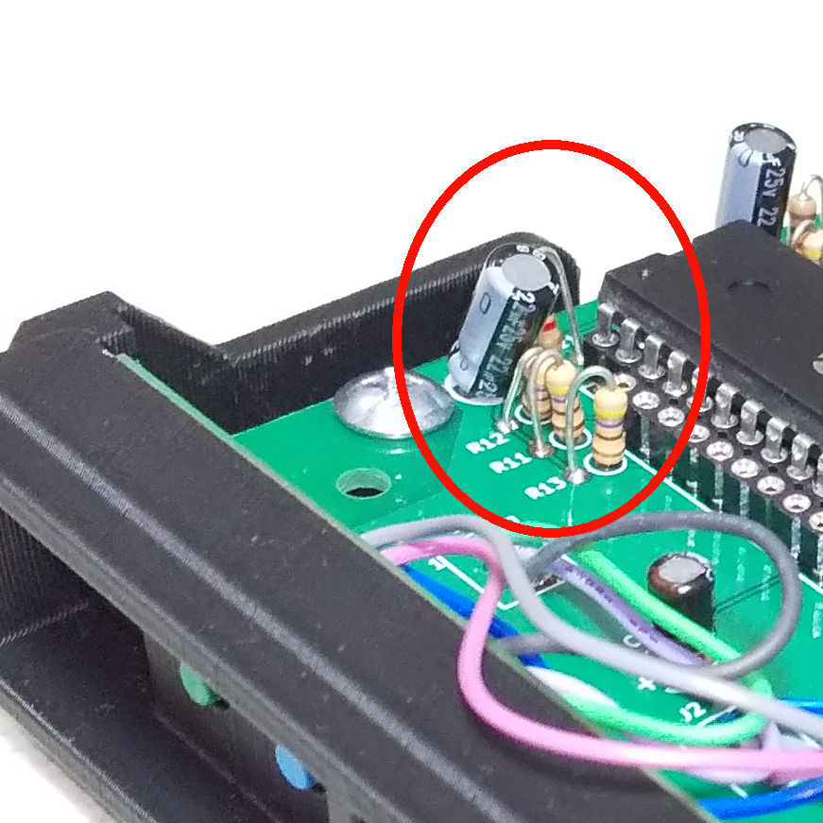
The capacitor near screw hole
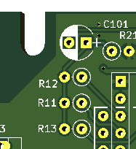
When attaching the C101, R11, R12, and R13 to the board, bend them slightly to avoid interference with the tapping screw and the adjacent expansion card.

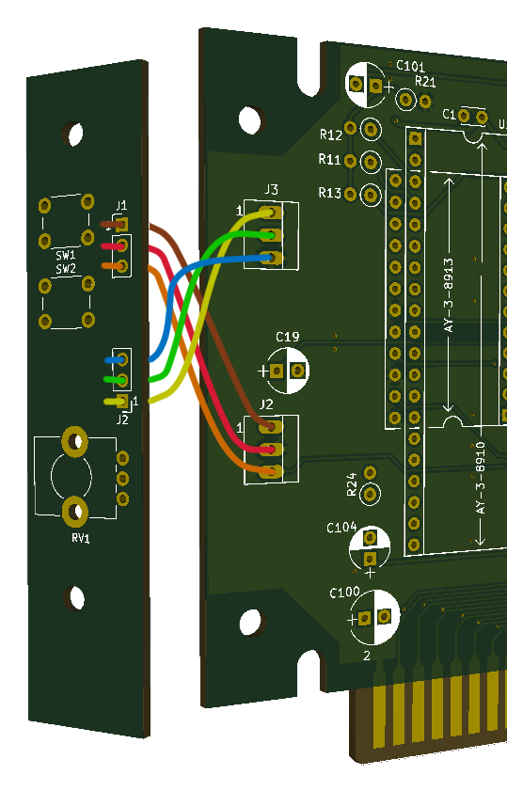

Connect the main and sub board
Connect the main J2 <-> sub J1 and the main J3 <-> sub J2 with electric wires.
Match the main and sub pin numbers. When connected, the wires will cross each other.

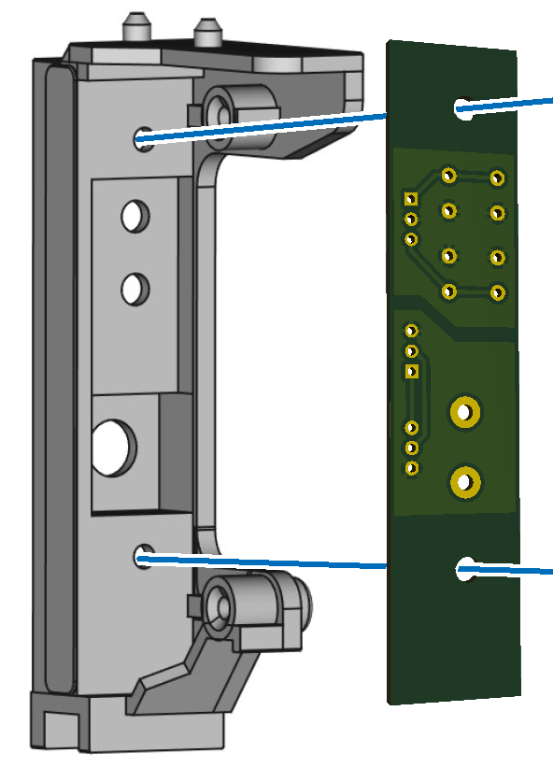
Attach the sub board to the back cover
Before soldering electronic components, temporarily fix the components to the sub-board and check if they can be attached to the back cover in that state.
If the board does not fit all the way into the cover, cut the lower part of the sub board by about 5 mm.
After confirming the mounting of the board, solder it and fix it to the cover with M3 screws.

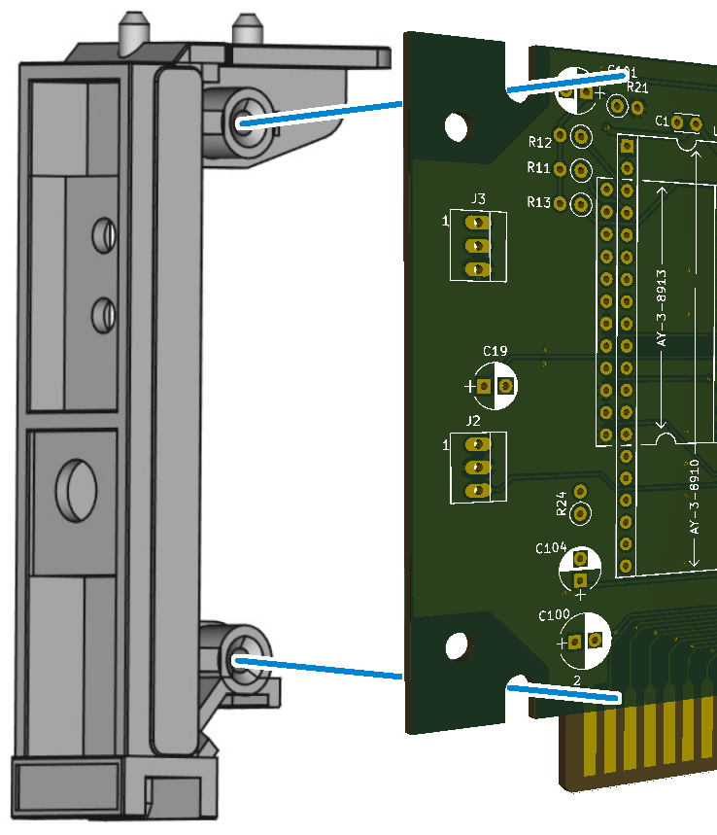

Attach the main board to the back cover
Attach the main board and cover to the positions shown in the figure with tapping screws.
The back cover is fragile, so be careful and do not use too much force when tightening a screw.

[Extra way] Use the black board as a back cover
The black board is used when you want to use it as a back cover as it is.
Connect to the main board using L-angled brackets and screws.
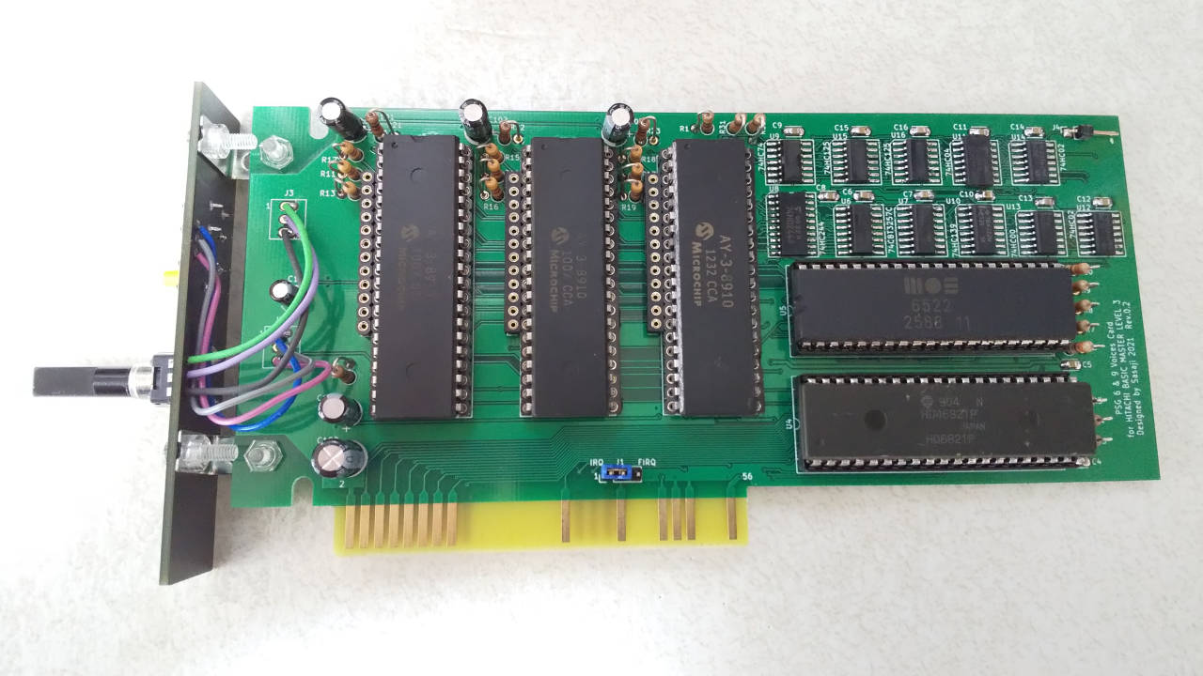

No warranty
We are not responsible for any damage caused by this card.
You use this card at your own risk.

Web
This document and CAD data are opened on the web.
GitHub(https://github.com/bml3mk5/L3PSG6n9Voices)
or
http://s-sasaji.ddo.jp/bml3mk5/l3psg6n9.htm#board

Sasaji (sasaji@s-sasaji.ddo.jp)
http://s-sasaji.ddo.jp/bml3mk5/
(Twitter: https://twitter.com/bml3mk5)

