PSG6&9Voices Card for HITACHI BASIC MASTER LEVEL3
Designed by Sasaji 2021 Rev. 0.2
This is an extension card for HITACHI BASIC MASTER LEVEL3, markII and mark5. This is equipped with 3 PSGs and you can play with up to 9 voices.
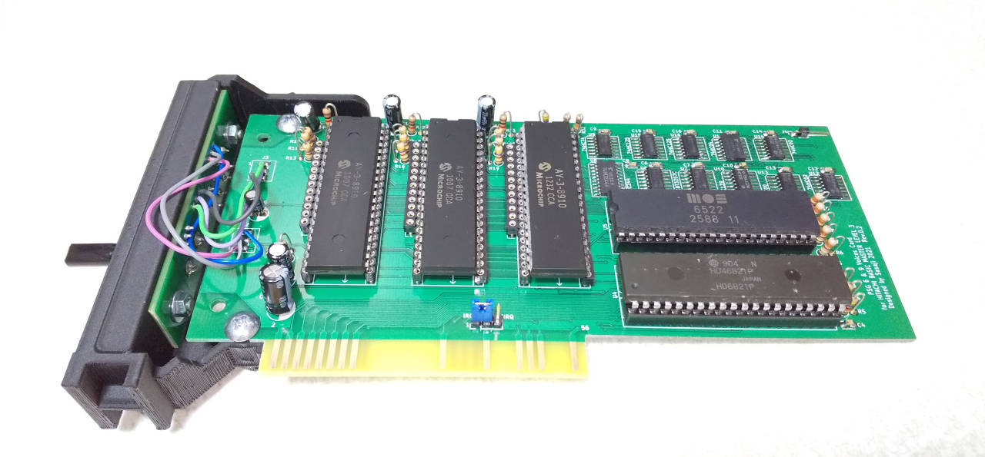
Implementation
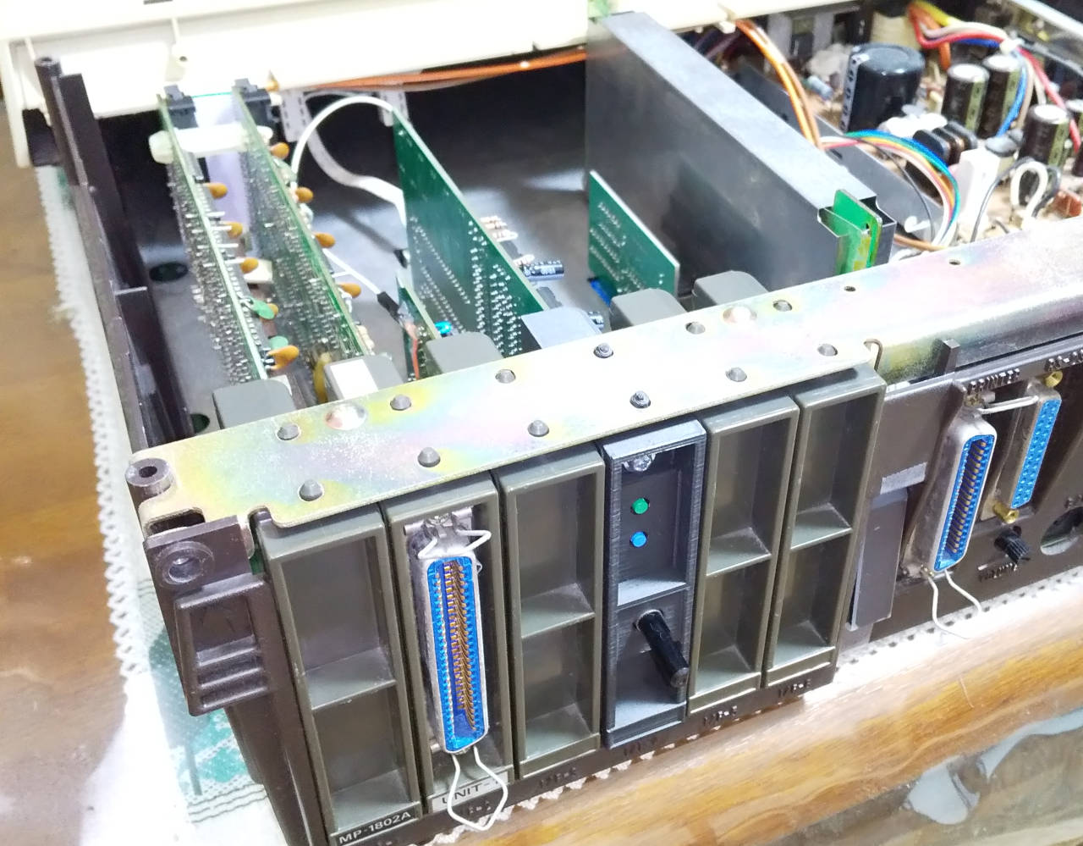
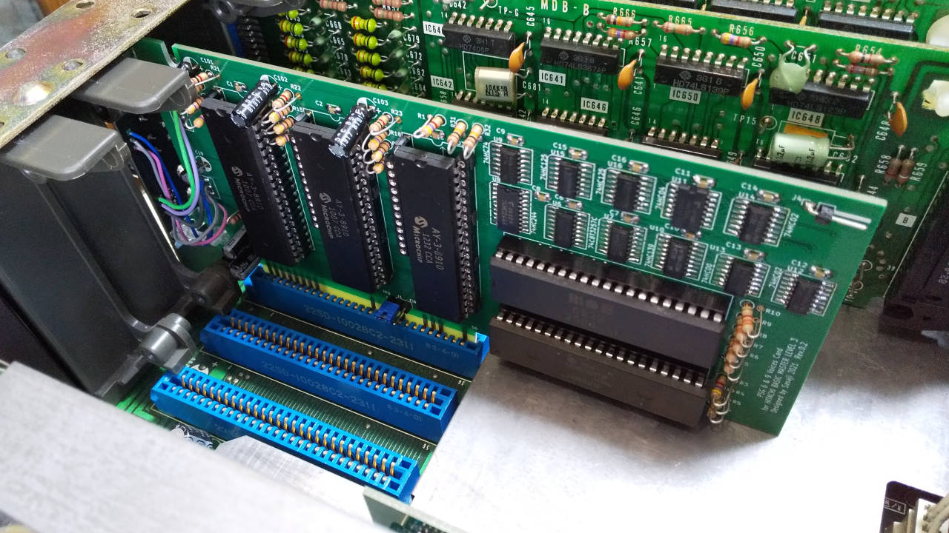
Installation

This card has two modes to control PSG via PIA and to do it via VIA.
PIA mode | This control two PSGs. You can play up to 6 voices.  Supported games:  Destroy Alien, The Cockpit
VIA mode | This control three PSGs. You can play up to 9 voices.  Supported games:  Skipper
You can toggle these modes using a I/O port by software, or buttons on the back side.

When specify from BASIC:

PIA: POKE &HFF34,0
VIA: POKE &HFF34,&H81

I/O Ports
PIA Register
Address | D7 | D6 | D5 | D4 | D3 | D2 | D1 | D0 | R/W
$FF30 | DA7 | DA6 | DA5 | DA4 | DA3 | DA2 | DA1 | DA0 | R/W | PIA Data Register A  Write to PSG
$FF31 |  |  |  |  |  |  |  |  | R/W | PIA Control Register A
$FF32 | x | x | x | x | x | SEL | BDIR | BC1 | R/W | PIA Data Register B  PSG Bus Control
$FF33 |  |  |  |  |  |  |  |  | R/W | PIA Control Register B
When BDIR = 1 and BC1 = 1, latch register number on PSG.
When BDIR = 1 and BC1 = 0, write data to PSG.
When BDIR = 0 and BC1 = 1, read data from PSG.
SEL : Select PSG1 = 0, Select PSG2 = 1

PIA/VIA Select
Address | D7 | D6 | D5 | D4 | D3 | D2 | D1 | D0 | R/W
$FF34  ($FF35) | CLK | x | x | x | x | x | x | V/P | R/W
V/P … “0”:Select PIA, “1”:Select VIA
CLK … Select clock on PSG “0”: 1MHz “1”:2MHz

VIA Register
Address | D7 | D6 | D5 | D4 | D3 | D2 | D1 | D0 | R/W
$FF70 | x | x | x | PSG3 | PSG2 | PSG1 | BC1 | BDIR | R/W | ORB  PSG Bus Control
$FF71 | DA7 | DA6 | DA5 | DA4 | DA3 | DA2 | DA1 | DA0 | R/W | ORA  Write to PSG
$FF72  ~  $FF7F |  |  |  |  |  |  |  |  |  | VIA Register  See datasheet of VIA for details.
When BDIR = 1 and BC1 = 1, latch register number on PSG.
When BDIR = 1 and BC1 = 0, write data to PSG.
When BDIR = 0 and BC1 = 1, read data from PSG.
PSG1:Select PSG1=1
PSG2:Select PSG2=1
PSG3:Select PSG3=1

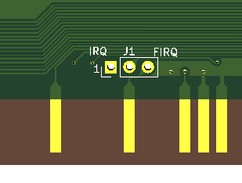
Jumper Pin

This connect the interrupt signals from PIA and VIA to the CPU side.
Normally, short the IRQ side (1-2).

The back cover Extended terminal
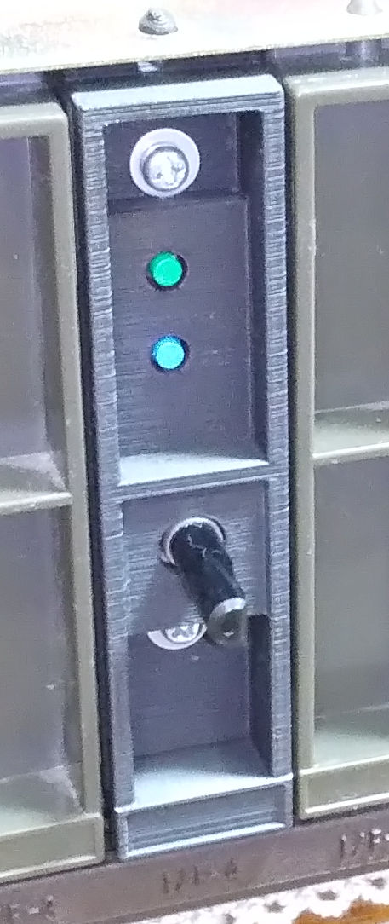
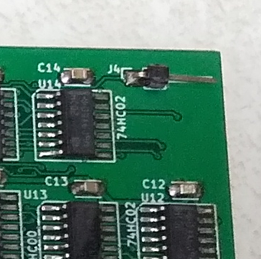
PIA select button

VIA select button

Sound volume
"H” level when PIA,
"L” level when VIA.

Attention
- You cannot adjust the sound using the volume on the main board. Please use it on the back cover.
- The Kanji ROM card and VIA address are duplicated. When select the VIA side, don’t read from Kanji ROM or VIA port.
- This board is a prototype. No consideration is given to noise generated during use and deterioration over time.

No warranty
We are not responsible for any damage caused by this card.
You use this card at your own risk.

Web
This document and CAD data are opened on the web.
GitHub(https://github.com/bml3mk5/L3PSG6n9Voices)
or
http://s-sasaji.ddo.jp/bml3mk5/l3psg6n9.htm#board

Sasaji (sasaji@s-sasaji.ddo.jp)
http://s-sasaji.ddo.jp/bml3mk5/
(Twitter: https://twitter.com/bml3mk5)

