HITACH BASIC MASTER LEVEL3 / MB-S1

VFO Interface for MP-1802 / MP-1870
Designed by Sasaji 2022 Rev. 0.1.2

Parts list

Parts Number | Parts Name | Qty. | Description
C1~C2 | Ceramic Capacitor | 2 | 0.1uF
C4 | Electrolytic Capacitor | 1 | 100uF, 10V~
C5, C7 | Ceramic Capacitor | 2 | 0.01uF
C6 | Ceramic Capacitor | 1 | 3300pF
C8 | Electrolytic Capacitor | 1 | 22uF, 10V~
C9, C10 | Ceramic Capacitor | 2 | 22pF
R1, R3, R5, R11, R12 | Carbon Resistor | 5 | 1KΩ, 1/4W~
R2, R9 | Carbon Resistor | 2 | 4.7KΩ, 1/4W~
R4 | Carbon Resistor | 1 | 1MΩ, 1/4W~
R6 | Carbon Resistor | 1 | 470Ω, 1/4W~
R7 | Carbon Resistor | 1 | 15KΩ, 1/4W~
R8 | Carbon Resistor | 1 | 33KΩ, 1/4W~
R10 | Carbon Resistor | 1 | 100KΩ, 1/4W~
U1 | TTL Logic IC | 1 | 74LS06, DIP14
U2 | VFO IC | 1 | SED9420C or SED9420CAC  DIP24, 600mil
Y1 | Crystal Oscillator | 1 | 16MHz
D1 | LED | 1 | Power Lamp 3mmΦ~
SW1 | Power Switch | 1 | SPDT SS12D10 etc.
J1 | BOX Header | 1 | 25pins x2rows 2.54mm pitch straight
J2 | BOX Header | 1 | 17pins x2rows 2.54mm pitch straight
J3, J4 | Jumper | 2 | Pinheader 2pin x2rows 2.54mmpitch straight
J5 | DC Jack | 1 | Barrel Jack 2.1mmΦ PJ-102 etc.
J6 | Power Connector | 1 | EI connector male 4pins L angled (3.5inch FDD)

Optional Parts
C3 | Ceramic Capacitor | 1 | 0.1uF
U3 | CMOS Logic IC | 1 | 74HC4066 or 4066(*1), DIP14
J8 | Jumper | 1 | Pinheader 3pins x1row 2.54mm pitch straight
J7 |  | 1 | Connect to 4 cables
* | FDD Connector | 1 | EIconnector female 4pins straight  Connect from J7
(*1) See “About optional functions” section.

Precautions for assembly

* This board has some problems.
Connect resistor R12 between pin 3 of U1 and Vcc.
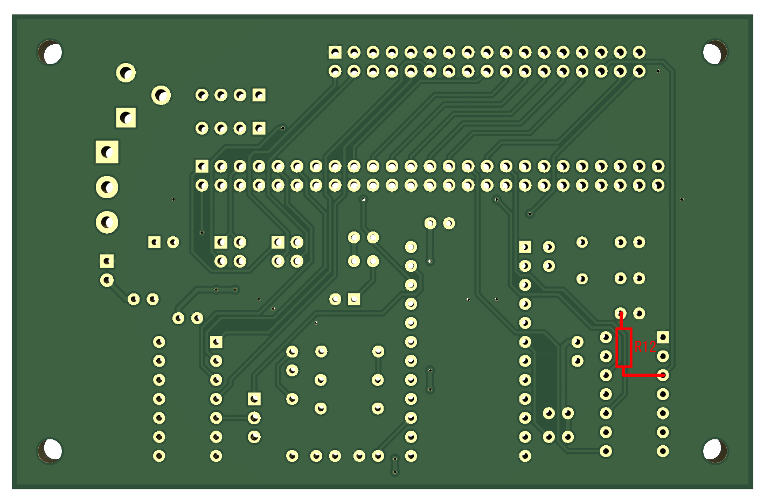

The notch of the BOX header is on the upper side.
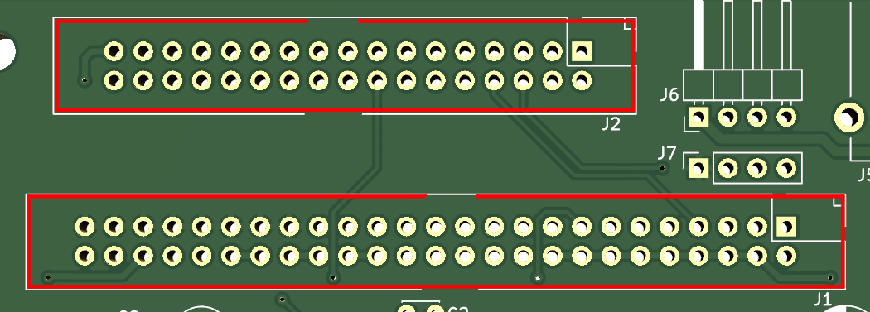

The anode (+) of the LED D1 is the lower side and the cathode (-) is the upper side.
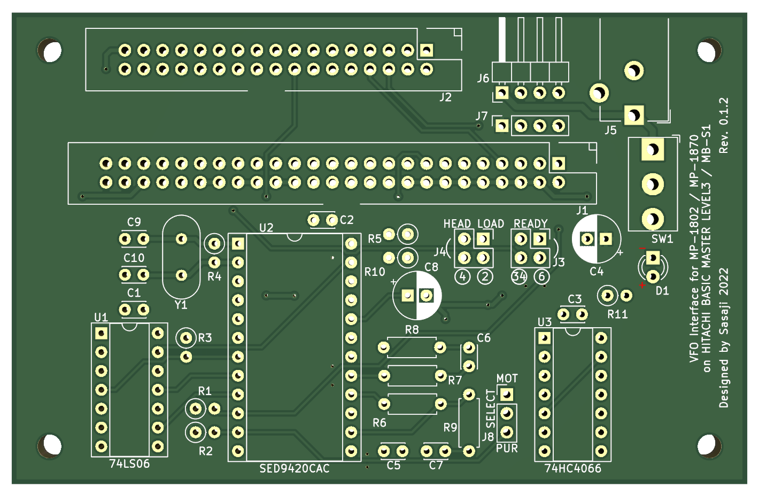

About optional functions

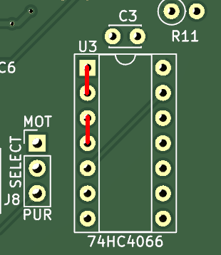
About U3
The 74HC4066 (U3) connects the DRIVE SELECT signal to the FDD while the MOTOR signal is ON.
You can omit this feature if always connect it.
If omit U3:
- Short to 1-2 and 3-4 on U3.
- C3 and J8 are unnecessary.
- J8 becomes meaningless as a jumper.

[Attention] If the physical FDD pull-up resistance value is low, drive select may not function properly.
In this case, short the pin on the connecting the physical FDD (drive 0 is pin 3-4, drive 1 is pin 1-2).

About J7
J7 is a power output for connecting to the FDD emulator (GOTEK). It works in conjunction with the power switch on this board.
pin1:+5V pin2,3:GND pin4:N/C [attention] not connected to +12V

No Warranty
We are not responsible for any damage caused by this board.
Use this board at your own risk.

Web Site
GitHub(https://github.com/bml3mk5/MP1802Gotek)

Sasaji (sasaji@s-sasaji.ddo.jp)
http://s-sasaji.ddo.jp/bml3mk5/
(Twitter: https://twitter.com/bml3mk5)

