HITACH BASIC MASTER LEVEL3 / MB-S1

VFO Interface for MP-1802 / MP-1870
Designed by Sasaji 2022 Rev. 0.1.2
This is an interface board connecting between a floppy disk drive and MP-1802 / MP-1870, the FD interface card on a PC.
You can use this on HITACHI BASIC MASTER LEVEL3 / Mark II / Mark5 and MB-S1.
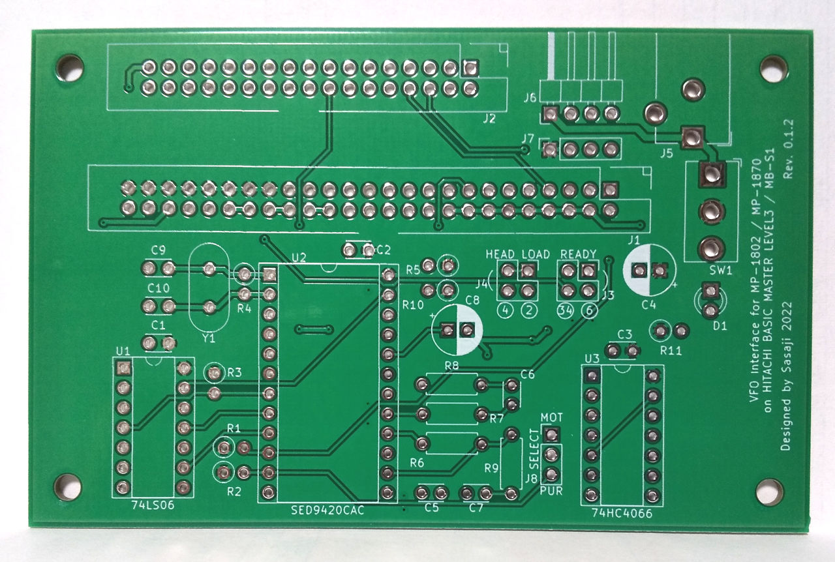
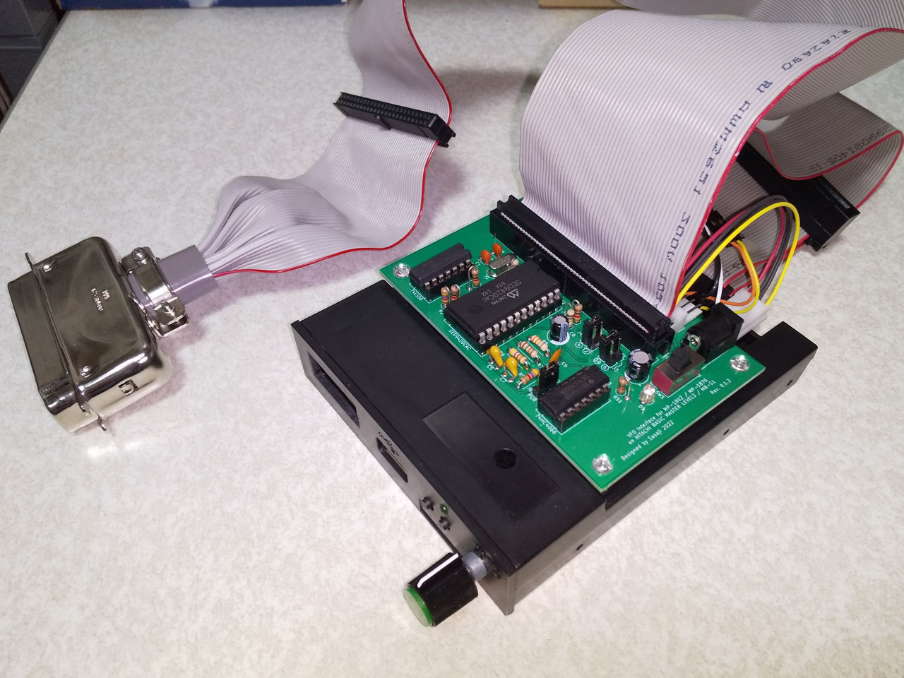
Connecting to the GOTEK floppy emulator

Preparing
To use this board, you need to prepare the following :
- The FD interface card MP-1802 or MP-1870 must be present on the computer.
- FDD Emulator (GOTEK)
- Power: +5V, 1A (A switching AC adapter etc.)
- Cable to connect with the computer: 50-pin Amphenol <-> 50-pin IDC connector (2.54mm pitch x 2 rows)
- Cable to connect with FDD: 34-pin IDC connector cable (2.54mm pitch x 2 rows)

Role of each part
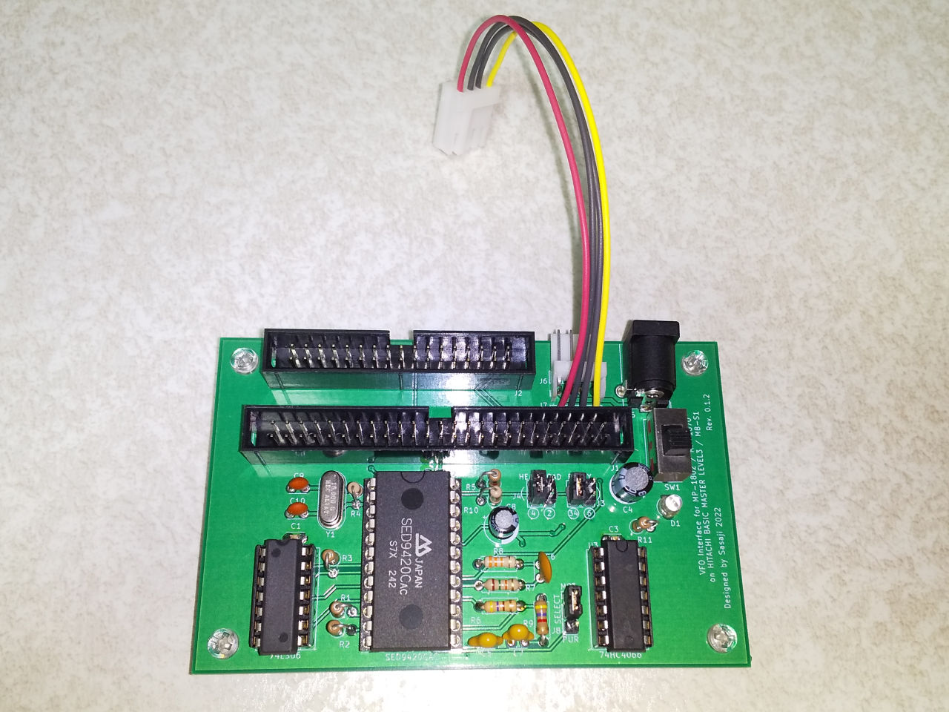
Power input +5V
DC Barrel Jack
(Center plus)
Power input +5V
EI connector
(+5V,Gnd,Gnd,N/C)
Connect to FDD
Connect to PC
Power output +5V
Connect to FDD
(Linked with power switch)
Power switch
Jumper
Jumper
+
-

Jumper pins
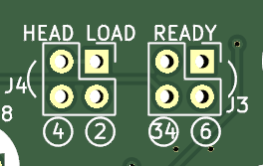
READY:
Select which the READY signal from the FDD is coming from.
pin34 or pin6
Short pins vertically.

HEAD LOAD:
Select which the HEAD LOAD signal from the computer is coming from.
pin4 or pin2
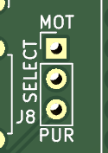
Short pins vertically.

SELECT:
Selects the behavior of the DRIVE SELECT signal.
- MOT(Short to 1-2)：Connect the signal while the MOTOR signal is ON.
- PUR(Short to 2-3)：Always connect the signal.

Pinout of the connector
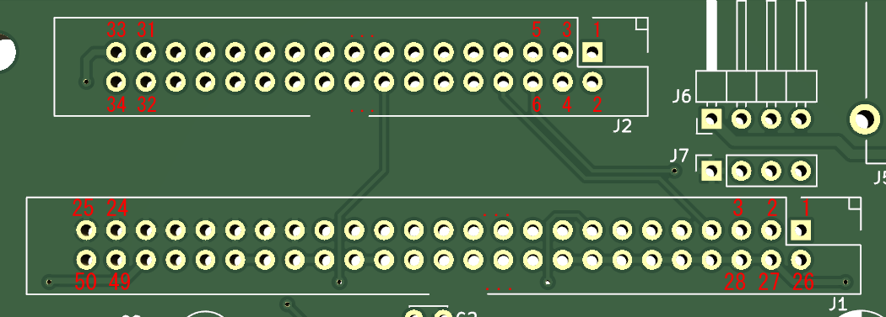
[Attention] The direction of silk printing is reversed. Correctly, the notch is on the upper side (pin 1 side).
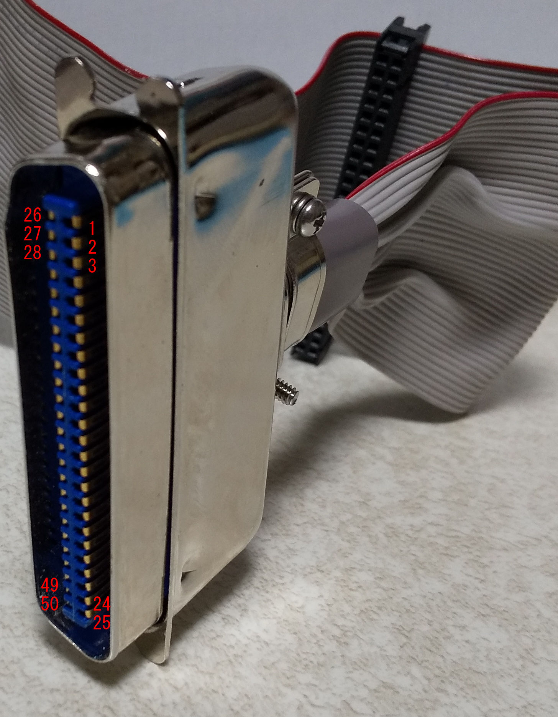

When making your own 50-pin cable
There is a protrusion near pin 26 on the MP-1802/MP-1870 side, so bend this part on the cable side so that it does not hit the protrusion.

Precautions for use
- Connect only one of the power input J5 (DC jack) and J6 (EI connector).
- Pin 4 (+12V line) of J6 is not connected to anything. When using an FDD that requires +12V, connect the power connector without going through this board.
- If the physical FDD pull-up resistance value is low, drive select may not function properly. In this case, see “About optional functions” section.
- This board is a prototype. Please note that we do not consider the noise generated during use or deterioration over time.

No Warranty
We are not responsible for any damage caused by this board.
Use this board at your own risk.

Web Site
GitHub(https://github.com/bml3mk5/MP1802Gotek)

Sasaji (sasaji@s-sasaji.ddo.jp)
http://s-sasaji.ddo.jp/bml3mk5/
(Twitter: https://twitter.com/bml3mk5)

