USBKeyboard for S1 [S]
Designed by Sasaji 2023 Rev. 0.1
This is a converter to connect a USB Keyboard to HITACHI MB-S1 and LimeLight.
You can use a USB Keyboard with a HUB and a simple one.

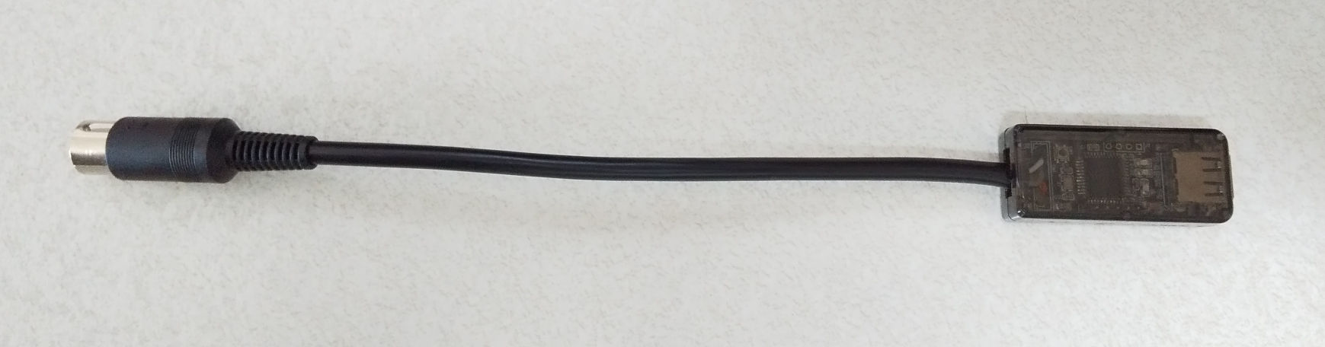
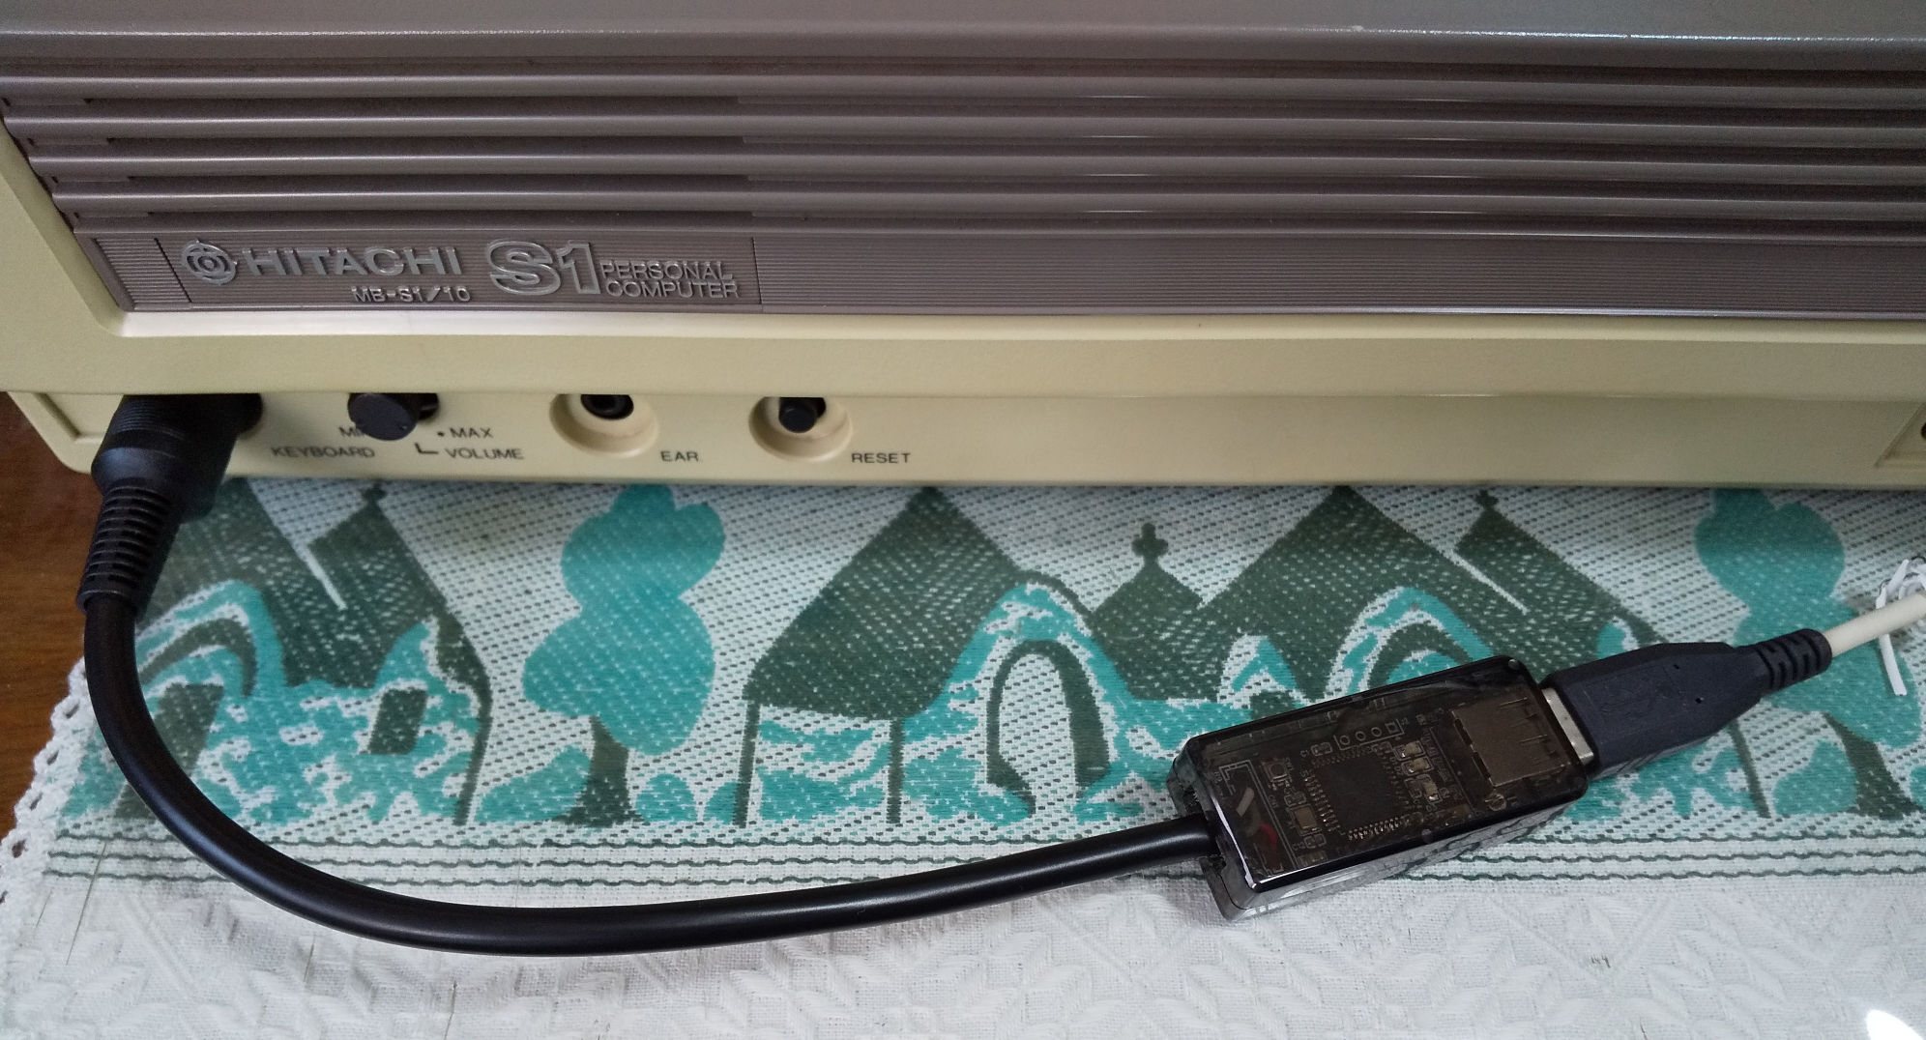
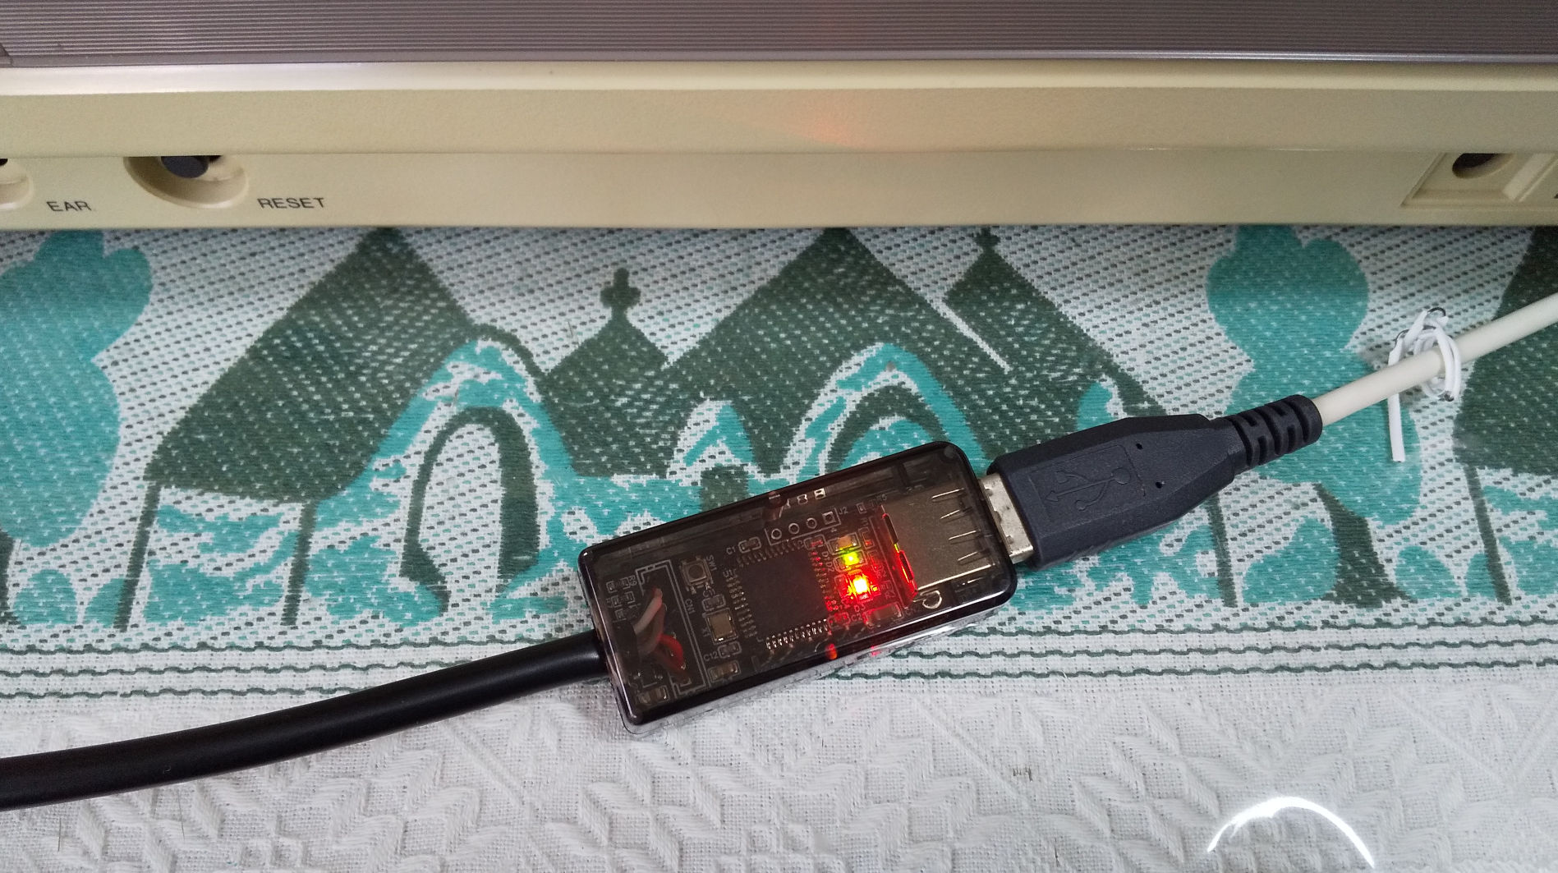
Example of the connection
Light the LED

How To Use

- Turn off the computer MB-S1.
- Connect this device to the keyboard connector of MB-S1.
- Connect a USB keyboard to this device.
- Turn on the MB-S1.
When the USB keyboard is recognized, the green LED blinks about 3 times.

Key Assign

Key assignment assumes a Japanese keyboard. We also recommend using a full keyboard.

These keys on the MB-S1 that are not on a USB keyboard are assigned as follows:

Table 1: Special key assignments
Key of MB-S1 | Key on USB Keyboard
[BREAK] | [F9]
[COPY] | [F12] / [PrintScreen]
[GRAPH] | [無変換] / [F7] / [Left Command]
[INS] | [Insert] / [F13]
[カタ/ひら] | [カタカナひらがな] / [F8] / [Right Command]
[変換] | [変換] / [F6]
[＿ロ] | [＿ろ] / [F11] / [Right ALT] / [Right Option]
[num ?] | [End]
[num ,] | [Page Down]

LED on This Converter
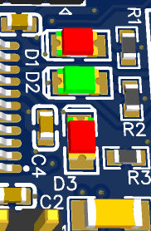
Red LED is ON
when katakana is ON.
Green LED is ON
when hiragana is ON.

Green LED blinks
about 3 times
when the USB keyboard
is recognized.

Red LED is ON
when caps is ON.

LED on a USB Keyboard

Num Lock → Turn on when katakana is ON.
Caps Lock → Turn on when caps is ON.
Scroll Lock → Turn on when hiragana is ON.

The Board Information
UART Connector
RESET Switch
PIC microcontroller
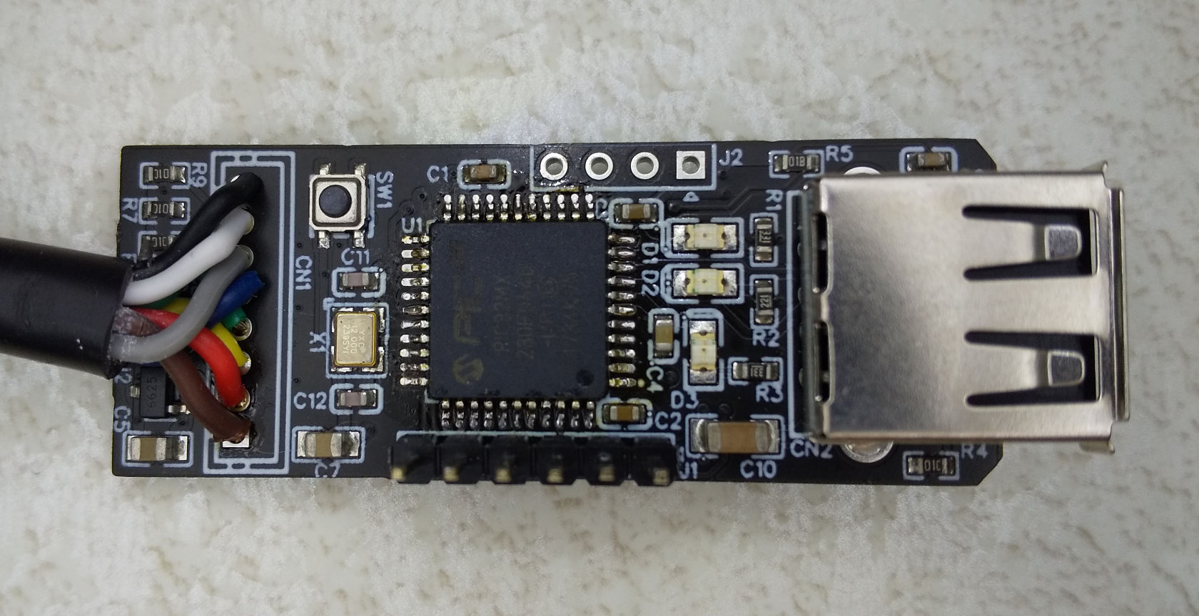
PICKit Connector
PIC microcontroller:
PIC32MX230F064D-I/PT

RESET Switch:
Initialize the PIC when you press this switch.

PICKit Connector:
Use for programming to the PIC.
Devices that can be connected are PICKit3, PICKit4 and compatibles.
These terminals are N/C, PGEC, PGED, GND, +3.3V, /MCLR from the left in the photo.

UART Connector:
Use for serial communication with the PIC. Nothing is outputted by default.
These terminals are GND, U1RX, U1TX, +5V from the left in the photo.

Attention

- You can use only a wired keyboard and one with a HUB.
- Use a keyboard that supports USB1.1.
- This does not support a wireless keyboard or Bluetooth.
- Do not connect anything to ports on a HUB.
- Behavior is undefined when you connect a device other than a keyboard. In the worst case, the device may fail.
- Avoid connecting and disconnecting USB devices while the power is on.
- Do not disconnect this from the computer while the power is on.

No Warranty

- This device is a prototype. Please note that we do not consider the noise generated during use or deterioration over time.
- We are not responsible for any damage caused by this device.
USE OF THIS EQUIPMENT IS AT YOUR OWN RISK.

Web
This document and CAD data are available here:
http://s-sasaji.ddo.jp/bml3mk5/s1usbkb.htm#smd

Sasaji (sasaji@s-sasaji.ddo.jp)
http://s-sasaji.ddo.jp/bml3mk5/
(Twitter: https://twitter.com/bml3mk5)

