USBKeyboard for S1 [S]
Designed by Sasaji 2023 Rev. 0.1.1

Parts List
Parts Number | Parts Name | Qty. | Description | Usage
C1, C6, C8, C9 | Ceramic Capacitor | 4 | 0.1uF 0603mil | Bypass
C2, C3 | Ceramic Capacitor | 2 | 1uF 0603mil | Bypass
C4 | Ceramic Capacitor | 1 | 10uF 10V~ 0603mil | Bypass
C5, C7 | Ceramic Capacitor | 2 | 47uF 10V~ 0805mil | Bypass
C10 | Ceramic Capacitor | 1 | 100uF 10V~ 1206mil | Bypass
C11, C12 | Ceramic Capacitor | 2 | 22pF 0603mil | For clock
C13 | Ceramic Capacitor | 1 | 22pF 0603mil | Noise Removal
D1, D3 | LED (Red Color) | 2 | 0805mil
D2 | LED (Green Color) | 1 | 0805mil
J2 | USB A Connector | 1 | For circuit board
R1, R3 | Carbon Resistor | 2 | 330Ω 1/6W~ 0603mil | For Red LED
R2 | Carbon Resistor | 1 | 220Ω 1/6W~ 0603mil | For Green LED
R5 | Carbon Resistor | 1 | 1kΩ 1/6W~ 0603mil | Reset
R4 | Carbon Resistor | 1 | 10kΩ 1/6W~ 0603mil | Pullup
R6, R7, R8, R9 | Carbon Resistor | 4 | 10kΩ 1/6W~ 0603mil | Pulldown
SW1 | Tact Switch | 1 | 4pins 3.4 x 3.4mm Momentary | Reset
U1 | Pic Microcontroller | 1 | PIC32MX230F064D-I/PT  TQFP 44
U2 | LDO Regurator | 1 | 5V to 3.3V SOT-23
Y1 | Crystal | 1 | 12MHz 4pins 3.2 x 2.5mm
J1 | Connector 6pins | 1 | Pinheader 1 x 6pins  2.54mm pitch | For PicKit
 | DIN connector 8pins | 1 | 8pins Type A male  (MP-018 etc.) | Connect to a PC.
 | Multicore Cable | 1 | 8cores AWM24 or 26  Outer diameter is less than 6mm.

Optional Parts
Parts Number | Parts Name | Qty. | Description | Usage
J2 | Connector 4pins | 1 | Pinheader 1 x 4pins  2.54mm pitch | For UART
 | Case | 1 | 53 x 24 x 14mm  (AK-N-12)

DIN8pins male assign:
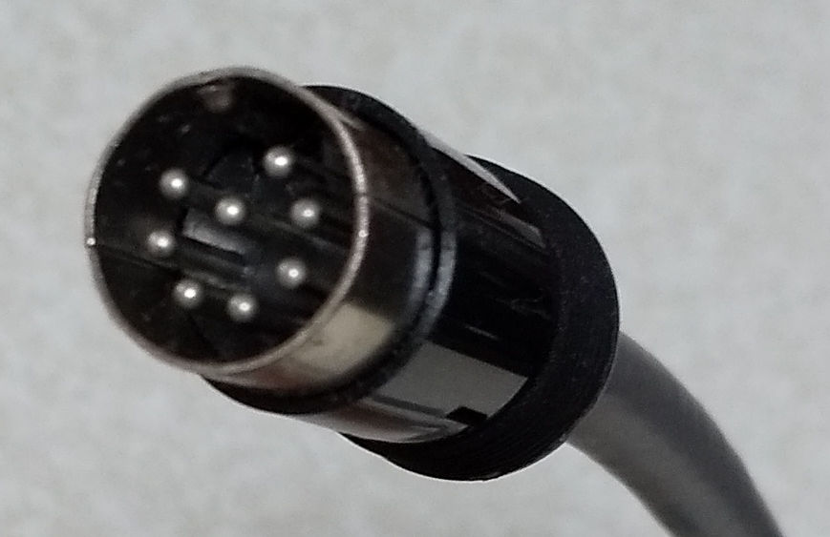
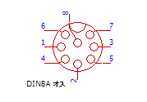

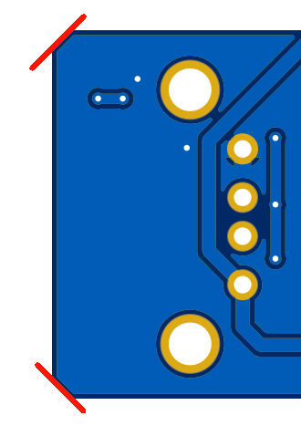
Warnings when housing the board in a case
- If the board does not fit in the case, cut off the slanted part a little.
- You must connect the multicore cable directly to the board. If you use a PH connector, it will not fit in a case due to its height.
- The height of the component side of the board should be about 8.5mm, and the height of the solder side should be about 1.5mm. (When thickness of the board is 1.6mm)

How to Program to The Microcontroller
- Connect a Programmer and Power supply to the circuit board.
  - Connect a programmer (PICKit3/4) to J1 on the board.
  - Connect a +5V Power supply to J2 or USB connector. When use the USB connector, don’t connect to the data line (D+,D-).
+5V Power Supply:
USB Connector
or
J2 Connector
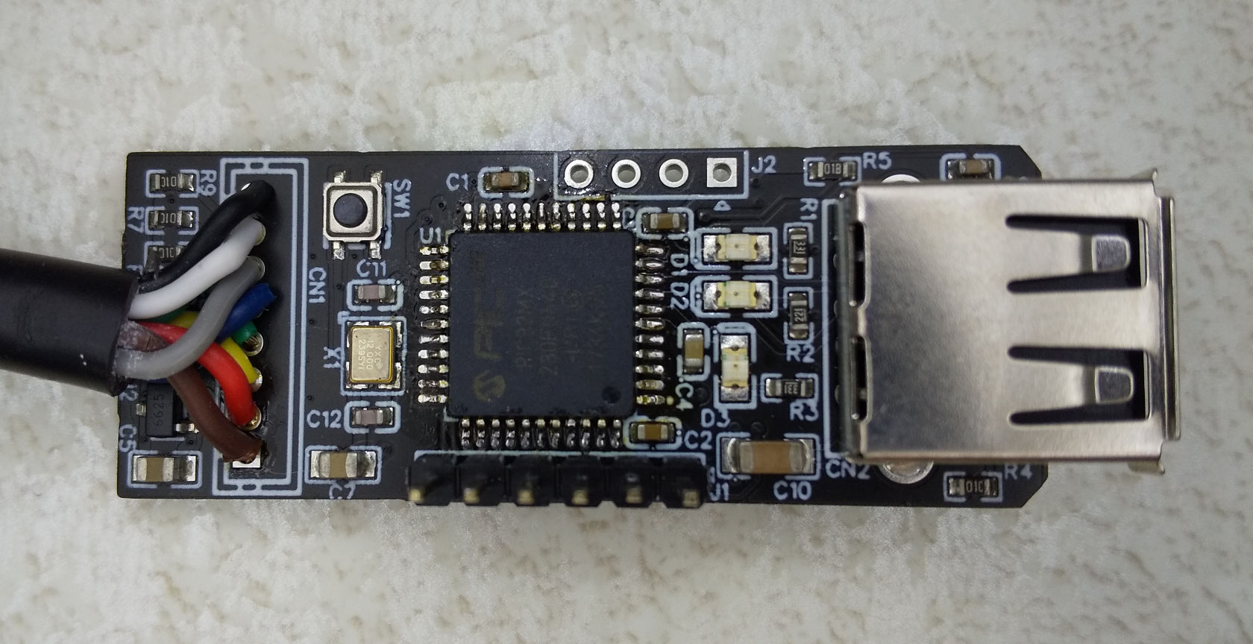
Programmer
(PICKit3/4)
- Program to PIC microcontroller using MPLAB IPE.
- Select a Device: PIC32MX230F064D
- Select a HEX file:
USBKeyboard4S1.X\dist\PIC32MX230F064D_I\production\USBKeyboard4S1.X.production.hex
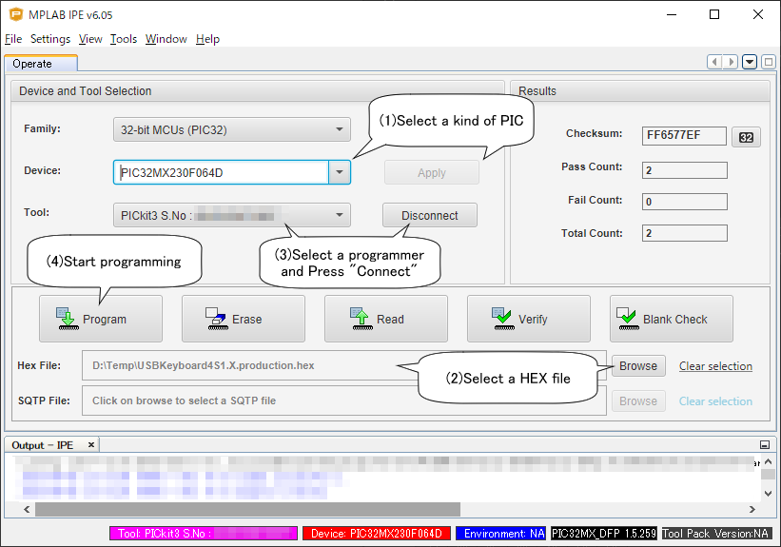
If succeed the programming, The Red LED(Caps) on the board is brighten.

Web
There are this document and a CAD data on the web:
http://s-sasaji.ddo.jp/bml3mk5/s1usbkb.htm#smd
or
https://github.com/bml3mk5/USBKeyboard4S1

Sasaji (sasaji@s-sasaji.ddo.jp)
http://s-sasaji.ddo.jp/bml3mk5/
(Twitter: https://twitter.com/bml3mk5)

If the outer diameter is more than 6mm , it will not pass in a bush of a DIN connector.

