USBKeyboard for S1 [N]
Designed by Sasaji 2023 Rev. 0.1.1

Parts List
Parts Number | Parts Name | Qty. | Description | Usage
C2, C6, C8, C9 | Ceramic Capacitor | 4 | 0.1uF | Bypass
C1, C3 | Ceramic Capacitor | 2 | 1uF | Bypass
C4 | Electrolytic Capacitor | 1 | 10uF 10V~ | Bypass
C5, C7 | Electrolytic Capacitor | 2 | 47uF 10V~ | Bypass
C10 | Electrolytic Capacitor | 1 | 100uF 10V~ | Bypass
C11, C12 | Ceramic Capacitor | 2 | 22pF | For clock
C13 | Ceramic Capacitor | 1 | 22pF | Noise Removal
D1, D3 | LED (Red Color) | 2 | Rectangle 2 x 5 x 7mm
D2 | LED (Green Color) | 1 | Rectangle 2 x 5 x 7mm
J2 | USB A Connector | 1 | For circuit board
R1, R3 | Carbon Resistor | 2 | 330Ω 1/4W | For Red LED
R2 | Carbon Resistor | 1 | 220Ω 1/4W | For Green LED
R5 | Carbon Resistor | 1 | 1kΩ 1/4W | Reset
R4 | Carbon Resistor | 1 | 10kΩ 1/4W | Pullup
R6, R7, R8, R9 | Carbon Resistor | 4 | 10kΩ 1/4W | Pulldown
SW1 | Tact Switch | 1 | 6 x 5mm Momentary | Reset
U1 | Pic Microcontroller | 1 | PIC32MX230F064B  DIP 28
U2 | LDO Regurator | 1 | 5V→ 3.3V / 100mA  (LM2940,LP2950 etc.)
Y1 | Crystal | 1 | 12MHz
J1 | Connector 8pins | 1 | JST XH 1 x 8pins  2.5mm pitch male | Connect between a cable and the board.  * It’s not necessary if connect a cable directly.
 | Connector 8pins Housing | 1 | JST XH 1 x 8pins  2.5mm pitch female
 | Pins | 8 | For XH connector
J3 | Connector 6pins | 1 | Pinheader 1 x 6pins  2.54mm pitch | For PicKit
 | DIN connector 8pins | 1 | 8pins Type A male  (MP-018 etc.) | Connect to a PC.
 | Multicore Cable | 1 | 8cores AWM24 or 26  Outer diameter is less than 6mm.

Optional Parts
Parts Number | Parts Name | Qty. | Description | Usage
J4 | Connector 4pins | 1 | Pinheader 1 x 4pins  2.54mm pitch | For UART
 | IC Socket | 1 | DIP 28 300mil
 | Case | 1 | 45 x 65mm  (TAKACHI SW-65 etc.)
 | Screws | 4 | M2 x 8mm
 | Nuts | 4
 | Washers | 4

DIN8pins male assign:
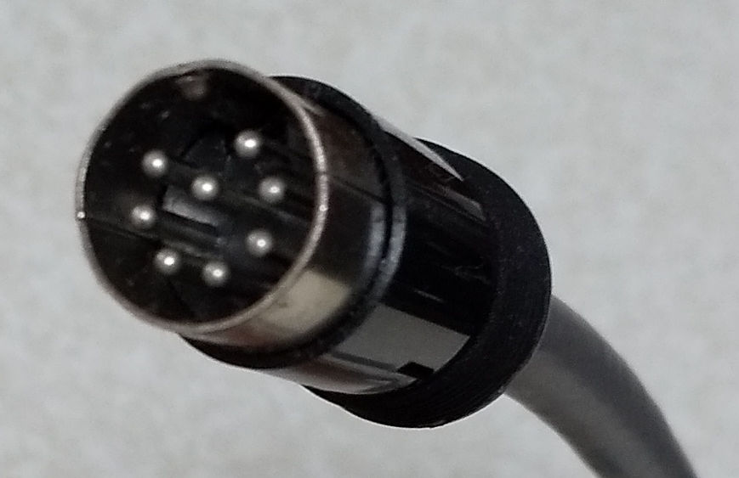
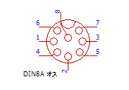

How to Program to The Microcontroller
- Connect a Programmer and Power supply to the circuit board.
  - Connect a programmer (PICKit3/4) to J3 on the board.
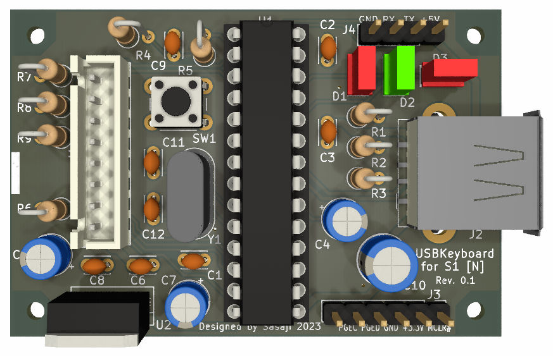
  - Connect a +5V Power supply to J4 or USB connector. When use the USB connector, don’t connect to the data line (D+,D-).
Programmer
(PICKit3/4)
+5V Power supply:
USB connector
or
J4 connector

- Program to PIC microcontroller using MPLAB IPE.
- Select a Device: PIC32MX230F064B
- Select a HEX file:
USBKeyboard4S1.X\dist\PIC32MX230F064B\production\USBKeyboard4S1.X.production.hex
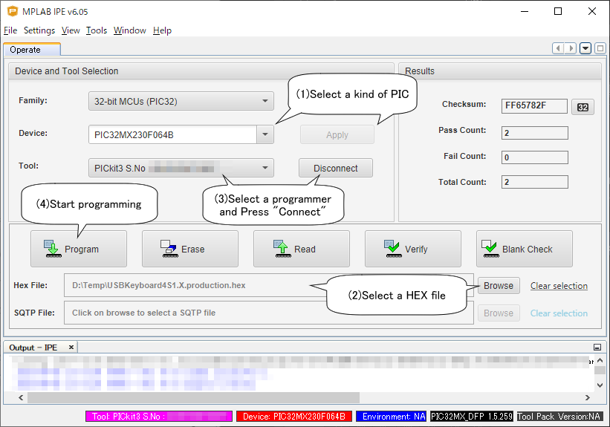
If succeed the programming, The Red LED(Caps) on the board is brighten.

Web
There are this document and a CAD data on the web:
http://s-sasaji.ddo.jp/bml3mk5/s1usbkb.htm#board
or
https://github.com/bml3mk5/USBKeyboard4S1

Sasaji (sasaji@s-sasaji.ddo.jp)
http://s-sasaji.ddo.jp/bml3mk5/
(Twitter: https://twitter.com/bml3mk5)

You can use PIC32MX2xxFxxxB series.
If the outer diameter is more than 6mm , it will not pass in a bush of a DIN connector.

