**EGN3204 — Engineering Software Tools**

**Pensacola (11193) Section**

**Spring 2017**

**Problem Set #1 (11 January, 2017 Lecture)**

**MATLAB R2015b, Multisim v14, Word**

Benjamin Linam

This handout presents general information on how problem set solutions for EGN3204 should be presented for grading; the information found in this document is a combination problem statement/solution for a sample problem set. This template file is presented as a Word 2007/2010/2013 *.docx and LibreOffice/OpenOffice *.odt file as each of these packages require slightly different techniques for including the required document page numbers. That is, any of the two template files can be used by EGN3204 students as needed throughout the semester.

As seen in this handout, the problem set solution must include a title page indicating the course name and number, section (Pensacola or Fort Walton Beach) as well as associated section number and semester, problem set number, with date it was assigned, and the student name. This title page is ***not*** numbered. The remaining pages are numbered starting with “1”.

In terms of presenting results, MATLAB work is to be organized so that a brief description of what is being presented is followed first by the MATLAB m file which is followed by any Command Window input/output and finally any graphical results. Each of these three items, if present, must be shown in a figure which has a numbered figure caption that describes what is being shown. Lastly, any analysis or interpretation of results that is called for in the problem statement is presented. Note that the MATLAB m file must contain the course number and semester as well as your name as a comment line while graphical results must contain your name as the title. The information just noted for MATLAB is presented in an example problem starting on page 2 where ten random numbers are generated and plotted to the screen as a function of where they are located in the random number vector. In addition, the number of random numbers greater than or equal to 0.5 as well as less than 0.5 are displayed to the command window. Also, the problem asks the student to comment on whether or not the results (i.e., the number of random numbers greater than or equal to 0.5 and less than 0.5) are as expected.

In terms of presenting Multisim results, after a brief description of what is being shown, the work is always organized in such a way that the circuit schematic is presented first followed by any necessary Grapher results. This is followed by any analysis or interpretation of results required as part of the problem statement. All Multisim schematics or Grapher results must be presented in figures with a numbered figure caption that describes what is being shown. Furthermore, the Multisim schematic and Grapher result must contain your name. The information just noted for Multisim is illustrated in an example starting on page 4 where the student is asked to construct a simple circuit and determine the power values and comment on whether or not a 50mW supply would be sufficient for the circuit.

As seen in this document, results are always presented in an enumerated list where the solution numbers correspond to those of the problem set. Also, MATLAB m files and command window input/output ***must*** be presented using a fixed width font (e.g., Courier) for proper horizontal spacing

In terms of the student presented solution for this assignment, remove all information from this page so that what was on page 2 is on page 1, what was on page 3 is on page 2, etc. with all formatting preserved. In addition, any red words (3 instances; two are on the title page and involve the section name and number and your name and one is in the MATLAB m file of Figure 1 and involves your name) are to be replaced by the appropriate words with the red changed to black. Then, as a new page at the end of the document to see how page numbers are automatically incremented, address when the due date/time is for the eighth problem set in the course (refer to the eLearning dropbox due date/time). That is, the document will have a title page followed by four numbered pages. Finally, generate a PDF file, name it correctly as noted in the syllabus and submit it to the appropriate [eLearning](https://elearning.uwf.edu) dropbox.

1. Figure 1 shows the MATLAB m file for addressing the first problem. Figure 2 shows the command window results indicating the number of values greater than or equal to 0.5 and less than 0.5 while Figure 3 shows a plot of the random numbers as a function of the index value where they are stored in the random number array.

% EGN3204, Spring 2016, Benjamin Linam

% Example MATLAB m file to generate 10 random number,

% determine the number greater than or equal to 0.5

% as well as plot the random numbers as a function

% of their index value.

clear all

random_numbers = rand(1,10);

index = 1:1:10;

greater_equal = length(find(random_numbers >= 0.5));

less_than = length(random_numbers) - greater_equal;

disp(['Number of random numbers >= 0.5 is ',num2str(greater_equal),'.'])

disp(['Number of random numbers < 0.5 is ',num2str(less_than),'.'])

figure(1)

plot(index,random_numbers,'ko')

xlabel('vector index number')

ylabel('random number value')

title('Your Name Goes Here')

**Figure 1**. MATLAB m file for random number determination.

>> example

Number of random numbers >= 0.5 is 7.

Number of random numbers < 0.5 is 3.

>>

**Figure 2**. MATLAB command window input/output showing number of random numbers >= 0.5 and < 0.5.



**Figure 3**. MATLAB plot showing numerical values of 10 random numbers.

The above results are a bit surprising. Typically, with a sufficiently large number of random numbers having a mean value of 0.5, one would expect approximately 50% to have a value >= 0.5. In this case, the number >= 0.5 is 70%.

1. Figure 3 shows the required circuit schematic for the circuit whose component power values are to be determined while Figure 4 shows the power associated with each circuit component.



**Figure 4**. Multisim circuit schematic for simple DC operating point circuit.

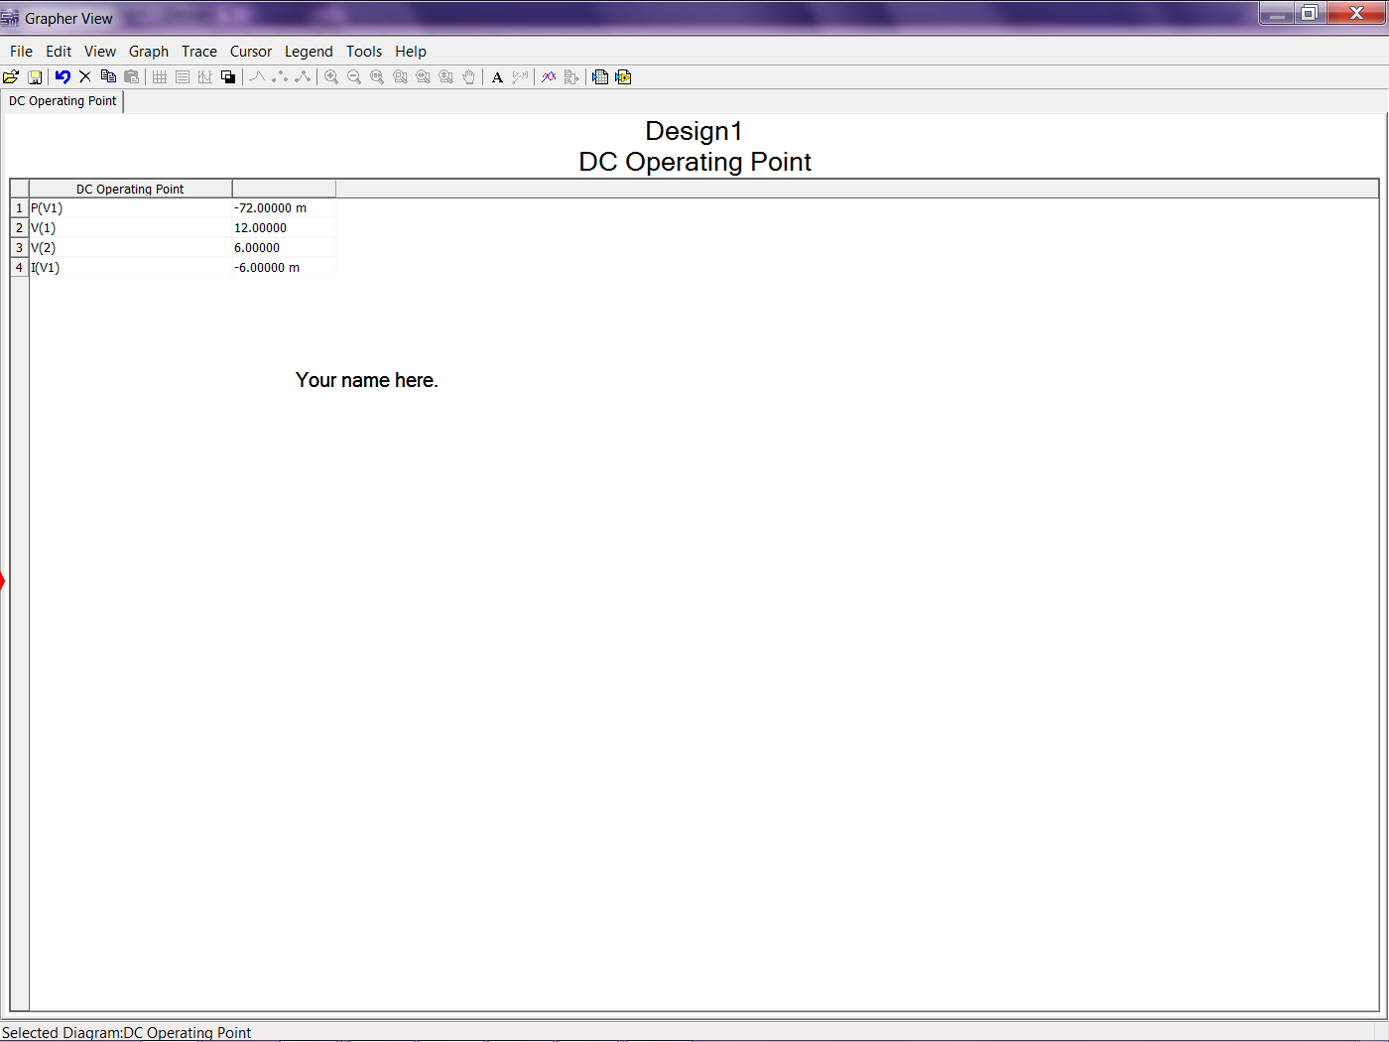

**Figure 5**. Grapher power results for Multisim circuit in Figure 4.

From the result shown in Grapher window of Figure 5, if the DC supply used for the circuit has a maximum power of 50mW, then it will ***not*** be sufficient for the circuit as the supply in the circuit requires a minimum of 72mW.