Token Ring Project

Benjamin Linam and Ali Al-Senan

COP4635 Systems and Networks 2

Screenshots of Token Ring:

Server running, 2/3 peers connected.

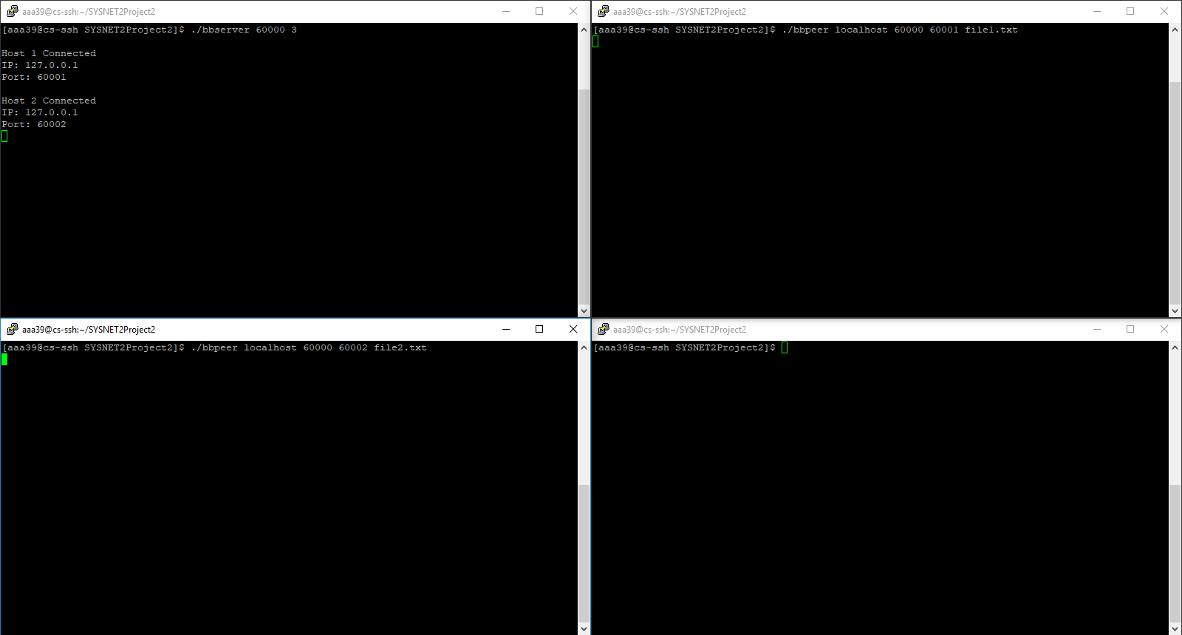

3 Peers connected, server shutting down.

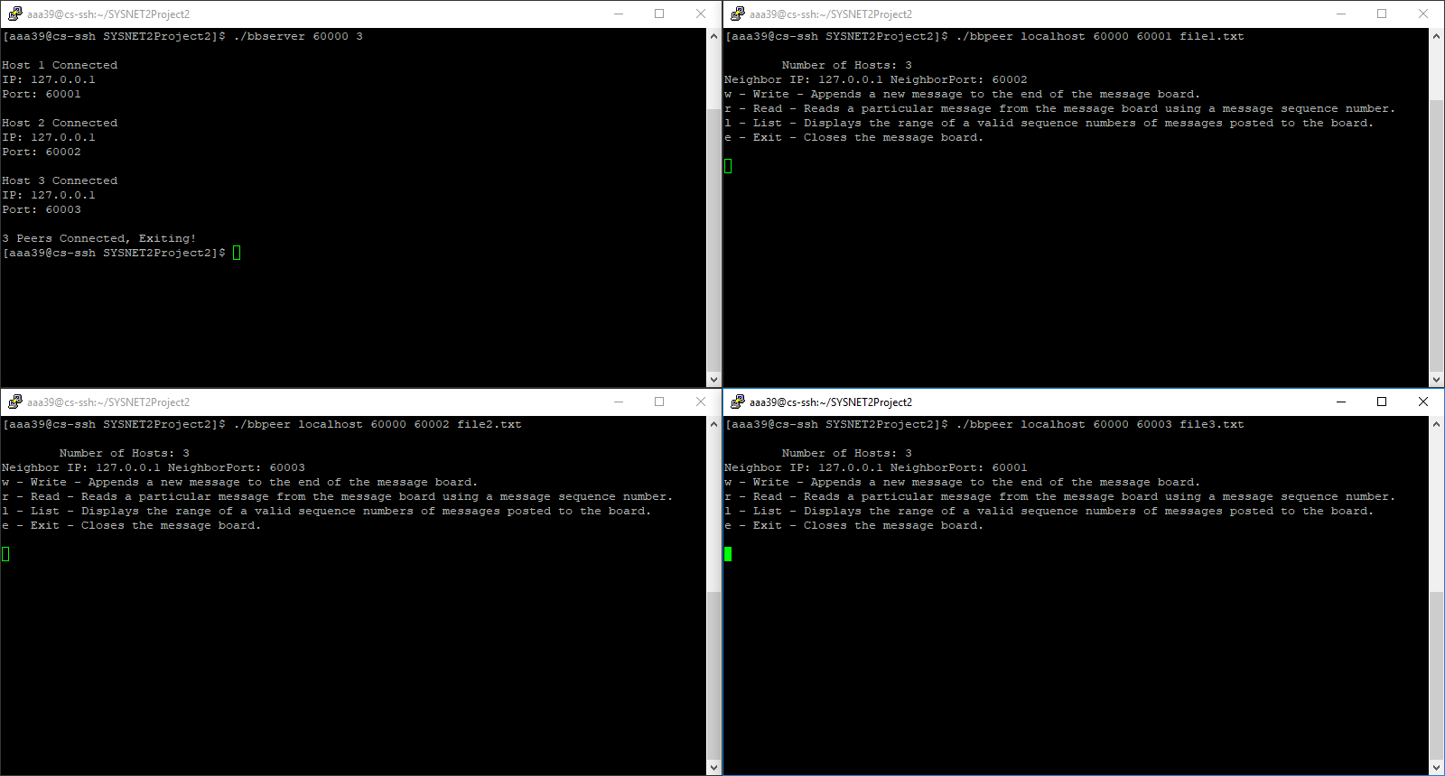

Peer 1: Wrote a message (n=1), Peer 2: Listed the number of valid sequences, Peer 3: Read message 1

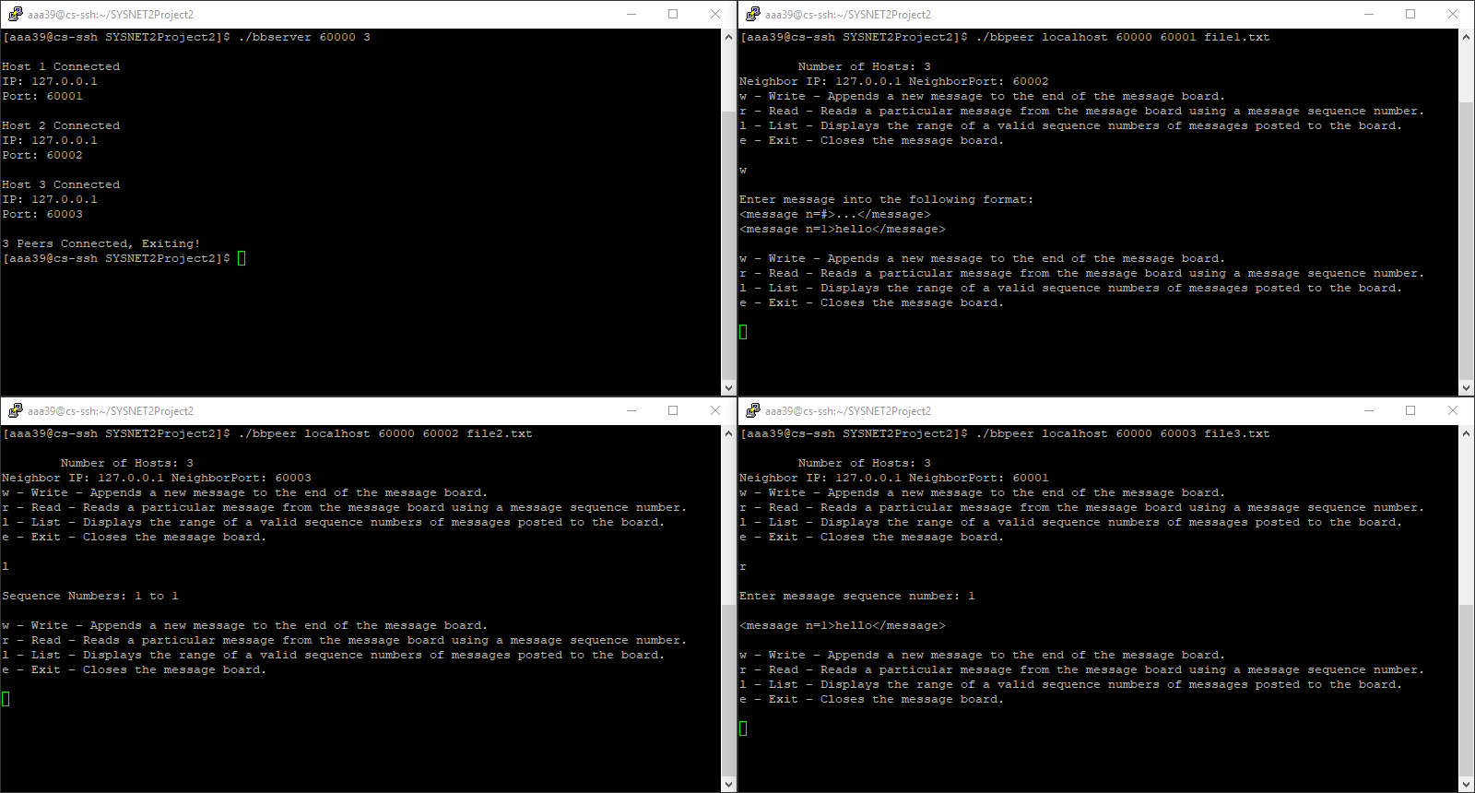

Peer 4 connected through Peer 1.

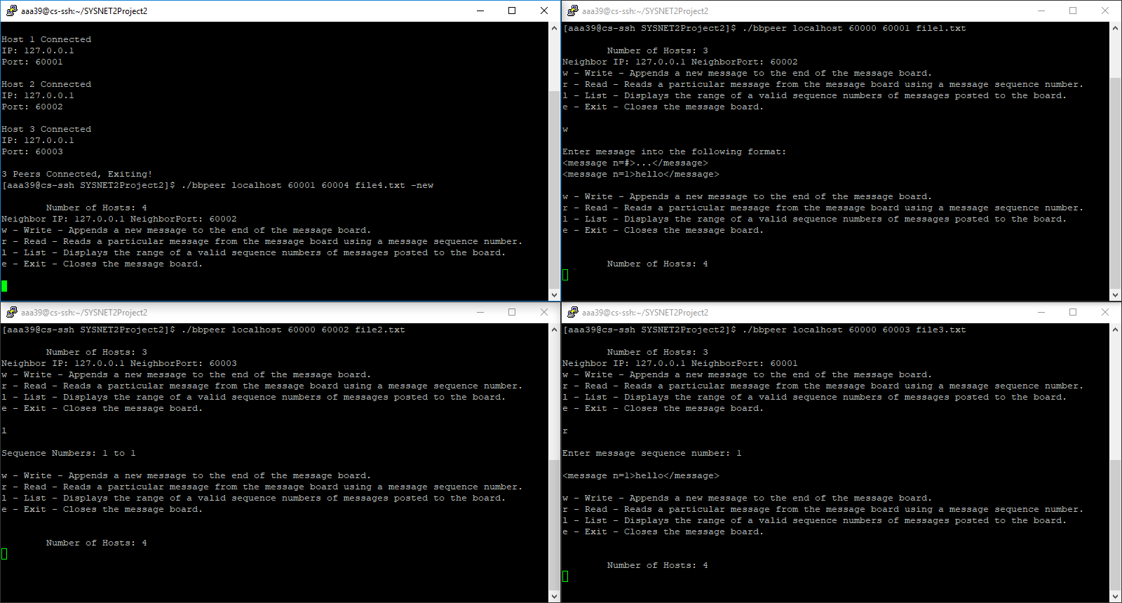

Peer 1 disconnected from the ring.

