The State of Ohio,
Plaintiff,
vs.Case No. {CaseNumber}
{DefendantFirstName} {DefendantLastName},
Defendant. Judge Marianne T. Hemmeter
Assigned to:
Judge Kyle E. Rohrer – Courtroom A Track

SCHEDULING ENTRY

The Court hereby advises the parties of the following:
- The parties shall file Pre-Trial Motions in accordance with the requirements set forth in Ohio Criminal Rule 12(D).

- All matters before the Court shall proceed as set forth below unless otherwise requested in advance by the parties, in writing, and approved by the Court.

- The parties shall participate in a telephonic pre-trial conference on or before {PretrialDate} between 3:00 PM and 5:00 PM.
- If you have not retained an attorney by the above pre-trial date, you must contact the Delaware City Prosecutor’s Office at 740.203.1175 on the pre-trial date.

- Following the pre-trial, Counsel for the State shall submit to the Court a Pre-Trial Conference Memorandum if the matter requires scheduling for a motion hearing or change of plea.

- The parties shall appear for an in-person Final Pre-trial Conference on {FinalPretrialDate} at {FinalPretrialTime}. The Court cannot conduct a change of plea hearing during the scheduled Final Pre-trial Conference without prior notice from the parties and approval of the Court.

- This matter is scheduled for Jury Trial on {JuryTrialDate} at {JuryTrialTime}.
- The parties shall reduce all stipulations to writing and file them with the Court no later than the beginning of trial.

- Prior to trial, the parties shall submit all proposed special jury instructions to the Court in writing.
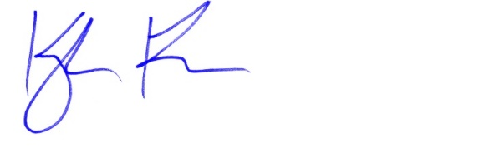
✍
Judge Kyle E. Rohrer

Dates were Confirmed with Counsel.
Interpreter Required: {LanguageRequired}

