Eclipse i Arduino
https://www.youtube.com/watch?v=TtPvkPpAx0E
https://links2004.github.io/Arduino/d4/dec/md_esp8266_doc_eclipse_eclipse.html
https://www.youtube.com/watch?v=AMyyAFkSj60
0. Instalirati Arduino
1. Instalirati Eclipse IDE for C/C++ Developers
2. Help -> Eclipse Marketplace
3. U tražilicu upisati "Arduino"
4. Instalirati "The Arduino Eclipse plugin named Sloeber V4"
5. U Arduino folderu napraviti sljedeće:
cd hardware
mkdir esp8266com
cd esp8266com
git clone https://github.com/esp8266/Arduino.git esp8266
cd esp8266/tools
python get.py
6. Otvoriti "Arduino perspektivu"
7. Project Explorer -> desni klik -> New -> Arduino Sketch:

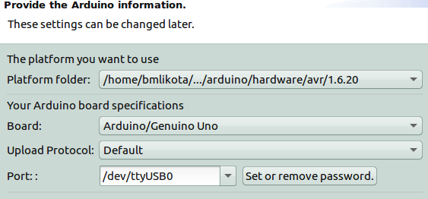
9. $ sudo apt install esptool

Instalacija ESP8266
U "Datoteka > Preporučene vrijednosti" dodati http://arduino.esp8266.com/stable/package_esp8266com_index.json:
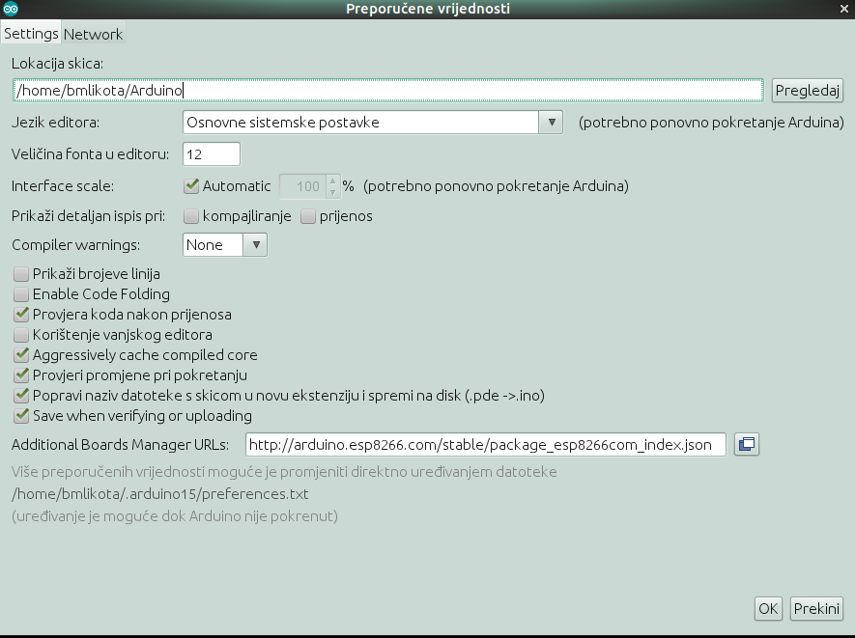

Alati -> Pločica -> Boards Manager -> esp8266

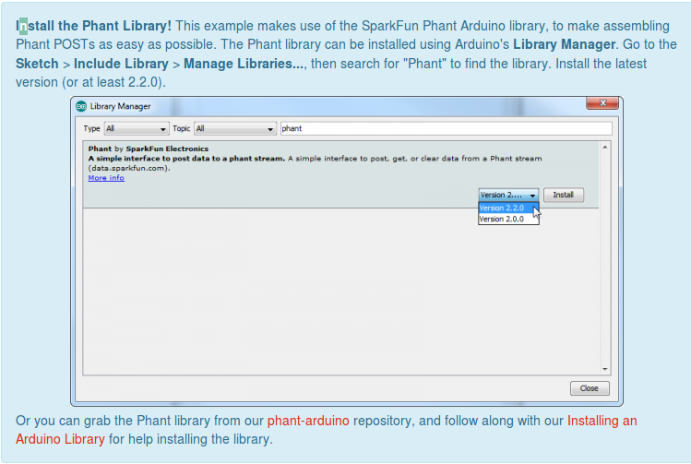

Terminal
~$ sudo chown bmlikota /dev/ttyUSB0

ESP8266
- to je bežični SoC (system on a chip) - mikroćip koji ima sve komponente kompjutera
- ima GPIO, I2C, ADC, SPI, PWM...
- CPU default je 80MHz, maksimalno može biti 160MHz
- baziran je na RISC arhitekturi
- jezgra je 106micro Diamond Standard core (LX3) - made by Tensilica

UART (universal asynchronous receiver-transmitter)
- računalni hardverski uređaj za asinkrono serijsko komuniciranje
- format podataka i brzina prijenosa je konfigurabilna
- standardno se stavljaju u mokrokontrolere
- uzima bajtove i transmitira ih u bitovima jedan za drugim (to je serijska transmisija kroz jednu žicu), a na odredištu drugi UART prima bitove i slaže ponovo u bajtove

SoftAP
- je skraćenica od "software enabled access point" je virtualni ruter – omogućuje da računalo, koje nije specificirano za to, postane wireless pristupna točka
- SoftAP pretvara ESP8266 u pristupnu točku preko koje se povezujete na WiFi
- Station mod pretvara ESP8266 u stanicu, tj. povezat će se na WiFi mrežu specificiranu u kodu
"Once you start working with ESP module, you would come across these two terms frequently. Let us say you and your friend would like to surf the internet on your smart phones but since he does not have an active internet connection you decide to turn on your hotspot and your friend connects to it. Here your phone which is sourcing the internet connection is the Access Point (AP) and your friend’s phone which is using the internet is called the Station (STA)."

DHCP (Dynamic Host Configuration Protocol)
Mrežni je protokol korišten od strane mrežnih računala za dodjeljivanje IP adresa i ostalih mrežnih postavki kao što su pretpostavljeni gateway, subnet maska i IP adrese DNS servera s DHCP servera. Olakšava konfiguraciju mreže jer eliminira ručno dodavanje osnovnih postavki za jednu računalnu mrežu. DHCP klijent se brine da su dodijeljene IP adrese ispravne i da u mreži nema sukoba adresa.

TCP
TCP je jedan od osnovnih protokola unutar IP grupe protokola. Naziv je kratica od engleskog naziva Transmission Control Protocol. Korištenjem protokola TCP aplikacija na nekom od hostova umreženog u računalnu mrežu kreira virtualnu konekciju prema drugom hostu, te putem te ostvarene konekcije zatim prenosi podatke. Stoga ovaj protokol spada u grupu tzv. spojnih protokola, za razliku od bespojnih protokola kakav je primjerice UDP. TCP garantira pouzdanu i isporuku podataka u kontroliranom redoslijedu od pošiljatelja prema primatelju. Osim toga, TCP pruža i mogućnost višestrukih istovremenih povezivanja prema jednoj aplikaciji više klijenata na jednom hostu više klijenata, gdje su najčešći primjeri za to web ili poslužitelji e-pošte.

UDP
UDP (User Datagram Protocol) je protokol koji se nalazi u dijelu transportne razine OSI modela, te je uz TCP jedan od temeljnih Internet protokola. UDP omogućuje slanje kratkih poruka (datagram) između aplikacija na umreženim računalima. U odnosu na mrežnu razinu OSI modela UDP dodaje samo funkcije multipleksiranja i provjeravanja pogreške prilikom prenošenja podataka, a nema mogućnost provjere primitka poruke jer ne čuva informaciju o stanju veze (tj. radi na principu pošalji i zaboravi). Zbog toga se koristi kada je bitnija brzina i efikasnost od pouzdanosti, npr. za prijenos govora u realnom vremenu (VoIP telefonija), a također i kada je potrebno slanje iste poruke na više odredišta (multicast).

SparkFun Logic Level Converter - Bi-Directional
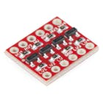

- The SparkFun bi-directional logic level converter je mali uređaj koji sigurno prevodi signal od 5V u signal od 3.3V i obratno signal od 3.3V prevoid u signal od 5V.

Povezivanje komponenti

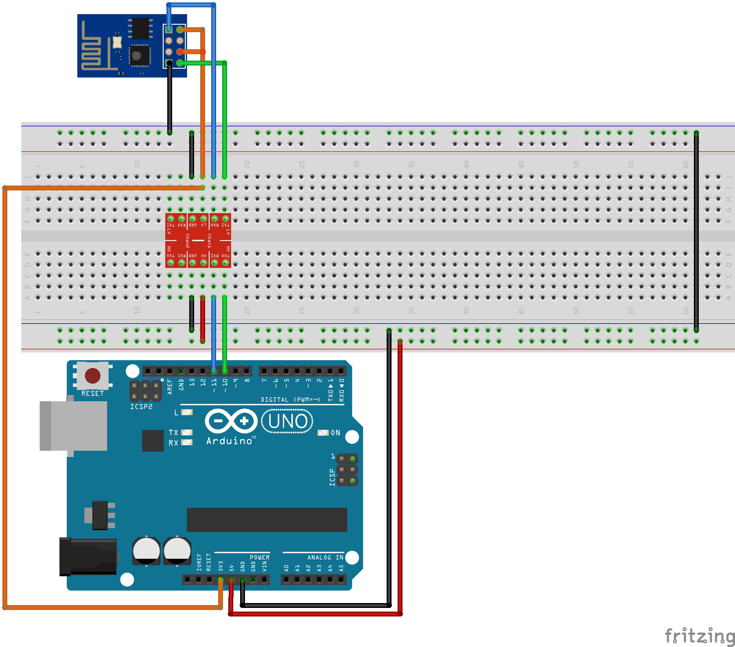
TX i RX
- TX je transmit signala. To je snaga u "decibel po milivatima" (-13 dBm po defaultu) po kojoj modem transmitira signal.
- RX je za primanje signala (recieve). To je snaga u dBm (od -18 do -25) od dolaznog signala.

AT instrukcije
- komande za modeme, nebitno dali su u pitanju modemi koji se nalaze u mobilnim telefonima ili kao interni/eksterni u računalim
- kod mobilnih telefona starijih generacija modem ima serijski izlaz, pa je zgodan za korištenje sa mikrokontrolerima. kod novijih telefona kada se telefon ukljuci u usb postoji negdje opcija da se kreira virtuelni serijski port koji sluzi za pristup modemu u telefonu
- ESP8266 se povezuje na drugi MCU (multipoint control unit)
- preko UART-aMCU šalje AT+CMD preko UART-a da bi kontrolirao ESP8266

Svaka instrukcija može sadržavati četiri komande:
1. Test – AT+CMD=? - provjerava da li je komanda postavljena ili parametre i njihov range
2. Query – At+CMD? - vraća trenutnu vrijednost parametra
3. Set – AT+CMD=Parameter – postavlja vrijednost koju je korisnik definirao i pokreće komandu
4. Execute – AT+CMD – pokreće komandu bez parametara koje je definirao korisnik
Napomene:
- nemaju sve AT instrukcije četiri komande
- [] = defaultna vrijednost
- string vrijendosti zahtjevaju duple navodnike, npr.: AT+CWSAP=“ESP756190”,”21030826”,1,4
- Baud rate = 115200 (jedinica brzine transmisije = broj koliko puta signal promijeni stanje u sekundi; 1 baud je ekvivalentan jednom bitu po sekundi)
- AT instrukcija završava s “\r\n”

Osnovne AT instrukcije
- AT – testira da li je AT startan
- AT+RST resetira modul
- AT+GMR – informacije o modulu
- AT+GSLP – ulazak u deep sleep mod
- ATE – echo AT komandi

AT
Type | Instruction | Response
execute | AT | OK

AT+RST – Restart module
Type | Instruction | Response
execute | AT+RST | OK

AT+GMR – View version info
Type | Instruction | Response | Parameter
execute | AT+GMR | number OK | number:version info, length:8 bytes

AT+GSLP – Enter deep-sleep mode
Type | Instruction | Response | Parameter
set | AT+GSLP=time | time OK | time : ms , set the sleep time of ESP8266 in ms.

ATE – AT commands echo
Type | Instruction | Response
set | ATE | OK
Opis
ATE0 : Disable echo
ATE1 : Enable echo

WIFI Function
Instruction | Description
AT+CWMODE | WIFI mode（station/softAP/station+softAP）
AT+CWJAP | Connect to AP
AT+CWLAP | Lists available APs
AT+CWQAP | Disconnect from AP
AT+ CWSAP | Set parameters under AP mode
AT+ CWLIF | Get station’s ip which is connected to ESP8266 softAP

AT+CWMODE - WIFI mode（station/softAP/station+softAP）
Type | Instruction | Response | Function
Query | AT+CWMODE? | +CWMODE:mode OK | Query AP’s info which is connect by ESP8266.
Execute | AT+CWMODE=mode | OK | Set AP’s info which will be connect by ESP8266.

Opis parametara
- mod：
1 Station mod
2 SoftAP mod
3 SoftAP + Station mod

AT+CWJAP – Connect to AP

Type | Instruction | Response | Function
Query | AT+CWJAP? | + CWJAP:ssid OK | Query AP’s info which is connect by ESP8266.
execute | AT+CWJAP=ssid,pwd | OK | Set AP’s info which will be connect by ESP8266.

Opis parametara：
ssid： string, AP’s SSID
pwd： string, MAX: 64 bytes
Primjer：
AT+CWJAP="wifi-1","12345678"

AT+CWLAP - Lists available APs
Type | Instruction | Response | Function
Set | AT+CWLAP=ssid,mac,ch | +CWLAP:ecn,ssid,rssi,mac OK | Search available APs with specific conditions.
execute | AT+CWLAP | +CWLAP:ecn,ssid,rssi,mac OK | Lists all available APs.
Opis parametara：
ecn:
0 OPEN
1 WEP
2 WPA_PSK
3 WPA2_PSK
4 WPA_WPA2_PSK
ssid: string, SSID od AP
rssi: jačina signala
mac: string, MAC adresa

AT+CWQAP - Disconnect from AP
Type | Instruction | Response | Function
execute | AT+CWQAP | OK | Disconnect from AP

AT+ CWSAP – Configuration of softAP mode
Type | Instruction | Response | Function
Query | AT+CWSAP? | +CWSAP:ssid,pwd,chl,ecn OK | Query configuration of ESP8266 softAP mode.
Set | AT+CWSAP=ssid,pwd,chl,ecn | OK | Set configuration of softAP mode.
Opis parametara
ssid: string, ESP8266 softAP’ SSID
pwd: string, MAX: 64 bytes
chl: channel id
ecn:
0 OPEN
2 WPA_PSK
3 WPA2_PSK
4 WPA_WPA2_PSK
Primjer
AT+CWSAP="esp_123","1234567890",5,3

AT+ CWLIF– ip of stations which are connected to ESP8266 softAP
Type | Instruction | Response | Function
execute | AT+CWLIF | ip addr OK | Get ip of stations which are connected to ESP8266 softAP
Parameter description：
ip addr: ip address of stations which are connected to ESP8266 softAP

AT+CWDHCP - Enable/Disable DHCP
Type | Instruction | Response
Set | AT+CWDHCP=mode,en | OK
Parameter Description
mode
0 : set ESP8266 softAP
1 : set ESP8266 station
2 : set both softAP and station
en
0 : Disable DHCP
1 : Enable DHCP

AT+CIPSTAMAC - Set mac address of ESP8266 station
Type | Instruction | Response | Function
Query | AT+CIPSTAMAC? | +CIPSTAMAC:mac OK | Query mac info of ESP8266 station.
Execute | AT+CIPSTAMAC=mac | OK | Set mac of ESP8266 station.
Parameter Description
mac： string,mac info of ESP8266 station.
Example
AT+CIPSTAMAC="18:aa:35:97:d4:7b"

AT+CIPAPMAC - Set mac address of ESP8266 softAP
Type | Instruction | Response | Function
Query | AT+CIPAPMAC? | +CIPAPMAC:mac OK | Get mac address of ESP8266 softAP.
Execute | AT+CIPAPMAC=mac | OK | Set mac of ESP8266 softAP.
Parameter Description
mac： string, mac address of ESP8266 softAP.
Example
AT+CIPAPMAC="2c:aa:35:97:d4:7b"

AT+CIPSTA - Set ip address of ESP8266 station
Type | Instruction | Response | Function
Query | AT+CIPSTA? | +CIPSTA:ip OK | Get ip address of ESP8266 station.
Execute | AT+CIPSTA=ip | OK | Set ip addr of ESP8266 station.
Parameter Description
ip： string, ip address of ESP8266 station.
Example
AT+CIPSTA="192.168.101.108"

AT+CIPAP - Set ip address of ESP8266 softAP
Type | Instruction | Response | Function
Query | AT+CIPAP? | +CIPAP:ip OK | Get ip address of ESP8266 softAP.
Execute | AT+CIPAP=ip | OK | Set ip addr of ESP8266 softAP.
Parameter Description
ip： string, ip address of ESP8266 softAP.
Example
AT+CIPAP="192.168.5.1"

TCPIP Function

AT+ CIPSTATUS – Information about connection
Type | Instruction | Response | Function
execute | AT+CIPSTATUS | STATUS:stat +CIPSTATUS:id,type,addr,port,tetype OK | Get information about connection.
Parameter description：
- stat：
- 2: Got IP
- 3: Connected
- 4: Disconnected
- id： id of the connection (0~4), for multi-connect
- type： string, “TCP” or “UDP”
- addr： string, IP address.
- port： port number
- tetype：
  - 0: ESP8266 runs as client
  - 1: ESP8266 runs as server

AT+CIPSTART – Establish TCP connection or register UDP port and start a connection
Type | Instruction | Response | Function
Set | AT+CIPSTART=type,addr,port | OK | Start a connection as client. (Single connection mode)
Set | AT+CIPSTART=id,type,addr,port | OK | Start a connection as client. (Multiple connection mode)
Param description:
- id: 0-4, id of connection
- type: string, “TCP” or “UDP”
- addr: string, remote ip
- port: integer, remote port

AT+CIPSEND – Send data
Type | Instruction | Response | Function
Set | AT+CIPSEND=length | SEND OK | Set length of the data that will be sent. For normal send (single connection).
Set | AT+CIPSEND=id,length | SEND OK | Set length of the data that will be sent. For normal send (multiple connection).
Execute | AT+CIPSEND

Normal Mode
Parameter description：
id: ID no. of transmit connection
length: data length, MAX 2048 bytes

Unvarnished Transmission Mode
Wrap return “>” after execute command. Enters unvarnished transmission, 20ms interval between each packet, maximum 2048 bytes per packet. When single packet containing “+++” is received, it returns to command mode.

AT+CIPCLOSE – Close TCP or UDP connection
Type | Instruction | Response | Function
Set | AT+CIPCLOSE=id | OK | Close TCP or UDP connection.For multiply connection mode
execute | AT+CIPCLOSE | OK | Close TCP or UDP connection.For single connection mode
Parameter description：
id： ID no. of connection to close, when id=5, all connections will be closed.
(In server mode, id=5 has no effect)

AT+CIFSR – Get local IP address
Type | Instruction | Response | Function
Execute | AT+CIFSR | +CIFSR:IP_address +CIFSR:IP_address OK | Get local IP address.
Parameter description：
IP_address:
IP address of ESP8266 softAP
IP address of ESP8266 station

AT+CIPMUX – Enable multiple connections or not
Type | Instruction | Response | Function
Set | AT+CIPMUX=mode | OK | Set connection mode, single connection or multiple connection.
Parameter description：
mode:
- 0: single connection
- 1: multiple connection
NOTE
This mode can only be changed after all connections are disconnected. If server is started, reboot is required.

AT+CIPSERVER – Configure as server
Type | Instruction | Response | Function
Set | AT+CIPSERVER=mode[,port] | OK | Configure ESP8266 as server
Parameter description：
- mode:
- 0: Delete server (need to follow by restart)
- 1: Create server
- port: port number, default is 333
NOTE
- Server can only be created when AT+CIPMUX=1
- Server monitor will automatically be created when Server is created.
- When a client is connected to the server, it will take up one connection，and be provided an ID

AT+CIPMODE – Set transfer mode
Type | Instruction | Response | Function
Set | AT+CIPMODE=mode | OK | Set transfer mode,normal or transparent transmission.
Parameter description：
- mode:
- 0: normal mode
- 1: unvarnished transmission mode

AT+CIPSTO – Set server timeout
Type | Instruction | Response | Function
Query | AT+CIPSTO? | +CIPSTO:time | Query server timeout.
Set | AT+CIPSTO=time | OK | Set server timeout.
Parameter description：
- time: server timeout, range 0~7200 seconds

AT+CIUPDATE – update through network
Type | Instruction | Response | Function
execute | AT+CIUPDATE | +CIPUPDATE:n OK | Start update through network
Parameter description：
-n:
- 1: found server
- 2: connect server
- 3: got edition
- 4: start update

+IPD – Receive network data
Type | Instruction | Response | Function
execute |  | +IPD,len:data | Receive network data from single connection.
execute |  | +IPD,id,len:data | Receive network data from multiple connection.
Parameter description：
- id: id no. of connection
- len: data length
- data: data received

IPR
execute | response | Information
AT+IPR=Baud | OK/ERROR | Sets baudrate of ESP module
Don't use this command on newer firmwares! Configuration will be wrong and you will have to erase the configuration part of flash memory.
See UART_CUR and UART_DEF commands.

at_example_0020000903

Single connection

(ESP8266 as TCP client)
- Set wifi mode：
AT+CWMODE=3 // softAP+station mode
Response：OK
- Reboot to take effect:
AT+RST
Response：OK
- Connect to router
AT+CWJAP="ssid","password" // ssid and password of router
Response：OK
- Query device’s IP
AT+CIFSR
Response：192.168.3.106 // Device got an IP from router.
- Using a network tool (eg: ”NetAssist.exe”) on the computer to create a server.
For example, server ip address:192.168.3.116, port 8080
- ESP8266EX connect to server as a client
AT+CIPSTART="TCP","192.168.3.116",8080 //protocol、server IP & port
Response：OK
- Send data
AT+CIPSEND=4 // set date length which will be sent, such as 4 bytes
>DGFY // enter the data, no CR
Response：SEND OK
Note: If the number of bytes sent is bigger than the size defined (n), will reply busy, and after sending n number of bytes, reply SEND OK.
- Receive data:
+IPD,n:xxxxxxxxxx // received n bytes, data=xxxxxxxxxxx

Transparent transmission
- Set wifi mode：
AT+CWMODE=3 // softAP+station mode
Response：OK
- Connect to router
AT+CWJAP="ssid","password" // ssid and password of router
Response：OK
- Query device’s IP
AT+CIFSR
Response：192.168.101.105 // Device’s ip that got from router.
- Using a network tool (eg: ”NetAssist.exe”) on the computer to create a server.
For example, server ip address:192.168.101.110, port 8080
- Device connect to server
AT+CIPSTART="TCP","192.168.101.110",8080 // protocol、server IP & port
Response：OK
Linked
- Enable transparent transmission mode
AT+CIPMODE=1
Response：OK
- Start send
AT+CIPSEND
Response： >
Note: From now on, data received from uart will be transparent transmited to server.
- Stop send
Data packet contains only “+++” exits Unvarnished transmission.

Multiple connection

(ESP8266 as TCP server)
- Set wifi mode：
AT+CWMODE=3 // softAP+station mode
Response：OK
- Enable multiple connection
AT+CIPMUX=1
Response：OK
- Setup server
AT+CIPSERVER=1 // default port = 333
Response：OK
- PC connects to ESP8266EX softAP as station, then PC connects to ESP8266EX server as client.
NOTE: ESP8266EX acting as server has a timeout mechanism. When connection is established and no data is transmitted within a period of time, it will disconnect the client. Please setup a recurring packet transmission every 5s on the computer to ensure connection is maintained.
- Send data
AT+CIPSEND=4 // set date length which will be sent, such as 4 bytes
>iopd // enter the data, no CR
Response：SEND OK
Note: If the number of bytes sent is bigger than the size defined (n), will reply busy, and after sending n number of bytes, reply SEND OK.
- Receive data: +IPD,n:xxxxxxxxxx // received n bytes, data = xxxxxxxxxx

UDP transmission
- Set wifi mode：
AT+CWMODE=3 // softAP+station mode
Response：OK
- Connect to router
AT+CWJAP="ssid","password" // ssid and password of router
Response：OK
- Query device’s IP
AT+CIFSR
Response：+CIFSR:STAIP,"192.168.101.104" // IP address of ESP8266 station
- PC connects to the same router which ESP8266 connects to. Using a network tool (eg: ”NetAssist.exe”) on the computer to create UDP .
- Enable multiple connection
AT+CIPMUX=1
Response：OK
- Create a UDP transmission, for example, id is 4.
AT+CIPSTART=4,"UDP","192.168.101.110",8080,1112,0
Response：4,CONNECT OK
Note：
"192.168.101.110",8080 here is the remote ip and port of UDP transmission which create on PC in step 4;
1112 is the local port of ESP8266, user-define, if user does not define it, it will be a random value;
0 means destination peer entity of UDP will not change. For example, in this case, if another PC also creates a UDP entity and sends data to ESP8266 port 1112, ESP8266 can receive these data, but when we send data with command “AT+CIPSEND=4,X”, it will still be sent to the first PC. If this parameter is not 0, it will send to the new PC.
- Send data
AT+CIPSEND=4,5 // Send 5 bytes to transmission NO.4
Response > DGFYQ // enter the data, no CR
SEND OK
Note: If the number of bytes sent is bigger than the size defined (n), will reply busy, and after sending n number of bytes, reply SEND OK.
- Receive data:
+IPD,4,n:xxxxxxxxxx // received n bytes, data=xxxxxxxxxxx
- Delete transmission NO.4
AT+CIPCLOSE=4
Response：4,CLOSED OK

