World Reacts with Suspicion to Putin's Endorsement of Ukraine's Election
Zlatica Hoke
May 08,2014
WASHINGTON — The world has welcomed, but also expressed suspicion about the Russian president's endorsement of Ukraine's upcoming presidential election. President Vladimir Putin on Wednesday also called on pro-Russian groups in eastern Ukraine to postpone their referendum on independence planned for the coming days. He said Russian troops have been withdrawn from the border with Ukraine as the United States and the European Union requested.
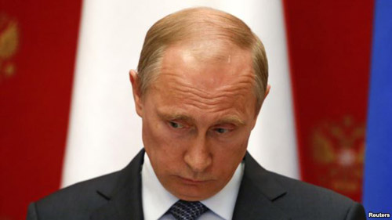
President Putin said Wednesday the vote, set by Kyiv for May 25, is a step in the right direction, but that his support is limited.
"I want to emphasize that the presidential election to be held in Kyiv is going in the right direction, but it will not solve anything if all Ukrainian citizens do not understand how their rights will be guaranteed after the presidential election,” said Putin.
Putin made his remarks during a visit by an OSCE representative in Moscow, a day after the top EU and U.S. diplomats threatened tougher sanctions if Russia disrupts the Ukrainian elections.
In Washington, analyst Stephen Blank said it is clear that two previous rounds of sanctions imposed on Moscow have begun to hurt.
"So if there were going to be more sanctions -- and they'll be even more severe -- against the Russian banking, energy industries and the Russian economy, that's not something he wanted to risk," said Blank.
Blank said Russia will covertly continue to try to destabilize Ukraine before, during and after the elections, because it does not want an independent, pro-western Ukraine near its borders.
Separatist leaders in Ukraine's Donetsk region said the referendum will take place as planned, despite Putin's advice, if Kyiv does not fulfill their demands.
"The troops must return to their bases, all illegal armed units created after February 22, including Internal Ministry's and National Guard's special units must disarm. Only after that can we talk about postponement of the referendum," said Alexander Kofman, a separatist leader.
Kyiv has sent military forces to retake occupied government buildings in Donetsk, Slovyansk, Luhansk and other areas of eastern Ukraine. Acting Prime Minister Arseniy Yatsenyuk said that operation will continue, along with the efforts to find a political solution to the crisis.
"Those who have weapons and are shooting must surrender their weapons and take the punishment. Those who will surrender their weapons willingly and leave buildings, if they didn't do serious crimes will be pardoned," said Yatsenyuk.
Moscow has denied accusations that it is arming the separatists who have so far largely held their positions. Blank said that even if Russia has withdrawn its forces from the border, they can easily be mobilized to march into Ukraine if Moscow determines the situation is right.

