Pakistan Moves to Contain Polio Virus after Travel Sanctions
Sharon Behn
May 16,2014
RAWALPINDI, PAKISTAN — Pakistan is moving quickly to try to contain the polio virus after the World Health Organization imposed international travel restrictions on anyone coming from the polio endemic country. Health workers in Rawalpindi are working with parents to vaccinate their children.
Pakistan has ordered mandatory polio vaccinations for anyone leaving the country’s tribal northwest where the virus is concentrated.
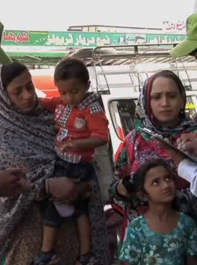
The World Health Organization has imposed international travel restrictions on anyone leaving Pakistan without proof of vaccination as of June 1.
Nosherwan Khan, who owns a bus depot and belongs to the Pakistan Polio Plus committee, calls the WHO decision a wake-up call.
“They have to do something, Pakistani government has to do something," said Khan. "This travel ban has come as a kind of shock to all Pakistanis, and it opened their eyes up, actually, very much.
The country has the highest number of new polio cases in the world, and Pakistanis such as Sohail Qoreshi, like most people, understand the vaccine's importance.
“Polio is an epidemic in Pakistan and spreading rapidly," said Qoreshi. "Our health workers have worked hard, they’ve gone house to house with the polio drops. Now they are providing the drops at bus stops.
Much of the country has been inoculated, leaving the virus concentrated in Pakistan’s volatile tribal regions, where Taliban militants banned vaccination efforts in 2012, leaving many beyond the reach of health workers.
World Health Organization's Nima Saeed Abid says infections will persist until vaccinations resume.
“There should be a means by all parties in conflict, or all parties who have influence in this area, to sit actually and allow vaccination of these children," said Abid. "So many children have been crippled ... due to a completely avoidable disease. I mean, health is impartial and all stakeholders should understand that.
There is evidence that polio from Pakistan has reached as far as Egypt and Israel. Now everyone here, including adults, must be vaccinated as the global effort to wipe out the disease focuses on the last few places where polio is still spreading.

