Huge Victory for Modi Raises Expectations for Change in India
Aru Pande
May 16,2014
WASHINGTON — He’s been called polarizing, efficient and autocratic - often in the same sentence. No Indian politician has generated so much attention and focus in recent years as India's next prime minister, Narendra Modi, whose Bharatiya Janata Party swept India's parliamentary elections.
Like so many other members of India's lower class, housekeeper Bhagwat Singh said the country's economic boom has escaped him. “Every place is corrupt, everywhere.
Without money, you can’t get anything done. If a poor man wants something done, they are just sent from place to place,” he said.
Corruption, bureaucracy, and red tape have long plagued India, the world’s largest democracy.
This new prime minister Modi, however, is promising change.
Humble beginning
With humble roots as the son of a tea vendor, Modi has risen through the ranks of the Hindu nationalist Bharatiya Janata Party and served as the chief minister of Gujarat for 13 years.
Supporters say in that time, he has transformed the western Indian state into an economic success, powering homes, building roads and attracting investment through high-profile summits like this one - with a results-driven approach and a no-nonsense attitude towards graft.
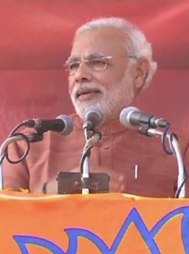
It is this change that many, including India’s business leaders, hope Modi will implement on a national level as prime minister.
Rick Rossow, a senior fellow at the Center for Strategic and International Studies in Washington, said, "Seeing him as prime minister, I think, would be very much welcomed in [my] conversations with business leaders. They do want to see some sort of change - regulatory consistency, new economic reforms to take place, the ability to cut down on corruption.”
High expectations
But while much of the country remains hopeful about Modi's leadership, some also are fearful. He was accused of doing nothing to stop deadly sectarian riots that hit Gujarat in 2002. At least 1,000 people were killed, mostly Muslims.
Although the Indian Supreme Court cleared the 63-year-old of involvement in the violence, many, particularly the country's 180 million Muslims, are wary of a man who was a longtime member of the hardline Hindu nationalist group Rashtriya Swayamsevak Sangh, or RSS.
Brookings Institution fellow Tanvi Madan said Indians will be watching to see if Modi focuses on growth and development and not promoting Hindu nationalism.
“If he is seen as moving away from his promises during the campaign to be the prime minister of all Indians, I think you will see these issues [of sectarianism] emerge again. But if he proves that he is going to focus on what he has promised to deliver, I think people will not necessarily set them aside, but they will move to the background,” said Madan.
With Modi's BJP winning in a landslide, expectations are certainly high.

