Sanctions Threat Weighs on Russian Oil Industry
James Brooke
June 23,2014
MOSCOW — Russia’s economy runs on oil and gas, but with Russia’s economy on the edge of recession, a new threat has emerged: possible sanctions against energy technology sales from the West.
The World Petroleum Congress was supposed to bring together Russia, the world’s largest energy producer, and the United States, the world’s largest producer of cutting-edge energy technology.
But oil expert Pat Szymczak says the United States was almost a no-show.
“There are very few American companies here," Szymczak said. "Of the 3,000 delegates, I noticed only 250 that really appeared to be coming from the United States.”
Clouding the party were sanctions against Russia for its role in fueling the separatist war in southeastern Ukraine.
After targeting powerful Russians with sanctions, European Union leaders are to meet Thursday in Brussels to discuss escalating sanctions to companies or to sectors such as energy technology. It is unclear whether Russian President Vladimir Putin’s qualified support for Ukraine’s new cease-fire will blunt the momentum for sanctions.
Last week, with Russian troops massing again at Ukraine’s border, U.S. Treasury Secretary Jacob Lew warned in Berlin that Russia has what he called "a fundamental choice to make.”
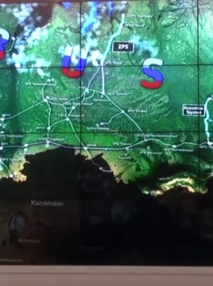
"If Russia is unwilling to reverse the course, the United States and the international community are prepared to impose additional cost," Lew said.
In Moscow, Western energy executives with big Russia investments tried to project a business as usual image. Rex Tillerson, CEO of Exxon Mobil, and Bob Dudley, CEO of BP spoke on panels at the meeting.
But in the halls, there was unease.
“I heard a lot of questions about sanctions from our customers," said Vitaly Cho, who works in Russia for Baker Hughes, the Houston-based international oilfield service company. "They are worried. Baker Hughes is a technology provider. We have high-tech, and our customers need these technologies to develop their fields.”
Russia needs American and European drilling and platform technology to unlock, what Bloomberg reports, is an estimated $8 trillion worth of oil.
Wilhelm Sicking, a German marketer for PennWell, the Oklahoma group of energy publications, believes business will come back.
“The Western companies need to sell their technology to the Russians, and the Russians need the technology," Sicking said. "This will not last long.”
Szymczak says uncertainty over sanctions is causing many American companies to cut investments in Russia.
“It is shooting ourselves in the foot ... because, if we do not sell to the Russians, somebody else will sell to the Russians,” he said.
Coming days will tell if Russia’s support for the cease-fire is enough for Western powers to put sanctions on the shelf.

